**Objective**

The objective of lab is exploring inkwell widgets and its usages. Also learn how to use scrollview and listview widget.

**Assessment**

**Task 1:** Create a Flutter application that:

* Displays a column of widgets (e.g., Text, Image, Buttons) inside a SingleChildScrollView.
* The scrollable content should exceed the height of the screen, enabling vertical scrolling.
* Add padding and some decoration to make the items stand out.

**Ans:**

**Main.dart:**

import 'package:flutter/material.dart';

void main() {

runApp(MyApp());}

class MyApp extends StatelessWidget {

@override

Widget build(BuildContext context) {

return MaterialApp(

debugShowCheckedModeBanner: false,

home: abc(), );}}

class abc extends StatelessWidget {

@override

Widget build(BuildContext context) {

return Scaffold(

appBar: AppBar(title: Text("MyApp")),

body: Center(

child:SingleChildScrollView(

child: Padding(

padding: EdgeInsets.all(16.0),

child: Column(

crossAxisAlignment: CrossAxisAlignment.center,

children: [

Container(

padding: EdgeInsets.all(16),

decoration: BoxDecoration(

color: Colors.blue.shade100,

borderRadius: BorderRadius.circular(12), ),

child: Text(

"Welcome to myApp",

style: TextStyle(fontSize: 24, fontWeight: FontWeight.bold),),),

SizedBox(height: 20),

ClipRRect(

borderRadius: BorderRadius.circular(12),

child: Image.asset("assets/image.jpeg", width: 300, height: 200, fit: BoxFit.cover),

),

SizedBox(height: 20),

ElevatedButton(

onPressed: () {},

child: Text("Click Me!"),

),

SizedBox(height: 20),

Container(

padding: EdgeInsets.all(16),

decoration: BoxDecoration(

color: Colors.green.shade100,

borderRadius: BorderRadius.circular(12),),

child: Text(

"This my lab#4 of flutter",

style: TextStyle(fontSize: 18),

textAlign: TextAlign.center,), ),

SizedBox(height: 500), // To ensure content exceeds screen height ], ), ),), ), ); }}

OUTPUT:

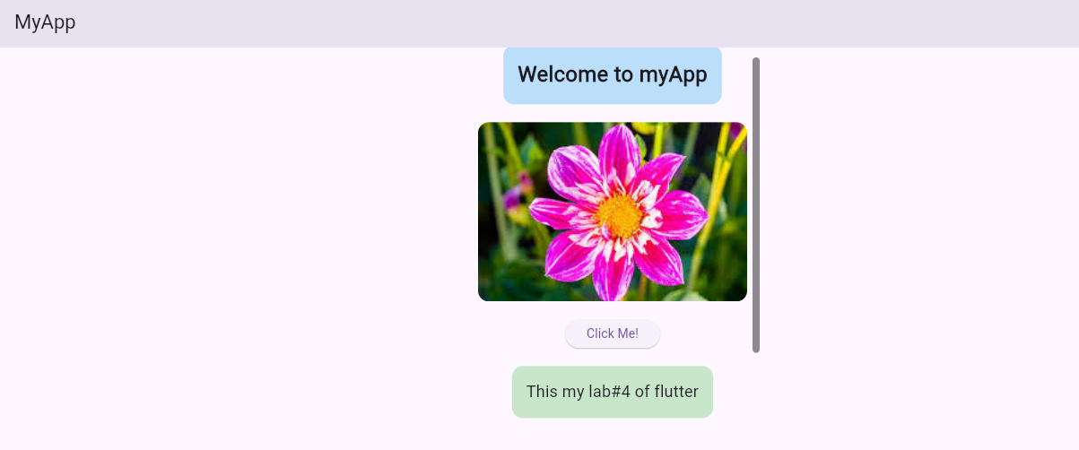

**Task 2:** Modify the application to use ListView instead of SingleChildScrollView.

* Implement a simple ListView with 50 items, each displaying text or an image.
* Use ListView.builder to dynamically generate list items as the user scrolls.

**Ans:**

**Main.dart:**

import 'package:flutter/material.dart';

void main() {

runApp(MyApp());}

class MyApp extends StatelessWidget {

@override

Widget build(BuildContext context) {

return MaterialApp(

debugShowCheckedModeBanner: false,

home: abc(), );}}

class abc extends StatelessWidget {

@override

Widget build(BuildContext context) {

return Scaffold(

appBar: AppBar(title: Text("MyApp")),

body: ListView.builder(

padding: EdgeInsets.all(16.0),

itemCount: 50,

itemBuilder: (context, index) {

return Padding(

padding: const EdgeInsets.symmetric(vertical: 8.0),

child: Container(

padding: EdgeInsets.all(16),

decoration: BoxDecoration(

color: index % 2 == 0 ? Colors.blue.shade100 : Colors.green.shade100,

borderRadius: BorderRadius.circular(12), ),

child: Column(

crossAxisAlignment: CrossAxisAlignment.center,

children: [

Text(

"Item #$index",

style: TextStyle(fontSize: 20, fontWeight: FontWeight.bold), ),

SizedBox(height: 10),

ClipRRect(

borderRadius: BorderRadius.circular(12),

child: Image.asset("assets/image.jpeg", width: 300, height: 200, fit: BoxFit.cover),

),

SizedBox(height: 10),

ElevatedButton(

onPressed: () {},

child: Text("Click Me!") ), ], ), ), ); }, ), );}}

OUTPUT:

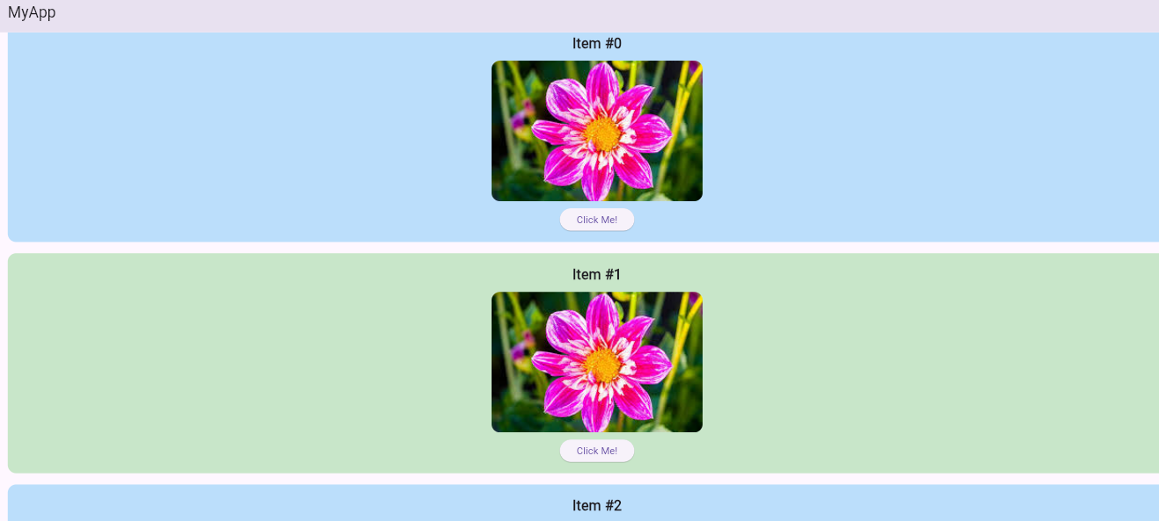

**Task3:** Modify the ListView implementation to include:

* Different types of items (e.g., text, images, buttons).
* Add dividers between the list items.
* Implement scrolling in both directions (horizontal and vertical).

**Ans:**

**Main.dart:**

import 'package:flutter/material.dart';

void main() {

runApp(MyApp());}

class MyApp extends StatelessWidget {

@override

Widget build(BuildContext context) {

return MaterialApp(

debugShowCheckedModeBanner: false,

home: abc(), );}}

class abc extends StatelessWidget {

@override

Widget build(BuildContext context) {

return Scaffold(

appBar: AppBar(title: Text("MyApp")),

body: Scrollbar(

child: SingleChildScrollView(

scrollDirection: Axis.horizontal,

child: SizedBox(

width: MediaQuery.of(context).size.width * 1.5, // Allows horizontal scrolling

child: ListView.separated(

padding: EdgeInsets.all(16.0),

itemCount: 50,

separatorBuilder: (context, index) => Divider(thickness: 2),

itemBuilder: (context, index) {

return Padding(

padding: const EdgeInsets.symmetric(vertical: 8.0),

child: Container(

padding: EdgeInsets.all(16),

decoration: BoxDecoration(

color: index % 2 == 0 ? Colors.blue.shade100 : Colors.green.shade100,

borderRadius: BorderRadius.circular(12),),

child: Column(

crossAxisAlignment: CrossAxisAlignment.center,

children: [

Text(

"Item #$index",

style: TextStyle(fontSize: 20, fontWeight: FontWeight.bold), ),

SizedBox(height: 10),

if (index % 3 == 0)

ClipRRect(

borderRadius: BorderRadius.circular(12),

child: Image.asset("assets/image.jpeg", width: 300, height: 200, fit: BoxFit.cover), )

else if (index % 3 == 1)

ElevatedButton(

onPressed: () {},

child: Text("Click Me!"), )

else

Text(

"This is a text item",

style: TextStyle(fontSize: 18),),],), ), ); }, ), ), ), ),);}}

OUTPUT:

