Objective: To be familiar with programming using shell scripting in linux.

Exercises:

1. Write a shell program that takes three parameter (your name,your ID and Department) and displays it on the

screen.

Ans:

File.sh:

|  |
| --- |
| #!/bin/bash  echo "Enter your name: "  read NAME  echo "Enter your ID: "  read ID  echo "Enter your Department: "  read DEPT  echo "Name: $NAME"  echo "ID: $ID"  echo "Department: $DEPT" |

Output:

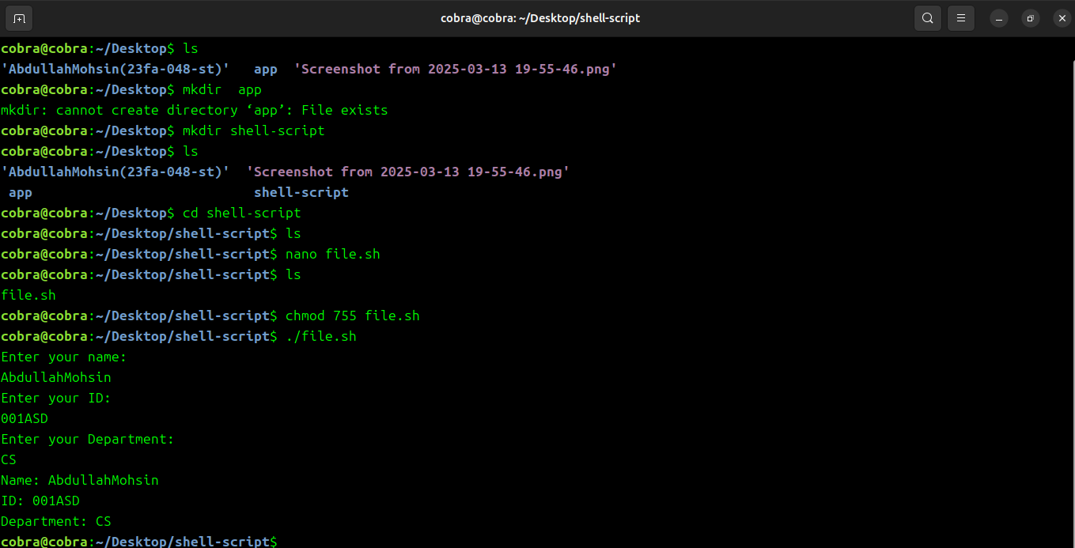

2.Write a shell program that takes a number parameters equal to the last digit of your roll number and displays

the values of the built in variables such as $#, $0, and $* on the screen.

Ans:

file_1.sh:

|  |
| --- |
| #!/bin/bash  echo "Enter parameters: "  read PARAMS  set -- $PARAMS  echo "Total Number of Parameters: $#"  echo "Script Name: $0"  echo "All Parameters: $*" |

Output:

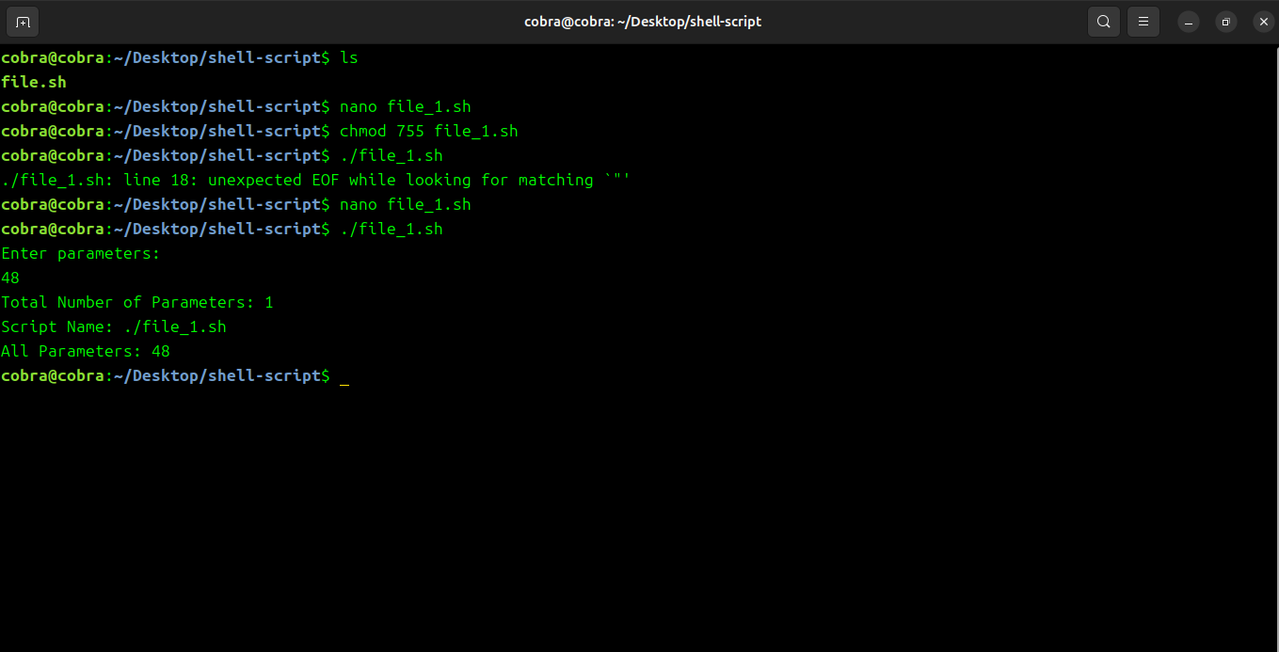

3. Write a script that uses the read command which takes the input from the keyboard and assigns it as the

value of the variable PERSON and finally prints it on screen.

Ans:

file_2.sh:

|  |
| --- |
| #!/bin/bash  PERSON="Abdullah"  echo "$PERSON is running on the street." |

Output:

