**Objective:** To learn the usage of different types of operators and conditional statements.

# Exercise:

1. What test command should be used to test that /usr/bin is a directory or a symbolic link?

Ans:

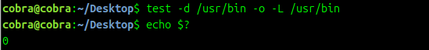

1. Write a script that takes two strings as input compares them and depending upon the results of the comparison prints the results.

*The user may provide input to the Bash script using:*

*read var*

*Ans: user.sh*

|  |
| --- |
| *#!/bin/bash*  *echo "Enter first string: "*  *read str1*  *echo "Enter second string: "*  *read str2*  *if [ "$str1" = "$str2" ]; then*  *echo "Strings are equal."*  *else*  *echo "Strings are not equal."*  *fi* |

*Output:*

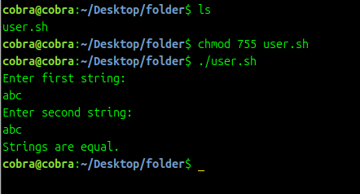

1. Write a script that takes a number (parameter) from 1-12 as input and uses case to display the name of corresponding month.

Ans:

Month.sh

|  |
| --- |
| #!/bin/bash  echo "Enter a number (1-12): "  read num  case $num in  1) echo "January" ;;  2) echo "February" ;;  3) echo "March" ;;  4) echo "April" ;;  5) echo "May" ;;  6) echo "June" ;;  7) echo "July" ;;  8) echo "August" ;;  9) echo "September" ;;  10) echo "October" ;;  11) echo "November" ;;  12) echo "December" ;;  *) echo "Invalid input. Please enter a number between 1 and 12." ;;  esac |

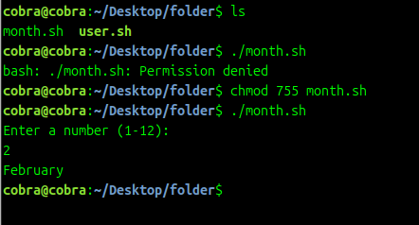

1. Write a script that takes command-line argument for age and marks , and decide whether student is eligible for admission or not.

# Eligibility Criteria:

Age should be lesser than 18 and marks should be greater than 700

Ans:

Age.sh

|  |
| --- |
| #!/bin/bash  if [ $# -ne 2 ]; then  echo "Usage: $0 <age> <marks>"  exit 1  fi  age=$1  marks=$2  if [ "$age" -lt 18 ] && [ "$marks" -gt 700 ]; then  echo "Student is eligible for admission."  else  echo "Student is not eligible for admission."  fi |

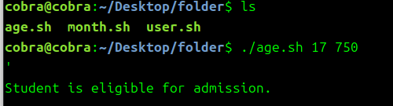Output: