

**SET-224 /CET-225**

**Operating Systems LAB # 01**

**LAB Title**

InstallationofLinuxOperatingSystem(Ubuntu)andsomebasiccommands.

**Assessment of CLO: 04, PLO: 05**

|  |  |  |  |
| --- | --- | --- | --- |
| Student Name: |  | | |
| Roll No. |  | | |
| Semester |  | Session |  |

|  |  |  |  |  |  |  |
| --- | --- | --- | --- | --- | --- | --- |
| **S.**  **No.** | **Perf. Level**  **Criteria** | **Excellent (2.5)** | **Good (2)** | **Satisfactory (1.5)** | **Needs Improvement (0 ~ 1)** | **Marks Obtained** |
| **1** | Project Execution & Implementation | Fully functional, optimized, and well-structured. | Minor errors, mostly functional. | Some errors, requires guidance. | Major errors, non-functional, or not  Performed. |  |
| **2** | Results & Debugging Or  Troubleshooting | Accurate results with effective debugging  Or Troubleshooting. | Mostly correct, some debugging Or Troubleshooting needed. | Partial results, minimal debugging  Or Troubleshooting. | Incorrect results, no debugging Or Troubleshooting, or not attempted. |  |
| **3** | Problem- Solving & Adaptability (VIVA) | Creative approach, efficiently solves challenges. | Adapts well, minor struggles. | Some adaptability, needs guidance. | Lacks innovation or no innovation, unable to solve  problems. |  |
| **4** | Report Quality & Documentation | Clear, structured, with detailed visuals. | Mostly clear, minor gaps. | Some clarity issues, missing details. | Poorly structured, lacks  clarity, or not submitted. |  |
| **Total Marks Obtained Out of 10** | | | | | |  |

**Experiment evaluated by**

|  |  |  |  |
| --- | --- | --- | --- |
| Instructor’s Name | Engr.Bushra Aziz | | |
| Date |  | Signature |  |

Copyright © Department of Engineering & Technology – UIT University Karachi

**Objective:** To get familiarize with virtual machines, installation of Linux and some basic commands in Linux.

# EXERCISES

Write a command to:

* + List all files (and subdirectories) in the home directory.

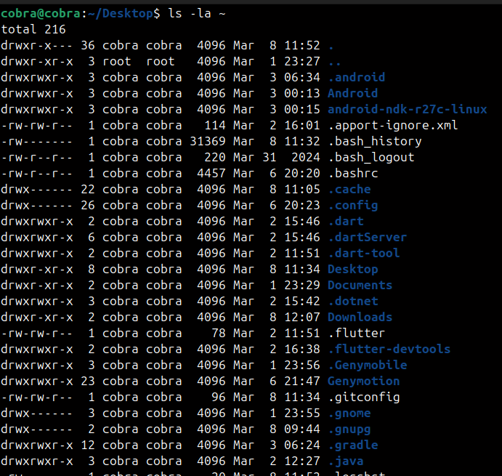

* + Count all files in the current directory.



* + Create a Text file “test_lastDigitOfyourRollNumber”. Store some data in it then use “grep” to find some text_pattern in it.



* + Display the content of “test_lastDigitOfyourRollNumber” file with as many lines at a time as the last digit of your roll number.

