Lab_5.sh:

|  |
| --- |
| #!/bin/bash  roll_number=48  sum=0  count=0  for (( i=2; i<=roll_number; i+=2 ))  do  sum=$((sum + i))  count=$((count + 1))  done  if [ $count -gt 0 ]; then  average=$((sum / count))  echo "Average of even numbers ≤ $roll_number is: $average"  else  echo "No even numbers to calculate average."  fi |

OUTPUT:

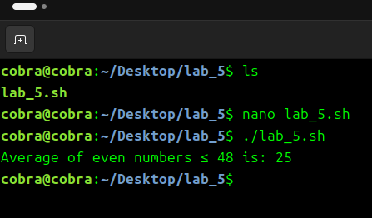

Fac.sh

|  |
| --- |
| #!/bin/bash  factorial() {  num=$1  result=1  if [ $num -lt 0 ]; then  echo "Factorial not defined for negative numbers."  return  fi  for (( i=1; i<=num; i++ ))  do  result=$((result * i))  done  echo "Factorial of $num is: $result"  } |

OUTPUT:

