**1. What is Jenkins?**

* Jenkins is an open-source automation server used for Continuous Integration (CI) and Continuous Deployment (CD).
* It helps automate software development processes like building, testing, and deployment.
* Originally developed as Hudson, later forked and renamed Jenkins.

**2. Features of Jenkins**

* Free and open-source.
* Supports a vast range of plugins for customization.
* Integrates with version control tools like Git, SVN, and Bitbucket.
* Distributed builds and parallel execution.
* Extensible with pipeline scripting.

**3. How Jenkins Works?**

* Developers push code to a repository (e.g., GitHub, GitLab).
* Jenkins fetches the latest code and triggers a build.
* The build process includes compiling, testing, and packaging.
* If successful, the code is deployed to staging or production environments.
* Jenkins notifies stakeholders of build status (success/failure).

**4. Installing Jenkins**

* Install Java (JDK 11 or later recommended).
* Download Jenkins from <https://www.jenkins.io/>.
* Run Jenkins using:

java -jar jenkins.war

* Access Jenkins via http://localhost:8080/.

**5. Jenkins Pipeline**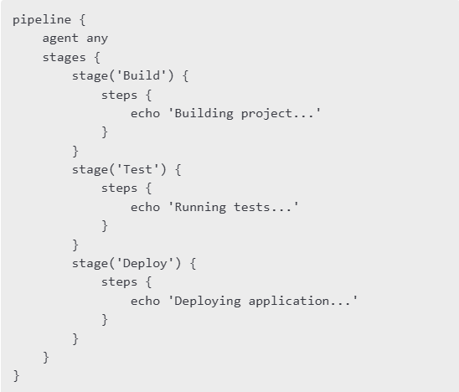

**6. Advantages of Jenkins**

* Automates repetitive tasks, reducing manual work.
* Improves code quality by integrating tests in CI/CD.
* Provides real-time feedback on code changes.
* Scalable and customizable for enterprise environments.

**7. Conclusion**

* Jenkins is an essential tool for DevOps and software automation.
* Helps achieve efficient and reliable CI/CD workflows.
* Learning Jenkins enhances software development and deployment efficiency.