**Objective:**

* Understand the concept of CI and its benefits.
* Set up a CI pipeline using a CI/CD tool.
* Automate code testing and integration.
* Analyze pipeline execution results and troubleshoot errors.

### **Exercise 1: Setting Up a CI Pipeline with GitHub Actions**

1.Create a repository on GitHub.

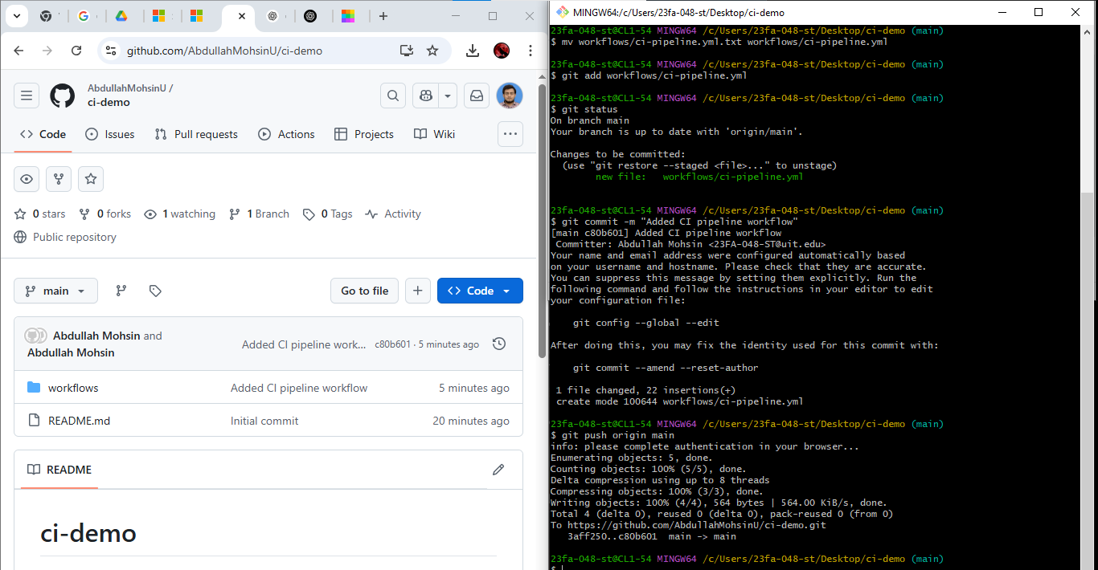

2.Navigate to the **Actions** tab and set up a new workflow.

3.Create a .github/workflows/ci-pipeline.yml file with the following example content:

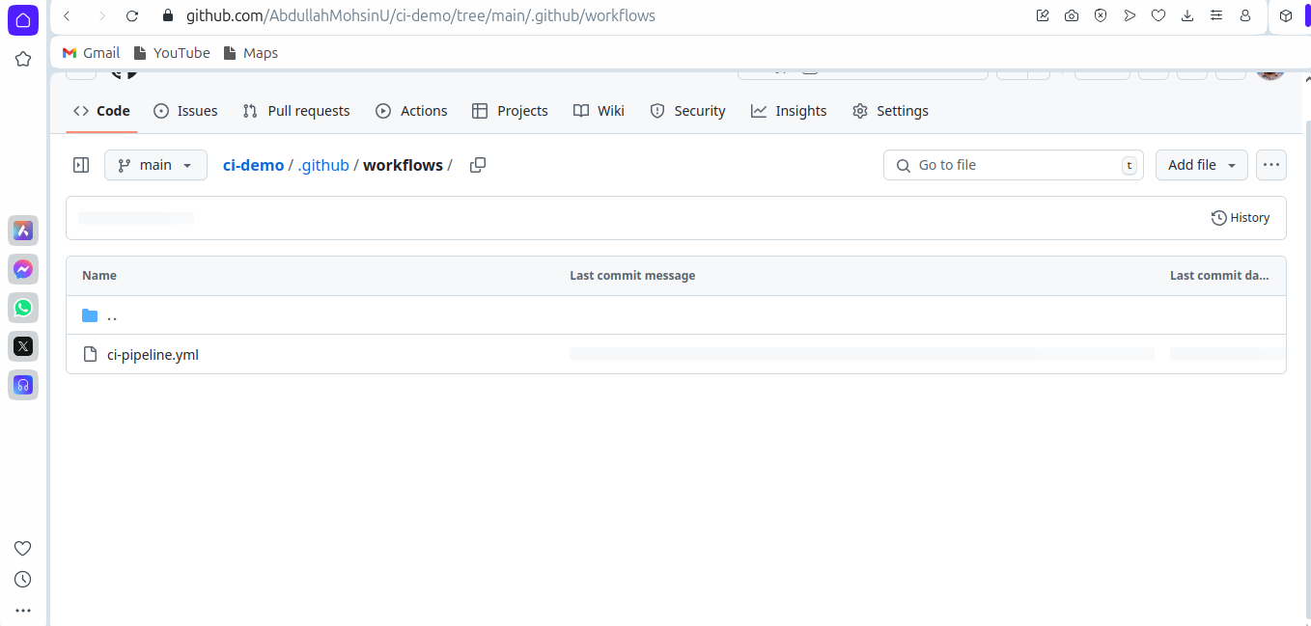

4. Commit and push the file to the repository.

5. Observe the pipeline execution under the **Actions** tab.

* **ci-pipeline.yml**:

|  |
| --- |
| **name: CI Pipeline**  **on: [push, pull_request]**  **jobs:**  **build:**  **runs-on: ubuntu-latest**  **steps:**  **- name: Checkout Repository**  **uses: actions/checkout@v3**  **- name: Set up Node.js**  **uses: actions/setup-node@v3**  **with:**  **node-version: 16**  **- name: Install Dependencies**  **run: npm install**  **- name: Run Tests**  **run: npm test** |

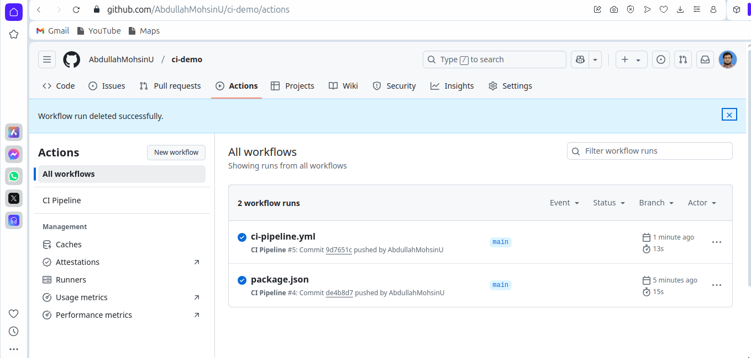

**Exercise 2: Configuring a CI Pipeline in Jenkins**

1. Install Jenkins and required plugins (Git, Pipeline, NodeJS, etc.).
2. Create a new **Freestyle Project** or **Pipeline Project**.
3. Configure the Git repository URL and branch.
4. Add build steps to:
   * Clone the repository.
   * Install dependencies.
   * Run tests.
5. Save and trigger the pipeline to test execution.

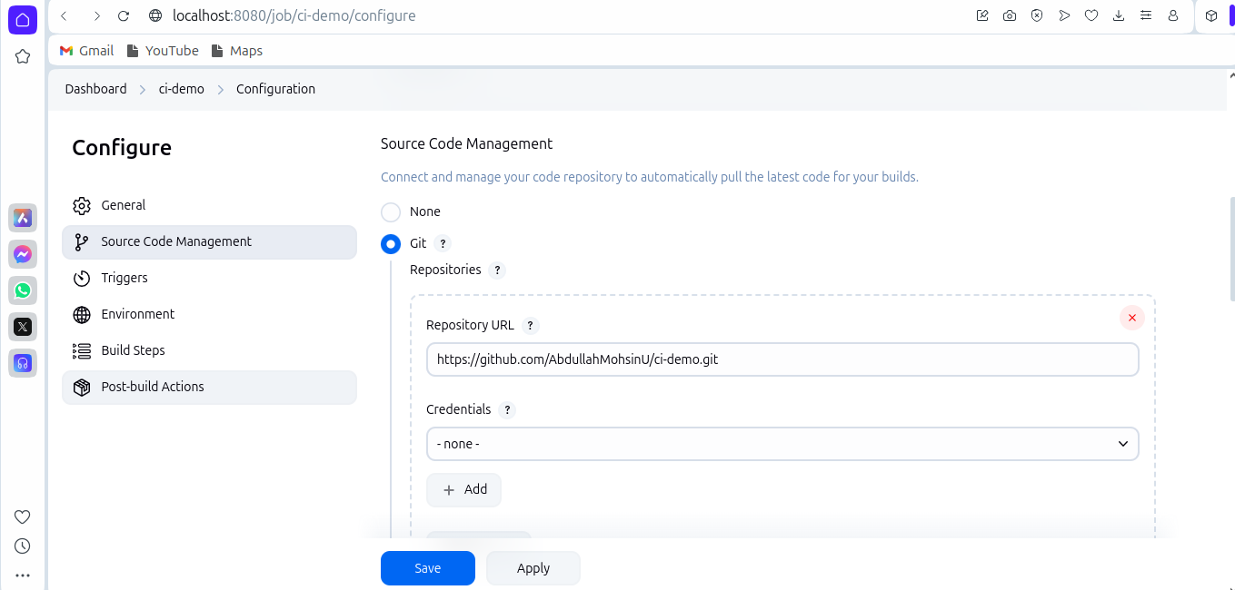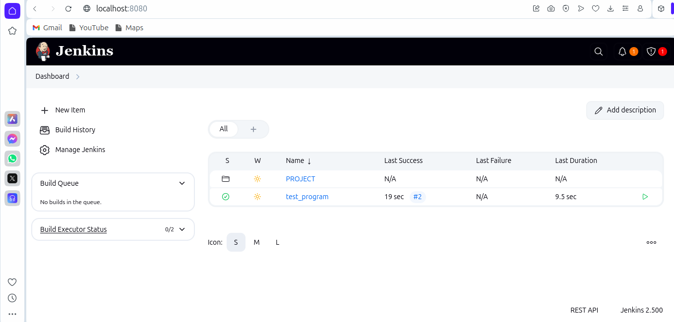

**Exercise 3: Implementing CI with GitLab CI/CD**

1. Create a .gitlab-ci.yml file in the root of your GitLab repository.
2. Add the following sample configuration:
3. Push the file to GitLab and check the **CI/CD > Pipelines** section.

* **.gitlab-ci.yml:**

|  |
| --- |
| **stages:**  **- test**  **- build**  **test:**  **stage: test**  **script:**  **- echo "Running tests..."**  **- npm install**  **- npm test || echo "Tests failed, but continuing..."**  **build:**  **stage: build**  **script:**  **- echo "Building the project..."**  **- npm run build || echo "Build failed, but continuing..."** |

