* **INTEGRATION PROMETHEUS WITH GRAFANA:**

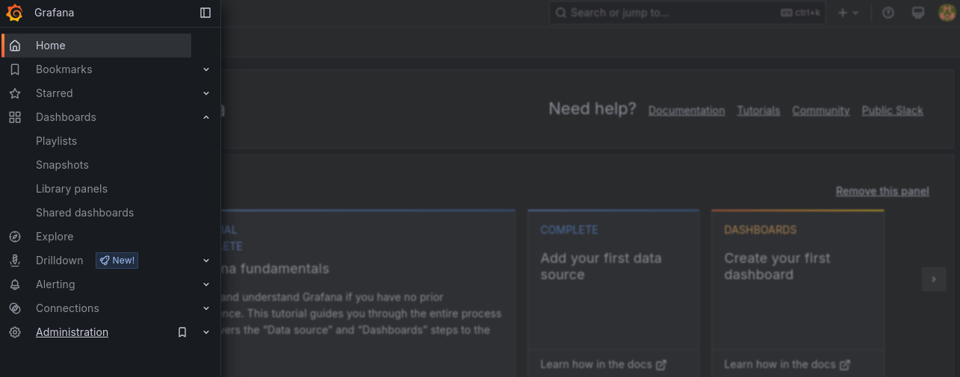

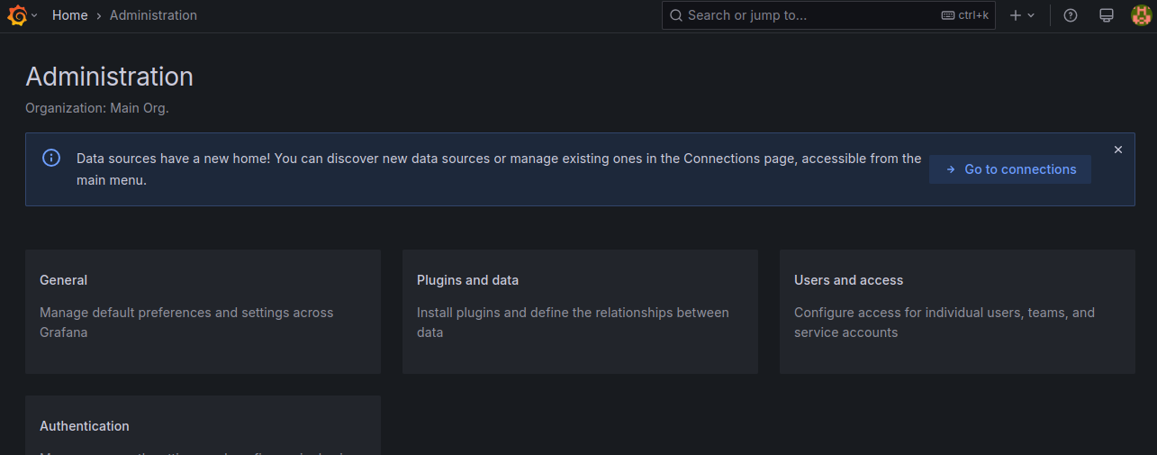

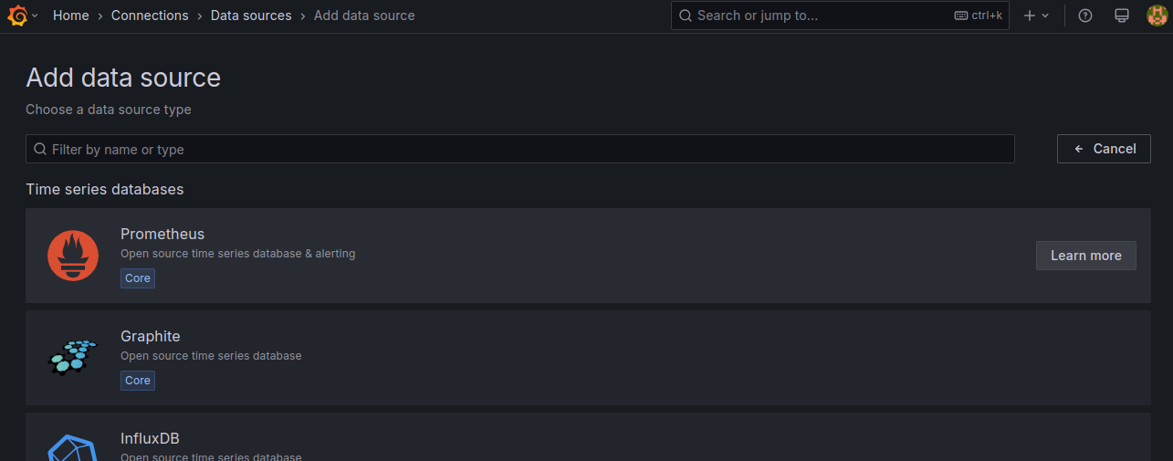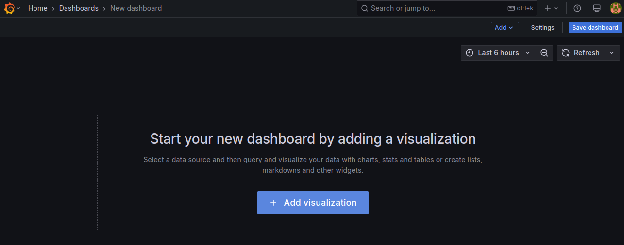

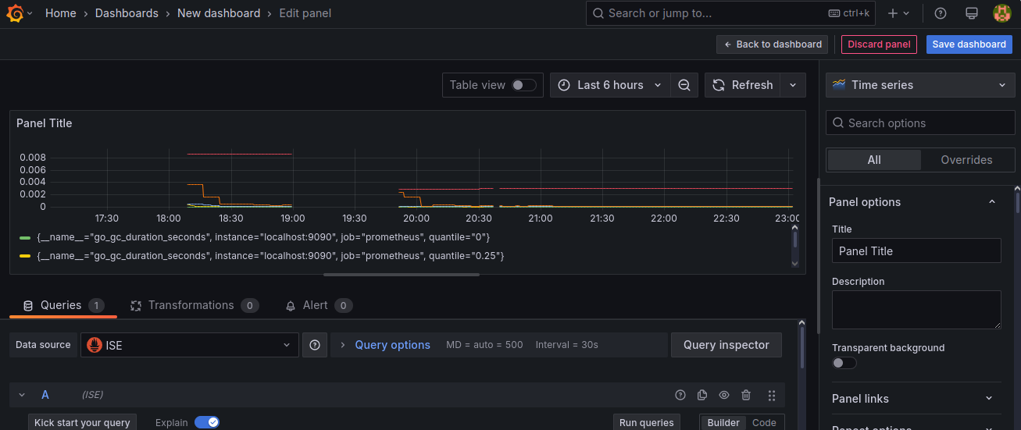

1. What are the advantages of using Grafana for monitoring systems?  
   Ans:

Grafana offers real-time visualization of metrics, supports multiple data sources, allows interactive and customizable dashboards, and includes alerting features for proactive issue detection.

1. How do you integrate Prometheus with Grafana?

Ans:

1. Install both Prometheus and Grafana
2. In Grafana, go to "Settings" > "Data Sources"
3. Choose Prometheus as the type
4. Enter the Prometheus server URL (e.g., http://localhost:9090)
5. Click "Save & Test"
6. Describe the steps to create a panel in Grafana.
7. Open a dashboard
8. Click “Add Panel”
9. Select the data source
10. Enter a query (e.g., node_cpu_seconds_total)
11. Choose visualization type (e.g., graph, gauge, bar)
12. Customize title, colors, and thresholds
13. Save the panel
14. What types of visualizations are supported in Grafana?  
    Ans: Grafana supports graphs, bar charts, tables, heatmaps, gauges, stat panels, pie charts, and more.
15. Explain how Grafana handles alerting.  
    Ans: Grafana allows users to create alert rules for panels. When conditions are met (e.g., CPU > 80%), it triggers an alert and can send notifications via email, Slack, PagerDuty, or other channels.