

SET-222

Software Operations & Maintenance

Experiment # 04

**Experiment Title**

**Automating Deployment Pipelines.**

**Assessment of CLO(s): 03**

**Performed on ____________________**

|  |  |  |  |
| --- | --- | --- | --- |
| **Student Name:** |  | | |
| **Roll No.** |  | **Group** |  |
| **Semester** |  | **Session** |  |

|  |  |  |  |  |  |  |
| --- | --- | --- | --- | --- | --- | --- |
| **S. No.** | **Perf. Level**  **Criteria** | **Excellent**  **(2.5)** | **Good**  **(2)** | **Satisfactory**  **(1.5)** | **Needs Improvement**  **(0 ~ 1)** | **Marks Obtained** |
| **1** | Project Execution & Implementation | Fully functional, optimized, and well-structured. | Minor errors, mostly functional. | Some errors, requires guidance. | Major errors, non-functional, or not Performed. |  |
| **2** | Results & Debugging  Or Troubleshooting | Accurate results with effective debugging  Or Troubleshooting. | Mostly correct, some debugging Or Troubleshooting needed. | Partial results, minimal debugging  Or Troubleshooting. | Incorrect results, no debugging Or Troubleshooting, or not attempted. |  |
| **3** | Problem-Solving & Adaptability  (VIVA) | Creative approach, efficiently solves challenges. | Adapts well, minor struggles. | Some adaptability, needs guidance. | Lacks innovation or no innovation, unable to solve problems. |  |
| **4** | Report Quality & Documentation | Clear, structured, with detailed visuals. | Mostly clear, minor gaps. | Some clarity issues, missing details. | Poorly structured, lacks clarity, or not submitted. |  |
| **Total Marks Obtained Out of 10** | | | | | |  |

**Experiment evaluated by**

|  |  |  |  |
| --- | --- | --- | --- |
| **Instructor’s Name** | **Ms. Shagufta Aftab** | | |
| **Date** |  | **Signature** |  |

**Objective:**

* To understand and implement automated deployment pipelines for continuous integration and deployment (CI/CD) in software development.

**Procedure:**

Step 1: Clone github repository:

Step 2: Create App.py file and push it in repository:

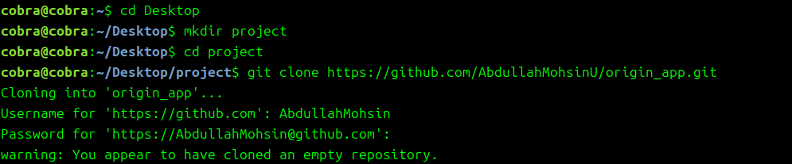

App.py

|  |
| --- |
| print ("HELLO WORLD") |

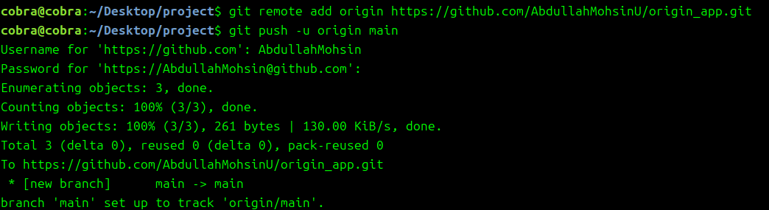

Step 3: Configure CI/CD Pipeline using GitHub Actions



Main.yaml

|  |
| --- |
| name: CI/CD Pipeline  on:  push:  branches:  - main  jobs:  build:  runs-on: ubuntu-latest  steps:  - name: Checkout code  uses: actions/checkout@v2  - name: Set up Python  uses: actions/setup-python@v3  with:  python-version: '3.8'  - name: Run application  run: python app.py |

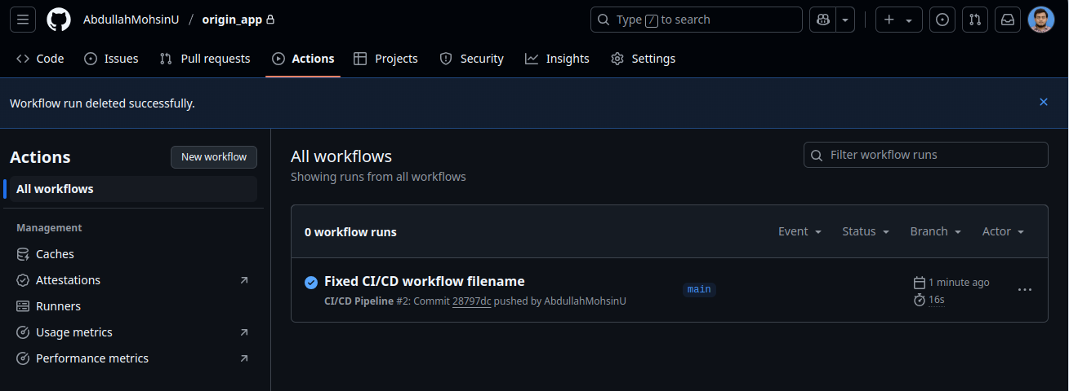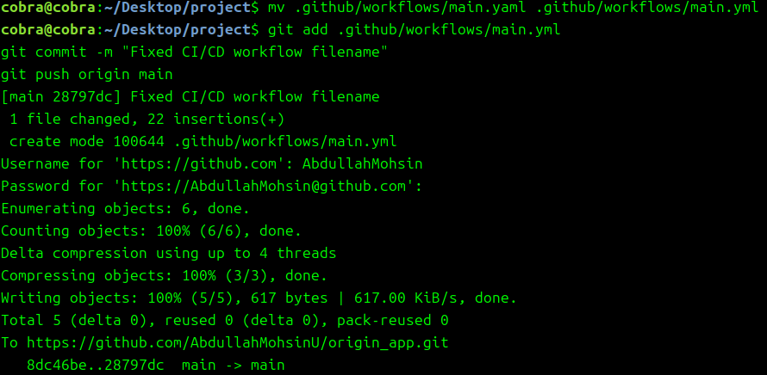

Step 3:Automating Deployment

App.py

|  |
| --- |
| Print(“PROGRESS”) |

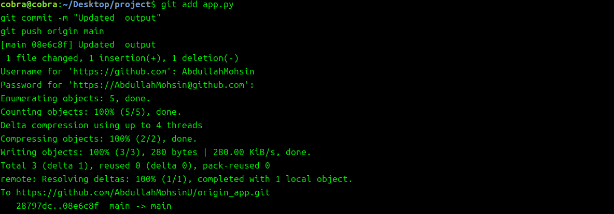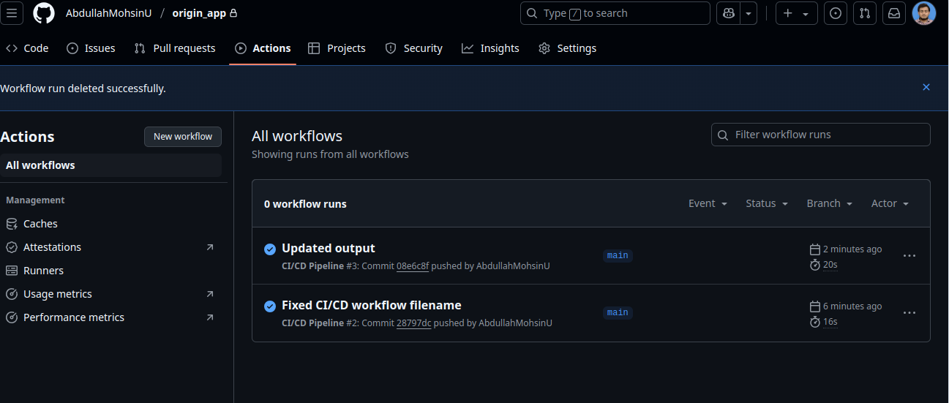

Step 4:Deploying the Application Using Docker (Optional):

