**Objective:**

* To understand the basics of version control.
* To learn how to install and set up Git.
* To practice using Git for version control and GitHub for remote repository management.

Assessment & Exercises

1.Explain the difference between Git and GitHub.

|  |  |  |
| --- | --- | --- |
| Feature | Git | GitHub |
| Definition | A distributed version control system that manages code changes locally. | A cloud-based hosting service that allows developers to store, collaborate, and manage Git repositories. |
| Functionality | Tracks file changes, branches, and commits locally. | Provides remote repository hosting, collaboration tools, and issue tracking. |
| Usage | Used via the command line for version control. | Web-based interface with additional tools for team collaboration. |
| Installation Required? | Yes, must be installed on a local system. | No, accessed via a web browser or GitHub Desktop. |
| Example Command | git commit -m "message" | git push origin main |

2.List the commands used to check repository status and commit history.

|  |  |
| --- | --- |
| Task | Command |
| Check repository status | git status |
| View commit history | git log |

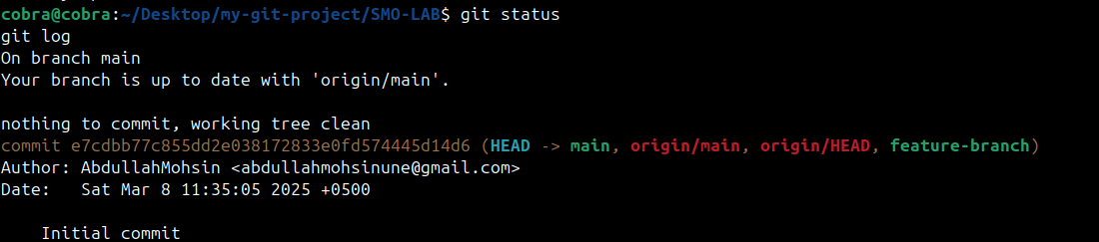

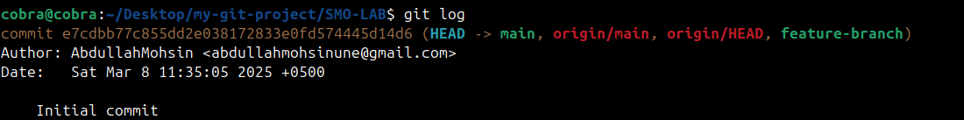

3.What command is used to push local changes to a remote repository?

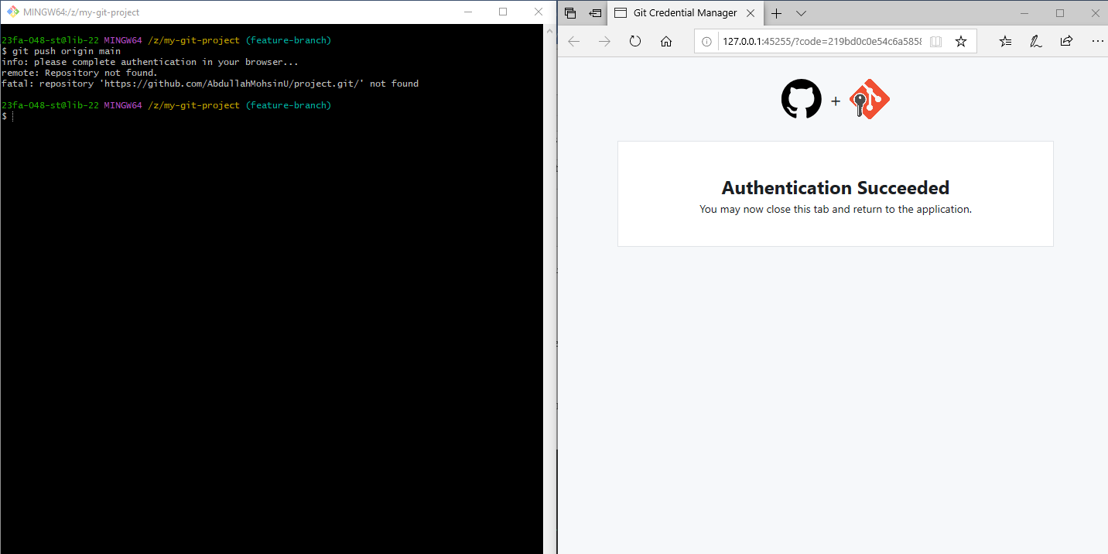git push origin main

4.Write the command to create and switch to a new branch.

git branch feature-branch # Create a new branch

git checkout feature-branch # Switch to the new branch

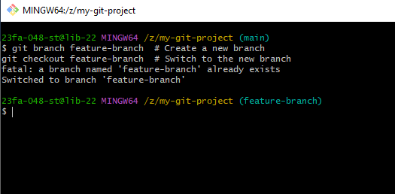

5.Clone a repository from GitHub and take a screenshot of the output.

