

**Department of Engineering Technology**

SET-222

Software Operations & Maintenance

Experiment # 10

**Experiment Title**

**Disaster Recovery Planning (**Concepts, backup strategies, failover mechanisms)

**Assessment of CLO(s): 03**

**Performed on ____________________**

|  |  |  |  |
| --- | --- | --- | --- |
| **Student Name:** |  | | |
| **Roll No.** |  | **Group** |  |
| **Semester** |  | **Session** |  |

|  |  |  |  |  |  |  |
| --- | --- | --- | --- | --- | --- | --- |
| **S. No.** | **Perf. Level**  **Criteria** | **Excellent**  **(2.5)** | **Good**  **(2)** | **Satisfactory**  **(1.5)** | **Needs Improvement**  **(0 ~ 1)** | **Marks Obtained** |
| **1** | Project Execution & Implementation | Fully functional, optimized, and well-structured. | Minor errors, mostly functional. | Some errors, requires guidance. | Major errors, non-functional, or not Performed. |  |
| **2** | Results & Debugging  Or Troubleshooting | Accurate results with effective debugging  Or Troubleshooting. | Mostly correct, some debugging Or Troubleshooting needed. | Partial results, minimal debugging  Or Troubleshooting. | Incorrect results, no debugging Or Troubleshooting, or not attempted. |  |
| **3** | Problem-Solving & Adaptability  (VIVA) | Creative approach, efficiently solves challenges. | Adapts well, minor struggles. | Some adaptability, needs guidance. | Lacks innovation or no innovation, unable to solve problems. |  |
| **4** | Report Quality & Documentation | Clear, structured, with detailed visuals. | Mostly clear, minor gaps. | Some clarity issues, missing details. | Poorly structured, lacks clarity, or not submitted. |  |
| **Total Marks Obtained Out of 10** | | | | | |  |

**Experiment evaluated by**

|  |  |  |  |
| --- | --- | --- | --- |
| **Instructor’s Name** | **Ms. Shagufta Aftab** | | |
| **Date** |  | **Signature** |  |

## Copyright © Department of Engineering & Technology – UIT University Karachi

**Objective:**

To understand disaster recovery principles, explore backup methods, and simulate failover scenarios in IT systems to maintain business continuity.

**Backup Strategies**

**Lab Tasks:**

**Task 1: Backup Simulation**

* Perform a full backup of selected files/folders using a backup utility
* Perform an incremental backup
* Verify restoration by restoring selected files to a test folder

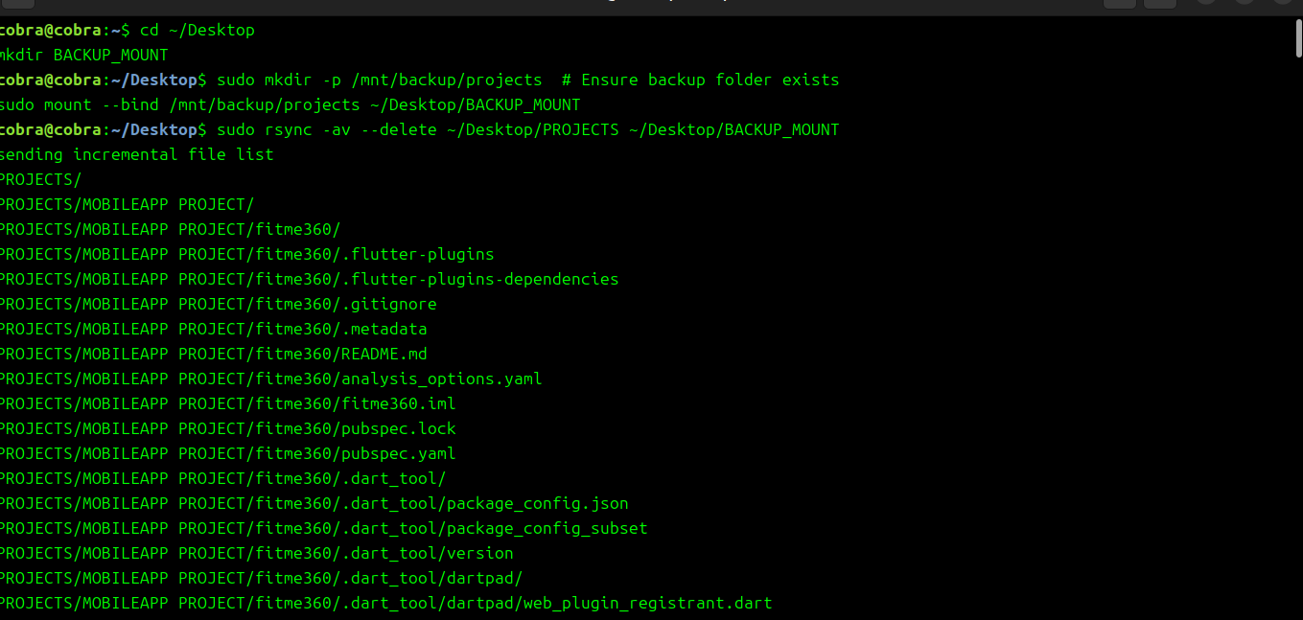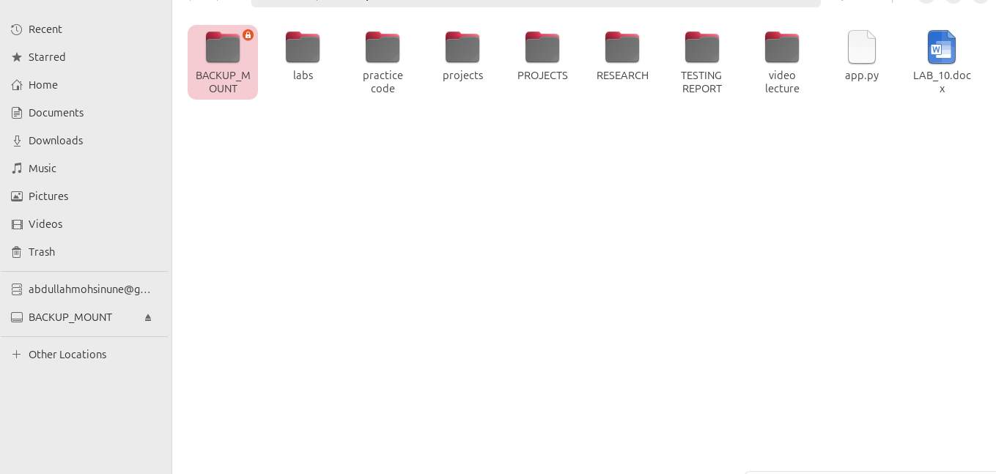

**Task 2: Failover Demonstration (Basic Simulation)**

* Use two virtual machines to simulate primary and backup systems
* Shut down the primary VM and test access to the secondary system

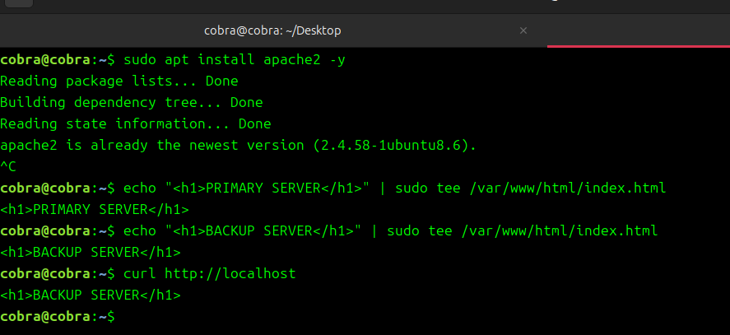

**Task 3: Create a Basic DR Plan Document**

**Document Summary:**

* **Assets Protected:** File server, Web server, Admin PC
* **RTO (Recovery Time Objective):** 4 hours
* **RPO (Recovery Point Objective):** 12 hours
* **Backup Strategy:**
  + Daily incremental using rsync
  + Weekly full backup (USB + Google Drive)
* **Failover Plan:**
  + Switch DNS to backup server
  + Notify IT support group via SMS/email

**Expected Outcomes:**

* Understand disaster recovery frameworks and backup strategies
* Perform basic backup and restore operations
* Simulate and understand failover concepts
* Draft a recovery plan for a small IT setup

**Assessment Questions:**

1. **What is the difference between RTO and RPO?**  
   ➤ **RTO** is how long it takes to recover; **RPO** is how much data can be lost.
2. **Name and describe three types of backup strategies.**  
   ➤ **Full Backup:** Entire system  
   ➤ **Incremental Backup:** Only recent changes  
   ➤ **Differential Backup:** Changes since last full backup
3. **What is the purpose of a failover system?**  
   ➤ To automatically or manually switch to a backup system in case of failure.
4. **Why is the 3-2-1 backup rule important?**  
   ➤ Ensures redundancy: 3 copies, 2 storage types, 1 offsite to protect against loss.
5. **List two common tools used in disaster recovery planning.**  
   ➤ rsync, Windows Backup, Pacemaker (Linux), and cloud platforms like AWS S3/Glacier.