**Objective:**

* To understand and implement automated deployment pipelines for continuous integration and deployment (CI/CD) in software development.

**Procedure:**

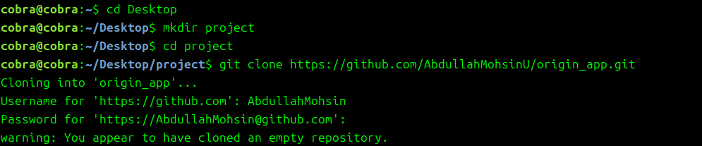Step 1: Clone github repository:

Step 2: Create App.py file and push it in repository:

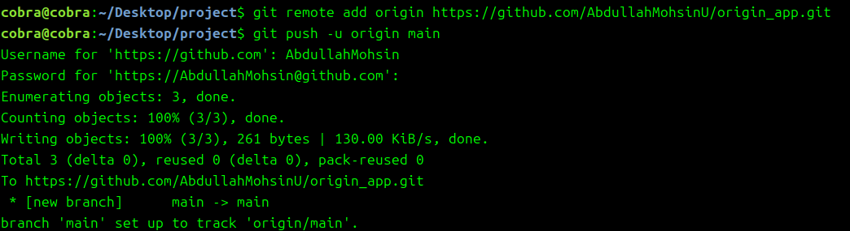App.py

|  |
| --- |
| print ("HELLO WORLD") |

Step 3: Configure CI/CD Pipeline using GitHub Actions



Main.yaml

|  |
| --- |
| name: CI/CD Pipeline  on:  push:  branches:  - main  jobs:  build:  runs-on: ubuntu-latest  steps:  - name: Checkout code  uses: actions/checkout@v2  - name: Set up Python  uses: actions/setup-python@v3  with:  python-version: '3.8'  - name: Run application  run: python app.py |

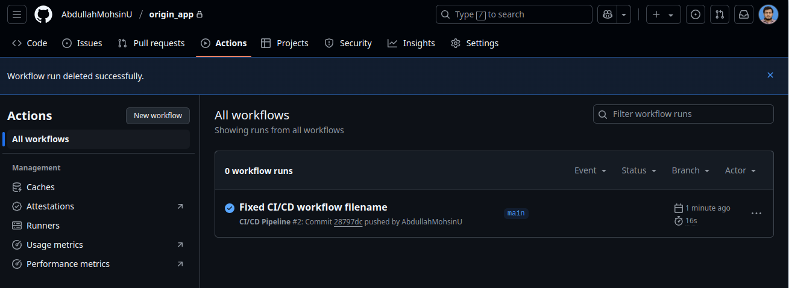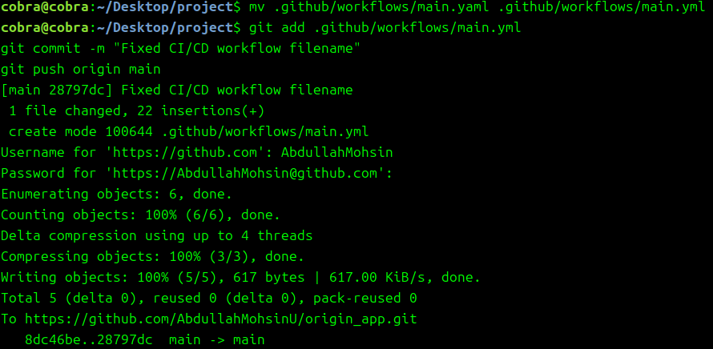

Step 4:Automating Deployment

App.py

|  |
| --- |
| Print(“PROGRESS”) |

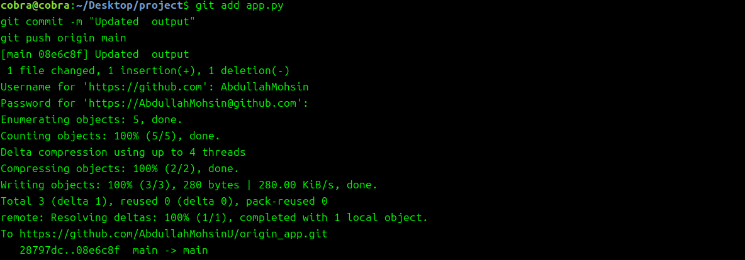

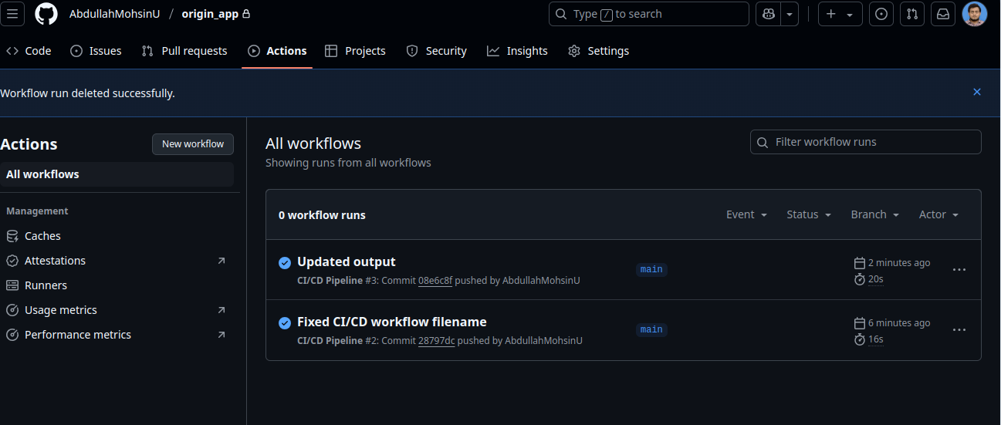

Step 5:Deploying the Application Using Docker (Optional):

