**Task:**

1. Find and select any 10 web elements using selenium python

Ans:

a. Any 2 by CSS selector

b. Any 2 by Hyperlinks

c. Any 2 by Xpaths

d. Any 2 by Id

e. Any 2 by name

Ans: **Output:**

1. **Index.html:**

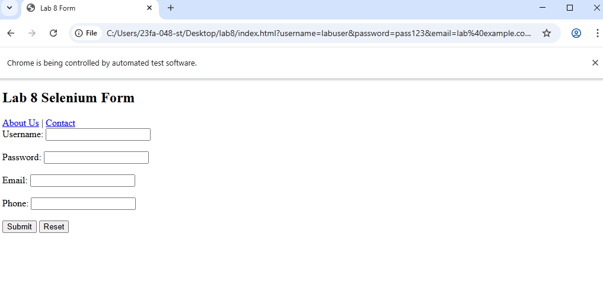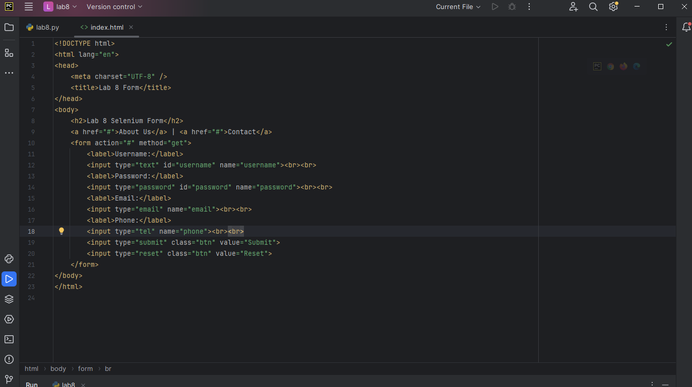

1. 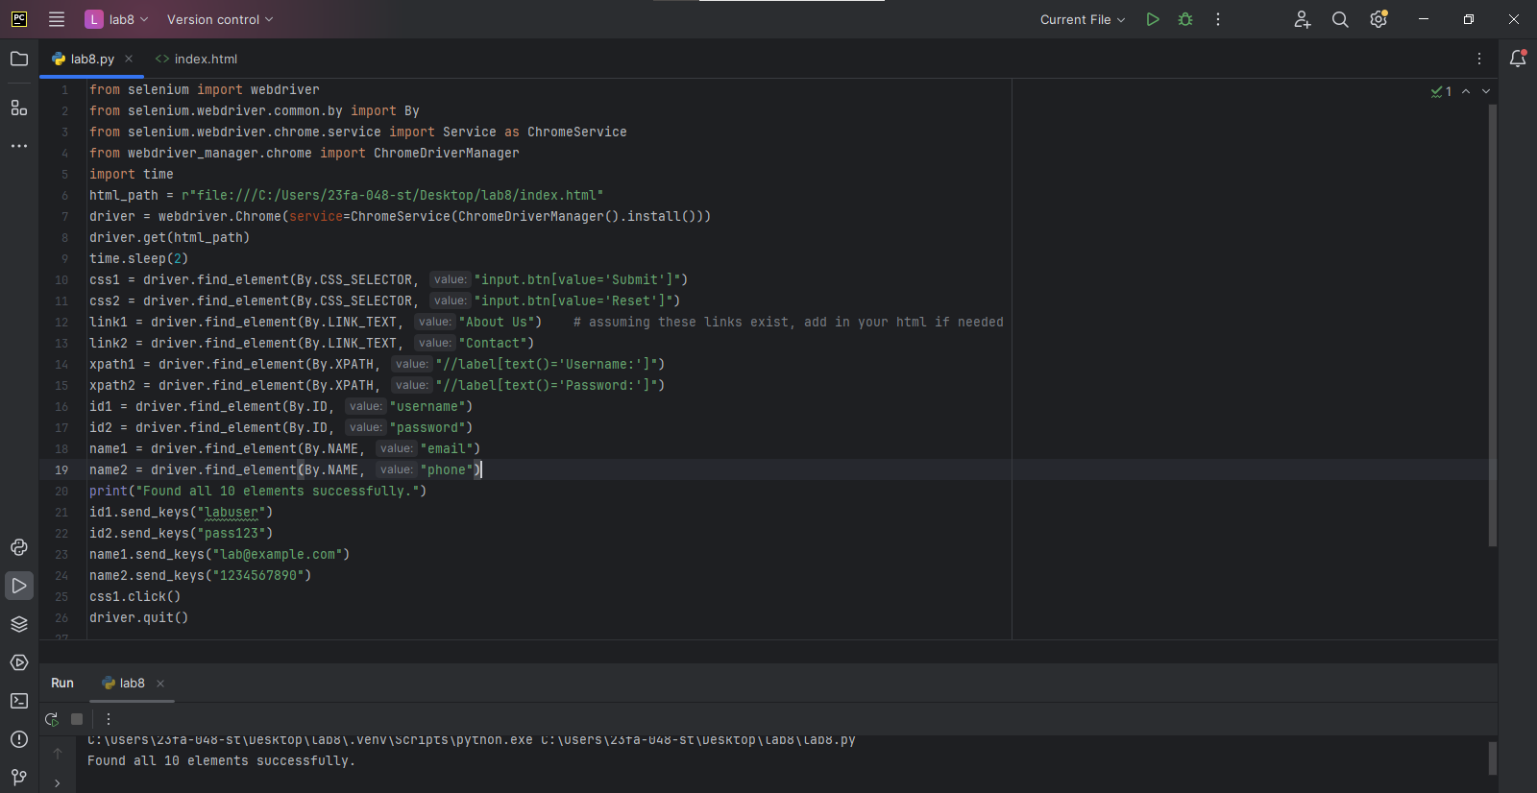**Lab9.py:**