

**SET-221**

**Software Testing Technologies**

**LAB # 01**

**LAB Title**

| Installation of Google Test and Visual Studio. |
| --- |

**Assessment of CLO: 04, PLO: 03**

| **Student Name:** | Abdullah Mohsin | | |
| --- | --- | --- | --- |
| **Roll No.** | 23fa-048-st | | |
| **Semester** | 3rd | **Session** | SPRING-2025 |

| **S. No.** | **Marks Criteria / Rubrics** | **Total**  **Marks** | **Marks Obtained** |
| --- | --- | --- | --- |
| 1 | **Experiment/Project Execution** – Successfully implements the Lab (programming, simulation, circuit design or hardware setup) with correct methodology. | 2 |  |
| 2 | **Accuracy of Results & Debugging** – Obtains correct outputs (program/Code results, waveforms, measurements) with minimal errors and demonstrates debugging skills. | 2 |  |
| 3 | **Analysis & Interpretation** – Compares results with theoretical expectations, identifies errors, and explains deviations logically. | 2 |  |
| 4 | **Observation & Adaptability** – Responds effectively to unexpected challenges, adjusts configurations, and troubleshoots issues in real-time. | 2 |  |
| 5 | **Report Quality & Documentation** – Clearly presents findings, including structured reports with diagrams, code snippets (for software), schematics (for Circuits), or explanations. | 2 |  |
|  | **Marks Obtained** | **10** |  |

**Experiment evaluated by**

| **Instructor’s Name** | **Engr.Bushra Aziz** | | |
| --- | --- | --- | --- |
| **Date** |  | **Signature** |  |

**Objective:** To install and set up Visual Studio for software development and download GoogleTest for testing.

**Lab Task:**

1. Develop a C++ program to compute the cube of a given number (Number should be your roll number). Test the program for both successful and unsuccessful scenarios.

**Ans:**

**APP.CPP**

#include <iostream>

#include"cube.h"

using namespace std;

int main()

{

cout << "Abdullah Mohsin,23fa-048-st\n";

cout << cube(48);

}

**TEST.CPP**

#include "pch.h"

#include "C:\Users\23fa-048-st\source\repos\Abdullah Mohsin\APP\cube.cpp"

TEST(TestCase_1, A) {

EXPECT_EQ(110592, cube(48));

EXPECT_TRUE(true);}

TEST(TestCase_2, B) {

EXPECT_EQ(2354, cube(48));

EXPECT_TRUE(false);}

**CUBE.CPP**

#include"cube.h"

int cube(int a) {

return a * a * a;}

**CUBE.H**

#pragma once

int cube(int);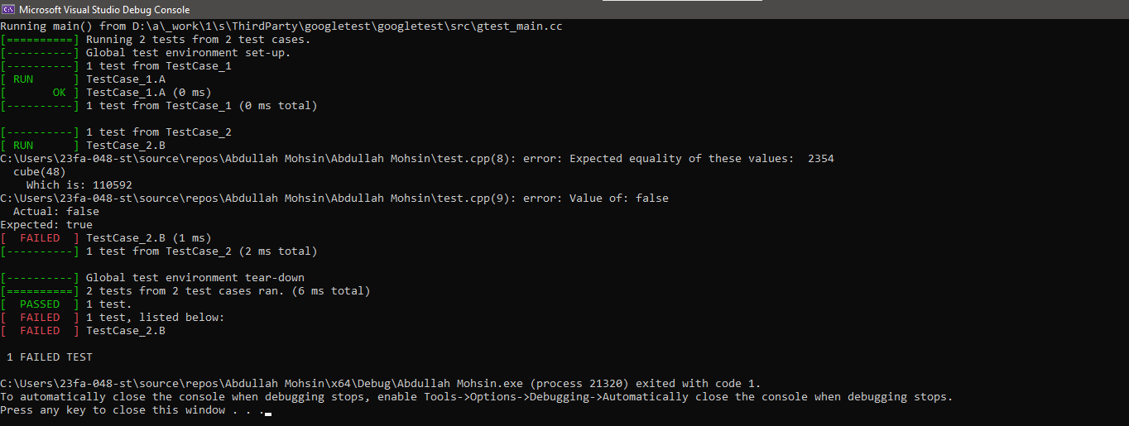

2.Develop a C++ program to compute the number sum Test the program for both successful and unsuccessful scenarios.

**Ans:**

**APP.CPP**

#include <iostream>

#include "add.h"

using namespace std;

int main()

{ cout << "Abdullah Mohsin,23fa-048-st\n";

cout << add(4,4);}

**TEST.CPP**

#include "pch.h"

#include "C:\Users\23fa-048-st\source\repos\Abdullah Mohsin\APP\add.cpp"

TEST(TestCase_1, A) {

EXPECT_EQ(8, add(4,4));

EXPECT_TRUE(true);}

**ADD.CPP**

#include"add.h"

int add(int a,int b) {

return a+b;}

**ADD.H**

#pragma once

int add(int,int );

