Task 1. Create a new Python file named test_math_operations.py. Write at least three new test functions in this file to test basic arithmetic operations (e.g., multiplication, division, modulo).Ensure at least one test is designed to fail .Run only the tests in test_math_operations.py. 2. Modify your conftest.py file to add a new fixture called sample_string. This fixture should yield a string like "Pytest is awesome!". Create a new test file named test_string_fixture.py. Write two test functions in test_string_fixture.py that use the sample_string fixture: • One test should check if the string contains a specific substring (e.g., "awesome"). • Another test should check the length of the string. Run these new tests and observe the fixture's setup and teardown messages (remember the -s flag). 3. In test_math_operations.py (from Task 1), ensure you have a failing test.Use PyCharm's debugging features: • Set a breakpoint on the assert line of the failing test. • Right-click the green play icon next to the failing test and select Debug 'test_...'. • Step through the code and inspect variables to understand why the assertion is failing. • Fix the test so it passes.

Ans:

Test_math_operation.py:

|  |
| --- |
| import pytest  def test_multiplication():  assert 5 * 3 == 15, "Multiplication of 5 and 3 should equal 15"  def test_division():  assert 10 / 2 == 5, "Division of 10 by 2 should equal 5"  def test_modulo_failing():  assert 10 % 3 == 2, "Modulo of 10 by 3 should equal 2" |

Test_string_fixture.py:

|  |
| --- |
| import pytest def test_string_contains_substring(sample_string):  assert "awesome" in sample_string, "String should contain 'awesome'" def test_string_length(sample_string):  assert len(sample_string) == 17, "String length should be 17" |

Conftest.py:

|  |
| --- |
| import pytest @pytest.fixture def sample_string():  print("\nSetting up sample_string fixture")  yield "Pytest is awesome!"  print("\nTearing down sample_string fixture") |

OUTPUT:

A)Test_math_operation.py:

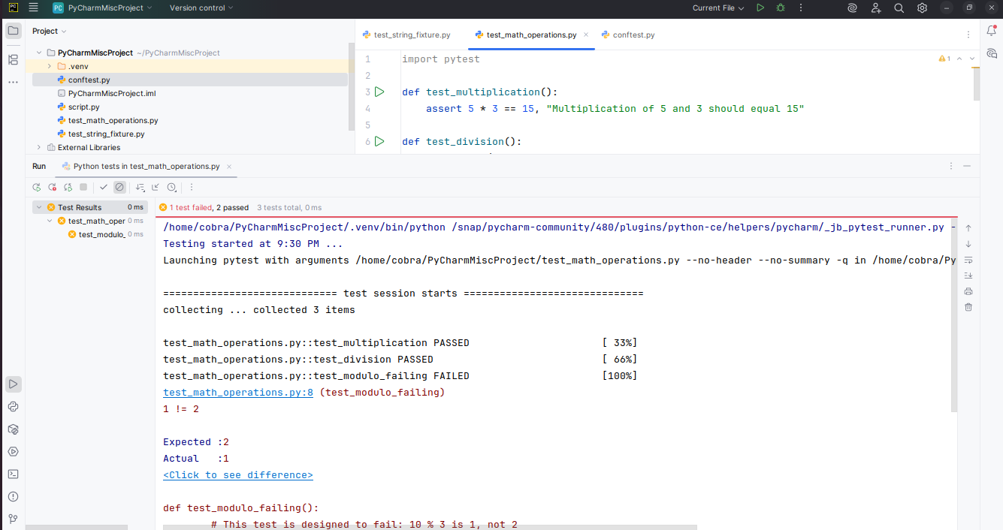

B)Test_string_fixture.py:

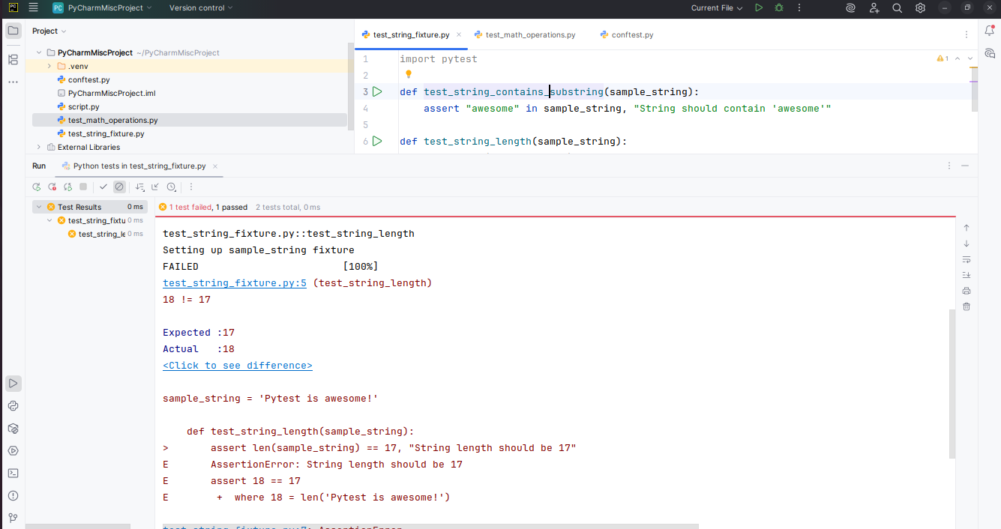

C)Conftest.py:

