**Objective:** To install and set up Visual Studio for software development and download GoogleTest for testing.

**Steps to Install Visual Studio:**

1. **Download the Installer:**
   * Visit the official Visual Studio website: <https://visualstudio.microsoft.com/>
   * Click on "Download Visual Studio."
   * Choose the desired edition (Community, Professional, or Enterprise).

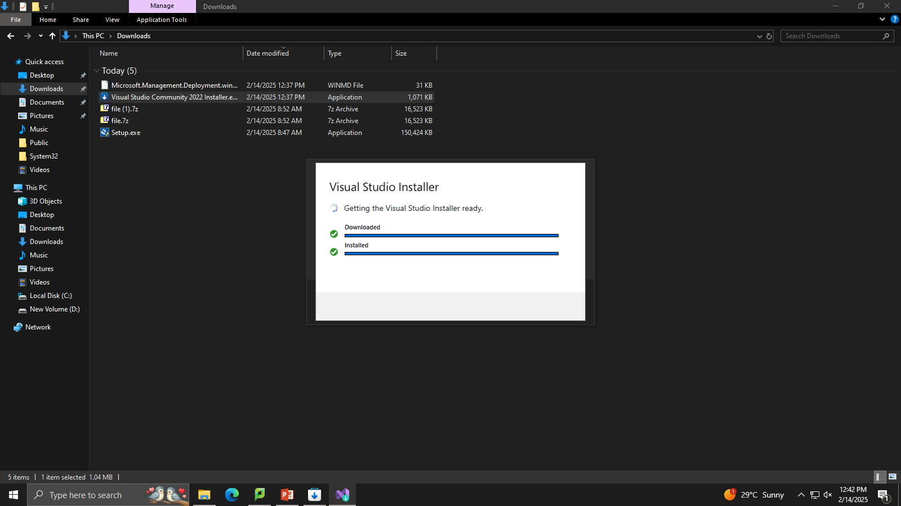

**2: Run the Installer:**

* + Locate the downloaded setup file and double-click to open it.
  + Allow the installer to run if prompted by User Account Control (UAC).

**3: Choose Installation Options:**

* + Select the components required for your development needs (Desktop development with C++)

Click "Install" to begin the installation process.

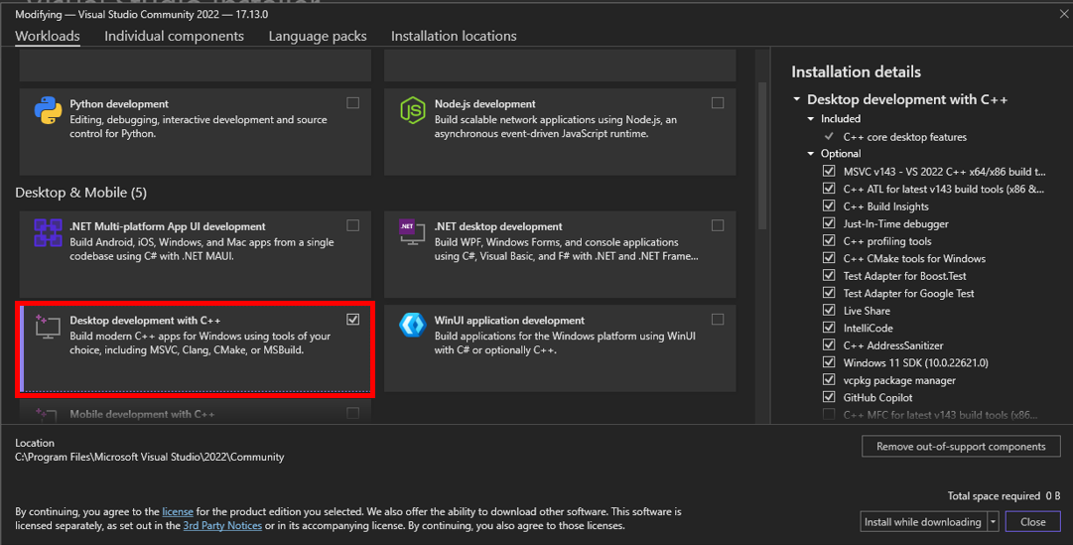

**4: Installation Process:**

* + Wait for the installation to complete. This may take some time depending on the selected components and internet speed.

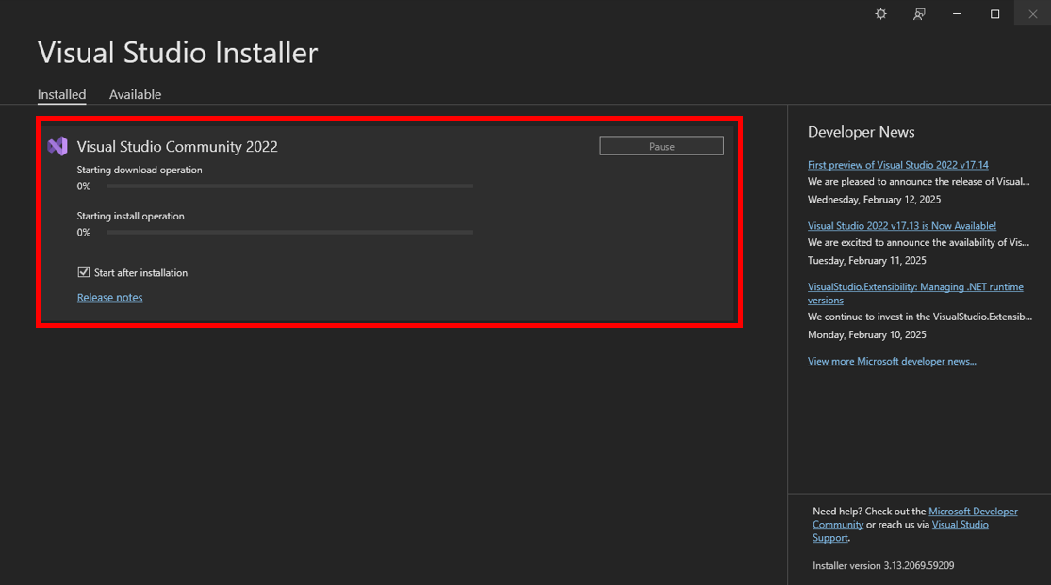

**5: Launch Visual Studio:**

* + Once the installation is complete, open Visual Studio.
  + Sign in with a Microsoft account if prompted.
  + Select the preferred theme and development settings.

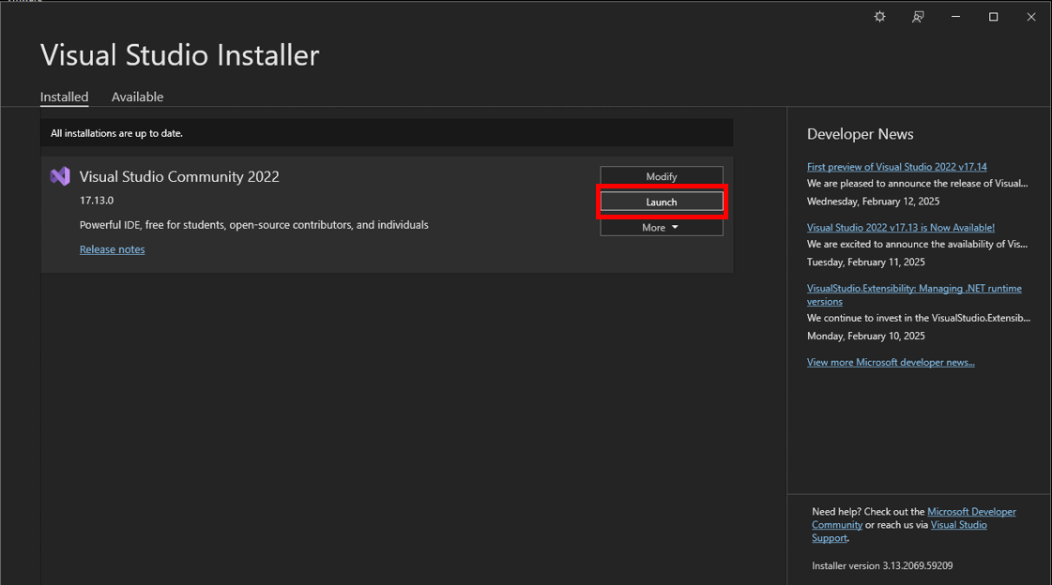

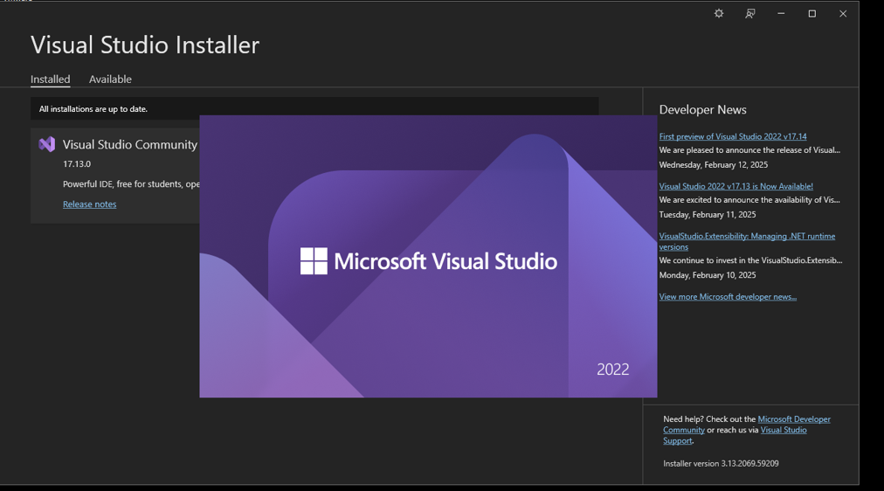

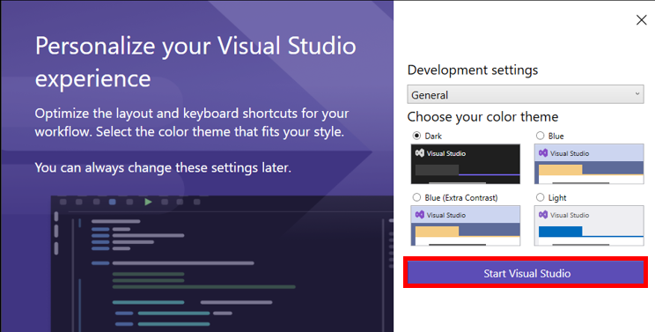

**Downloading and Setting Up GoogleTest:**

GoogleTest is a widely used C++ testing framework for writing unit tests.

1. **Download GoogleTest:**
   * Open Visual Studio.
   * Go to "Extensions" > "Manage Extensions."
   * Search for "GoogleTest Adapter" and install it.
2. **Install GoogleTest via vcpkg:**
   * Open a command prompt and navigate to a desired directory.
   * Clone vcpkg repository:

git clone https://github.com/microsoft/vcpkg.git

* + Navigate into the cloned directory and bootstrap vcpkg:
  + cd vcpkg

.\bootstrap-vcpkg.bat

* + Install GoogleTest:

.\vcpkg install gtest

1. **Link GoogleTest in a Visual Studio Project:**
   * Open Visual Studio and create a new C++ project.
   * Go to "Project" > "Properties."
   * Under "C/C++" > "General," add the include path for GoogleTest.
   * Under "Linker" > "General," add the library path for GoogleTest.
   * Under "Linker" > "Input," add gtest.lib and gtest_main.lib.

**Verify Installation:**

* + Create a new project to ensure that all components are properly installed.
  + Run a sample program to confirm the installation is successful.

Open Visual studio Go to Create new project:

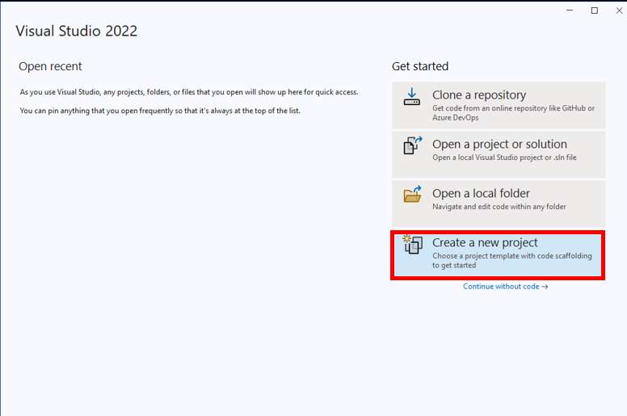

Choose Google Test c++ Module

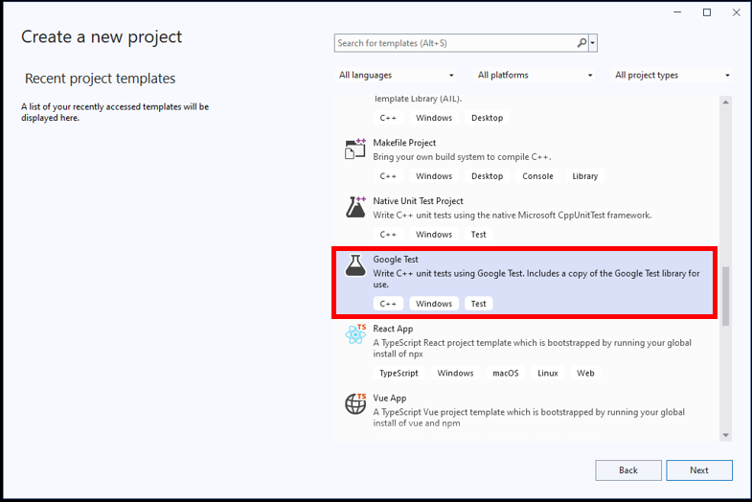

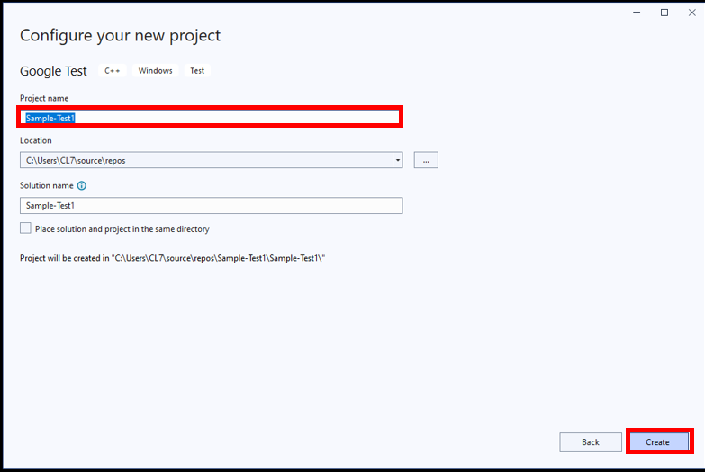

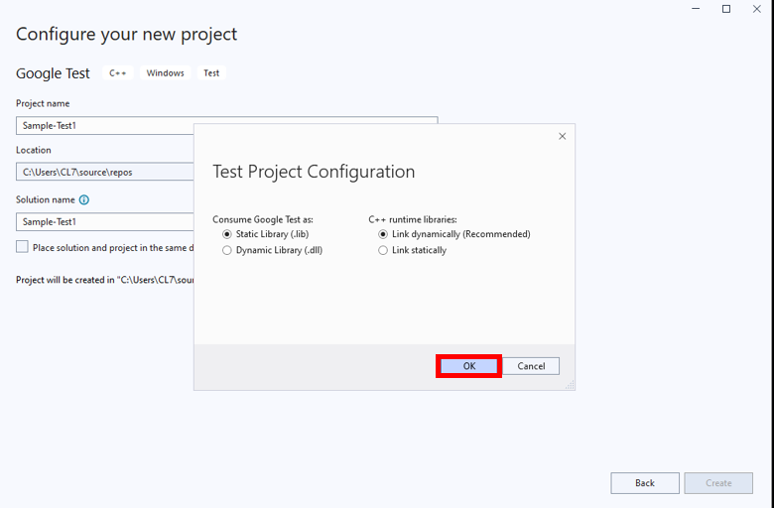

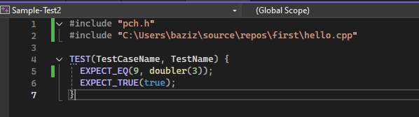

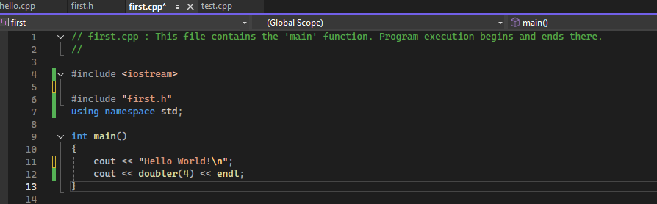

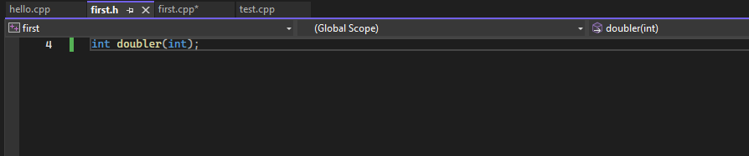

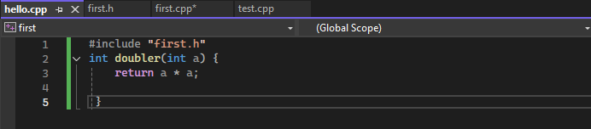

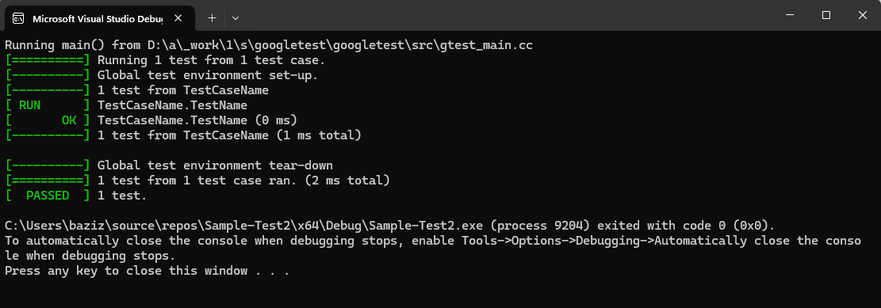

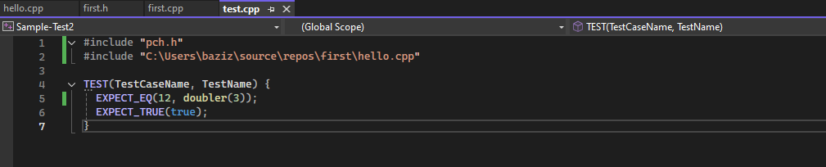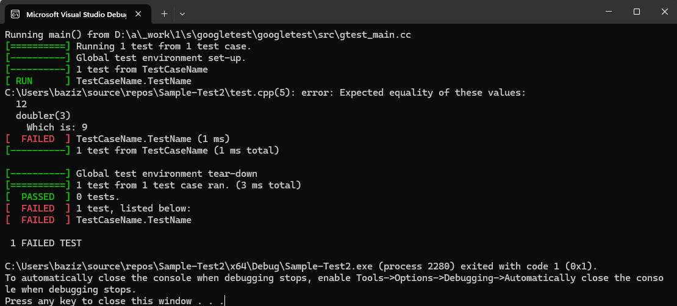

**Lab Task:**

1. Develop a C++ program to compute the cube of a given number (Number should be your roll number). Test the program for both successful and unsuccessful scenarios.