**Task: 1.**

1.Test a signup/registration form of a website, form must contain multiple elements like username, email id and password etc, test also contain Click/submit button to continue for registration.

**Ans:**

**Output:**

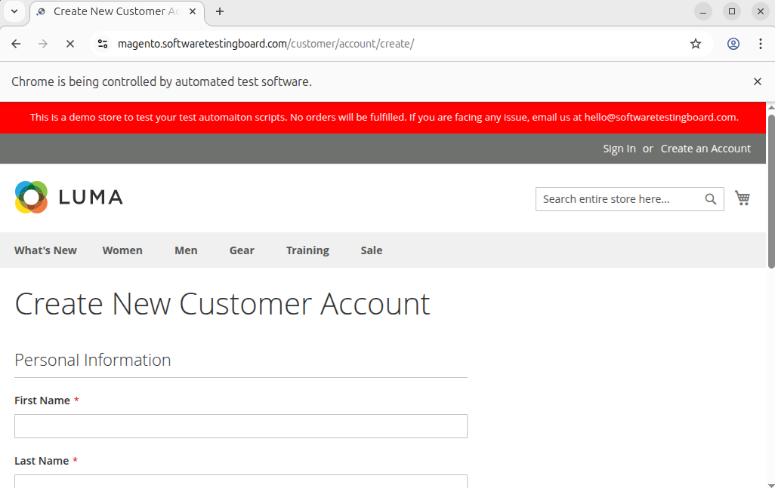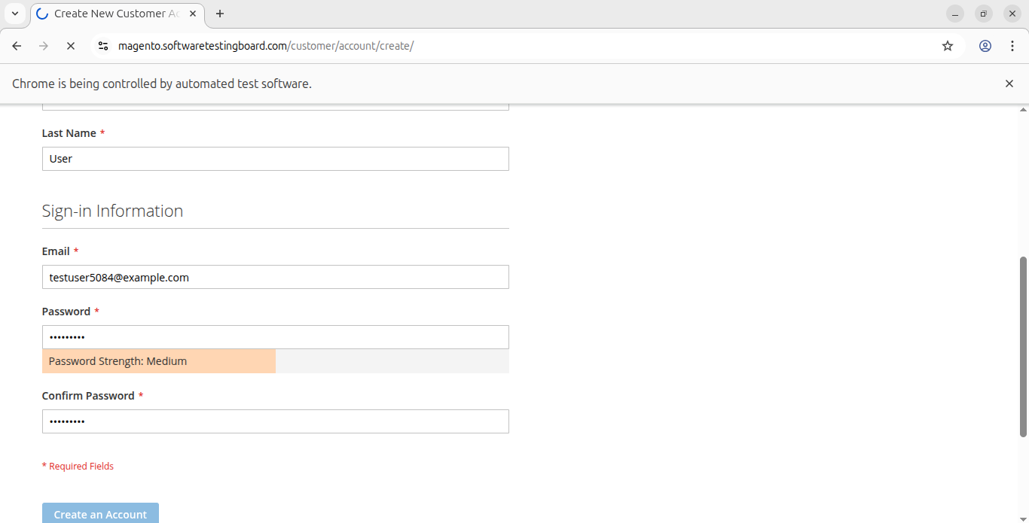

App.py:

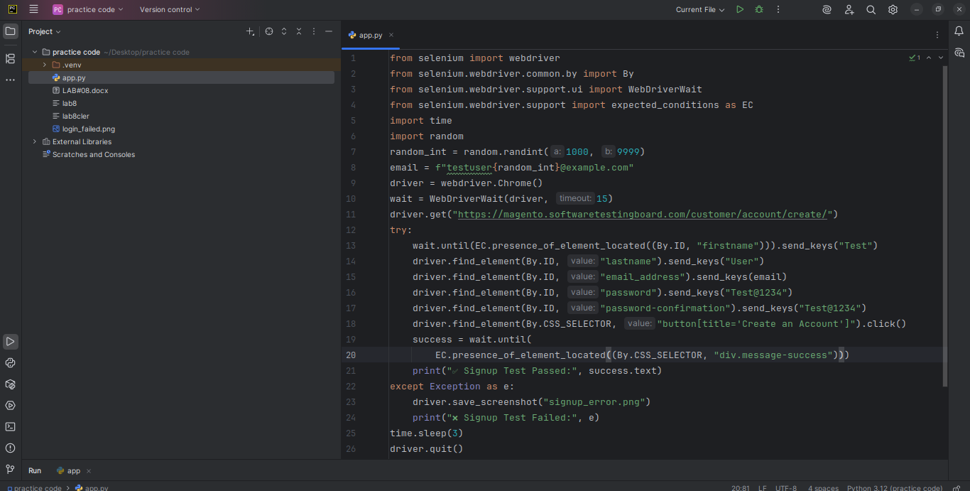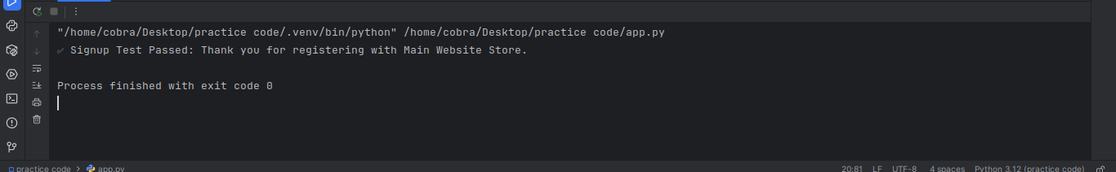

2. Now test the login/sign form for the same above website, by entering username, password and signbutton, after testing submit button, assert/confirmation of login must also be tested.

**Ans:**

**OUTPUT:**

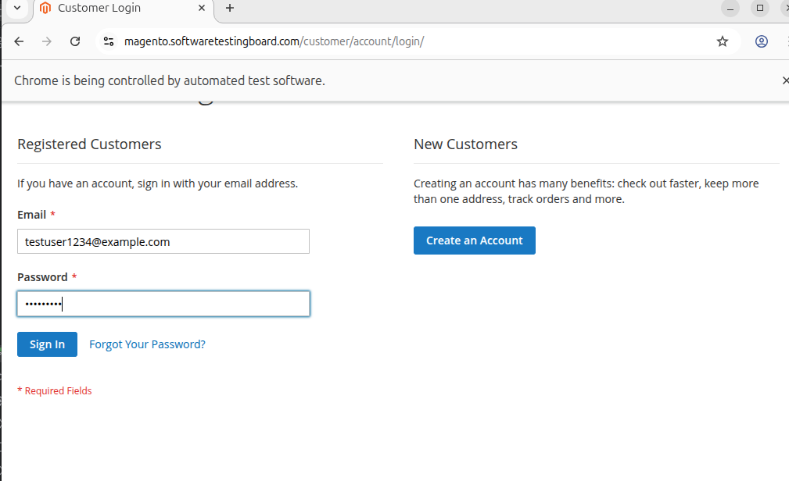

APP.PY

