Task:

1. Find and select any 10 web elements using selenium python

a. Any 2 by CSS selector

app.py:

|  |
| --- |
| from selenium import webdriver  from selenium.webdriver.common.by import By # Correct import  from selenium.webdriver.chrome.service import Service  from webdriver_manager.chrome import ChromeDriverManager  import time  driver = webdriver.Chrome(service=Service(ChromeDriverManager().install()))  driver.get(r"file:\\\C:\Users\cl5.UIT\PyCharmMiscProject\log.html")  heading_1 = driver.find_element(By.CSS_SELECTOR, "h1[style*='color:red']")  heading_2= driver.find_element(By.CSS_SELECTOR, "h2[style*='color:cornflowerblue']")  print(heading_1.text)  print(heading_2.text)  time.sleep(20)  driver.quit() |

log.html:

|  |
| --- |
| <!DOCTYPE html> <html lang="en"> <head>  <meta charset="UTF-8">  <title>web</title> </head> <body> <h1 style="color:red">Testing Login Form</h1> <h2 style="color:cornflowerblue">WORKING DIRECTORY</h2> <p>Testing using selenium</p> </body> </html> |

Output:

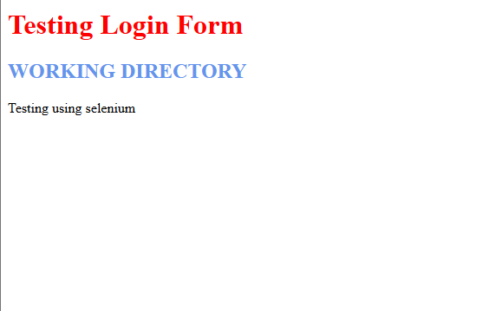

b. Any 2 by Hyperlinks

app.py:

|  |
| --- |
| from selenium import webdriver  from selenium.webdriver.common.by import By # Correct import  from selenium.webdriver.chrome.service import Service  from webdriver_manager.chrome import ChromeDriverManager  import time  driver = webdriver.Chrome(service=Service(ChromeDriverManager().install()))  driver.get(r"file:\\\C:\Users\cl5.UIT\PyCharmMiscProject\log.html")  heading_1 = driver.find_element(By.CSS_SELECTOR, "h1[style*='color:red']")  heading_2= driver.find_element(By.CSS_SELECTOR, "h2[style*='color:cornflowerblue']")  print(heading_1.text)  print(heading_2.text)  time.sleep(20)  driver.quit() |

log.html:

|  |
| --- |
| <!DOCTYPE html> <html lang="en"> <head>  <meta charset="UTF-8">  <title>web</title> </head> <body> <h1 style="color:red">Testing Login Form</h1> <h2 style="color:cornflowerblue">WORKING DIRECTORY</h2> <p>Testing using selenium</p> </body> </html> |

c. Any 2 by Xpaths

app.py:

|  |
| --- |
| from selenium import webdriver  from selenium.webdriver.common.by import By # Correct import  from selenium.webdriver.chrome.service import Service  from webdriver_manager.chrome import ChromeDriverManager  import time  driver = webdriver.Chrome(service=Service(ChromeDriverManager().install()))  driver.get(r"file:\\\C:\Users\cl5.UIT\PyCharmMiscProject\log.html")  heading_1 = driver.find_element(By.CSS_SELECTOR, "h1[style*='color:red']")  heading_2= driver.find_element(By.CSS_SELECTOR, "h2[style*='color:cornflowerblue']")  print(heading_1.text)  print(heading_2.text)  time.sleep(20)  driver.quit() |

log.html:

|  |
| --- |
| <!DOCTYPE html> <html lang="en"> <head>  <meta charset="UTF-8">  <title>web</title> </head> <body> <h1 style="color:red">Testing Login Form</h1> <h2 style="color:cornflowerblue">WORKING DIRECTORY</h2> <p>Testing using selenium</p> </body> </html> |

d. Any 2 by Id

app.py:

|  |
| --- |
| from selenium import webdriver  from selenium.webdriver.common.by import By # Correct import  from selenium.webdriver.chrome.service import Service  from webdriver_manager.chrome import ChromeDriverManager  import time  driver = webdriver.Chrome(service=Service(ChromeDriverManager().install()))  driver.get(r"file:\\\C:\Users\cl5.UIT\PyCharmMiscProject\log.html")  heading_1 = driver.find_element(By.CSS_SELECTOR, "h1[style*='color:red']")  heading_2= driver.find_element(By.CSS_SELECTOR, "h2[style*='color:cornflowerblue']")  print(heading_1.text)  print(heading_2.text)  time.sleep(20)  driver.quit() |

log.html:

|  |
| --- |
| <!DOCTYPE html> <html lang="en"> <head>  <meta charset="UTF-8">  <title>web</title> </head> <body> <h1 style="color:red">Testing Login Form</h1> <h2 style="color:cornflowerblue">WORKING DIRECTORY</h2> <p>Testing using selenium</p> </body> </html> |

e. Any 2 by name

app.py:

|  |
| --- |
| from selenium import webdriver  from selenium.webdriver.common.by import By # Correct import  from selenium.webdriver.chrome.service import Service  from webdriver_manager.chrome import ChromeDriverManager  import time  driver = webdriver.Chrome(service=Service(ChromeDriverManager().install()))  driver.get(r"file:\\\C:\Users\cl5.UIT\PyCharmMiscProject\log.html")  heading_1 = driver.find_element(By.CSS_SELECTOR, "h1[style*='color:red']")  heading_2= driver.find_element(By.CSS_SELECTOR, "h2[style*='color:cornflowerblue']")  print(heading_1.text)  print(heading_2.text)  time.sleep(20)  driver.quit() |

log.html:

|  |
| --- |
| <!DOCTYPE html> <html lang="en"> <head>  <meta charset="UTF-8">  <title>web</title> </head> <body> <h1 style="color:red">Testing Login Form</h1> <h2 style="color:cornflowerblue">WORKING DIRECTORY</h2> <p>Testing using selenium</p> </body> </html> |