Task:

1. Write and implement a test case to verify your website Title.

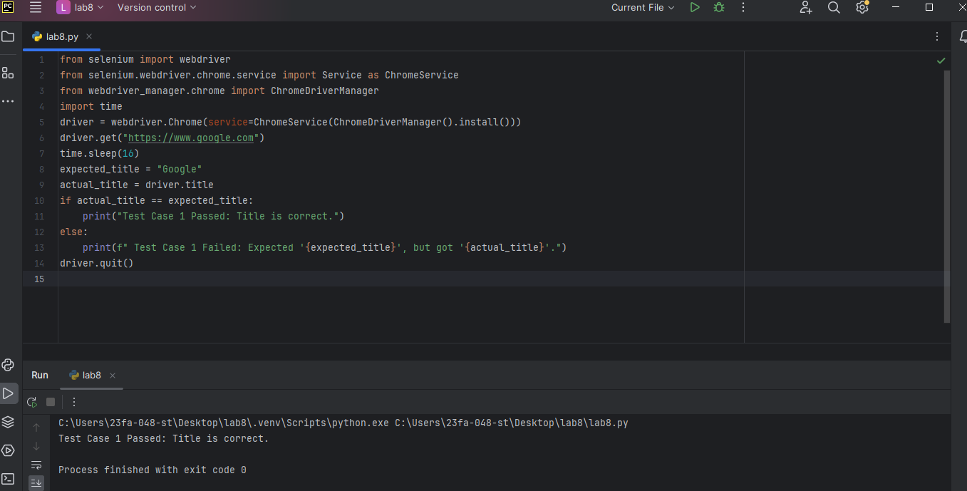Ans: Output:

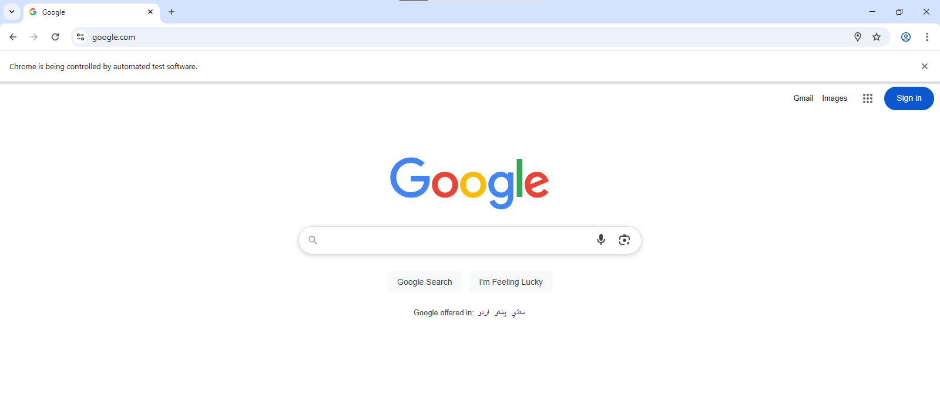

2.Write and implement a test case to URL of your website.

Ans: Output:

