**Objective: To learn how to design and write effective test cases for software applications**

**Lab Tasks:**

1. Write manual test cases for testing an addition function program from Lab01 (Task 2). Consider different test scenarios including positive numbers, negative numbers, and zero.

Ans:

Code:

#include <iostream>

using namespace std;

int add(int a, int b) {

return a + b;}

int main() {

int num1 = 5, num2 = 6;

cout << "Sum: " << add(num1, num2) << endl;

int num1 = -5, num2 = 6;

cout << "Sum: " << add(num1, num2) << endl;

int num1 = 0, num2 = 6;

cout << "Sum: " << add(num1, num2) << endl;

int num1 = 0, num2 = 0;

cout << "Sum: " << add(num1, num2) << endl;

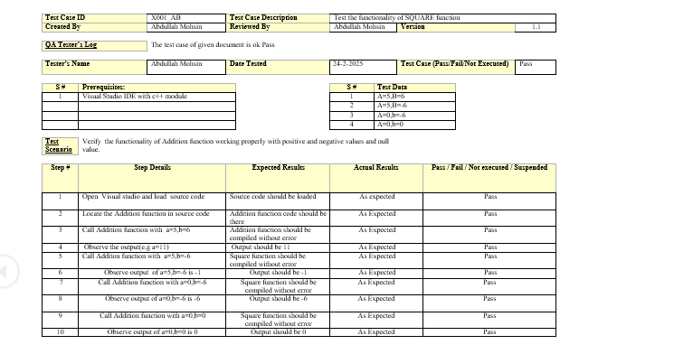 return 0;}

1. Design and write test cases for checking the login functionality of a UIT’S Edu Smart portal. Use your ID and Passwords for login.

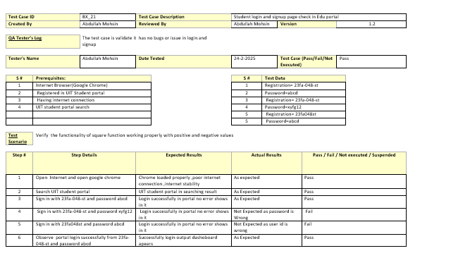Ans:

