**Task#1:**

1. Create a counter application that allows users to increase or decrease the count using buttons

**Message.js:**

|  |
| --- |
| import React, { useState } from 'react';  function App() {  const [count, setCount] = useState(0);  const increase = () => setCount(count + 1);  const decrease = () => setCount(count - 1);  return (  <div style={{ textAlign: 'center', marginTop: '50px' }}>  <h1>Counter App</h1>  <h2>Count: {count}</h2>  <button onClick={increase}>Increase</button>  <button onClick={decrease} style={{ marginLeft: '10px' }}>Decrease</button>  </div>  );  }  export default App; |

**Output:**

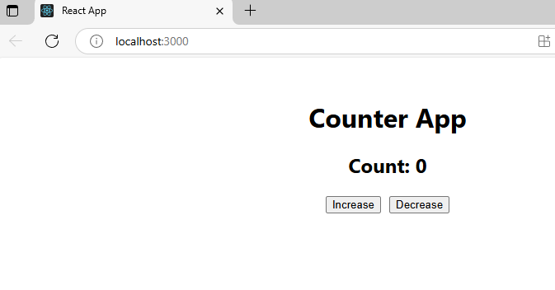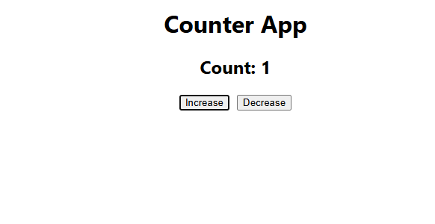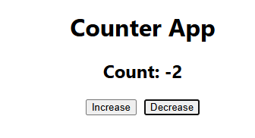

**Task#2:**

**2. Create a button that changes the background color of the page when clicked.**

**App.js:**

|  |
| --- |
| **import React, { useState } from 'react';**  **function App() {**  **const [bgColor, setBgColor] = useState('white'); // New state for background color**  **const changeColor = () => {**  **const randomColor = '#' + Math.floor(Math.random()*16777215).toString(16); // Random color**  **setBgColor(randomColor);**  **};**  **return (**  **<div style={{ backgroundColor: bgColor, height: '100vh', textAlign: 'center', paddingTop: '50px' }}>**  **<h1>BG COLOR CHANGES:</h1>**  **<hr style={{ margin: '40px 0' }} />**  **<button onClick={changeColor}>Change Background Color</button>**  **</div>**  **);**  **}**  **export default App;** |

**OUTPUT:**

