Tasks:QCreate an e-commerce website using WordPress and WooCommerce. Your website should include:

1. At least five products, each with a title, description, price, and image.
2. 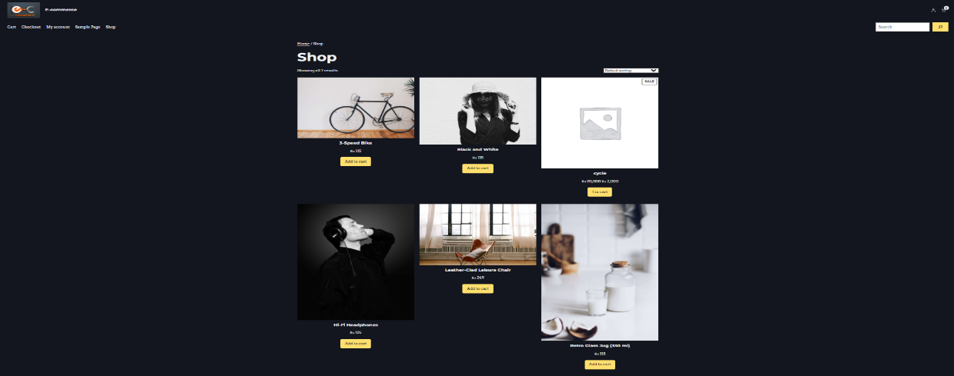
3. A homepage showcasing featured products.



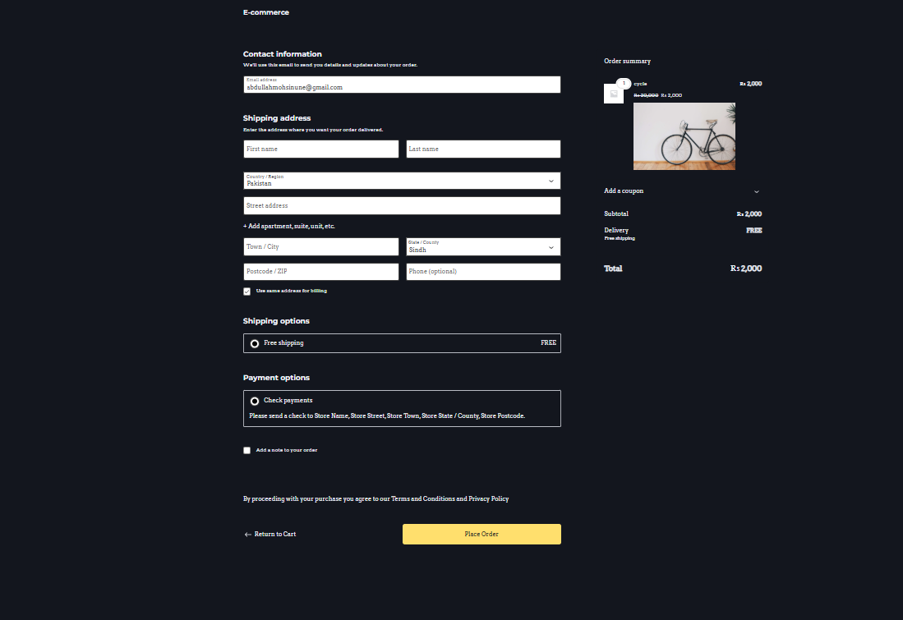3. A functional cart and checkout process.

4. A contact page with a form and store details

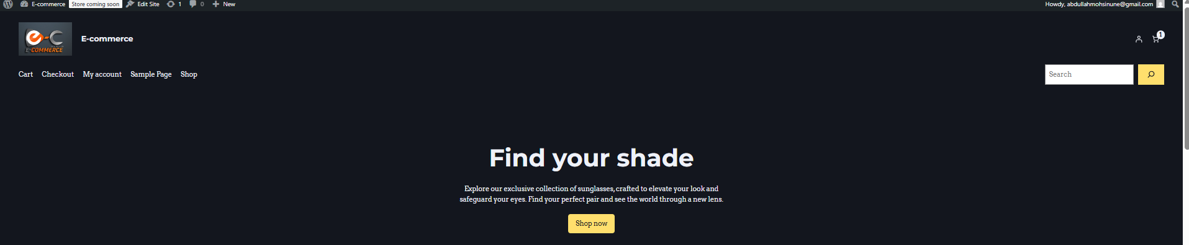

1. A contact page with a form and store details