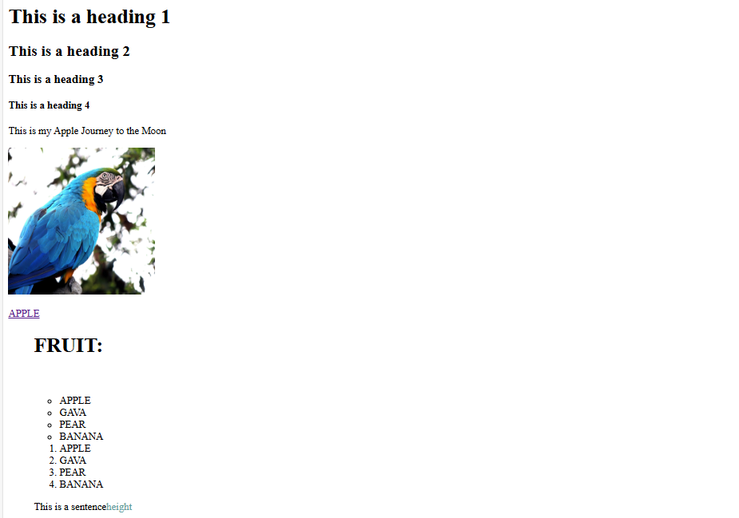

HTML-CODE:

<!DOCTYPE html>

<html lang="en">

<head>

<meta charset="UTF-8">

<meta http-equiv="X-UA-Compatible" content="IE=edge">

<meta name="viewport" content="width=device-width, initial-scale=1.0">

<link rel="icon" type="image/x-icon" href="star.ico">

<title>WEB</title>

</head>

<body >

<h1>This is a heading 1</h1>

<h2>This is a heading 2</h2>

<h3>This is a heading 3</h3>

<h4>This is a heading 4</h4>

<p>This is my Apple Journey to the Moon</p>

<img src="https://images.pexels.com/photos/53360/macaw-parrot-bird-pet-53360.jpeg?cs=srgb&dl=pexels-pixabay-53360.jpg&fm=jpg" alt=" PARROT" width="230px" height="230px" >

<p><a href="https://www.freeconvert.com/png-to-ico/download" target="blank"><label>APPLE</label></a></p>

<ul>

<h1>FRUIT:</h1>

<br></br>

<ul style="list-style-type: circle;">

<li> APPLE</li>

<li>GAVA</li>

<li>PEAR</li>

<li>BANANA</li>

</ul>

<ol symbol="square">

<li> APPLE</li>

<li>GAVA</li>

<li>PEAR</li>

<li>BANANA</li>

</ol>

<div class="BOX"><p>This is a sentence<span style="color:cadetblue;">height</span></p></div>

</body>

</html>