Lab Tasks:

Task 1: Create Documents • Create a collection called books. • Insert at least 5 documents into the books collection, each containing fields such as: o title, author, year_published, genre, price

Ans: task_1_insert.js:

|  |
| --- |
| use library;  db.books.insertMany([  { title: "To Kill a Mockingbird", author: "Harper Lee", year_published: 1960, genre: "Fiction", price: 12.99 },  { title: "1984", author: "George Orwell", year_published: 1949, genre: "Dystopian", price: 9.99 },  { title: "Moby Dick", author: "Herman Melville", year_published: 1851, genre: "Adventure", price: 15.50 },  { title: "Pride and Prejudice", author: "Jane Austen", year_published: 1813, genre: "Romance", price: 8.75 },  { title: "The Great Gatsby", author: "F. Scott Fitzgerald", year_published: 1925, genre: "Tragedy", price: 10.50 }  ]); |

Output:

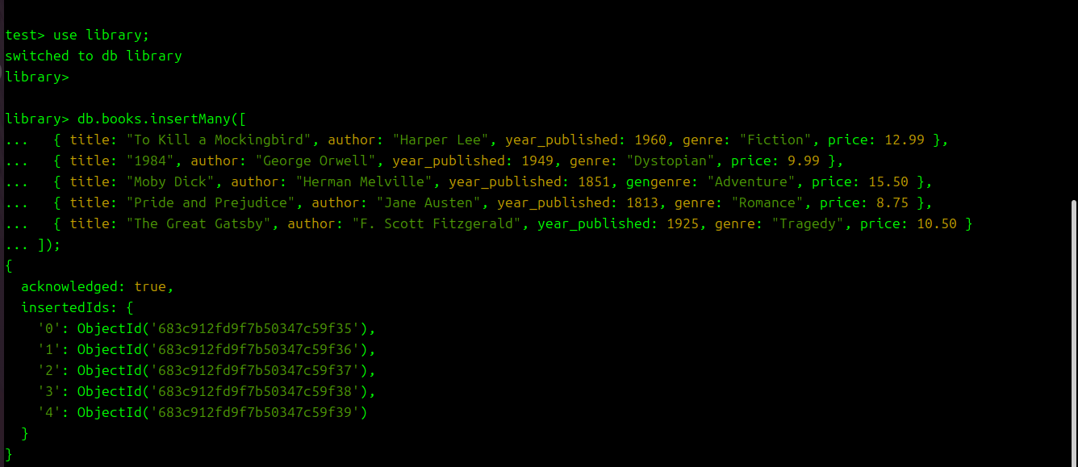

Task 2: Read Documents • Retrieve all documents from the books collection. • Find books by a specific author • Find books where the price is greater than 10.

Ans: task_2_read.js:

|  |
| --- |
| use library;  // Retrieve all documents  db.books.find();  // Find books by a specific author  db.books.find({ author: "George Orwell" });  // Find books where price > 10  db.books.find({ price: { $gt: 10 } }); |

OUTPUT:

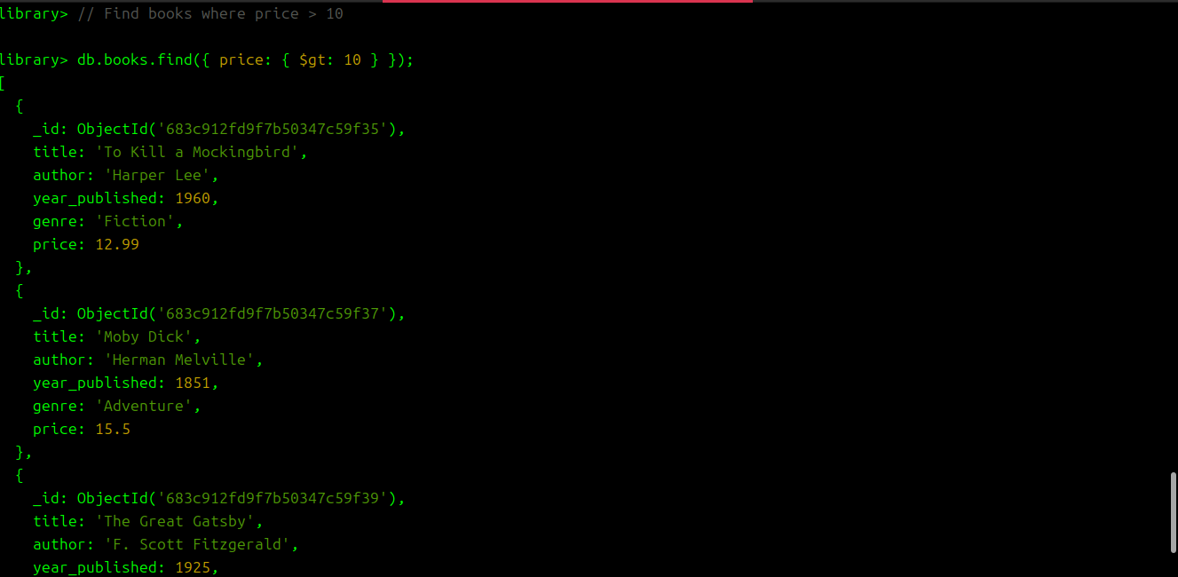

Task 3: Update Documents • Update the price of a book with a specific title to a new value. • Update the genre of all books published before 1950 to "Classic".

task3_update.js:

|  |
| --- |
| use library;  // Update price of a book with specific title  db.books.updateOne(  { title: "1984" },  { $set: { price: 11.99 } }  );  // Update genre of books published before 1950  db.books.updateMany(  { year_published: { $lt: 1950 } },  { $set: { genre: "Classic" } }  ); |

OUTPUT:

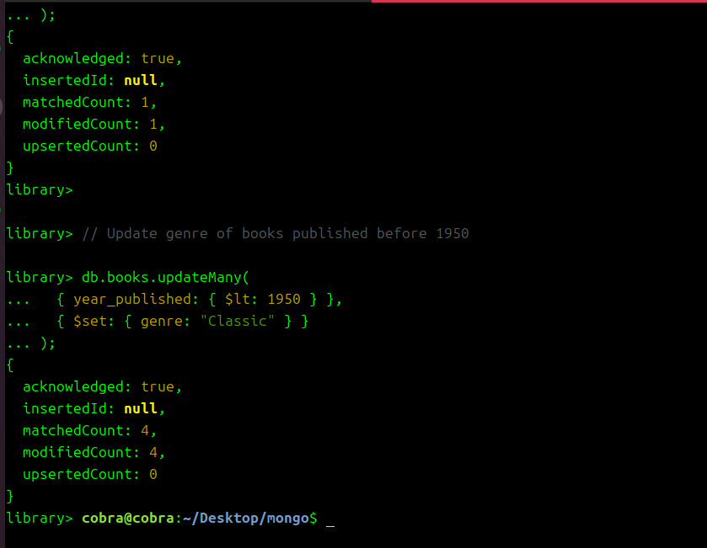

Task 4: Delete Documents • Delete a book by its title • Delete all books that have a price greater than 10

Ans:

Task_4 delete.js:

|  |
| --- |
| use library;  // Delete a book by title  db.books.deleteOne({ title: "Moby Dick" });  // Delete books with price > 10  db.books.deleteMany({ price: { $gt: 10 } }); |

Output:

