**LAB TASK:**

Apply PHP get and post method after designing below form

Ans:

* **GET METHOD:**

**Index.html**

|  |
| --- |
| <!DOCTYPE html>  <html>  <head>      <title>User Info Form (GET Method)</title>  </head>  <body style="font-family: Arial; background-color: #f9f9f9; padding: 20px;">      <h2 style="color: #2c3e50;">User Information Form</h2>      <form action="get.php" method="get">          <label style="font-weight: bold;">Name:</label><br>          <input type="text" name="name" required style="padding: 5px; width: 300px;"><br><br>          <label style="font-weight: bold;">Email:</label><br>          <input type="email" name="email" required style="padding: 5px; width: 300px;"><br><br>          <label style="font-weight: bold;">Age:</label><br>          <input type="number" name="age" required style="padding: 5px; width: 300px;"><br><br>          <label style="font-weight: bold;">Phone Number:</label><br>          <input type="tel" name="phone" required style="padding: 5px; width: 300px;"><br><br>          <input type="submit" value="Submit" style="padding: 8px 16px; background-color: #2ecc71; color: white; border: none; font-weight: bold; cursor: pointer;">          <input type="reset" value="Reset" style="padding: 8px 16px; background-color: #e74c3c; color: white; border: none; font-weight: bold; cursor: pointer;">      </form>  </body>  </html> |

**get.php**

|  |
| --- |
| <!DOCTYPE html>  <html>  <body style="font-family: Verdana; background-color: #ecf0f1; padding: 20px;">  <h2 style="color: #2980b9;">Submitted Information</h2>  <p style="font-size: 18px;">      <strong>Name:</strong> <span style="color: #2c3e50;"><?php echo htmlspecialchars($_GET["name"]); ?></span><br>      <strong>Email:</strong> <span style="color: #2c3e50;"><?php echo htmlspecialchars($_GET["email"]); ?></span><br>      <strong>Age:</strong> <span style="color: #2c3e50;"><?php echo htmlspecialchars($_GET["age"]); ?></span><br>      <strong>Phone Number:</strong> <span style="color: #2c3e50;"><?php echo htmlspecialchars($_GET["phone"]); ?></span>  </p>  </body>  </html> |

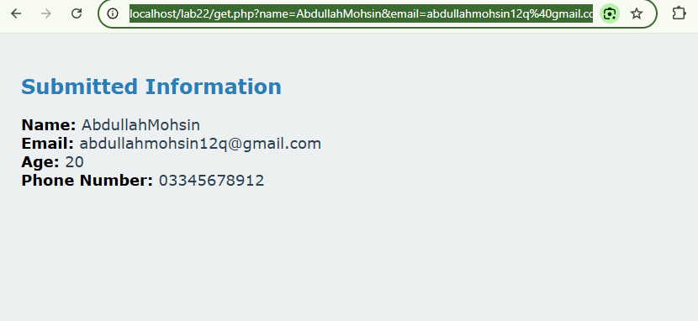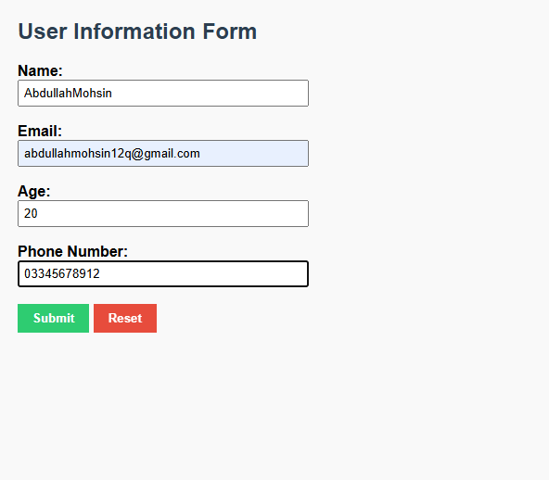**Output:**

* **POST METHOD:**

**Index.html**

|  |
| --- |
| <!DOCTYPE html>  <html>  <head>  <title>User Info Form (GET Method)</title>  </head>  <body style="font-family: Arial; background-color: #f9f9f9; padding: 20px;">  <h2 style="color: #2c3e50;">User Information Form</h2>  <form action="post.php" method="get">  <label style="font-weight: bold;">Name:</label><br>  <input type="text" name="name" required style="padding: 5px; width: 300px;"><br><br>  <label style="font-weight: bold;">Email:</label><br>  <input type="email" name="email" required style="padding: 5px; width: 300px;"><br><br>  <label style="font-weight: bold;">Age:</label><br>  <input type="number" name="age" required style="padding: 5px; width: 300px;"><br><br>  <label style="font-weight: bold;">Phone Number:</label><br>  <input type="tel" name="phone" required style="padding: 5px; width: 300px;"><br><br>  <input type="submit" value="Submit" style="padding: 8px 16px; background-color: #2ecc71; color: white; border: none; font-weight: bold; cursor: pointer;">  <input type="reset" value="Reset" style="padding: 8px 16px; background-color: #e74c3c; color: white; border: none; font-weight: bold; cursor: pointer;">  </form>  </body>  </html> |

**post.php**

|  |
| --- |
| <!DOCTYPE html>  <html>  <body style="font-family: Verdana; background-color: #f0f3f4; padding: 20px;">  <h2 style="color: #2c3e50;">Submitted Information</h2>  <p style="font-size: 18px;">  <strong>Name:</strong> <span style="color: #34495e;"><?php echo htmlspecialchars($_POST["name"]); ?></span><br>  <strong>Email:</strong> <span style="color: #34495e;"><?php echo htmlspecialchars($_POST["email"]); ?></span><br>  <strong>Age:</strong> <span style="color: #34495e;"><?php echo htmlspecialchars($_POST["age"]); ?></span><br>  <strong>Phone Number:</strong> <span style="color: #34495e;"><?php echo htmlspecialchars($_POST["phone"]); ?></span>  </p>  </body>  </html> |

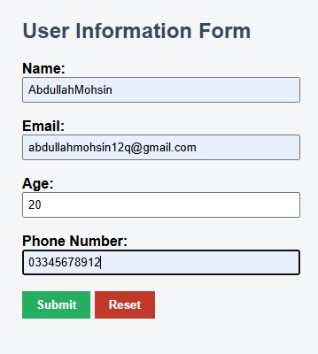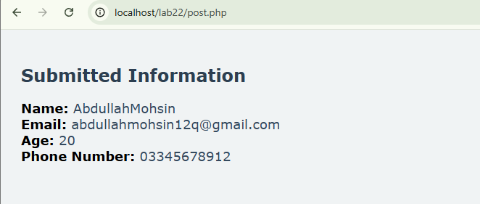**Output:**