Name: Abdullah Nabi Ahmed Rollno: se231040
Class: SE-6A Course: DevOps
Assignment 01:
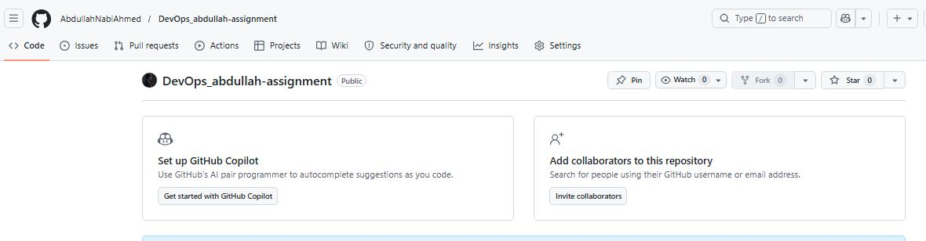
Step01:

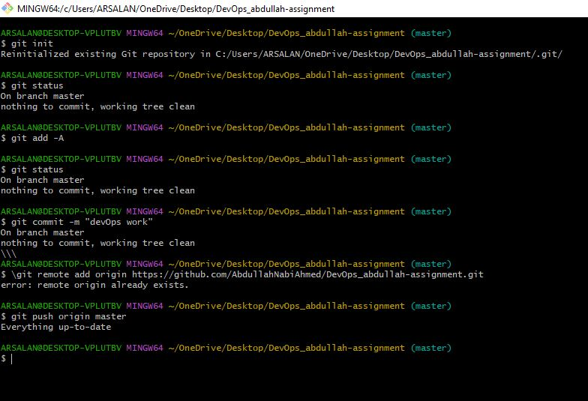

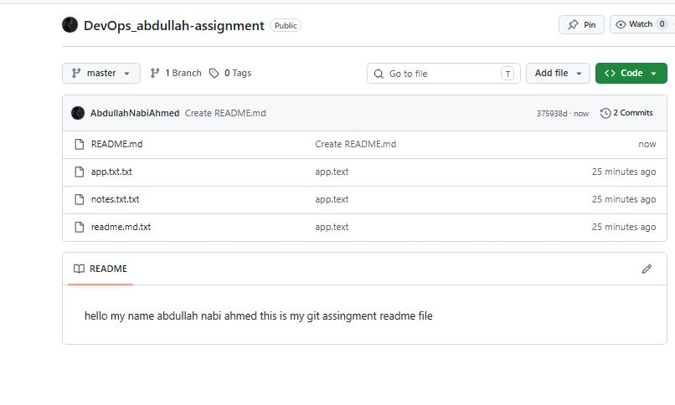
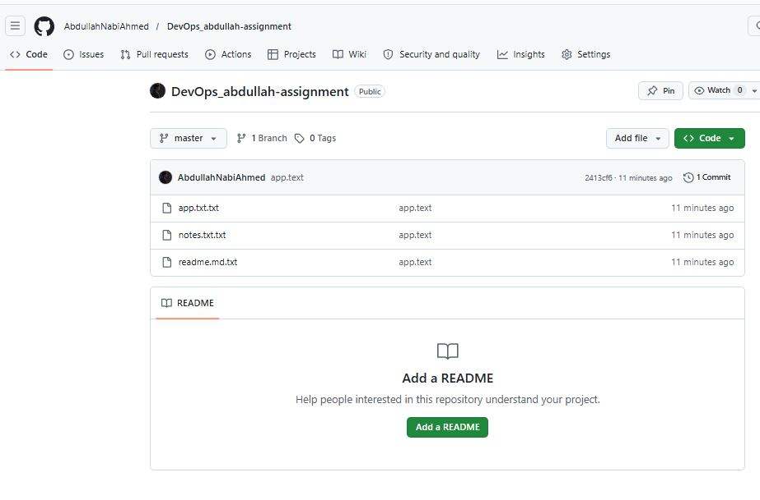

LINK:
https://github.com/AbdullahNabiAhmed/DevOps_abdullah-assignment/tree/master

Activity 02:
