**Data Structures and Algorithms (DSA)**

**Complex Computing Programming Assignment**



**Submitted by:**

Abdullah Khan 2023-CS-718

Ahmad Wahab 2023-CS-746

**Submitted to:**

Ma’am Darakshan

**Dated: 13th December, 2024.**

**Department of Computer Science**

**University of Engineering and Technology Lahore, New Campus.**

Table of Contents

Selection Sort 3

Graph: 3

Insertion Sort 4

Graph: 4

Bubble Sort 5

Graph: 5

Merge Sort 6

Graph: 6

Quick Sort 7

Graph: 7

Heap Sort 8

Graph: 8

Counting Sort 9

Graph: 9

# Selection Sort

|  |  |  |  |  |  |  |  |  |  |  |  |  |  |  |
| --- | --- | --- | --- | --- | --- | --- | --- | --- | --- | --- | --- | --- | --- | --- |
| Input Size [n] | 1000 | 2000 | 3000 | 4000 | 5000 | 10000 | 20000 | 40000 | 80000 | 100000 | 150000 | 200000 | 250000 | 500000 |
| Execution Time Machine A (sec) | 0.0020 | 0.0082 | 0.016 | 0.032 | 0.036 | 0.144 | 0.546 | 2.16 | 8.74 | 13.48 | 30.92 | 54.20 | 93.5 | 346.34 |
| Execution Time Machine B (sec) | 0.0026 | 0.0107 | 0.0209 | 0.0418 | 0.0471 | 0.1883 | 0.714 | 2.824 | 11.42 | 17.62 | 40.43 | 70.87 | 122.26 | 452.90 |

# Graph:

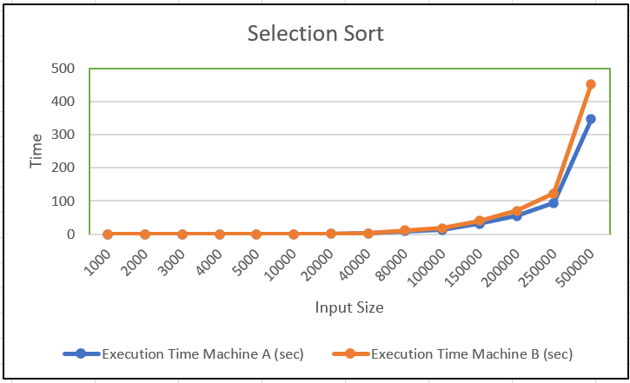

# Insertion Sort

|  |  |  |  |  |  |  |  |  |  |  |  |  |  |  |
| --- | --- | --- | --- | --- | --- | --- | --- | --- | --- | --- | --- | --- | --- | --- |
| Input Size [n] | 1000 | 2000 | 3000 | 4000 | 5000 | 10000 | 20000 | 40000 | 80000 | 100000 | 150000 | 200000 | 250000 | 500000 |
| Execution Time Machine A (sec) | 0.0082 | 0.0091 | 0.0098 | 0.013 | 0.031 | 0.080 | 0.28 | 1.11 | 4.62 | 8.11 | 17.39 | 29.95 | 44.38 | 183 |
| Execution Time Machine B (sec) | 0.010 | 0.011 | 0.012 | 0.0167 | 0.0407 | 0.1047 | 0.366 | 1.451 | 6.015 | 10.60 | 22.80 | 39.17 | 58.27 | 240.22 |

# Graph:

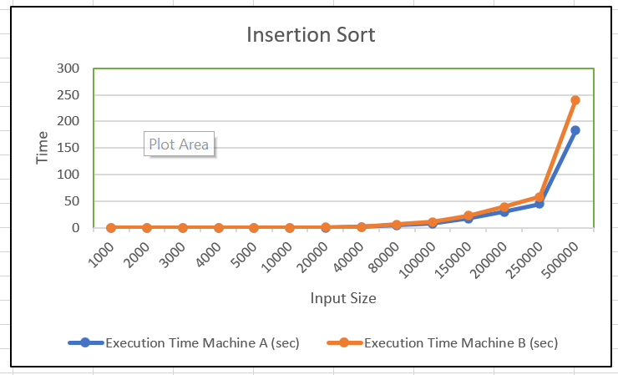

# Bubble Sort

|  |  |  |  |  |  |  |  |  |  |  |  |  |  |  |
| --- | --- | --- | --- | --- | --- | --- | --- | --- | --- | --- | --- | --- | --- | --- |
| Input Size [n] | 1000 | 2000 | 3000 | 4000 | 5000 | 10000 | 20000 | 40000 | 80000 | 100000 | 150000 | 200000 | 250000 | 500000 |
| Execution Time Machine A (sec) | 0.0049 | 0.022 | 0.052 | 0.087 | 0.130 | 0.52 | 2.14 | 8.52 | 34.24 | 54.94 | 117.88 | 216.6 | 341.46 | 1308.97 |
| Execution Time Machine B (sec) | 0.0062 | 0.027 | 0.065 | 0.109 | 0.163 | 0.655 | 2.695 | 10.73 | 43.09 | 69.19 | 148.34 | 272.54 | 430.35 | 1646.21 |

# 

# Graph:

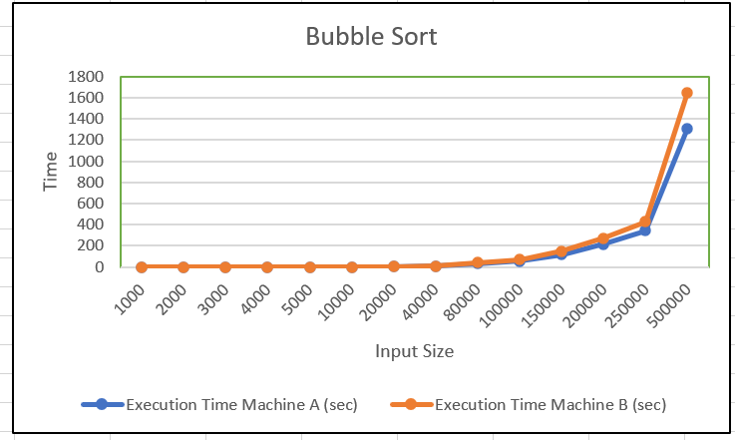

# Merge Sort

|  |  |  |  |  |  |  |  |  |  |  |  |  |  |  |
| --- | --- | --- | --- | --- | --- | --- | --- | --- | --- | --- | --- | --- | --- | --- |
| Input Size [n] | 1000 | 2000 | 3000 | 4000 | 5000 | 10000 | 20000 | 40000 | 80000 | 100000 | 150000 | 200000 | 250000 | 500000 |
| Execution Time Machine A (sec) | 0.0094 | 0.0027 | 0.0030 | 0.0047 | 0.0030 | 0.0079 | 0.011 | 0.017 | 0.027 | 0.036 | 0.065 | 0.096 | 0.115 | 0.288 |
| Execution Time Machine B (sec) | 0.0114 | 0.0033 | 0.0036 | 0.0057 | 0.0040 | 0.0096 | 0.013 | 0.020 | 0.032 | 0.043 | 0.078 | 0.116 | 0.139 | 0.349 |

# Graph:

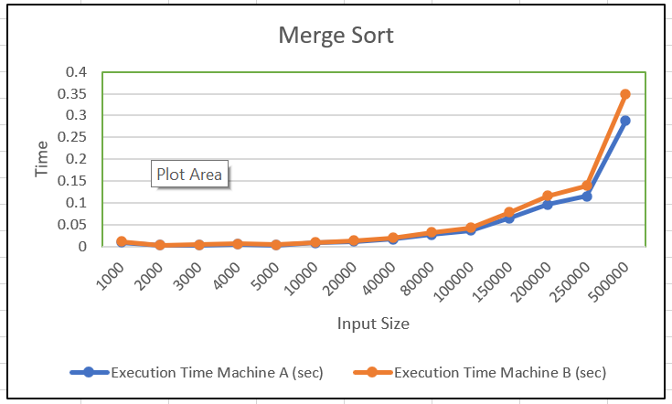

# Quick Sort

|  |  |  |  |  |  |  |  |  |  |  |  |  |  |  |
| --- | --- | --- | --- | --- | --- | --- | --- | --- | --- | --- | --- | --- | --- | --- |
| Input Size [n] | 1000 | 2000 | 3000 | 4000 | 5000 | 10000 | 20000 | 40000 | 80000 | 100000 | 150000 | 200000 | 250000 | 500000 |
| Execution Time Machine A (sec) | 0.0052 | 0.0067 | 0.0030 | 0.0074 | 0.0080 | 0.0079 | 0.0088 | 0.024 | 0.048 | 0.078 | 0.160 | 0.250 | 0.398 | 1.485 |
| Execution Time Machine B (sec) | 0.0063 | 0.0081 | 0.0036 | 0.0090 | 0.0097 | 0.0099 | 0.010 | 0.030 | 0.056 | 0.088 | 0.181 | 0.303 | 0.483 | 1.802 |

# Graph:

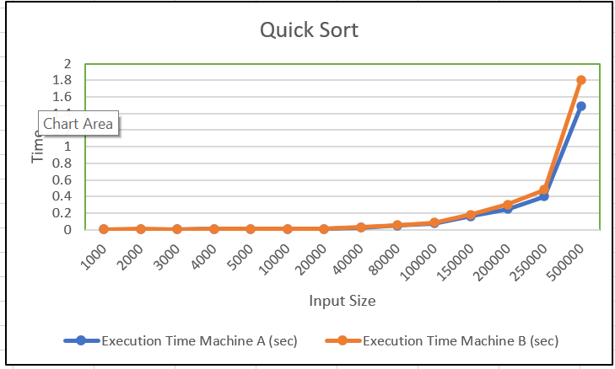

# Heap Sort

|  |  |  |  |  |  |  |  |  |  |  |  |  |  |  |
| --- | --- | --- | --- | --- | --- | --- | --- | --- | --- | --- | --- | --- | --- | --- |
| Input Size [n] | 1000 | 2000 | 3000 | 4000 | 5000 | 10000 | 20000 | 40000 | 80000 | 100000 | 150000 | 200000 | 250000 | 500000 |
| Execution Time Machine A (sec) | 0.0014 | 0.0079 | 0.0036 | 0.0050 | 0.0071 | 0.0086 | 0.0090 | 0.0210 | 0.0362 | 0.0470 | 0.0732 | 0.0998 | 0.106 | 0.239 |
| Execution Time Machine B (sec) | 0.0017 | 0.0090 | 0.0044 | 0.0061 | 0.0086 | 0.010 | 0.011 | 0.025 | 0.043 | 0.057 | 0.088 | 0.121 | 0.128 | 0.290 |

# Graph:

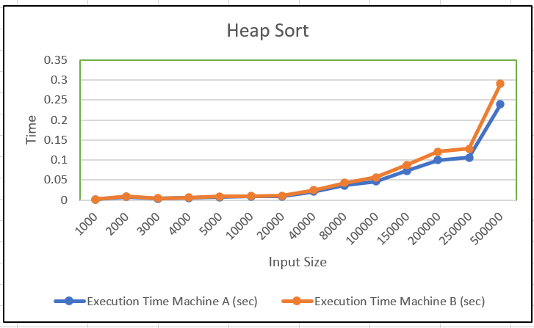

# Counting Sort

|  |  |  |  |  |  |  |  |  |  |  |  |  |  |  |
| --- | --- | --- | --- | --- | --- | --- | --- | --- | --- | --- | --- | --- | --- | --- |
| Input Size [n] | 1000 | 2000 | 3000 | 4000 | 5000 | 10000 | 20000 | 40000 | 80000 | 100000 | 150000 | 200000 | 250000 | 500000 |
| Execution Time Machine A (sec) | 0.0007 | 0.0008 | 0.00096 | 0.00099 | 0.0010 | 0.0039 | 0.0010 | 0.0013 | 0.0014 | 0.0039 | 0.0091 | 0.003 | 0.0080 | 0.0234 |
| Execution Time Machine B (sec) | 0.0008 | 0.0010 | 0.0012 | 0.0013 | 0.0020 | 0.0047 | 0.0012 | 0.0016 | 0.0019 | 0.0051 | 0.011 | 0.0045 | 0.0097 | 0.0284 |

# Graph:

