

**Name: Abdullah Nazir**

**Reg No: L1F22BSCS0788**

**Course: OS Lab 2**

**Section: E12**

1. man ls

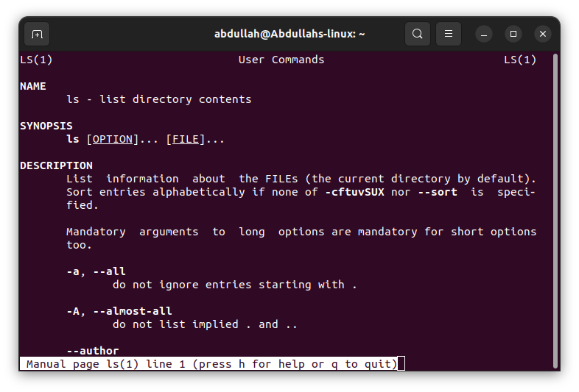

1. ls

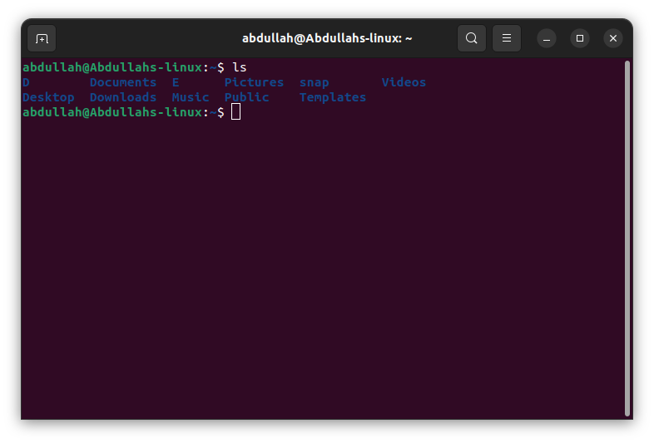

1. ls -R.

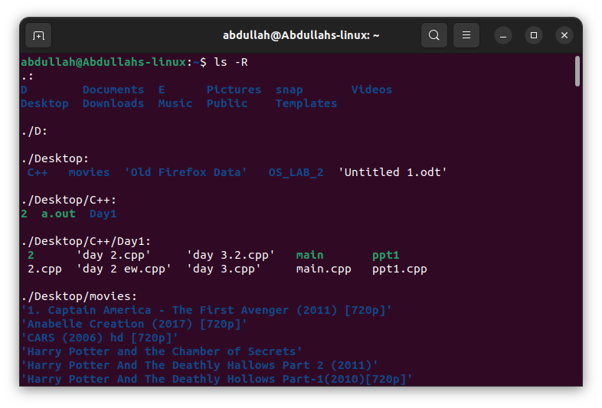

1. ls -a

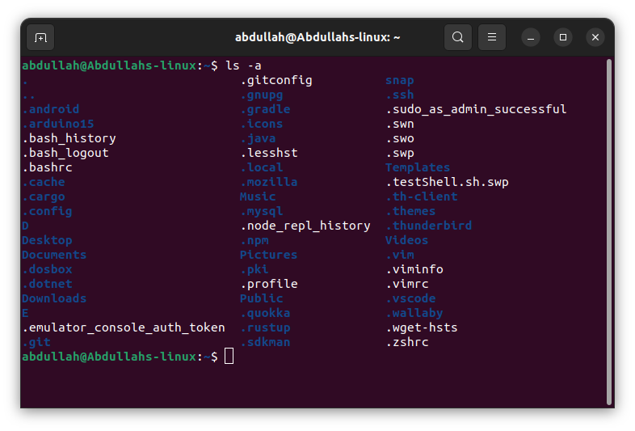

1. gedit lab2.txt

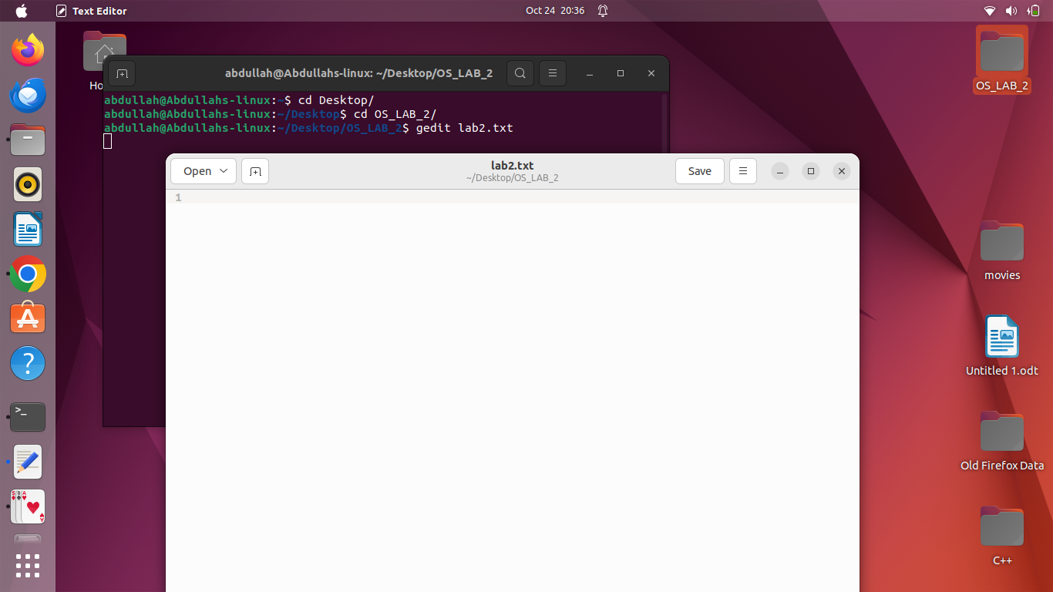

1. cat > lab2.txt

This is sample text

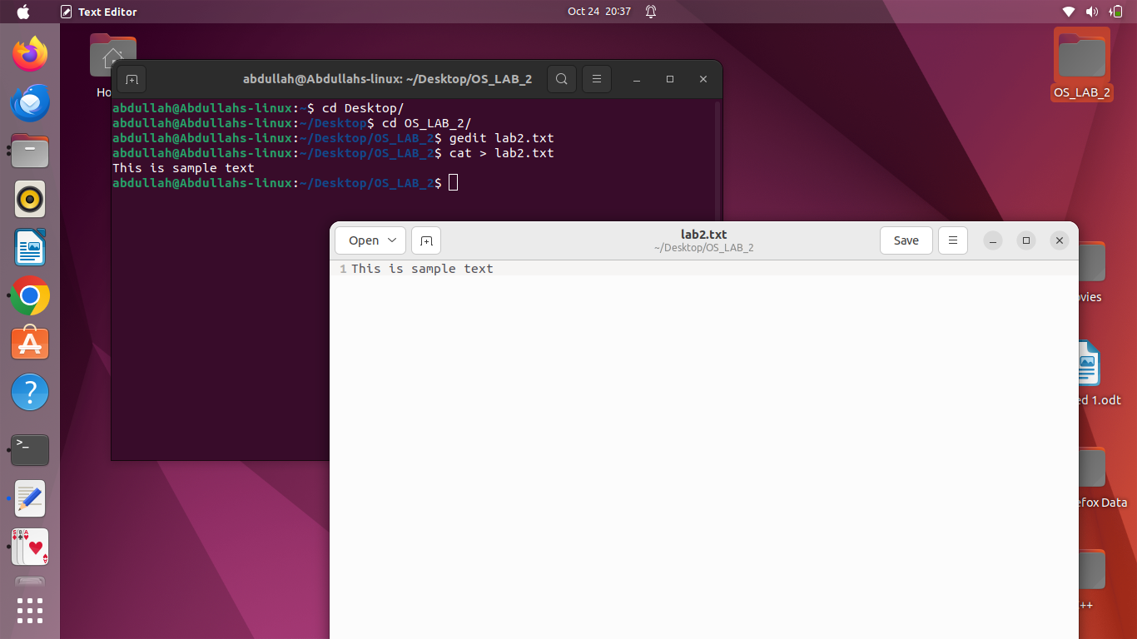

1. touch lab2-touch.txt

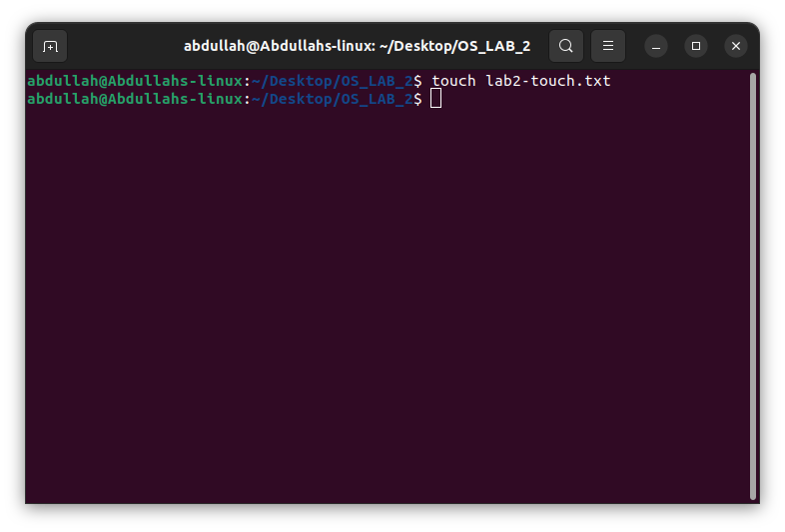

1. cat lab2.txt

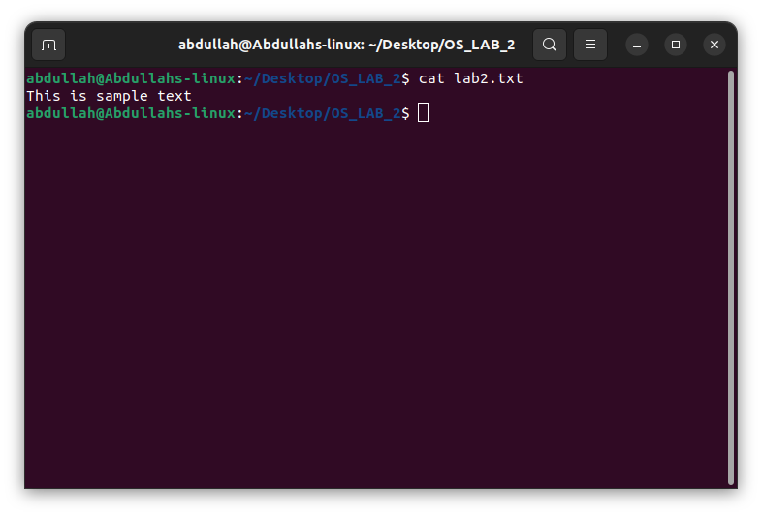

1. cat lab2.txt lab2-touch.txt > abdullah.txt

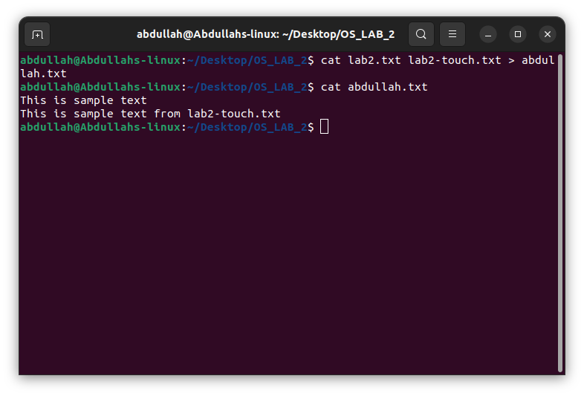

1. less abdullah.txt

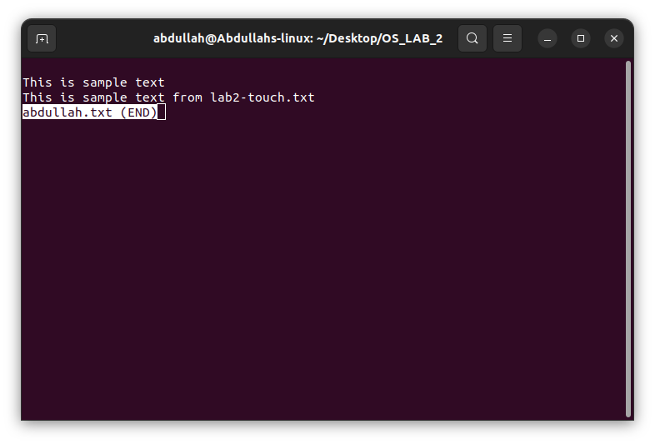

1. cat abdullah.txt l1f22bscs0788.txt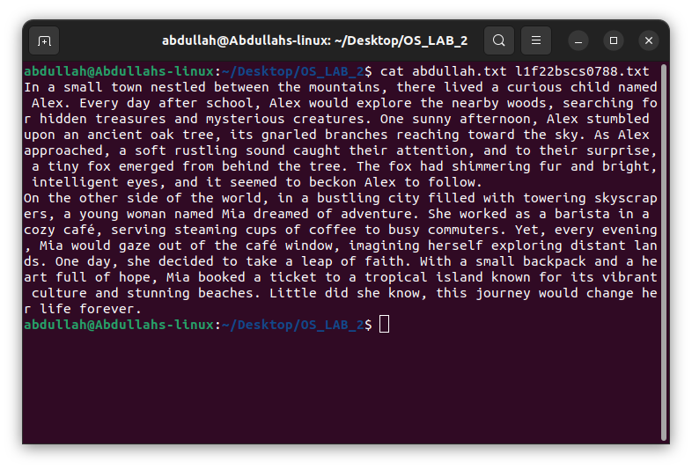
2. less abdullah.txt l1f22bscs0788.txt

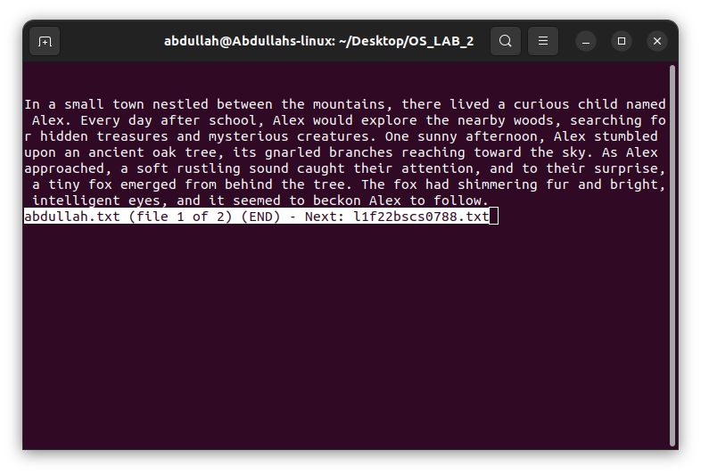

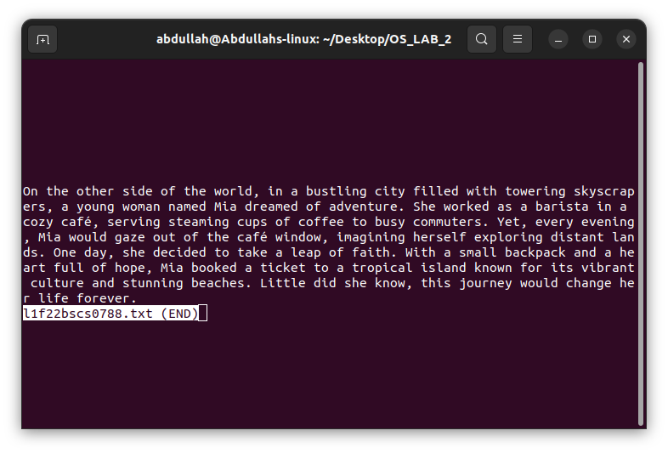

1. cat abdullah.txt l1f22bscs0788.txt > combined.txt

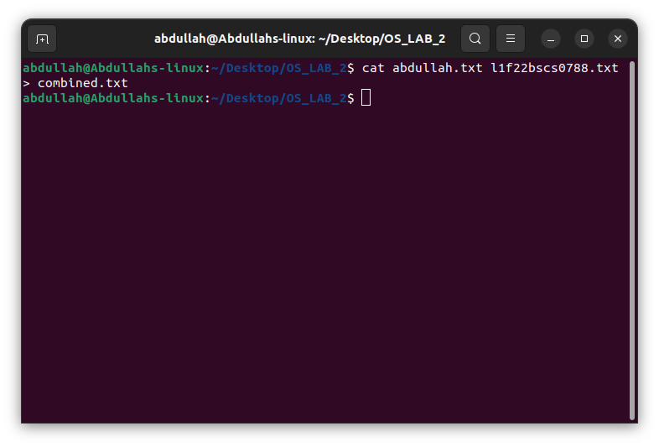

1. rm lab2.txt

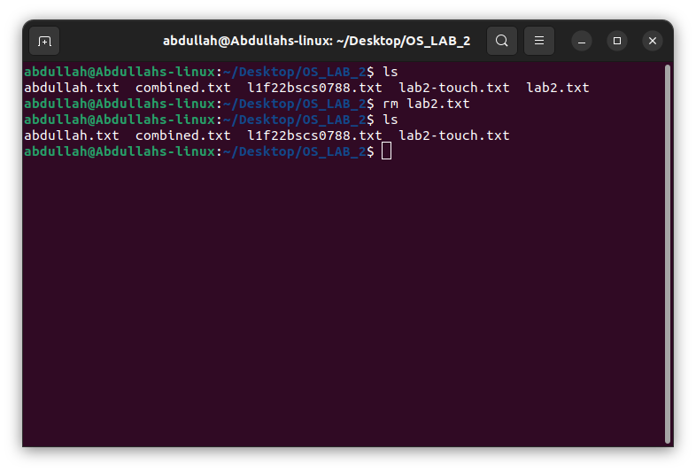

1. mv combined.txt combined-updated.txt

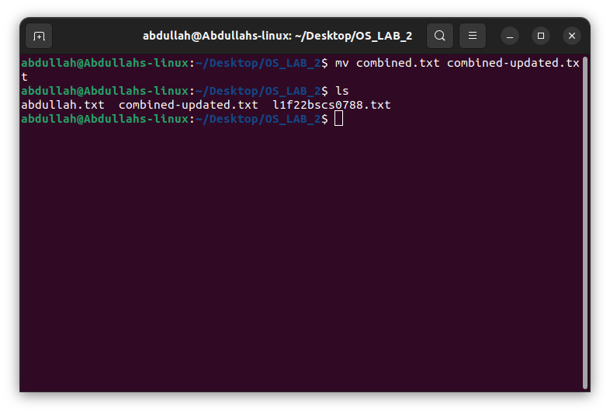

1. cp combined-updated.txt ../

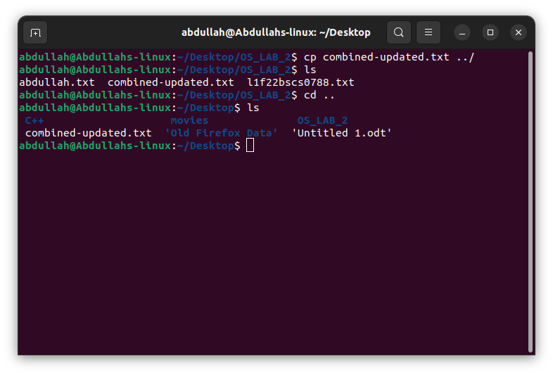

1. less combined-updated.txt /named

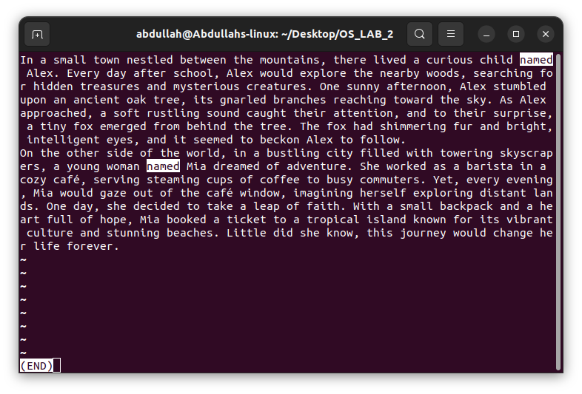

1. grep named combined-updated.txt

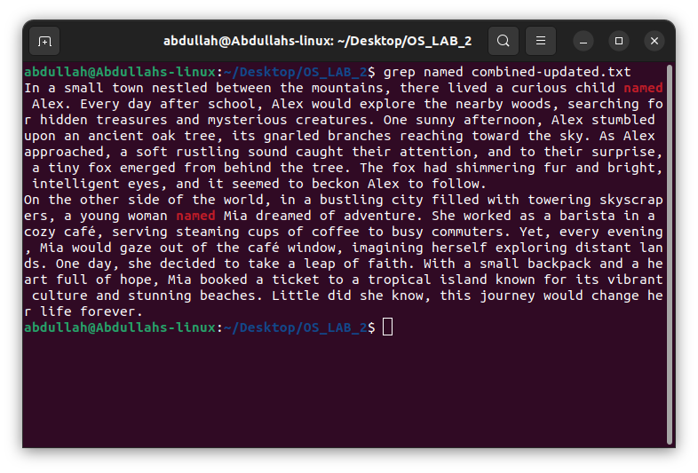

1. wc combined-updated.txt

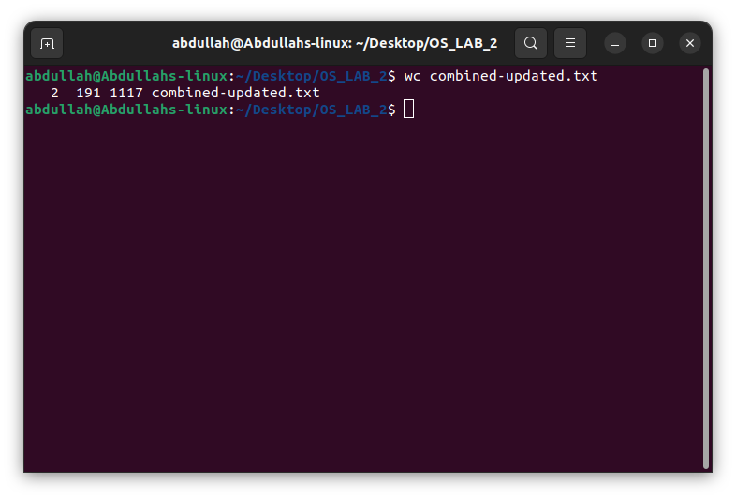

1. wc -w combined-updated.txt

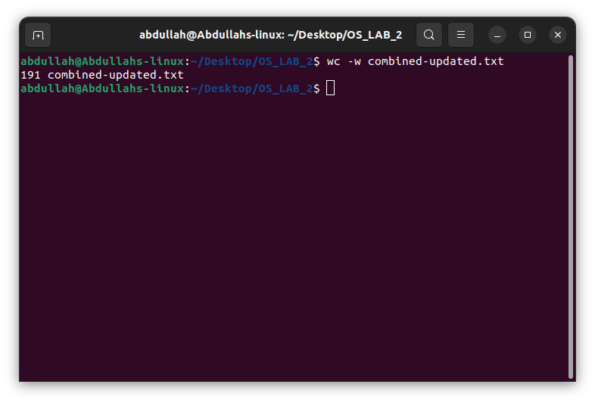

1. wc -l combined-updated.txt

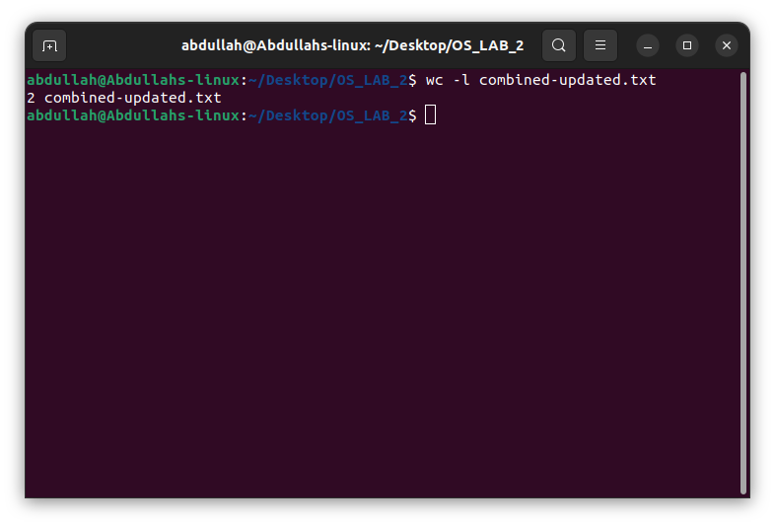

1. cat >> combined-updated.txt

There are name of five fruits:

1. apple
2. banana
3. pineapple
4. orange
5. mango

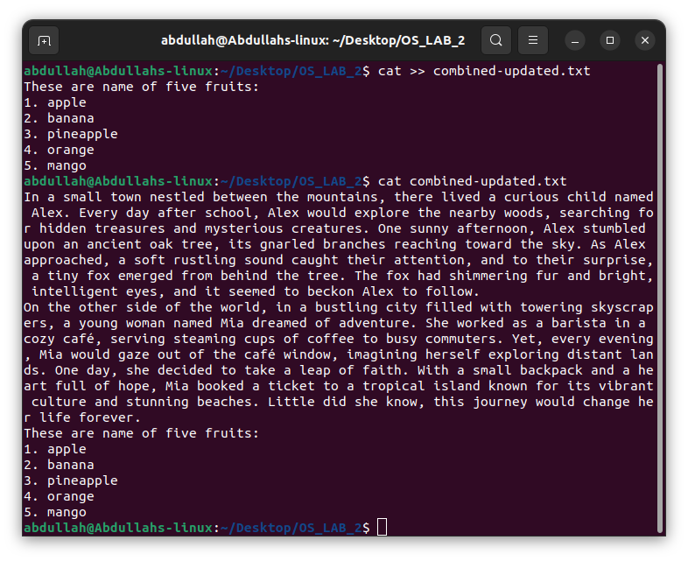

1. ls -l

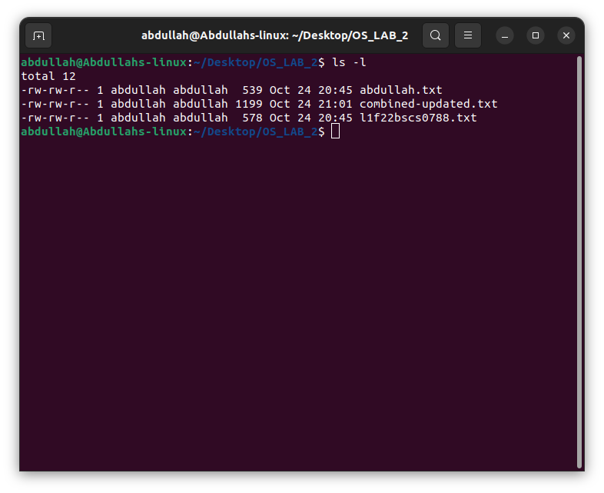

1. chmod a+rw combined-updated.txt

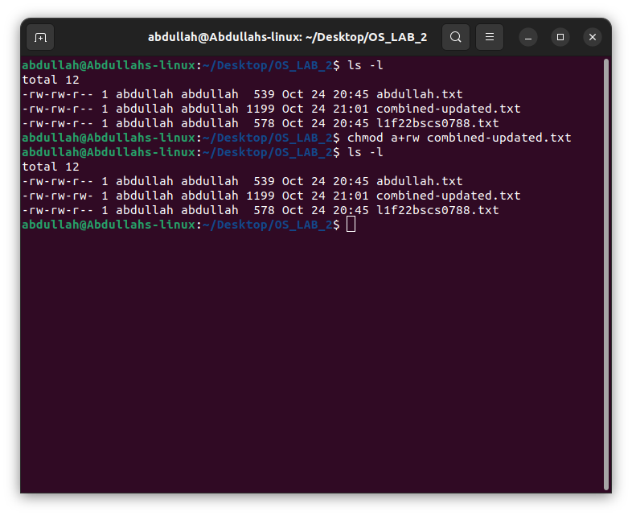

1. mkdir OS

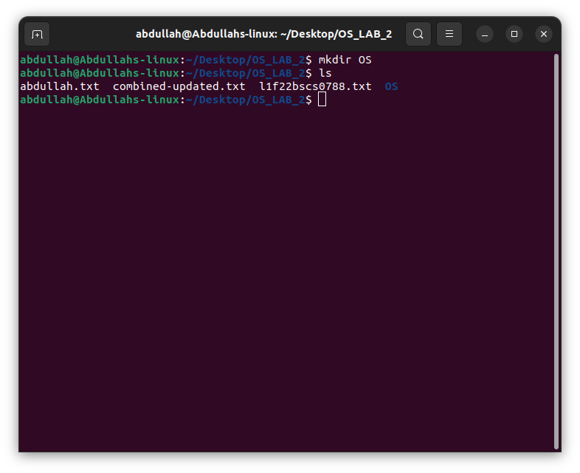

1. cd OS

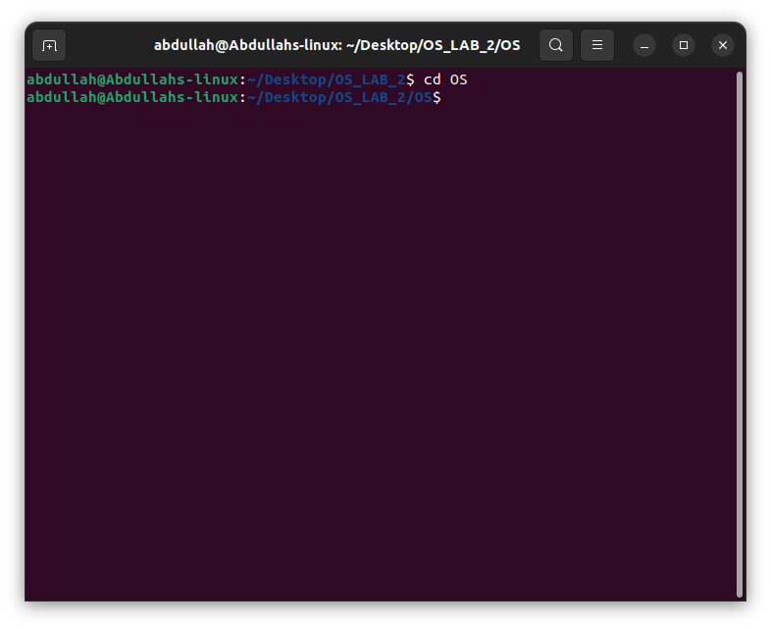

1. cd ..

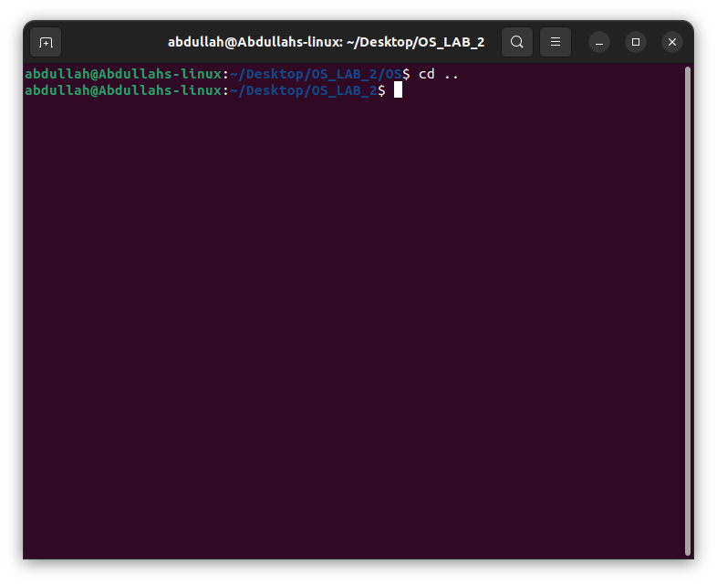

1. ls ~/..

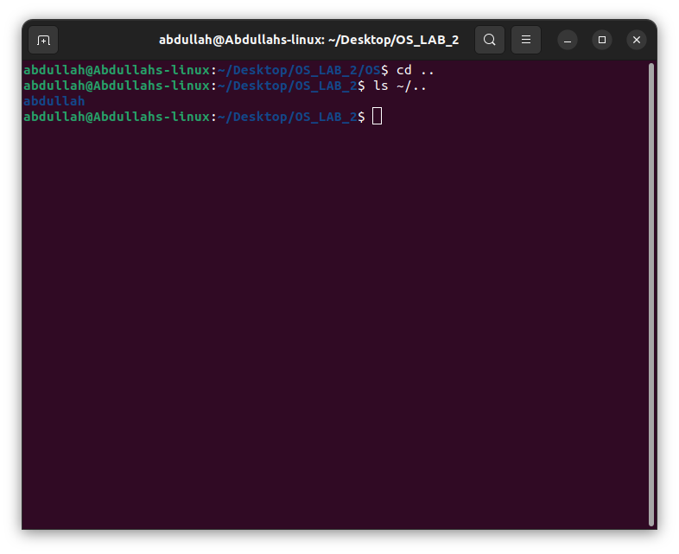

1. pwd

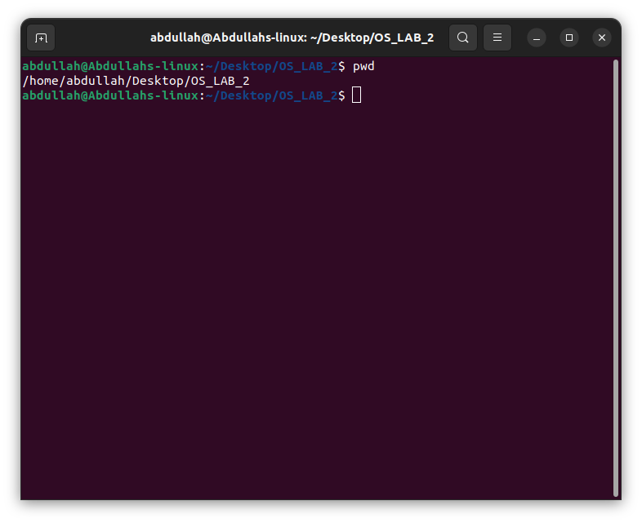

1. mv OS OS_Updated

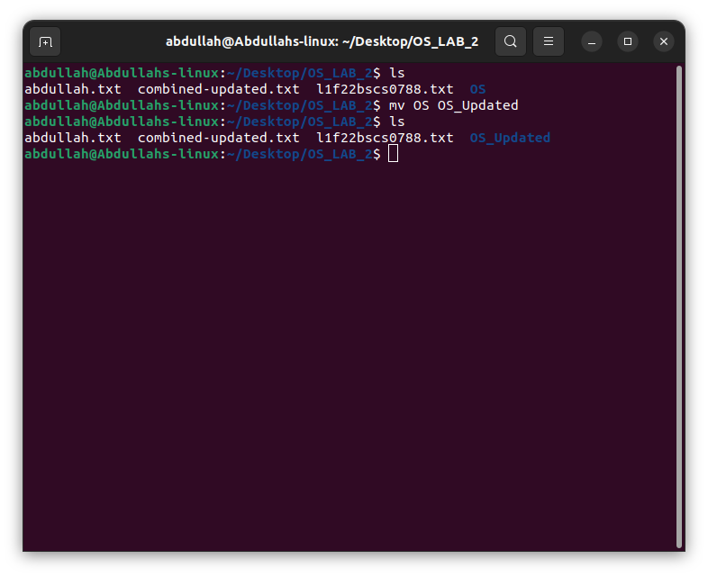

1. rmdir OS_Updated

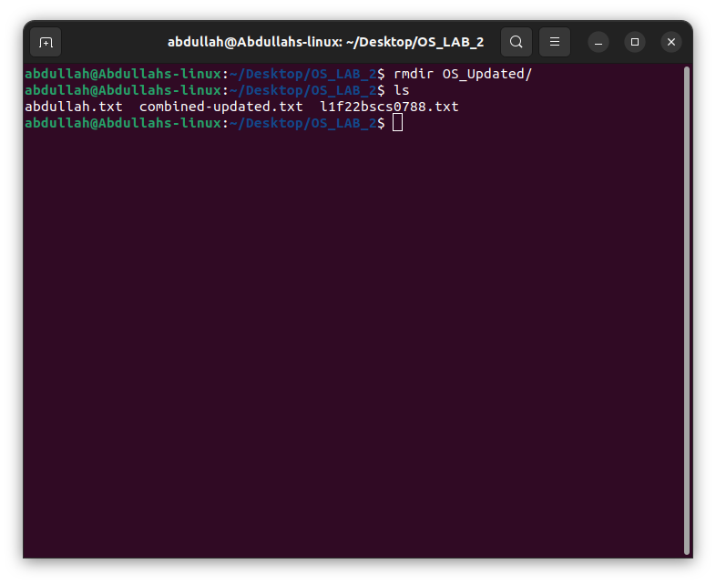

1. who

who > names.txt

sort < names.txt

cat names.txt

who | sort

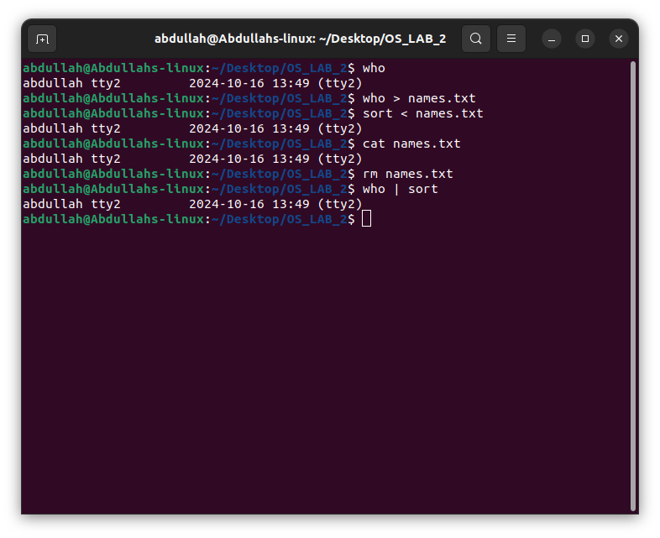

1. ls com*

ls ?ombined-updated.txt

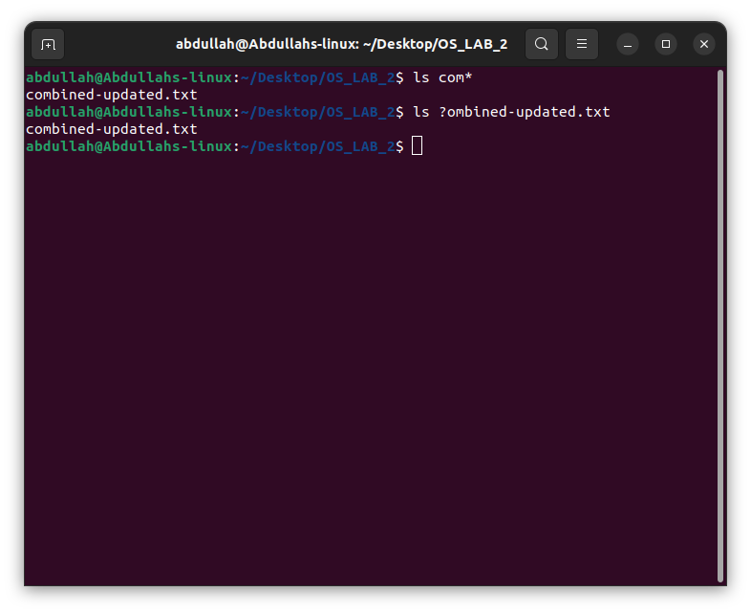

1. history

