
Name: Abdullah Nazir
Reg no: L1F22BSCS0788
Course: Operating Systems Lab
Section: E12
Lab-5

Sample1 output:
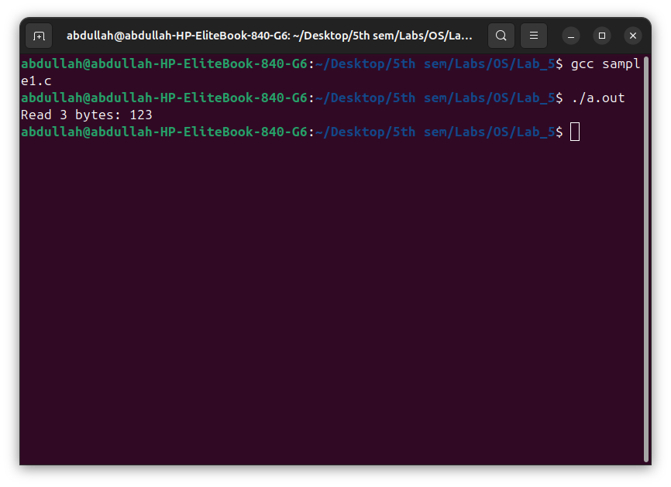

Sample2 output:
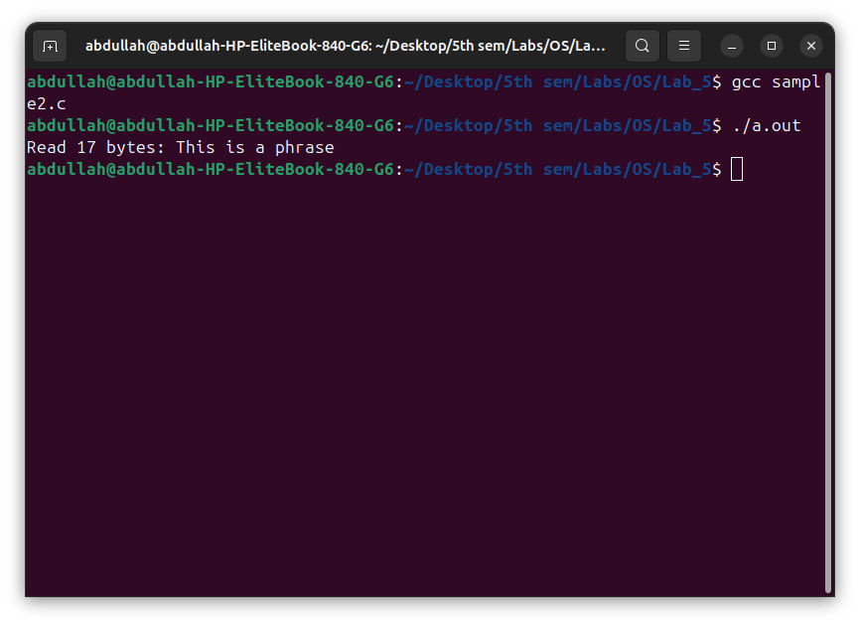

Task code:
#include <stdio.h>
#include <stdlib.h>
#include <unistd.h>
#include <sys/types.h>
#include <sys/wait.h>
#include <string.h>

#define READ 0
#define WRITE 1

int find_sum(int[], int);
int find_min(int[], int);

int main(int argc, char *argv[])
{

if (argc < 2)
{
printf("Insufficient command-line arguments\n");
exit(EXIT_FAILURE);
}

int *arr;
int size = argc - 1;
arr = malloc(size * sizeof(int));

for (int i = 0; i < size; i++)
{
arr[i] = atoi(argv[i + 1]);
}

int p_to_c1_fd[2];
int p_to_c2_fd[2];
int c1_to_p_fd[2];
int c2_to_p_fd[2];

if (pipe(p_to_c1_fd) == -1)
{
printf("Pipe failed\n");
exit(EXIT_FAILURE);
}
if (pipe(p_to_c2_fd) == -1)
{
printf("Pipe failed\n");
exit(EXIT_FAILURE);
}
if (pipe(c1_to_p_fd) == -1)
{
printf("Pipe failed\n");
exit(EXIT_FAILURE);
}
if (pipe(c2_to_p_fd) == -1)
{
printf("Pipe failed\n");
exit(EXIT_FAILURE);
}

pid_t pid;
pid = fork();
if (pid < 0)
{
printf("Fork failed\n");
exit(EXIT_FAILURE);
}
else if (pid == 0)
{
// child1
close(c1_to_p_fd[READ]);
close(c2_to_p_fd[WRITE]);
close(c2_to_p_fd[READ]);
close(p_to_c1_fd[WRITE]);
int received_array_size;
read(p_to_c1_fd[READ], &received_array_size, sizeof(int));
int received_array[received_array_size];
read(p_to_c1_fd[READ], received_array, received_array_size * sizeof(int));
int sum = find_sum(received_array, received_array_size);
close(p_to_c1_fd[READ]);
close(p_to_c2_fd[WRITE]);
close(p_to_c2_fd[READ]);
write(c1_to_p_fd[WRITE], &sum, sizeof(int));
close(c1_to_p_fd[WRITE]);
}
else
{
pid = fork();
if (pid < 0)
{
printf("Fork failed\n");
exit(EXIT_FAILURE);
}
else if (pid == 0)
{
// child2

close(c2_to_p_fd[READ]);
close(c1_to_p_fd[WRITE]);
close(c1_to_p_fd[READ]);
close(p_to_c1_fd[WRITE]);
close(p_to_c1_fd[READ]);
close(p_to_c2_fd[WRITE]);
int received_array_size;
read(p_to_c2_fd[READ], &received_array_size, sizeof(int));
int received_array[received_array_size];
read(p_to_c2_fd[READ], received_array, received_array_size * sizeof(int));
int min = find_min(received_array, received_array_size);
close(p_to_c2_fd[READ]);
write(c2_to_p_fd[WRITE], &min, sizeof(int));
close(c2_to_p_fd[WRITE]);
}
else
{
// parent
close(c1_to_p_fd[WRITE]);
close(c2_to_p_fd[WRITE]);
close(p_to_c1_fd[READ]);
write(p_to_c1_fd[WRITE], &size, sizeof(int));
write(p_to_c1_fd[WRITE], arr, size * sizeof(int));
close(p_to_c1_fd[WRITE]);
close(p_to_c2_fd[READ]);
write(p_to_c2_fd[WRITE], &size, sizeof(int));
write(p_to_c2_fd[WRITE], arr, size * sizeof(int));
close(p_to_c2_fd[WRITE]);
int sum, min;
read(c1_to_p_fd[READ], &sum, sizeof(int));
close(c1_to_p_fd[READ]);
read(c2_to_p_fd[READ], &min, sizeof(int));
close(c2_to_p_fd[READ]);
printf("The sum of array is: %d\n", sum);
printf("The min of array is: %d\n", min);
free(arr);
wait(NULL);
wait(NULL);
}
}

return 0;
}

int find_sum(int arr[], int size)
{
int sum = 0;
for (int i = 0; i < size; i++)
{
sum += arr[i];
}
return sum;
}

int find_min(int arr[], int size)
{
if (size == 0)
{
return -1;
}

int min = arr[0];
for (int i = 1; i < size; i++)
{
if (arr[i] < min)
{
min = arr[i];
}
}
return min;
}

Task output:
