# Department of Computing

**CS-213: Advanced Programming**

**Name: Abdullah**

**CMS ID : 207515**

**Class: BSCS 7A**

# Lab 2: Javascript

**Date: 12 September, 2019**

**Time: 10:00-01:00pm & 02:00-05:00pm**

# Lab 2: Javascript

**Task**

Create a simple web based calculator as shown in the image below.

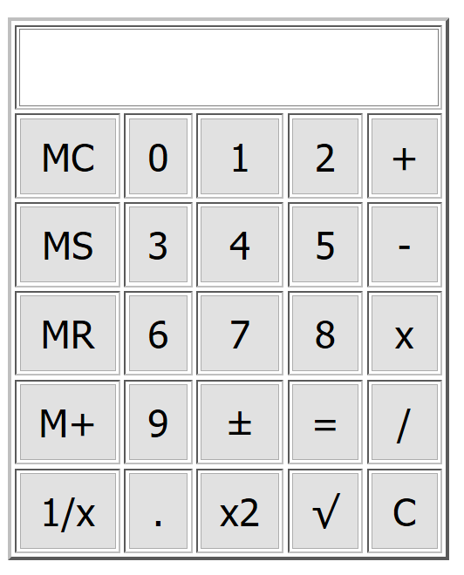

|  |
| --- |
| Solution |
| Task Code:  <html>  <head>      <title>Basic Calculator In Javascript</title>      <style>      .display{          height: 15%;          width: 40%;          padding: 1.5%;          font-size: 18;      }      .box{          height: 105%;          width: 106%;          background-color: #ffd6b3;      }      .btn{          height: 103%;          width: 105%;          background-color: #ffe5cc;      }      </style>  </head>  <body style="background-color: whitesmoke">      <div>      <table style="background-color:#fff2e6; border: solid black; width: 20%; height: 30%;" >          <tr class="display" style="background-color:#fff1e6" ><th id="screen" colspan="5"></th></tr>            <tr >              <td ><button class="box" onclick="m_clear();" value="MC">MC</button></td> <td ><button class="btn" onclick="check();" value="0" >0</button></td> <td ><button class="btn" onclick="check();" value="1">1</button></td>              <td ><button class="btn" onclick="check();" value="2">2</button></td> <td ><button class="btn" onclick="check();" value="+">+</button></td>          </tr>          <tr >                  <td ><button class="box" onclick="m_save();" value="MS">MS</button></td> <td ><button class="btn" onclick="check();" value="3">3</button></td> <td ><button class="btn" class="btn" onclick="check();" value="4">4</button></td>                  <td ><button class="btn" onclick="check();" value="5">5</button></td> <td ><button class="btn" onclick="check();" value="-">-</button></td>          </tr>          <tr >                  <td ><button  class="box" onclick="m_read();" value="MR">MR</button></td> <td ><button class="btn" onclick="check();" value="6">6</button></td> <td ><button class="btn" onclick="check();" value="7">7</button></td>                  <td ><button class="btn" onclick="check();" value="8">8</button></td> <td ><button class="btn" onclick="check();" value="*">*</button></td>          </tr>          <tr >                  <td ><button class="box" onclick="m_add();" value="M+">M+</button></td> <td ><button class="btn" onclick="check();" value="9">9</button></td> <td ><button class="btn" onclick="change_sign();" value="+/-">+/-</button></td>                  <td ><button class="btn" onclick="equal1();" value="=">=</button></td> <td ><button class="btn" onclick="check();" value="/">/</button></td>          </tr>          <tr >                  <td ><button class="box" onclick="one_by_x();" value="1/x">1/x</button></td> <td ><button class="btn" onclick="zero();" value="."> . </button></td> <td ><button class="btn" onclick="sqr();" value="x2">x2</button></td>                  <td ><button class="btn" onclick="sqroot();" value="√">sqrt</button></td> <td ><button class="btn" onclick="clear_screen()" value="C">C</button></td>          </tr>      </table>  </div>      <script>           var text = "";           var result = 0;           var mem = 0;           scr = document.getElementById("screen");          function check(){              text = event.target.textContent;              scr.innerHTML += text;          }          function zero(){              scr.innerHTML += '.';          }          function clear_screen(){              scr.innerHTML = "";          }          function one_by_x(){              var x = scr.innerHTML;              result = eval("1/x");              scr.innerHTML = result;          }          function sqr(){              scr.innerHTML = scr.innerHTML*scr.innerHTML;          }          function equal1(){              result = eval(scr.innerHTML);              scr.innerHTML = result;          }          function sqroot(){              scr.innerHTML = Math.sqrt(scr.innerHTML);          }          function m_clear(){              mem = 0;              scr.innerHTML = "Memory Cleared.";          }          function m_read(){              scr.innerHTML = mem;          }          function m_add(){              mem = eval(parseInt(mem,10) + parseInt(scr.innerHTML,10));              scr.innerHTML = "Added in Memory.";          }          function m_save(){              mem = scr.innerHTML;              scr.innerHTML = "Saved in Memory.";          }          function change_sign(){              var res = parseInt(scr.innerHTML,10);              res = -(res);              scr.innerHTML = res;          }      </script>  </body>  </html>  Task Output Screenshot: |

### Deliverables

Compile a single word document by filling in the solution part and submit this Word file on LMS. This lab grading policy is as follows: The lab is graded between 0 to 10 marks. The submitted solution can get a maximum of 5 marks. At the end of each lab or in the next lab, there will be a viva related to the tasks. The viva has a weightage of 5 marks. Insert the solution/answer in this document. You must show the implementation of the tasks in the designing tool, along with your complete Word document to get your work graded. You must also submit this Word document on the LMS. In case of any problems with submissions on LMS, submit your Lab assignments by emailing it to Ms. Ayesha Asif: [ayesha.asif@seecs.edu.pk](mailto:ayesha.asif@seecs.edu.pk).