Lab-7
Updated Model.py
from django.db import models
from django.contrib.auth.models import User

class Course(models.Model):
title = models.CharField(max_length=25)
descriptions = models.TextField()
durations = models.IntegerField(help_text="Durations in hours")
thumbnail = models.ImageField(upload_to="courses_thumbnail/", null=True, blank=True)
created_at = models.DateTimeField(auto_now_add=True,null=True,blank=True)

def __str__(self):
return self.title

class Lesson(models.Model):
title = models.CharField(max_length=60)
content = models.TextField()
course = models.ForeignKey(Course, on_delete=models.CASCADE, related_name="lessons") # ✅ Corrected related_name
video_URL = models.URLField(null=True,blank=True)
completion_status = models.BooleanField(default=False)

def __str__(self):
return self.title

class Student(models.Model):
user = models.OneToOneField(User, on_delete=models.CASCADE,null=True,blank=True)
name = models.CharField(max_length=30)
roll = models.IntegerField()
email = models.EmailField(max_length=60,unique=True)
enrolled_courses = models.ManyToManyField(Course, related_name="students") # ✅ Changed related_name to plural
completed_lesson = models.ManyToManyField(Lesson,related_name='completed_by',blank=True)

def __str__(self):
return self.name

ORM queries and results in the Django shell.

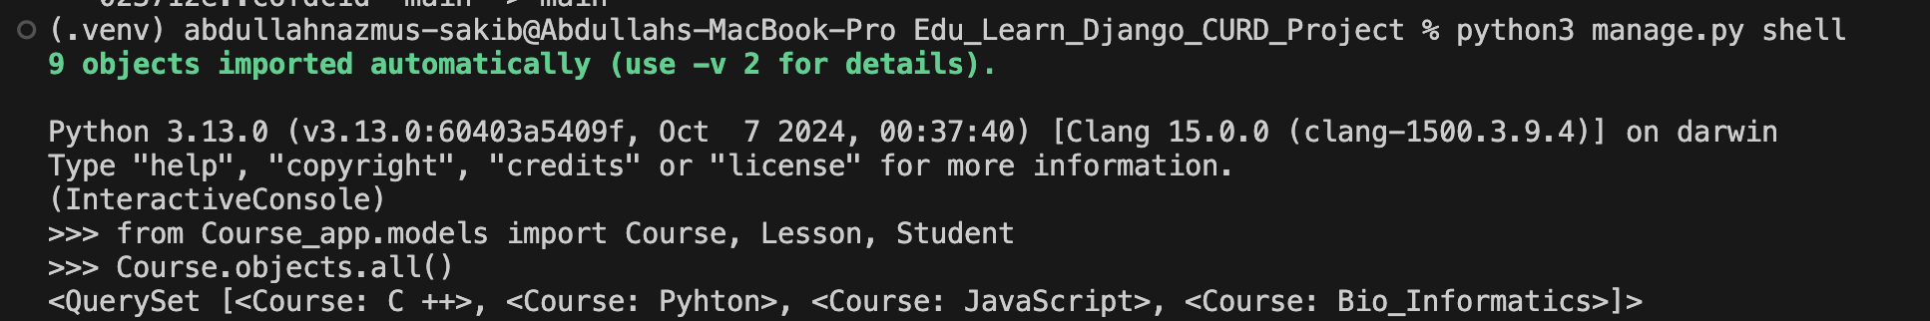

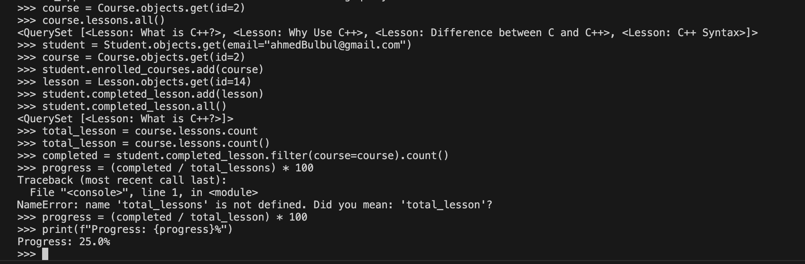

course detail page showing lesson progress.
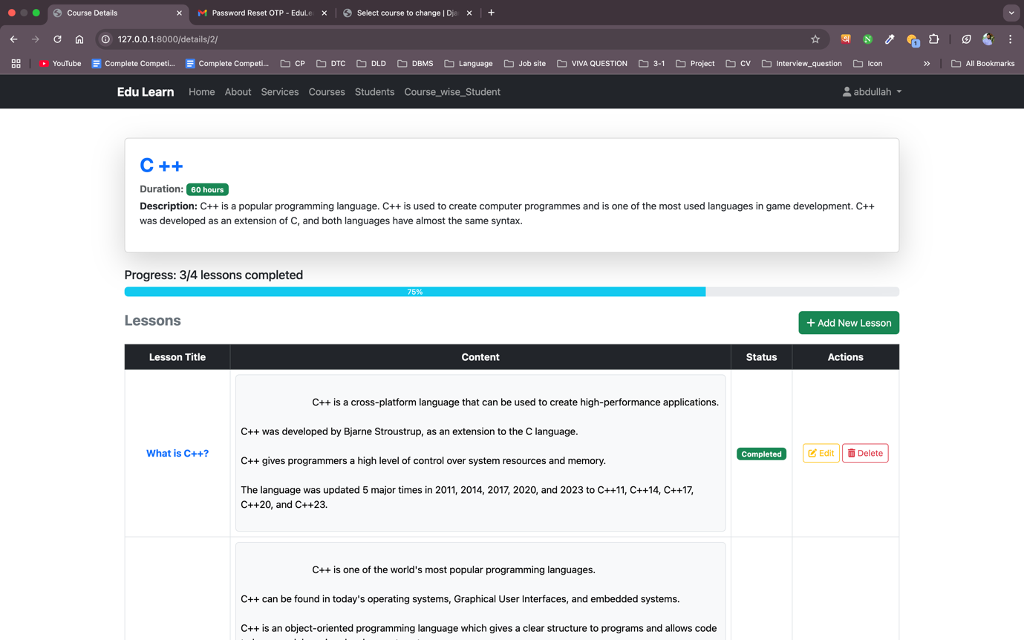

Updated course_detail.html
{% extends 'Course_app/base.html' %}

{% block title %}Course Details{% endblock title %}

{% block content %}
<div class="container">
<!-- Course Info -->
<div class="card shadow-lg p-4 mb-4">
<h2 class="text-primary fw-bold">{{ course.title }}</h2>
<p class="text-muted mb-1">
<strong>Duration:</strong>
<span class="badge bg-success">{{ course.durations }} hours</span>
</p>
<p><strong>Description:</strong> {{ course.descriptions }}</p>
</div>

<!-- Lesson Progress -->
<div class="mb-4">
<h5>Progress: {{ completed_lessons }}/{{ total_lessons }} lessons completed</h5>
<div class="progress">
<div class="progress-bar bg-info" role="progressbar"
style="width: {{ percent_complete }}%"
aria-valuenow="{{ completed_lessons }}" aria-valuemin="0" aria-valuemax="{{ total_lessons }}">
{{ percent_complete }}%
</div>
</div>
</div>

<!-- Add Lesson Button -->
<div class="d-flex justify-content-between align-items-center my-3">
<h4 class="fw-bold text-secondary">Lessons</h4>
<a href="{% url 'create_lesson' %}" class="btn btn-success">
<i class="fas fa-plus"></i> Add New Lesson
</a>
</div>

<!-- Lessons Table -->
<div class="table-responsive">
<table class="table table-bordered table-hover text-center align-middle">
<thead class="table-dark">
<tr>
<th>Lesson Title</th>
<th>Content</th>
<th>Status</th>
<th>Actions</th>
</tr>
</thead>
<tbody>
{% for lesson in lessons %}
<tr>
<td class="fw-bold text-primary">{{ lesson.title }}</td>
<td class="text-start">
<div class="border rounded p-2 bg-light" style="white-space: pre-wrap;">
{{ lesson.content | linebreaksbr }}
</div>
</td>
<td>
{% if lesson in student.completed_lesson.all %}
<span class="badge bg-success">Completed</span>
{% else %}
<span class="badge bg-secondary">Incomplete</span>
{% endif %}
</td>
<td>
<a href="{% url 'lesson_edit' lesson.id %}" class="btn btn-sm btn-outline-warning my-1">
<i class="fas fa-edit"></i> Edit
</a>

<form action="{% url 'lesson_delete' lesson.id %}" method="POST" class="d-inline">
{% csrf_token %}
<button type="submit" class="btn btn-outline-danger btn-sm my-1">
<i class="fas fa-trash-alt"></i> Delete
</button>
</form>

{% if lesson not in student.completed_lesson.all %}
<!-- Show Complete Button -->
<form action="{% url 'complete_lesson' lesson.id %}" method="POST" class="d-inline">
{% csrf_token %}
<button type="submit" class="btn btn-outline-success btn-sm my-1">
<i class="fas fa-check-circle"></i> Complete
</button>
</form>
{% comment %} {% else %}
<!-- Show Incomplete Button -->
<form action="{% url 'uncomplete_lesson' lesson.id %}" method="POST" class="d-inline">
{% csrf_token %}
<button type="submit" class="btn btn-outline-secondary btn-sm my-1">
<i class="fas fa-times-circle"></i> Incomplete
</button>
</form> {% endcomment %}
{% endif %}
</td>
</tr>
{% empty %}
<tr>
<td colspan="4" class="text-center text-danger fw-bold">No lessons available for this course.</td>
</tr>
{% endfor %}
</tbody>
</table>
</div>

<!-- Back Button -->
<div class="d-flex justify-content-center mt-4">
<a href="{% url 'course_list' %}" class="btn btn-outline-primary">
<i class="fas fa-arrow-left"></i> Back to Courses
</a>
</div>
</div>
{% endblock content %}

Lab-8
Updated views.py using CourseListView

class CourseListView(LoginRequiredMixin, ListView):
model = Course
template_name = "Course_app/course_list.html"
context_object_name = "courses"
login_url = 'login_user'

Updated views.py using CourseDetailView

class CourseDetailView(LoginRequiredMixin, View):
login_url = 'login_user' # Redirect to login if not authenticated

def get(self, request, id):
course = get_object_or_404(Course, id=id)
lessons = course.lessons.all()

# Get the logged-in student (assuming one-to-one relation with user)
try:
student = request.user.student
except Student.DoesNotExist:
student = None

total_lessons = lessons.count()
completed_lessons = (
student.completed_lesson.filter(course=course).count() if student else 0
)
percent_complete = int((completed_lessons / total_lessons) * 100) if total_lessons > 0 else 0

context = {
'course': course,
'lessons': lessons,
'student': student,
'total_lessons': total_lessons,
'completed_lessons': completed_lessons,
'percent_complete': percent_complete,
}

return render(request, "Course_app/Course_details.html", context)

Updated views.py using CourseCreateView
class CourseCreateView(LoginRequiredMixin, CreateView):
model = Course
form_class = CourseForm
template_name = html_path_for_input_and_update
login_url = 'login_user'
success_url = reverse_lazy('course_list')

def form_valid(self, form):
response = super().form_valid(form)
messages.success(self.request, "Course added successfully!")
return response

def get_context_data(self, **kwargs):
context = super().get_context_data(**kwargs)
context['check'] = 2 # Passing 'check' like in your FBV
return context

Updated urls.py to include CBVs.
# For CBV
from .views import CourseListView, CourseDetailView, CourseCreateView

urlpatterns = [
# path('',views.course_list,name='course_list'),
path('', CourseListView.as_view(), name='course_list'),

# path('details/<int:id>/',views.Course_Details,name='coursedetails'),
path('details/<int:id>/', CourseDetailView.as_view(), name='coursedetails'),

# path('create_course/',views.create_course,name='create_course'),
path('create_course/', CourseCreateView.as_view(), name='create_course'),
]
Templates: course_list.html
{% extends 'Course_app/base.html' %}

{% block title %}Home Page{% endblock title %}

{% block content %}
<div class="container">
<!-- Page Heading -->
<div class="text-center mb-4">
<h1 class="fw-bold text-primary">Welcome to <span class="text-success">Edu Learn</span></h1>
<p class="text-muted">Manage courses, lessons, and student enrollments with ease.</p>
</div>

<!-- Action Buttons -->
<div class="d-flex justify-content-between mb-4">
<a href="{% url 'create_course' %}" class="btn btn-outline-primary fw-bold">
<i class="fas fa-book"></i> Add New Course
</a>
<a href="{% url 'Enroll_student' %}" class="btn btn-outline-warning fw-bold">
<i class="fas fa-user-plus"></i> Enroll Student
</a>
</div>

<!-- Courses Table -->
<div class="table-responsive">
<table class="table table-bordered table-hover text-center align-middle">
<thead class="table-dark">
<tr>
<th>ID</th>
<th>Title</th>
<th>Description</th>
<th>Duration</th>
<th>Thumbnail</th>
<th>Actions</th>
<th>Manage Lesson</th>
</tr>
</thead>
<tbody>
{% for course in courses %}
<tr>
<td>{{ forloop.counter }}</td>
<td class="fw-bold text-primary">{{ course.title }}</td>
<td class="text-muted">{{ course.descriptions | truncatewords:10 }}</td>
<td><span class="badge bg-success">{{ course.durations }} hrs</span></td>
<td>
{% if course.thumbnail %}
<img src="{{ course.thumbnail.url }}" alt="{{ course.title }}" class="img-thumbnail" width="100">
{% else %}
<span class="text-muted">No Image</span>
{% endif %}
</td>
<td>
<a href="{% url 'course_edit' course.id %}" class="btn btn-sm btn-outline-warning my-1">
<i class="fas fa-edit"></i> Edit
</a>
<form action="{% url 'course_delete' course.id %}" class="d-inline">
{% csrf_token %}
<button type="submit" class="btn btn-outline-danger btn-sm my-1">
<i class="fas fa-trash-alt"></i> Delete
</button>
</form>
</td>
<td>
<a href="{% url 'create_lesson' %}" class="btn btn-outline-info btn-sm mb-1">
<i class="fas fa-plus"></i> Add Lesson
</a>
<a href="{% url 'coursedetails' course.id %}" class="btn btn-outline-secondary btn-sm mb-1">
<i class="fas fa-eye"></i> View Lessons
</a>
<a href="{% url 'individual_course_enrolled_student' course.id %}" class="btn btn-outline-primary btn-sm mt-1">
<i class="fas fa-users"></i> View Students
</a>
</td>
</tr>
{% empty %}
<tr>
<td colspan="7" class="text-center text-danger fw-bold">No courses available.</td>
</tr>
{% endfor %}
</tbody>
</table>
</div>

<!-- Back Button -->
<div class="d-flex justify-content-center mt-4">
<a href="{% url 'course_list' %}" class="btn btn-outline-success">
<i class="fas fa-arrow-left"></i> Back to Dashboard
</a>
</div>
</div>
{% endblock content %}

Templates: course_detail.html,
{% extends 'Course_app/base.html' %}

{% block title %}Course Details{% endblock title %}

{% block content %}
<div class="container">
<!-- Course Info -->
<div class="card shadow-lg p-4 mb-4">
<h2 class="text-primary fw-bold">{{ course.title }}</h2>
<p class="text-muted mb-1">
<strong>Duration:</strong>
<span class="badge bg-success">{{ course.durations }} hours</span>
</p>
<p><strong>Description:</strong> {{ course.descriptions }}</p>
</div>

<!-- Lesson Progress -->
<div class="mb-4">
<h5>Progress: {{ completed_lessons }}/{{ total_lessons }} lessons completed</h5>
<div class="progress">
<div class="progress-bar bg-info" role="progressbar"
style="width: {{ percent_complete }}%"
aria-valuenow="{{ completed_lessons }}" aria-valuemin="0" aria-valuemax="{{ total_lessons }}">
{{ percent_complete }}%
</div>
</div>
</div>

<!-- Add Lesson Button -->
<div class="d-flex justify-content-between align-items-center my-3">
<h4 class="fw-bold text-secondary">Lessons</h4>
<a href="{% url 'create_lesson' %}" class="btn btn-success">
<i class="fas fa-plus"></i> Add New Lesson
</a>
</div>

<!-- Lessons Table -->
<div class="table-responsive">
<table class="table table-bordered table-hover text-center align-middle">
<thead class="table-dark">
<tr>
<th>Lesson Title</th>
<th>Content</th>
<th>Status</th>
<th>Actions</th>
</tr>
</thead>
<tbody>
{% for lesson in lessons %}
<tr>
<td class="fw-bold text-primary">{{ lesson.title }}</td>
<td class="text-start">
<div class="border rounded p-2 bg-light" style="white-space: pre-wrap;">
{{ lesson.content | linebreaksbr }}
</div>
</td>
<td>
{% if lesson in student.completed_lesson.all %}
<span class="badge bg-success">Completed</span>
{% else %}
<span class="badge bg-secondary">Incomplete</span>
{% endif %}
</td>
<td>
<a href="{% url 'lesson_edit' lesson.id %}" class="btn btn-sm btn-outline-warning my-1">
<i class="fas fa-edit"></i> Edit
</a>

<form action="{% url 'lesson_delete' lesson.id %}" method="POST" class="d-inline">
{% csrf_token %}
<button type="submit" class="btn btn-outline-danger btn-sm my-1">
<i class="fas fa-trash-alt"></i> Delete
</button>
</form>

{% if lesson not in student.completed_lesson.all %}
<!-- Show Complete Button -->
<form action="{% url 'complete_lesson' lesson.id %}" method="POST" class="d-inline">
{% csrf_token %}
<button type="submit" class="btn btn-outline-success btn-sm my-1">
<i class="fas fa-check-circle"></i> Complete
</button>
</form>
{% comment %} {% else %}
<!-- Show Incomplete Button -->
<form action="{% url 'uncomplete_lesson' lesson.id %}" method="POST" class="d-inline">
{% csrf_token %}
<button type="submit" class="btn btn-outline-secondary btn-sm my-1">
<i class="fas fa-times-circle"></i> Incomplete
</button>
</form> {% endcomment %}
{% endif %}
</td>
</tr>
{% empty %}
<tr>
<td colspan="4" class="text-center text-danger fw-bold">No lessons available for this course.</td>
</tr>
{% endfor %}
</tbody>
</table>
</div>

<!-- Back Button -->
<div class="d-flex justify-content-center mt-4">
<a href="{% url 'course_list' %}" class="btn btn-outline-primary">
<i class="fas fa-arrow-left"></i> Back to Courses
</a>
</div>
</div>
{% endblock content %}

Templates:course_form.html.

{% extends 'Course_app/base.html' %}

{% block title %}
{% if check == 1 %} Update Course Details
{% elif check == 2 %} Add New Course
{% elif check == 3 %} Add New Lesson
{% elif check == 4 %} Update Lesson Details
{% elif check == 5 %} Enroll Student
{% elif check == 6 %} Update Student
{% endif %}
{% endblock title %}

{% block content %}
<div class="container mt-5">
<div class="card shadow-lg border-0">
<div class="card-body p-4">
<h2 class="text-center text-primary fw-bold">
{% if check == 1 %} Update Course Details
{% elif check == 2 %} Add New Course
{% elif check == 3 %} Add New Lesson
{% elif check == 4 %} Update Lesson Details
{% elif check == 5 %} Enroll Student
{% elif check == 6 %} Update Student
{% endif %}
</h2>

<!-- Display form errors -->
{% if form.errors %}
<div class="alert alert-danger">
<strong>Please correct the errors below:</strong>
<ul>
{% for field, errors in form.errors.items %}
{% for error in errors %}
<li>{{ field|title }}: {{ error }}</li>
{% endfor %}
{% endfor %}
</ul>
</div>
{% endif %}

<form method="POST" enctype="multipart/form-data" class="mt-3">
{% csrf_token %}
<div class="mb-3">
{{ form.as_p }}
</div>
<div class="d-flex justify-content-between">
<button type="submit" class="btn btn-primary fw-bold">
<i class="fas fa-check"></i> Submit
</button>
<a href="{% url 'course_list' %}" class="btn btn-secondary">
<i class="fas fa-arrow-left"></i> Back to Home
</a>
</div>
</form>
</div>
</div>
</div>
{% endblock content %}

Course list page.

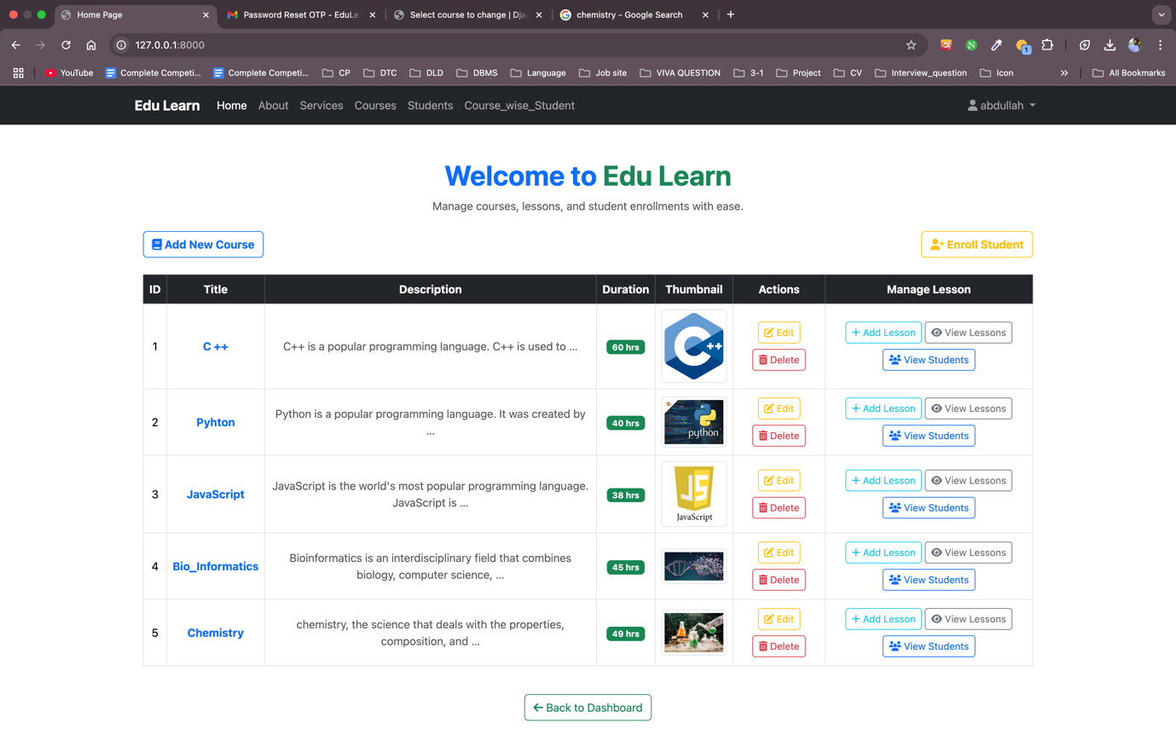

Course detail page.


Course creation form

