Genetic Algorithms

- Genetic algorithms belong to a class of stochastic search method based on biological evolution. They represent a highly parallel adaptive search process. Central to the idea of GA is a population where individuals in the population represent possible solutions. An individual is called chromosome, in analogy with the genetic chromosome. The chromosome is usually represented by a bit string consisting of 0s and 1s. New population is generated from old population with three basic genetic operators namely selection, cross-over, and mutation.
- A genetic algorithm (GA) is a search and optimization technique inspired by Charles Darwin’s theory of natural evolution, used to find high-quality solutions to complex problems.

Main Components of Genetic Algorithm / Key Terms
The main components of a genetic algorithm:
- A population of solutions,
- A fitness function, and
- Operators such as selection, crossover, and mutation.

- Population: A set of potential solutions (chromosomes) to the problem which are usually represented as binary strings.
- Fitness Function: The fitness function is a measure of how good a solution is, and is used to select the best solutions for reproduction. (Evaluates how well a solution solves the problem, with higher scores favoring survival).
  - Higher fitness implies better solution quality
  - Fitness function is problem-specific
  - Can be designed for maximization or minimization

- Operator: The operators in a genetic algorithm are used to generate new solutions from the existing ones.
  - The selection operator chooses the best solutions for reproduction,
  - the crossover operator combines two solutions to produce a new one,
  - and the mutation operator introduces random changes into a solution to maintain diversity in the population.
- Chromosome (Individual): A chromosome represents a complete candidate solution to the problem. A single solution, often represented as a string of bits (genes).

- Gene: A gene is the smallest unit of information in a chromosome and represents a single variable, parameter or trait of the solution. The collective behavior of all genes determines the quality of the chromosome.
- Generation: GA represents an iterative process. Each iteration is called a generation.
- Run: A typical number of generations for a simple GA can range from 50 to over 500. The entire set of generations is called a run. At the end of a run, we expect to find one or more highly fit chromosomes.

Population:
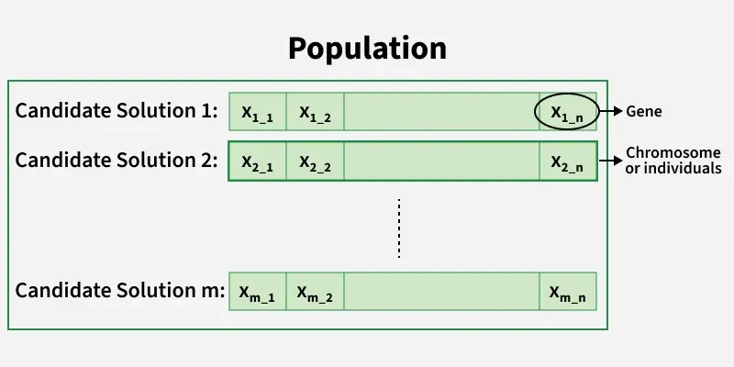

- A population is a collection of candidate solutions (individuals). Instead of working with a single solution, GAs simultaneously evaluate and evolve multiple solutions which helps maintain diversity and reduces the risk of getting trapped in local optima.
  - Population size significantly affects convergence behavior
  - Larger populations increase exploration but raise computational cost
  - Smaller populations converge faster but risk premature convergence

Genetic Algorithm (GA)
Given a clearly defined problem to be solved and a binary string representation for candidate solutions, a basic GA can be represented as shown in Fig. 1.

A GA applies the following major steps:
Step 1: Represent the problem variable domain as a chromosome of a fixed length, choose the size of a chromosome population N, the crossover probability p_{c} and the mutation probability p_{m}.

Step 2: Define a fitness function to measure the performance, or fitness of an individual chromosome in the problem domain. The fitness function establishes the basis for selecting chromosomes that will be mated during reproduction.

Step 3: Randomly generate an initial population of chromosomes of size N:
X₁, X₂, X₃, …., X_{n}.

Step 4: Calculate the fitness of each individual chromosome.

Step 5: Select a pair of chromosomes for mating from the current population. Parent chromosomes are selected with a probability related to their fitness. Highly fit chromosomes have a higher probability of being selected for mating than less fit chromosomes.

Step 6: Create a pair of offspring chromosomes by applying the genetic operators – crossover and mutation.

Step 7: Place the created offspring chromosomes in the new population.

Step 8: Repeat Step 5 until the size of the new chromosome population becomes equal to the size of the initial population, N.

Step 9: Replace the initial (parent) chromosome population with the new (offspring) population.

Step 10: Go to Step 4, and repeat the process until the termination criterion is satisfied.

Replace current chromosome population with new population
Stop
Is the size of the new population equal to N?
Place the resulting chromosomes in the new population
With the mutation probability randomly change the gene values in the two offspring chromosomes
No
Yes
With the crossover probability, exchange parts of the two selected chromosomes and create two offspring
Select a pair of chromosomes for mating
Is the termination condition satisfied?
No
Yes
Generate a Population of chromosomes of size N:

Start
Calculate the fitness of each chromosome:

As we see, a GA represents an iterative process. Each iteration is called a generation. A typical number of generations for a simple GA can range from 50 to over 500. The entire set of generations is called a run. At the end of a run, we expect to find one or more highly fit chromosomes.

How GA works step by step (Evolutionary Process / Process of Genetic Algorithm)
- Initialization: A population of random candidate solutions is created.
- Evaluation (Fitness): Each solution is evaluated; better solutions are assigned higher probabilities of being chosen for reproduction.
- Selection: Fitter individuals are selected to become parents for the next generation.
- Crossover (Recombination): Selected parents exchange parts of their genes to produce offspring, inheriting characteristics from both.
- Mutation: Small, random changes are introduced into some offspring to maintain diversity and prevent premature convergence.
- Termination: The process repeats until a satisfactory solution is found or a maximum number of generations is reached.

Termination / Stopping Criteria of GA
- Termination criteria define the conditions under which the genetic algorithm stops executing. Proper termination prevents unnecessary computation while ensuring solution quality. Common termination conditions:
  - Maximum number of generations reached
  - Desired or threshold fitness achieved
  - No improvement in fitness for several generations
  - Computational time limit exceeded

Applications:
The GAs has been employed in a wide variety of problems. Some common uses include 1.
- pattern recognition and image processing,
- medical image registration,
- image segmentation,
- the traveling salesman problem,
- neural network training,
- scheduling,
- engineering design optimization,
- AI game development. and so on.

Process of Genetic Algorithm
GA starts with the generation of a random population of solutions. Each solution is then evaluated using the fitness function, and the best solutions are selected for reproduction. The selected solutions are then combined using the crossover operator to produce new solutions, which are then mutated to introduce randomness.
The new solutions are then added to the population, replacing the worst solutions. This process is repeated until a satisfactory solution is found or a certain number of generations have passed. The final solution is the best solution found during the process, and is not necessarily the optimal solution to the problem.

Genetic Representation and Initialization
- In genetic algorithms, each solution is represented as a chromosome, which is a string of genes. The genes can be binary, real-valued, or represent some other type of data. The initial population of solutions is usually generated randomly.
- The size of the population is an important parameter in genetic algorithms. A larger population provides more diversity, which can help to avoid local optima, but it also increases the computational cost. The population size is usually chosen based on the complexity of the problem and the computational resources available.
- Before starting GA, the setting of the following six parameters are required:
- Number of genes per chromosome
- Depending on the type of problem, the value of each gene is required, i.e. the value of each gene is 0 or 1 in binary coding system.
- The size of population per generation
- Crossover probability
- Mutation Probability
- Termination criteria and the maximum number of generation

Encoding Methods:
Encoding refers to the way candidate solutions are represented inside chromosomes. Three most widely used encoding techniques of gene:
- Binary Encoding
- Real-number Encoding
- Permutation Encoding

Binary Encoding:
- Most traditional method.
- GA prefers binary encoding in most of the cases; where each gene is a binary bit (either 0 or 1).
- Simple and easy to implement
- Example:
Chromosome 1: 1011010010
Chromosome 2: 0111101010

Widely used for:
- Classic optimization problems
- Knapsack problem
- Feature selection

Disadvantages:
- Not efficient for real-valued problems
- May require long strings for precision

Real-number Encoding
- Chromosome contains real numbers instead of bits (Genes are real numbers).
- Suitable for continuous optimization problems
- Faster convergence and higher precision
- Example:
Chromosome 1: 2.35 1.78 4.90 0.12
Chromosome 2: 0.23 0.19 0.65 1.87

Widely used for:
- Continuous optimization problems
- Function optimization
- Engineering design problems

Advantages:
- More precise
- No binary-to-decimal conversion needed

Disadvantages:
- Requires specialized crossover and mutation operators

Integer Encoding
- Chromosomes are sequences of integers.

Example:
Chromosome: 3 5 2 1 4

Widely used for:
- Scheduling problems
- Resource allocation
- Discrete optimization

Permutation Encoding
- Each chromosome is a string of symbols which represents a valid sequence of operations.
- Each symbol (gene) appears only once.
- In traveling salesman problem (TSP), for example, the set of cities is represented as C = { a, b, c, d, e, f }. Now consider the following two chromosomes:
Chromosome 1: a-c-b-d-e-f
Chromosome 2: a-b-b-c-d-f-e
- Chromosome 1 is valid whereas Chromosome 2 is invalid. During crossover or mutation, the constraints of algorithm should be set so that the chromosomes are not formed in an inconsistent manner.

Widely used for:
- Traveling Salesman Problem (TSP)
- Routing problems
- Job sequencing

Disadvantage:
- Requires specialized crossover and mutation operators

Selection of Chromosomes:
- Selection is the process of choosing chromosomes from the current population to act as parents for the next generation.
- The selection operator chooses the best solutions (Chromosomes) for reproduction.
- There are many different selection methods:
Roulette wheel selection,
Tournament selection,
Rank selection,
Boltzmann selection,
Deterministic selection,
Elitism.
- The selection method can have a significant impact on the performance of the algorithm.

Roulette Wheel Selection / Fitness Proportionate Selection:
- It is a fitness-proportionate selection technique where each individual’s probability of being selected is directly proportional to its fitness value.
- Individuals with higher fitness occupy larger segments of the roulette wheel, making them more likely to be chosen.

Formula:
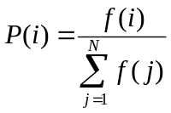​
Where:
f(i) = fitness of individual i
P(i) = probability of selection

Pros:
Simple

Cons:
Can lead to premature convergence if fitness differences are large.

Selection Process:
To simulate the selection process of roulette wheel, follow the steps below:
    - Randomly select m chromosomes.
    - Determine the fitness value of each chromosome.
    - Normalize the fitness values by dividing each fitness value by the sum of all fitness values. The normalized fitness value represents the probability of the corresponding chromosome being selected.
    - From the individual probabilities, calculate the cumulative probability sequence. Chromosomes with higher fitness values will have larger gaps in this sequence, while those with lower fitness values will have smaller gaps.
    - Generate a random number and determine its position within the cumulative probability sequence. By matching the random number to the corresponding gap in the cumulative probability, select the corresponding chromosome.

Example:
Determine the percentage of occupation of roulette wheel for six chromosomes with fitness values of 22, 8, 17, 47, 15 and 62. Show the results graphically.

Solution:
Table: Percentage of occupation in roulette wheel

Chromosome | Fitness | Probability, P(i) | Coverage of roulette wheel in %
1 | 22 | 0.13 | 13%
2 | 8 | 0.05 | 5%
3 | 17 | 0.1 | 10%
4 | 47 | 0.27 | 27%
5 | 15 | 0.09 | 9%
6 | 62 | 0.36 | 36%

Sum of fitness values = 171

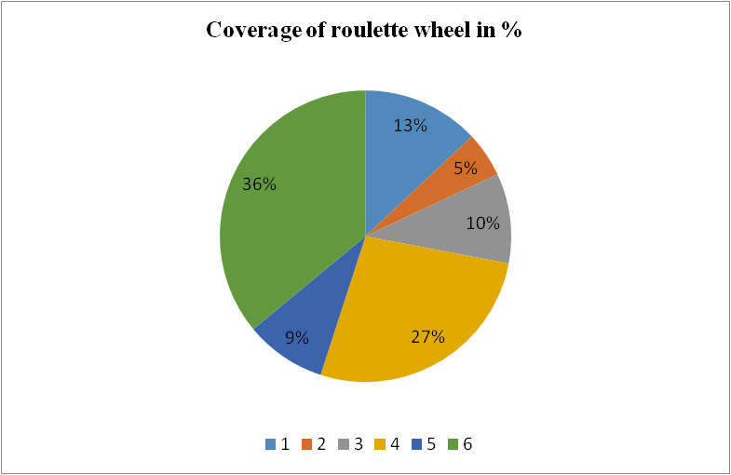
chromosomes:
Spin direction

Example:
Eight individuals / chromosomes of initial population are given as People = {a, b, c, d, e, f, g, h} and the fitness value of elements are found as f(a) = 1.2, f(b) = 1.7, f(c) = 3.1, f(d) = 2.7, f(e) = 1.89, f(f) = 1.08, f(g) = 1.88, and f(h) = 3.4. Apply roulette wheel selection on 8 population space and find the selected mating pool.

Solution:
Sum of fitness value = 1.2 + 1.7 + 3.1 + 2.7 + 1.89 + 1.08 + 1.88 + 3.4 = 16.95

Table: roulette Wheel selection procedure
Initial Population (x) | Fitness Value, f(x) | Probability, Px | Cumulative Probability | Expected Count (Px*8) | r_{x} = rand() | Selected member | Frequency
a | 1.2 | 0.07 | 0.07 | 0.56 | 0.24 | c | 0
b | 1.7 | 0.10 | 0.17 | 0.80 | 0.09 | b | 2
c | 3.1 | 0.18 | 0.35 | 1.44 | 0.31 | c | 3
d | 2.7 | 0.16 | 0.51 | 1.28 | 0.88 | h | 1
e | 1.89 | 0.11 | 0.62 | 0.88 | 0.95 | h | 0
f | 1.08 | 0.06 | 0.68 | 0.48 | 0.49 | d | 0
g | 1.88 | 0.11 | 0.79 | 0.88 | 0.14 | b | 0
h | 3.4 | 0.20 | 0.99 | 1.60 | 0.27 | c | 2
Sum | 16.95 | 1.00 |  | 8.00 |  |  | 8

Normalized Fitness values or Probabilities, P_{x} :
P_{a} = 1.2/16.95 = 0.07, P_{b} = … P_{c} = ………
Cumulative probabilities are shown in col.4.
Random numbers, r = rand() in the range of [0, 1] are generated in col.6.
If the random number is in the range of [0, 0.7], the 1st individual ‘a’ will be selected.
If the random number is in the range of [0.7, 0.17], the 2nd individual ‘b’ will be selected and so on.

Observe 4th and 6th col.:
- The 1st random number, r₁ = 0.24 falls between [0.17, 0.35]; therefore, individual / chromosome ‘c’ will be selected.
- The 2nd random number, r₂ = 0.09 falls between [0.07, 0.17]; therefore, individual / chromosome ‘b’ will be selected.
- The 3rd random number, r₃ = 0.31 falls between [0.17, 0.35]; therefore, individual / chromosome ‘c’ will be selected.
- The 4th random number, r₄ = 0.88 falls between [0.79, 0.99]; therefore, individual / chromosome ‘h’ will be selected and so on .. .

- From the above table, the selected population for mating pool will be {b, b, c, c, c, d, h, h}. That is, {a, e, f ,g} are not selected whereas, c is selected thrice, b and h are selected twice.

- If we compare col.5 (expected count = 8) and col.8 (Frequency = 8), we found that they agree with each other.

