Lab Experiment: 1

Title: Basics of Arduino with Simple Application (LED Blinking)

Course title: IOT Laboratory

Course code: CSE-460
4th Year 1st Semester Examination 2025

Date of Submission: 27/01/2026

Submitted to-

Dr. Md. Ezharul Islam, B.SC.(JU), M.ENGG.(JAPAN), PHD(JAPAN)
Professor
Department of Computer Science and Engineering
Jahangirnagar University

&

Samsun Nahar Khandakar
Assistant Professor
Department of Computer Science and Engineering
Jahangirnagar University
Savar, Dhaka-1342

Class Roll | Exam Roll | Name
379 | 210899 | Shah Sultan
1. Objectives
The primary objectives of this laboratory session were:
- To understand the basics of Arduino hardware and its pin configuration.
- To install and configure the Arduino Integrated Development Environment (IDE).
- To write and upload a C++ program to the Arduino board.
- To design a simple circuit to control an onboard and an outboard (external) LED.

2. Equipment & Software
- Hardware:
- Arduino Uno Microcontroller Board (with USB cable)
- Light Emitting Diode (LED)
- Resistor (330Ω)
- Breadboard and Jumper Wires
- Software:
- Arduino IDE (Downloaded from arduino.cc)

3. Theory
Arduino Uno: An open-source microcontroller board based on the ATmega328P. It allows for the control of physical devices through digital and analog input/output (I/O) pins.
LED (Light Emitting Diode): A semiconductor light source that emits light when current flows through it. It has polarity: an anode (positive, longer leg) and a cathode (negative, shorter leg).
Resistor: Used in series with the LED to limit the current and prevent the LED from burning out.

4. Procedure

Part A: Setup and Installation
- Group Formation: A group of 3 students was formed to perform the experiment.
- Hardware Demonstration: We examined the Arduino Uno board, identifying the USB-to-serial converter, digital pins (0-13), analog pins (A0-A5), power pins (3.3V, 5V, GND), and the microcontroller chip.
- Software Configuration: We downloaded and installed the Arduino IDE. We connected the Arduino to the PC via USB and verified the board and port settings in the IDE.

Part B: Internal LED Blinking
- We opened the Arduino IDE and wrote the code to control the built-in LED (typically connected to Pin 13).
- The setup() function was used to initialize LED_BUILTIN as an output.
- The loop() function was used to turn the LED on and off with a 1-second delay.

Part C: Outboard LED Circuit Design
- We constructed the circuit as shown in Fig-2 of the lab sheet.
- Connections:
- Anode (+): Connected the long leg of the LED to Digital Pin 13 (via a 330Ω resistor).
- Cathode (-): Connected the short leg of the LED to the GND (Ground) pin on the Arduino.
We uploaded the same code to test the external LED.

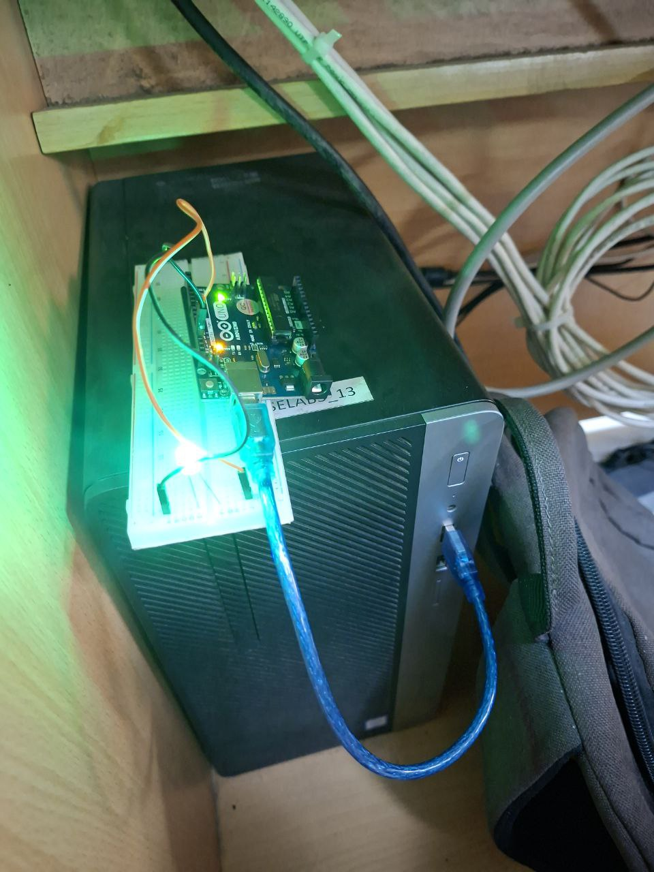

5. Source Code
The following code was written and uploaded to the board:

C++

// The setup function runs once when you press reset or power the board
void setup() {
// Initialize digital pin LED_BUILTIN as an output.
pinMode(LED_BUILTIN, OUTPUT);
}
// The loop function runs over and over again forever
void loop() {
digitalWrite(LED_BUILTIN, HIGH); // Turn the LED on (HIGH is the voltage level)
delay(1000); // Wait for a second
digitalWrite(LED_BUILTIN, LOW); // Turn the LED off by making the voltage LOW
delay(1000); // Wait for a second
}

6. Circuit Diagram Analysis
- Fig. 1 (Pinout): Showed the Arduino Uno architecture, highlighting the USB connector, power jack, ATmega processor, and the digital/analog headers.
- Fig. 2 (Schematic): Illustrated the connection of an external LED. A 330Ω resistor (R1) was placed in series between Digital Pin 13 and the LED anode to limit current, ensuring safe operation.

7. Observation & Conclusion
Upon uploading the code, we observed that:
- The onboard LED (labeled 'L' on the board) started blinking with a 1-second interval.
- When the external circuit was connected, the external LED blinked synchronously with the command defined in the code.
Conclusion:
The experiment was successfully completed. We learned how to interface the Arduino Uno with the PC, configure the IDE, and control digital outputs to blink an LED. This foundational lab provided the necessary skills for future IoT projects involving sensor interfacing and actuator control.

