Lab Report: 09
Title: Line and Circle Detection using Hough Transform Algorithm
Course title: Digital Image Processing Laboratory
Course code: CSE-406
4th Year 1st Semester Examination 2023

Date of Submission: 03/11/2024

Submitted to-
Dr. Md. Golam Moazzam
Professor
Department of Computer Science and Engineering
Jahangirnagar University
&
Dr. Morium Akter
Professor
Department of Computer Science and Engineering
Jahangirnagar University
Savar, Dhaka-1342

Class Roll | Exam Roll | Name
402 | 202214 | Jubaer Ahmad Khan

Experiment No: 01
Experiment Name: Straight Line Detection using Hough Transform Algorithm
Objectives:
- The objective of this lab is to demonstrate line detection in an image using the Hough Transform in Python with OpenCV.
- Line detection is essential in computer vision applications for identifying boundaries, lane detection in self-driving cars, and various other applications where linear structures need to be identified.
- This lab includes preprocessing the image, applying edge detection, detecting lines with the Hough Transform, and visualizing the results.
Code-01: Python
import cv2
import numpy as np
import matplotlib.pyplot as plt
image = cv2.imread('lab1.webp')
inputImage = cv2.imread('lab1.webp')
gray = cv2.cvtColor(image, cv2.COLOR_BGR2GRAY)
edges = cv2.Canny(gray, 50, 150, apertureSize=3)
lines = cv2.HoughLines(edges, 1, np.pi / 180, 200)
if lines is not None:
for line in lines:
rho, theta = line[0]
a = np.cos(theta)
b = np.sin(theta)
x0 = a * rho
y0 = b * rho
x1 = int(x0 + 1000 * (-b))
y1 = int(y0 + 1000 * (a))
x2 = int(x0 - 1000 * (-b))
y2 = int(y0 - 1000 * (a))

cv2.line(image, (x1, y1), (x2, y2), (0, 0, 255), 2)
plt.imshow(cv2.cvtColor(image, cv2.COLOR_BGR2RGB))
plt.title("Detected Lines")
plt.axis('off')
plt.show()

Output:
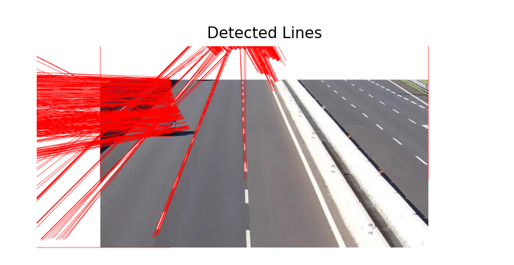
Figure 1.1: Line detection by Hough transform in Python
Explanation:
- Import libraries.
- cv2.cvtColor(image, cv2.COLOR_BGR2GRAY) converts the image from color (BGR) to grayscale, which is a typical preprocessing step for edge detection and reduces computational load.
- cv2.Canny(gray, 50, 150, apertureSize=3) applies Canny edge detection to the grayscale image. Canny edge detection detects edges in the image based on intensity gradients and returns a binary image with detected edges highlighted.
- cv2.HoughLines(edges, 1, np.pi / 180, 200) is used to detect lines in the edge-detected image.
- cv2.line(image, (x1, y1), (x2, y2), (0, 0, 255), 2) draws the detected line in red ((0, 0, 255)) with a thickness of 2.
- plt.imshow(cv2.cvtColor(image, cv2.COLOR_BGR2RGB)) is used to display the image with detected lines in the red color. cv2.cvtColor converts the image from BGR to RGB for correct color display with Matplotlib.

Code-02: MATLAB
image = imread('lab.jpg');
gray = rgb2gray(image);
edges = edge(gray, 'Canny');
[H, T, R] = hough(edges);
P = houghpeaks(H, 5, 'threshold', ceil(0.3 * max(H(:))));
lines = houghlines(edges, T, R, P, 'FillGap', 20, 'MinLength', 40);
figure, imshow(image), hold on
for k = 1:length(lines)
xy = [lines(k).point1; lines(k).point2];
plot(xy(:, 1), xy(:, 2), 'LineWidth', 2, 'Color', 'red');
plot(xy(1, 1), xy(1, 2), 'x', 'LineWidth', 2, 'Color', 'yellow');
plot(xy(2, 1), xy(2, 2), 'x', 'LineWidth', 2, 'Color', 'green');
end
title('Detected Lines using Hough Transform');
hold off;

Output:
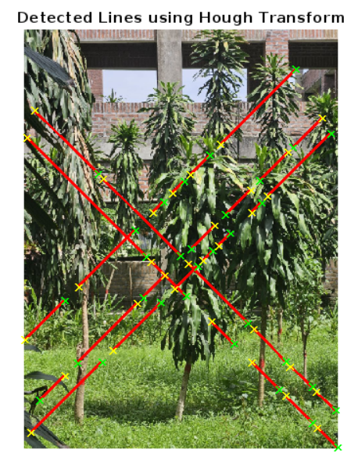
Figure 1.2: Line detection by Hough transform in MTLAB

Explanation:
- The edge() function with the 'Canny' method detects edges in the grayscale image. Canny edge detection is a popular method for finding edges in an image by identifying areas with strong intensity gradients.
- The hough() function applies the Hough Transform to the edge-detected image, producing a Hough matrix H, and vectors T (theta) and R (rho).
- houghpeaks() identifies the most significant peaks in the Hough matrix H, which represent potential lines.
- FillGap specifies the maximum gap between line segments to connect them into a single line, while MinLength sets the minimum length for a line to be considered.
Experiment No: 02
Experiment Name: Circle Detection using Hough Transform
Objectives:
- The purpose of this lab is to demonstrate circle detection in an image using the Hough Transform with OpenCV in Python.
- Detecting circular shapes is essential in various applications, including object tracking, detecting traffic signs, and analyzing medical images.
- In this lab, we preprocess an image, apply a circular Hough Transform, and visualize the detected circles on the image.
Code-01: Python
import cv2
import numpy as np
import matplotlib.pyplot as plt
image = cv2.imread('road.jpg')
inputImage = cv2.imread('road.jpg')
gray = cv2.cvtColor(image, cv2.COLOR_BGR2GRAY)
gray = cv2.GaussianBlur(gray, (9, 9), 2)
circles = cv2.HoughCircles(
gray,
cv2.HOUGH_GRADIENT,
dp=1.2,
minDist=30,
param1=50,
param2=30,
minRadius=10,
maxRadius=80
)
if circles is not None:
circles = np.uint16(np.around(circles))
for i in circles[0, :]:
center = (i[0], i[1])
radius = i[2]
cv2.circle(image, center, radius, (0, 255, 0), 3)
cv2.circle(image, center, 3, (0, 0, 255), 3)
plt.figure(figsize=(10, 10))
plt.subplot(2, 2, 1)
plt.imshow(cv2.cvtColor(inputImage, cv2.COLOR_BGR2RGB))
plt.title('Original Image')
plt.axis('off')
plt.subplot(2, 2, 2)
plt.imshow(cv2.cvtColor(image, cv2.COLOR_BGR2RGB))
plt.title("Detected Circles")
plt.axis('off')
plt.show()

Output:

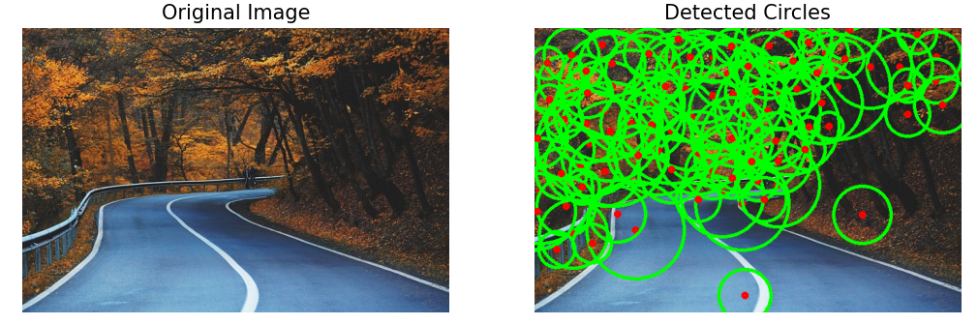
Figure 2.1: Circle Detection by Hough Transform in python
Explanation:
- The code imports cv2 for image processing, numpy for numerical operations, and matplotlib.pyplot for displaying images.
- The image is converted to grayscale using cv2.cvtColor(), a standard preprocessing step to reduce the computational load by eliminating color information.
- A Gaussian blur with a kernel size of (9, 9) and standard deviation 2 is applied to smooth the image. This step helps reduce noise, making circle detection more accurate by blurring out minor image details.
- The cv2.HoughCircles() function applies the Hough Circle Transform to detect circular shapes.
- If any circles are detected, their properties are rounded and converted to integers using np.uint16(np.around(circles)).
Code-02: MATLAB
image = imread('flower.jpeg');
gray = rgb2gray(image);
[centers, radii, metric] = imfindcircles(gray, [20 80], 'Sensitivity', 0.9, 'EdgeThreshold', 0.1);
imshow(image);
hold on;
viscircles(centers, radii, 'EdgeColor', 'r');
title('Detected Circles using Hough Transform');
hold off;

Output:

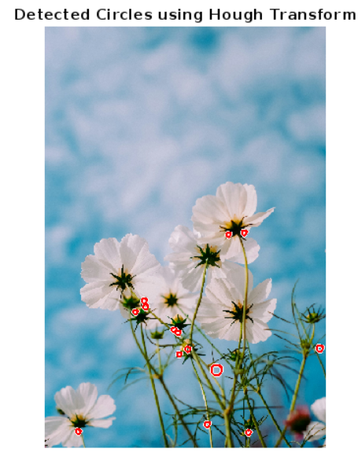

Figure 2.2: Circle Detection by Hough Transform in MATLAB
Explanation:
- The imfindcircles function uses the Hough Circle Transform to detect circles in the grayscale image.
- [20 80] that specifies the minimum and maximum radius range of circles to detect (between 20 and 80 pixels).
- 'Sensitivity', 0.9 that sets the sensitivity level for detection. Higher sensitivity (close to 1) allows the detection of fainter circles but may increase false positives.
- 'EdgeThreshold', 0.1 that determines the edge threshold used to detect circles. Lower values allow detecting weaker edges.
- imshow(image) displays the original image, and hold on ensures that additional plots (e.g., circles) can be overlaid on this image.
- viscircles overlays the detected circles on the image.

