**Name of the Problem: BFS**

|  |  |
| --- | --- |
| **#include<bits/stdc++.h>**  **using namespace std;**  **const int N=1e5+10;**  **vector<int>v[N];**  **int vis[N],level[N];**  **void bfs(int node)**  **{**  **queue<int>q;**  **q.push(node);**  **vis[node]=1;**  **level[node]=1;**  **cout<<"BFS :- ";**  **while(!q.empty())**  **{**  **int fr=q.front();**  **cout<<fr<<" ";**  **q.pop();**  **for(auto x:v[fr])**  **{**  **if(!vis[x])**  **{**  **vis[x]=1;**  **level[x]=level[fr]+1;**  **q.push(x);**  **}**  **}**  **}**  **cout<<endl;**  **}** | **int main()**  **{**  **cout<<"Enter the number of edge: ";**  **int n;**  **cin>>n;**  **for(int i=0; i<n; i++)**  **{**  **int x,y;**  **cin>>x>>y;**  **v[x].push_back(y);**  **v[y].push_back(x);**  **}**  **cout<<"\nAdjacency List: \n";**  **for(int i=1; i<=n; i++)**  **{**  **cout<<i;**  **for(auto x:v[i])cout<<"->"<<x;**  **cout<<endl;**  **}**  **cout<<endl;**  **bfs(1);**  **cout<<endl;**  **cout<<"Distance from source node: \n";**  **for(int i=1; i<=n; i++)**  **{**  **cout<<"\t\t\t"<<i<<"->"<<level[i]<<endl;**  **}**  **}** |

**Code:**

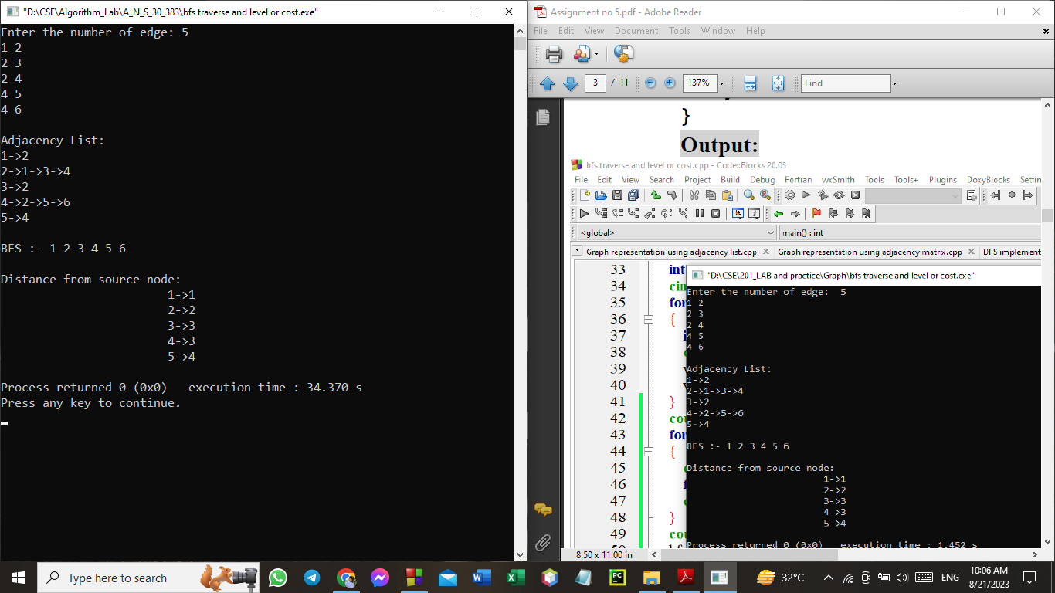**Output:**

**Name of the Problem: 3) Subset Sum Problem Using BitMasking**

**Code:**

|  |  |
| --- | --- |
| **#include<bits/stdc++.h>**  **using namespace std;**  **int main()**  **{**  **int n;**  **cout<<"Enter number of coin : ";**  **cin>>n;**  **int ara[n];**  **for(int i=0; i<n; i++)cin>>ara[i];**  **cout<<"Enter sum: ";**  **int sum,count=0;**  **cin>>sum;** | **for(int i=1; i<(1<<n); i++)**  **{**  **int x = i;**  **int subsetsum = 0;**  **for(int j=0; j<n; j++)**  **{**  **if( (x&(1<<j))!=0)**  **subsetsum+=ara[j];**  **}**  **if(sum==subsetsum)**  **{**  **count++;**  **}**  **}**  **cout<<"Total number of subset : "<<count<<endl;**  **return 0;**  **}** |

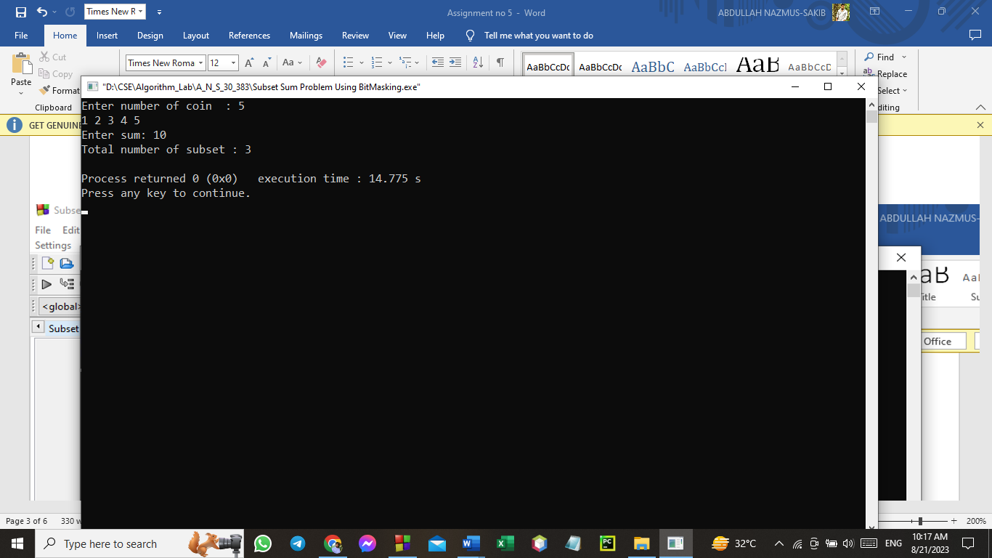**OUTPUT:**

**Name of the Problem: 4)** **Subset Sum Problem Using BitMask & Meet in the middle technique.**

**Code:**

|  |  |
| --- | --- |
| **#include<bits/stdc++.h>**  **using namespace std;**  **int SetOfElement[100];**  **void culculation_sum_of_subset(int n,int c,vector<int>&v)**  **{**  **for(int i=0; i<(1<<n); i++)**  **{**  **int sum=0;**  **for(int j=0; j<n; j++)**  **{**  **if(i&(1<<j))**  **{**  **sum=sum+SetOfElement[j+c];**  **}**  **}**  **v.push_back(sum);**  **}**  **}**  **int main()**  **{**  **vector<int>v1,v2;**  **int n,count=0;**  **cout<<"Enter the number of elements: ";**  **cin>>n;**  **for(int i=0; i<n; i++)** | **{**  **cin>>SetOfElement[i];**  **}**  **cout<<"Enter wanting values: ";**  **int values;**  **cin>>values;**  **culculation_sum_of_subset(n/2,0,v1);**  **culculation_sum_of_subset((n+1)/2,(n/2),v2)**  **sort(v1.begin(),v1.end());**  **int sz=v1.size();**  **for(int i=0; i<v2.size(); i++)**  **{**  **int seSetOfElementch=0;**  **if(v2[i]<=values)**  **{**  **seSetOfElementch=values-v2[i];**  **auto it=lower_bound(v1.begin(),v1.end(),seSetOfElementch)-v1.begin();**  **if(it==sz)**  **{**  **it--;**  **}**  **if(seSetOfElementch==v1[it])**  **{**  **count++;**  **}**  **}**  **}**  **cout<<"Total set of subSet : "<<count<<endl;**  **}** |

