# **Data Science Regression Project: Predicting Home Prices in Bangalore**

In [1]:

**import** pandas **as** pd

**import** numpy **as** np

**from** matplotlib **import** pyplot **as** plt

**%matplotlib** inline

**import** matplotlib

matplotlib**.**rcParams["figure.figsize"] **=** (20,10)

## **Data Load: Load banglore home prices into a dataframe**

In [2]:

df1 **=** pd**.**read_csv("bengaluru_house_prices.csv")

df1**.**head()

Out[2]:

|  | **area_type** | **availability** | **location** | **size** | **society** | **total_sqft** | **bath** | **balcony** | **price** |
| --- | --- | --- | --- | --- | --- | --- | --- | --- | --- |
| **0** | Super built-up Area | 19-Dec | Electronic City Phase II | 2 BHK | Coomee | 1056 | 2.0 | 1.0 | 39.07 |
| **1** | Plot Area | Ready To Move | Chikka Tirupathi | 4 Bedroom | Theanmp | 2600 | 5.0 | 3.0 | 120.00 |
| **2** | Built-up Area | Ready To Move | Uttarahalli | 3 BHK | NaN | 1440 | 2.0 | 3.0 | 62.00 |
| **3** | Super built-up Area | Ready To Move | Lingadheeranahalli | 3 BHK | Soiewre | 1521 | 3.0 | 1.0 | 95.00 |
| **4** | Super built-up Area | Ready To Move | Kothanur | 2 BHK | NaN | 1200 | 2.0 | 1.0 | 51.00 |

In [3]:

df1**.**shape

Out[3]:

(13320, 9)

In [4]:

df1**.**columns

Out[4]:

Index(['area_type', 'availability', 'location', 'size', 'society',

'total_sqft', 'bath', 'balcony', 'price'],

dtype='object')

In [5]:

df1['area_type']**.**unique()

Out[5]:

array(['Super built-up Area', 'Plot Area', 'Built-up Area',

'Carpet Area'], dtype=object)

In [6]:

df1['area_type']**.**value_counts()

Out[6]:

Super built-up Area 8790

Built-up Area 2418

Plot Area 2025

Carpet Area 87

Name: area_type, dtype: int64

**Drop features that are not required to build our model**

In [7]:

df2 **=** df1**.**drop(['area_type','society','balcony','availability'],axis**=**'columns')

df2**.**shape

Out[7]:

(13320, 5)

## **Data Cleaning: Handle NA values**

In [8]:

df2**.**isnull()**.**sum()

Out[8]:

location 1

size 16

total_sqft 0

bath 73

price 0

dtype: int64

In [9]:

df2**.**shape

Out[9]:

(13320, 5)

In [10]:

df3 **=** df2**.**dropna()

df3**.**isnull()**.**sum()

Out[10]:

location 0

size 0

total_sqft 0

bath 0

price 0

dtype: int64

In [11]:

df3**.**shape

Out[11]:

(13246, 5)

## **Feature Engineering**

**Add new feature(integer) for bhk (Bedrooms Hall Kitchen)**

In [12]:

df3['bhk'] **=** df3['size']**.**apply(**lambda** x: int(x**.**split(' ')[0]))

df3**.**bhk**.**unique()

C:\ProgramData\Anaconda3\lib\site-packages\ipykernel_launcher.py:1: SettingWithCopyWarning:

A value is trying to be set on a copy of a slice from a DataFrame.

Try using .loc[row_indexer,col_indexer] = value instead

See the caveats in the documentation: http://pandas.pydata.org/pandas-docs/stable/indexing.html#indexing-view-versus-copy

"""Entry point for launching an IPython kernel.

Out[12]:

array([ 2, 4, 3, 6, 1, 8, 7, 5, 11, 9, 27, 10, 19, 16, 43, 14, 12,

13, 18], dtype=int64)

**Explore total_sqft feature**

In [13]:

**def** is_float(x):

**try**:

float(x)

**except**:

**return** **False**

**return** **True**

In [14]:

2**+**3

Out[14]:

5

In [15]:

df3[**~**df3['total_sqft']**.**apply(is_float)]**.**head(10)

Out[15]:

|  | **location** | **size** | **total_sqft** | **bath** | **price** | **bhk** |
| --- | --- | --- | --- | --- | --- | --- |
| **30** | Yelahanka | 4 BHK | 2100 - 2850 | 4.0 | 186.000 | 4 |
| **122** | Hebbal | 4 BHK | 3067 - 8156 | 4.0 | 477.000 | 4 |
| **137** | 8th Phase JP Nagar | 2 BHK | 1042 - 1105 | 2.0 | 54.005 | 2 |
| **165** | Sarjapur | 2 BHK | 1145 - 1340 | 2.0 | 43.490 | 2 |
| **188** | KR Puram | 2 BHK | 1015 - 1540 | 2.0 | 56.800 | 2 |
| **410** | Kengeri | 1 BHK | 34.46Sq. Meter | 1.0 | 18.500 | 1 |
| **549** | Hennur Road | 2 BHK | 1195 - 1440 | 2.0 | 63.770 | 2 |
| **648** | Arekere | 9 Bedroom | 4125Perch | 9.0 | 265.000 | 9 |
| **661** | Yelahanka | 2 BHK | 1120 - 1145 | 2.0 | 48.130 | 2 |
| **672** | Bettahalsoor | 4 Bedroom | 3090 - 5002 | 4.0 | 445.000 | 4 |

**Above shows that total_sqft can be a range (e.g. 2100-2850). For such case we can just take average of min and max value in the range. There are other cases such as 34.46Sq. Meter which one can convert to square ft using unit conversion. I am going to just drop such corner cases to keep things simple**

In [16]:

**def** convert_sqft_to_num(x):

tokens **=** x**.**split('-')

**if** len(tokens) **==** 2:

**return** (float(tokens[0])**+**float(tokens[1]))**/**2

**try**:

**return** float(x)

**except**:

**return** **None**

In [17]:

df4 **=** df3**.**copy()

df4**.**total_sqft **=** df4**.**total_sqft**.**apply(convert_sqft_to_num)

df4 **=** df4[df4**.**total_sqft**.**notnull()]

df4**.**head(2)

Out[17]:

|  | **location** | **size** | **total_sqft** | **bath** | **price** | **bhk** |
| --- | --- | --- | --- | --- | --- | --- |
| **0** | Electronic City Phase II | 2 BHK | 1056.0 | 2.0 | 39.07 | 2 |
| **1** | Chikka Tirupathi | 4 Bedroom | 2600.0 | 5.0 | 120.00 | 4 |

**For below row, it shows total_sqft as 2475 which is an average of the range 2100-2850**

In [18]:

df4**.**loc[30]

Out[18]:

location Yelahanka

size 4 BHK

total_sqft 2475

bath 4

price 186

bhk 4

Name: 30, dtype: object

In [19]:

(2100**+**2850)**/**2

Out[19]:

2475.0

## **Feature Engineering**

**Add new feature called price per square feet**

In [20]:

df5 **=** df4**.**copy()

df5['price_per_sqft'] **=** df5['price']**\***100000**/**df5['total_sqft']

df5**.**head()

Out[20]:

|  | **location** | **size** | **total_sqft** | **bath** | **price** | **bhk** | **price_per_sqft** |
| --- | --- | --- | --- | --- | --- | --- | --- |
| **0** | Electronic City Phase II | 2 BHK | 1056.0 | 2.0 | 39.07 | 2 | 3699.810606 |
| **1** | Chikka Tirupathi | 4 Bedroom | 2600.0 | 5.0 | 120.00 | 4 | 4615.384615 |
| **2** | Uttarahalli | 3 BHK | 1440.0 | 2.0 | 62.00 | 3 | 4305.555556 |
| **3** | Lingadheeranahalli | 3 BHK | 1521.0 | 3.0 | 95.00 | 3 | 6245.890861 |
| **4** | Kothanur | 2 BHK | 1200.0 | 2.0 | 51.00 | 2 | 4250.000000 |

In [21]:

df5_stats **=** df5['price_per_sqft']**.**describe()

df5_stats

Out[21]:

count 1.320000e+04

mean 7.920759e+03

std 1.067272e+05

min 2.678298e+02

25% 4.267701e+03

50% 5.438331e+03

75% 7.317073e+03

max 1.200000e+07

Name: price_per_sqft, dtype: float64

In [69]:

df5**.**to_csv("bhp.csv",index**=False**)

**Examine locations which is a categorical variable. We need to apply dimensionality reduction technique here to reduce number of locations**

In [22]:

df5**.**location **=** df5**.**location**.**apply(**lambda** x: x**.**strip())

location_stats **=** df5['location']**.**value_counts(ascending**=False**)

location_stats

Out[22]:

Whitefield 533

Sarjapur Road 392

Electronic City 304

Kanakpura Road 264

Thanisandra 235

Yelahanka 210

Uttarahalli 186

Hebbal 176

Marathahalli 175

Raja Rajeshwari Nagar 171

Bannerghatta Road 151

Hennur Road 150

7th Phase JP Nagar 148

Haralur Road 141

Electronic City Phase II 131

Rajaji Nagar 106

Chandapura 98

Bellandur 96

KR Puram 88

Hoodi 88

Electronics City Phase 1 87

Yeshwanthpur 85

Begur Road 84

Sarjapur 80

Kasavanhalli 79

Harlur 79

Hormavu 74

Banashankari 74

Ramamurthy Nagar 72

Koramangala 72

...

Ckikkakammana Halli 1

Neelasandra 1

Gangondanahalli 1

Agara Village 1

Sundara Nagar 1

Binny Mills Employees Colony 1

Adugodi 1

Uvce Layout 1

Kenchanehalli R R Nagar 1

Whietfield, 1

manyata 1

Air View Colony 1

Thavarekere 1

Muthyala Nagar 1

Haralur Road, 1

Manonarayanapalya 1

GKW Layout 1

Marathalli bridge 1

Banashankari 6th Stage ,Subramanyapura 1

anjananager magdi road 1

akshaya nagar t c palya 1

Indiranagar HAL 2nd Stage 1

Maruthi HBCS Layout 1

Gopal Reddy Layout 1

High grounds 1

CMH Road 1

Chambenahalli 1

Sarvobhogam Nagar 1

Ex-Servicemen Colony Dinnur Main Road R.T.Nagar 1

Bilal Nagar 1

Name: location, Length: 1287, dtype: int64

In [23]:

location_stats**.**values**.**sum()

Out[23]:

13200

In [24]:

len(location_stats[location_stats**>**10])

Out[24]:

240

In [25]:

len(location_stats)

Out[25]:

1287

In [26]:

len(location_stats[location_stats**<=**10])

Out[26]:

1047

## **Dimensionality Reduction**

**Any location having less than 10 data points should be tagged as "other" location. This way number of categories can be reduced by huge amount. Later on when we do one hot encoding, it will help us with having fewer dummy columns**

Out[30]:

|  | **location** | **size** | **total_sqft** | **bath** | **price** | **bhk** | **price_per_sqft** |
| --- | --- | --- | --- | --- | --- | --- | --- |
| **0** | Electronic City Phase II | 2 BHK | 1056.0 | 2.0 | 39.07 | 2 | 3699.810606 |
| **1** | Chikka Tirupathi | 4 Bedroom | 2600.0 | 5.0 | 120.00 | 4 | 4615.384615 |
| **2** | Uttarahalli | 3 BHK | 1440.0 | 2.0 | 62.00 | 3 | 4305.555556 |
| **3** | Lingadheeranahalli | 3 BHK | 1521.0 | 3.0 | 95.00 | 3 | 6245.890861 |
| **4** | Kothanur | 2 BHK | 1200.0 | 2.0 | 51.00 | 2 | 4250.000000 |
| **5** | Whitefield | 2 BHK | 1170.0 | 2.0 | 38.00 | 2 | 3247.863248 |
| **6** | Old Airport Road | 4 BHK | 2732.0 | 4.0 | 204.00 | 4 | 7467.057101 |
| **7** | Rajaji Nagar | 4 BHK | 3300.0 | 4.0 | 600.00 | 4 | 18181.818182 |
| **8** | Marathahalli | 3 BHK | 1310.0 | 3.0 | 63.25 | 3 | 4828.244275 |
| **9** | other | 6 Bedroom | 1020.0 | 6.0 | 370.00 | 6 | 36274.509804 |

## **Outlier Removal Using Business Logic**

**As a data scientist when you have a conversation with your business manager (who has expertise in real estate), he will tell you that normally square ft per bedroom is 300 (i.e. 2 bhk apartment is minimum 600 sqft. If you have for example 400 sqft apartment with 2 bhk than that seems suspicious and can be removed as an outlier. We will remove such outliers by keeping our minimum thresold per bhk to be 300 sqft**

In [31]:

df5[df5**.**total_sqft**/**df5**.**bhk**<**300]**.**head()

Out[31]:

|  | **location** | **size** | **total_sqft** | **bath** | **price** | **bhk** | **price_per_sqft** |
| --- | --- | --- | --- | --- | --- | --- | --- |
| **9** | other | 6 Bedroom | 1020.0 | 6.0 | 370.0 | 6 | 36274.509804 |
| **45** | HSR Layout | 8 Bedroom | 600.0 | 9.0 | 200.0 | 8 | 33333.333333 |
| **58** | Murugeshpalya | 6 Bedroom | 1407.0 | 4.0 | 150.0 | 6 | 10660.980810 |
| **68** | Devarachikkanahalli | 8 Bedroom | 1350.0 | 7.0 | 85.0 | 8 | 6296.296296 |
| **70** | other | 3 Bedroom | 500.0 | 3.0 | 100.0 | 3 | 20000.000000 |

**Check above data points. We have 6 bhk apartment with 1020 sqft. Another one is 8 bhk and total sqft is 600. These are clear data errors that can be removed safely**

In [32]:

df5**.**shape

Out[32]:

(13200, 7)

In [33]:

df6 **=** df5[**~**(df5**.**total_sqft**/**df5**.**bhk**<**300)]

df6**.**shape

Out[33]:

(12456, 7)

## **Outlier Removal Using Standard Deviation and Mean**

In [34]:

df6**.**price_per_sqft**.**describe()

Out[34]:

count 12456.000000

mean 6308.502826

std 4168.127339

min 267.829813

25% 4210.526316

50% 5294.117647

75% 6916.666667

max 176470.588235

Name: price_per_sqft, dtype: float64

**Here we find that min price per sqft is 267 rs/sqft whereas max is 12000000, this shows a wide variation in property prices. We should remove outliers per location using mean and one standard deviation**

In [35]:

**def** remove_pps_outliers(df):

df_out **=** pd**.**DataFrame()

**for** key, subdf **in** df**.**groupby('location'):

m **=** np**.**mean(subdf**.**price_per_sqft)

st **=** np**.**std(subdf**.**price_per_sqft)

reduced_df **=** subdf[(subdf**.**price_per_sqft**>**(m**-**st)) **&** (subdf**.**price_per_sqft**<=**(m**+**st))]

df_out **=** pd**.**concat([df_out,reduced_df],ignore_index**=True**)

**return** df_out

df7 **=** remove_pps_outliers(df6)

df7**.**shape

Out[35]:

(10242, 7)

**Let's check if for a given location how does the 2 BHK and 3 BHK property prices look like**

In [36]:

**def** plot_scatter_chart(df,location):

bhk2 **=** df[(df**.**location**==**location) **&** (df**.**bhk**==**2)]

bhk3 **=** df[(df**.**location**==**location) **&** (df**.**bhk**==**3)]

matplotlib**.**rcParams['figure.figsize'] **=** (15,10)

plt**.**scatter(bhk2**.**total_sqft,bhk2**.**price,color**=**'blue',label**=**'2 BHK', s**=**50)

plt**.**scatter(bhk3**.**total_sqft,bhk3**.**price,marker**=**'+', color**=**'green',label**=**'3 BHK', s**=**50)

plt**.**xlabel("Total Square Feet Area")

plt**.**ylabel("Price (Lakh Indian Rupees)")

plt**.**title(location)

plt**.**legend()

plot_scatter_chart(df7,"Rajaji Nagar")

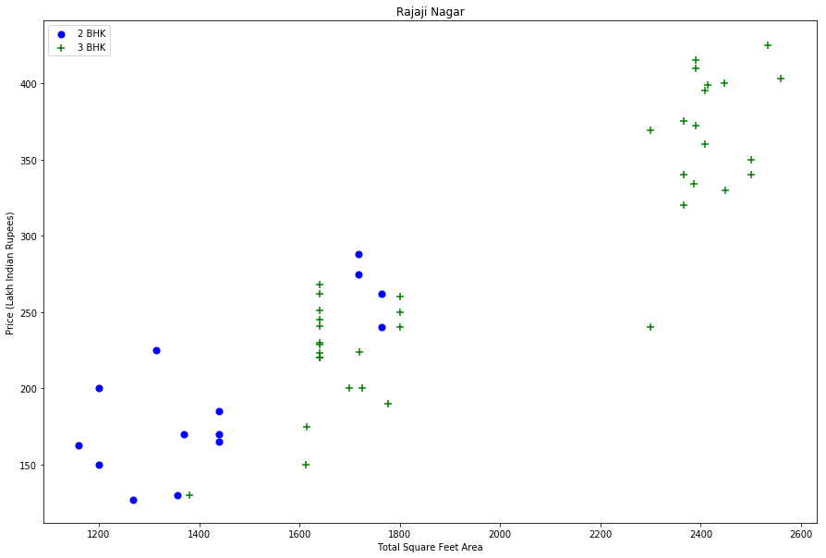

In [37]:

plot_scatter_chart(df7,"Hebbal")

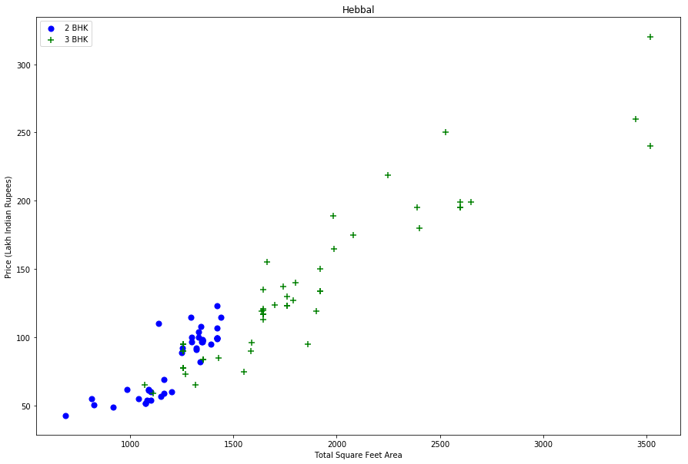

**We should also remove properties where for same location, the price of (for example) 3 bedroom apartment is less than 2 bedroom apartment (with same square ft area). What we will do is for a given location, we will build a dictionary of stats per bhk, i.e.**

{

'1' : {

'mean': 4000,

'std: 2000,

'count': 34

},

'2' : {

'mean': 4300,

'std: 2300,

'count': 22

},

}

**Now we can remove those 2 BHK apartments whose price_per_sqft is less than mean price_per_sqft of 1 BHK apartment**

In [38]:

**def** remove_bhk_outliers(df):

exclude_indices **=** np**.**array([])

**for** location, location_df **in** df**.**groupby('location'):

bhk_stats **=** {}

**for** bhk, bhk_df **in** location_df**.**groupby('bhk'):

bhk_stats[bhk] **=** {

'mean': np**.**mean(bhk_df**.**price_per_sqft),

'std': np**.**std(bhk_df**.**price_per_sqft),

'count': bhk_df**.**shape[0]

}

**for** bhk, bhk_df **in** location_df**.**groupby('bhk'):

stats **=** bhk_stats**.**get(bhk**-**1)

**if** stats **and** stats['count']**>**5:

exclude_indices **=** np**.**append(exclude_indices, bhk_df[bhk_df**.**price_per_sqft**<**(stats['mean'])]**.**index**.**values)

**return** df**.**drop(exclude_indices,axis**=**'index')

df8 **=** remove_bhk_outliers(df7)

*# df8 = df7.copy()*

df8**.**shape

Out[38]:

(7317, 7)

**Plot same scatter chart again to visualize price_per_sqft for 2 BHK and 3 BHK properties**

In [39]:

plot_scatter_chart(df8,"Rajaji Nagar")

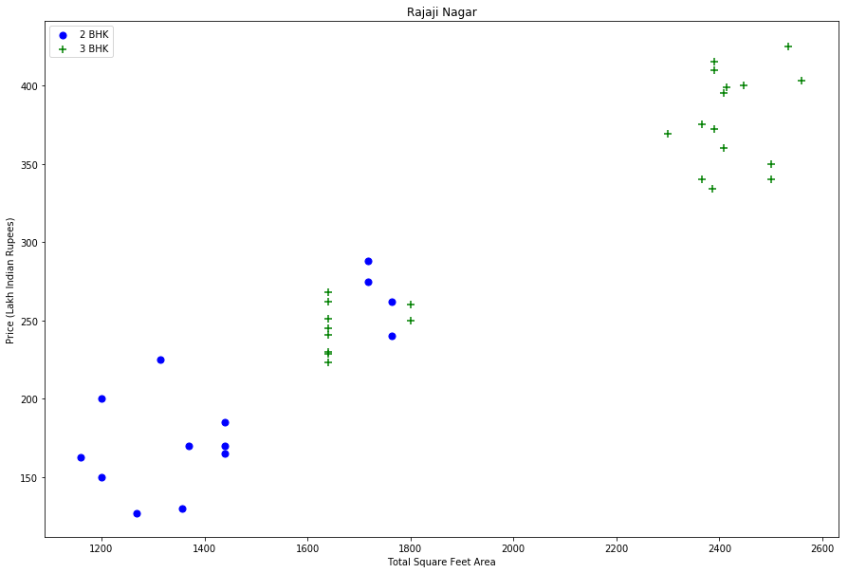

In [40]:

plot_scatter_chart(df8,"Hebbal")

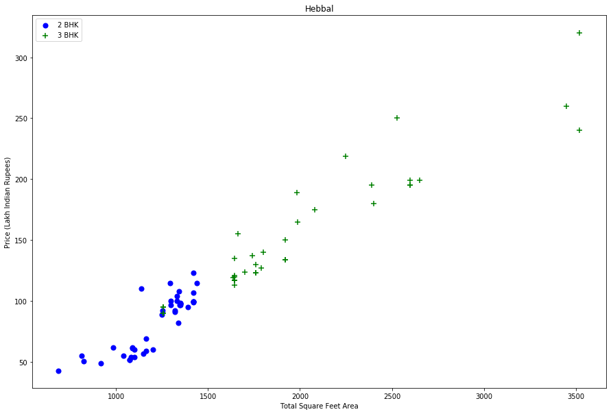

**Based on above charts we can see that data points highlighted in red below are outliers and they are being removed due to remove_bhk_outliers function**

### **Before and after outlier removal: Rajaji Nagar**

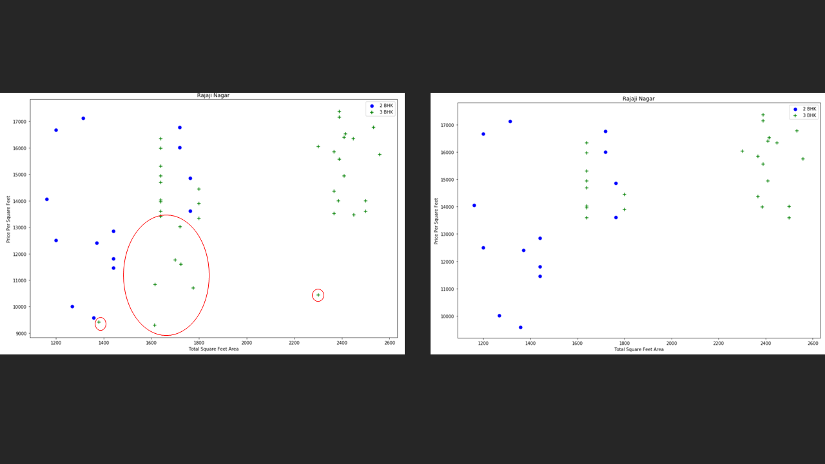

### **Before and after outlier removal: Hebbal**

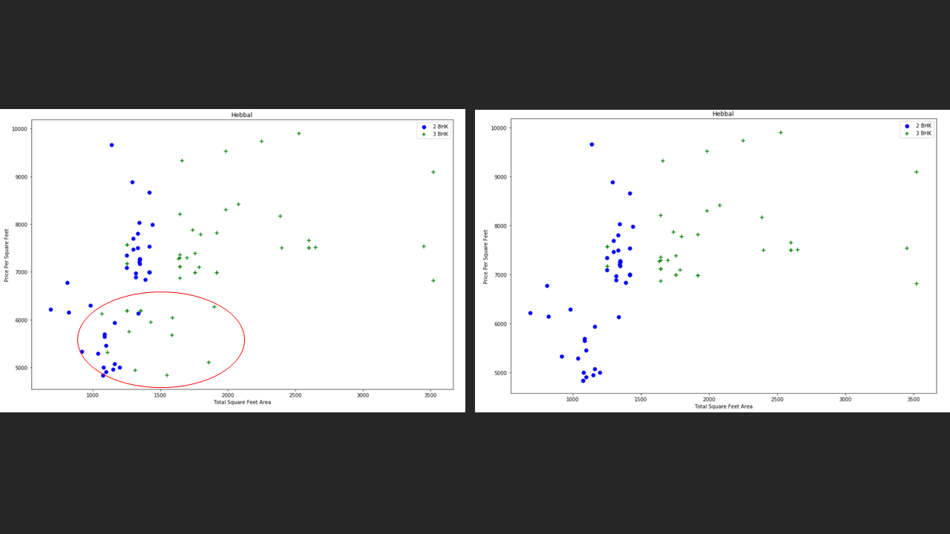

In [41]:

**import** matplotlib

matplotlib**.**rcParams["figure.figsize"] **=** (20,10)

plt**.**hist(df8**.**price_per_sqft,rwidth**=**0.8)

plt**.**xlabel("Price Per Square Feet")

plt**.**ylabel("Count")

Out[41]:

Text(0, 0.5, 'Count')

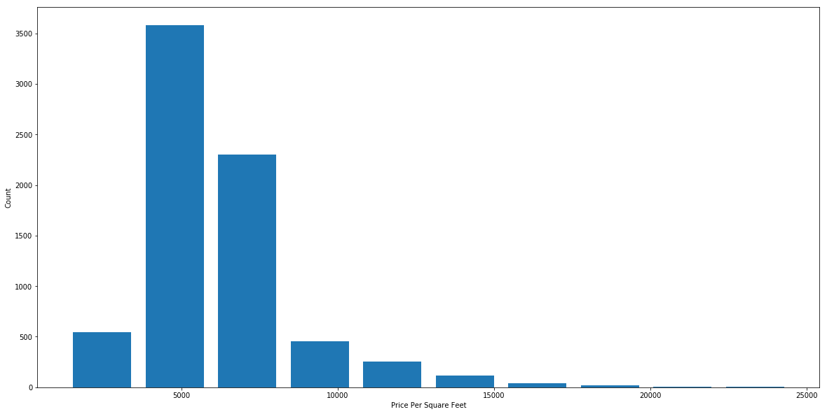

## **Outlier Removal Using Bathrooms Feature**

In [42]:

df8**.**bath**.**unique()

Out[42]:

array([ 4., 3., 2., 5., 8., 1., 6., 7., 9., 12., 16., 13.])

In [43]:

plt**.**hist(df8**.**bath,rwidth**=**0.8)

plt**.**xlabel("Number of bathrooms")

plt**.**ylabel("Count")

Out[43]:

Text(0, 0.5, 'Count')

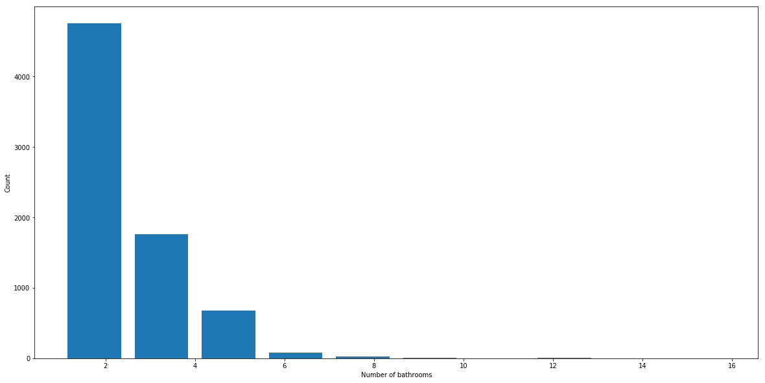

In [44]:

Out[44]:

|  | **location** | **size** | **total_sqft** | **bath** | **price** | **bhk** | **price_per_sqft** |
| --- | --- | --- | --- | --- | --- | --- | --- |
| **5277** | Neeladri Nagar | 10 BHK | 4000.0 | 12.0 | 160.0 | 10 | 4000.000000 |
| **8483** | other | 10 BHK | 12000.0 | 12.0 | 525.0 | 10 | 4375.000000 |
| **8572** | other | 16 BHK | 10000.0 | 16.0 | 550.0 | 16 | 5500.000000 |
| **9306** | other | 11 BHK | 6000.0 | 12.0 | 150.0 | 11 | 2500.000000 |
| **9637** | other | 13 BHK | 5425.0 | 13.0 | 275.0 | 13 | 5069.124424 |

**It is unusual to have 2 more bathrooms than number of bedrooms in a home**

In [45]:

df8[df8**.**bath**>**df8**.**bhk**+**2]

Out[45]:

|  | **location** | **size** | **total_sqft** | **bath** | **price** | **bhk** | **price_per_sqft** |
| --- | --- | --- | --- | --- | --- | --- | --- |
| **1626** | Chikkabanavar | 4 Bedroom | 2460.0 | 7.0 | 80.0 | 4 | 3252.032520 |
| **5238** | Nagasandra | 4 Bedroom | 7000.0 | 8.0 | 450.0 | 4 | 6428.571429 |
| **6711** | Thanisandra | 3 BHK | 1806.0 | 6.0 | 116.0 | 3 | 6423.034330 |
| **8408** | other | 6 BHK | 11338.0 | 9.0 | 1000.0 | 6 | 8819.897689 |

**Again the business manager has a conversation with you (i.e. a data scientist) that if you have 4 bedroom home and even if you have bathroom in all 4 rooms plus one guest bathroom, you will have total bath = total bed + 1 max. Anything above that is an outlier or a data error and can be removed**

In [46]:

df9 **=** df8[df8**.**bath**<**df8**.**bhk**+**2]

df9**.**shape

Out[46]:

(7239, 7)

In [47]:

df9**.**head(2)

## **Use K Fold cross validation to measure accuracy of our LinearRegression model**

In [59]:

**from** sklearn.model_selection **import** ShuffleSplit

**from** sklearn.model_selection **import** cross_val_score

cv **=** ShuffleSplit(n_splits**=**5, test_size**=**0.2, random_state**=**0)

cross_val_score(LinearRegression(), X, y, cv**=**cv)

Out[59]:

array([0.82702546, 0.86027005, 0.85322178, 0.8436466 , 0.85481502])

**We can see that in 5 iterations we get a score above 80% all the time. This is pretty good but we want to test few other algorithms for regression to see if we can get even better score. We will use GridSearchCV for this purpose**

## **Find best model using GridSearchCV**

In [60]:

**from** sklearn.model_selection **import** GridSearchCV

**from** sklearn.linear_model **import** Lasso

**from** sklearn.tree **import** DecisionTreeRegressor

**def** find_best_model_using_gridsearchcv(X,y):

algos **=** {

'linear_regression' : {

'model': LinearRegression(),

'params': {

'normalize': [**True**, **False**]

}

},

'lasso': {

'model': Lasso(),

'params': {

'alpha': [1,2],

'selection': ['random', 'cyclic']

}

},

'decision_tree': {

'model': DecisionTreeRegressor(),

'params': {

'criterion' : ['mse','friedman_mse'],

'splitter': ['best','random']

}

}

}

scores **=** []

cv **=** ShuffleSplit(n_splits**=**5, test_size**=**0.2, random_state**=**0)

**for** algo_name, config **in** algos**.**items():

gs **=** GridSearchCV(config['model'], config['params'], cv**=**cv, return_train_score**=False**)

gs**.**fit(X,y)

scores**.**append({

'model': algo_name,

'best_score': gs**.**best_score_,

'best_params': gs**.**best_params_

})

**return** pd**.**DataFrame(scores,columns**=**['model','best_score','best_params'])

find_best_model_using_gridsearchcv(X,y)

Out[60]:

|  | **model** | **best_score** | **best_params** |
| --- | --- | --- | --- |
| **0** | linear_regression | 0.847796 | {'normalize': False} |
| **1** | lasso | 0.726738 | {'alpha': 2, 'selection': 'cyclic'} |
| **2** | decision_tree | 0.716064 | {'criterion': 'friedman_mse', 'splitter': 'best'} |

**Based on above results we can say that LinearRegression gives the best score. Hence we will use that.**

## **Test the model for few properties**

In [61]:

**def** predict_price(location,sqft,bath,bhk):

loc_index **=** np**.**where(X**.**columns**==**location)[0][0]

x **=** np**.**zeros(len(X**.**columns))

x[0] **=** sqft

x[1] **=** bath

x[2] **=** bhk

**if** loc_index **>=** 0:

x[loc_index] **=** 1

**return** lr_clf**.**predict([x])[0]

In [62]:

predict_price('1st Phase JP Nagar',1000, 2, 2)

Out[62]:

83.86570258311222

In [63]:

predict_price('1st Phase JP Nagar',1000, 3, 3)

Out[63]:

86.08062284985995

In [64]:

predict_price('Indira Nagar',1000, 2, 2)

Out[64]:

193.31197733179556

In [65]:

predict_price('Indira Nagar',1000, 3, 3)

Out[65]:

195.52689759854331

## **Export the tested model to a pickle file**

In [66]:

**import** pickle

**with** open('banglore_home_prices_model.pickle','wb') **as** f:

pickle**.**dump(lr_clf,f)

## **Export location and column information to a file that will be useful later on in our prediction application**

In [67]:

**import** json

columns **=** {

'data_columns' : [col**.**lower() **for** col **in** X**.**columns]

}

**with** open("columns.json","w") **as** f:

f**.**write(json**.**dumps(columns))