BSSE FINAL PROJECT
<Requirements Specification>

DevConnect: Empowering Developers' Network



Project Advisor
Saira Latif

Presented by:
Group ID: F23SE104

Student Reg# Student Name

L1S20BSSE0011 ABDULLAH ZAHID
L1S20BSSE0016 AHSAN AHMAD
L1F19BSSE0248 UMAIR SHOKAT

Faculty of Information Technology

University of Central Punjab
Software Requirements Specification
Version 1.1

DevConnect: Empowering Developers' Network
Advisor: Saira Latif
Group:
Member Name | Primary Responsibility
Abdullah Zahid | nfrs, Intro, Discription, Features, Other Requirements
Ahsan Ahmad | Diagrams
Umair Shoqat | Diagrams

Table of Contents
Table of Contents i
Revision History ii
1. Introduction and Background 1
1.1 Product (Problem Statement) 1
1.2 Background 1
1.3 Scope 1
1.4 Objective(s)/Aim(s)/Target(s) 1
1.5 Challenges 1
1.6 Learning Outcomes 2
1.7 Nature of End Product 2
1.8 Completeness Criteria 2
1.9 Business Goals 2
1.10 Related Work/ Literature Survey/ Literature Review 2
1.11 Document Conventions 3
2. Overall Description 4
2.1 Product Features 4
2.2 User Classes and Characteristics 5
2.3 Operating Environment 5
2.4 Design and Implementation Constraints 6
2.5 Assumptions and Dependencies 7
3. Functional Requirements 8
3.1 Name of Use-Case 1 9
3.2 Name of Use-Case 2 (and so on) 10
3.3 Requirements Analysis and Modeling 13
4. Nonfunctional Requirements 22
4.1 Performance Requirements 22
4.2 Safety Requirements 23
4.3 Security Requirements 24
4.4 Additional Software Quality Attributes 25
5. Other Requirements 26
6. Revised Project Plan 27
7. References 29
Appendix A: Glossary 30
Appendix B: IV & V Report 32

Abstract

In the ever-evolving landscape of software engineering, our project titled "DevConnect" emerges as a dynamic solution to address the challenges that developers face in their daily pursuits. DevConnect is designed as a comprehensive platform that fosters collaboration, learning, and professional growth within the developer community. This project seeks to resolve the persistent issues of personalized assistance, fragmented learning resources, and limited networking opportunities that developers encounter.

By leveraging the knowledge areas of machine learning, web development, and database management, DevConnect offers a feature-rich environment where developers can connect with like-minded peers, seek guidance from experienced mentors, showcase their skills and projects, and discover tailored learning resources. The platform employs sophisticated content recommendation algorithms, ensuring that users receive content and answers that align with their unique interests and needs.

Our project's significance lies in its potential to transform the developer community, promoting a culture of collaboration and knowledge sharing. DevConnect aims to bridge the gap between novice and experienced developers, facilitating skill development and career advancement for all. By the conclusion of this project, we anticipate a thriving online ecosystem that empowers developers to connect, learn, and excel in their professional journeys.

Introduction and Background

Product (Problem Statement)
DevConnect is a comprehensive software platform designed to address the challenges faced by developers within the ever-evolving software engineering domain. The problem statement revolves around the fragmentation of developer resources, the lack of personalized assistance, and limited networking opportunities for developers worldwide.

Background
The field of software engineering is marked by continuous innovation and rapid technological advancements. Developers often find themselves inundated with vast amounts of information, ranging from coding queries to learning resources. Existing platforms may not effectively cater to the individual needs and personalized growth of developers. DevConnect is conceived as a solution to these challenges, creating a platform where developers can collaborate, learn, and showcase their skills.

Scope
This SRS document outlines the requirements for the development of the DevConnect platform, encompassing its core functionalities, user interactions, and system behavior.

Objective(s)/Aim(s)/Target(s)
The objectives of the DevConnect project are as follows:

- To create a dynamic platform where developers can connect and collaborate.
- To provide personalized learning resources and assistance.
- To facilitate mentorship and skill development.
- To offer a space for developers to showcase their projects.
- To streamline the job search process for developers.

Challenges
The challenges in developing DevConnect include:

- Implementing robust content recommendation algorithms.
- Ensuring data security and privacy.
- Balancing a dynamic user interface with scalability.
- Encouraging active user participation and engagement.

Learning Outcomes
The project aims to enhance learning outcomes by offering a rich ecosystem for developers to interact, learn, and collaborate, leading to skill enhancement and career growth.

Nature of End Product
The end product will be a web-based platform accessible to developers worldwide, offering a range of features to support their personal and professional development.

Completeness Criteria
The project will be considered complete when all core functionalities are implemented and tested successfully, user feedback is positive, and the system meets the specified performance and security criteria.

Business Goals
DevConnect aligns with several business goals, including:

- Enhancing user engagement and retention.
- Attracting potential recruiters and job opportunities.
- Building a thriving developer community.
- Providing value-added services to users.

Related Work

Features | DevConnect | Stack Overflow | GitHub | StudyPool | LinkedIn
User Profiles | ✔️ | ✔️ | ✔️ | ✔️ | ✔️
Question and Answer System | ✔️ | ✔️ | ❌ | ❌ | ❌
Personalized Feeds | ✔️ | ❌ | ❌ | ❌ | ✔️
Hire and Real-Time Chat | ✔️ | ❌ | ❌ | ❌ | ❌
Job Postings | ✔️ | ❌ | ❌ | ❌ | ✔️
Portfolio Showcase | ✔️ | ❌ | ❌ | ❌ | ✔️
Reputation System | ✔️ | ✔️ | ❌ | ✔️ | ✔️
Skill Endorsements | ✔️ | ❌ | ❌ | ❌ | ✔️
Community Forums | ✔️ | ✔️ | ❌ | ❌ | ❌
Collaborative Coding w.r.t problem solving | ✔️ | ✔️ | ❌ | ❌ | ❌

Legend:
✔️ - Feature present in the system
❌ - Feature absent in the system

Comparison with Other Systems:

Stack Overflow: Both DevConnect and Stack Overflow have user profiles, question and answer systems, and reputation systems. However, DevConnect offers additional features like personalized feeds, teacher-hire with real-time chat, job postings, portfolio showcase, skill endorsements, and community forums, making it more diverse and collaborative.

GitHub: DevConnect is primarily a developer community and learning platform, while GitHub is a version control platform for hosting and collaborating on code repositories. GitHub lacks features like personalized feeds, teacher-hire, job postings, and community forums found in DevConnect.

StudyPool: StudyPool is an online tutoring platform, and its focus is on connecting students with tutors for academic assistance. It lacks features like personalized feeds, community forums, job postings, and collaborative coding present in DevConnect.

LinkedIn: LinkedIn is a professional networking platform focused on connecting professionals for career-related purposes. It shares some features with DevConnect, such as user profiles, job postings, and skill endorsements. However, DevConnect offers additional features like personalized feeds, question and answer system, portfolio showcase, teacher-hire, and collaborative coding, which differentiate it as a specialized platform for developers.

DevConnect continues to stand out as a comprehensive developer-centric platform with unique and interactive features that foster collaboration, learning, and networking within the developer community. While other platforms like Stack Overflow, GitHub, StudyPool, and LinkedIn serve different purposes, DevConnect focuses specifically on empowering developers and offering a holistic environment for their professional growth and interactions.

Document Conventions
This SRS document follows standard typographical conventions, such as using headings for section titles and bullet points for listing items. However, the writing style is Times. Moreover, ✔️” – represents feature present in the system and “❌” - represents feature absent in the system in the heading 1.10. Also, the paragraph font size is 12px. Sub-heading font size is 14px and heading font size is 18px.

Overall Description

Product Features
DevConnect encompasses a range of major features, including but not limited to:

- User Profiles: Developers can create detailed profiles showcasing their skills, experience, and portfolios.

- Q&A Module: Users can post coding-related questions and receive answers from the developer community.

- Content Recommendation: A personalized recommendation system suggests learning resources, articles, and questions to users based on their interests and activities.

- Mentorship and Teacher-Hire: Users can seek mentorship and hire experienced developers for one-on-one guidance.

- Job Posting and Matching: Recruiters can post job openings, and developers receive job recommendations based on their skills and preferences.

- Collaborative Feeds: A dynamic feed displays content and updates relevant to a user's interests.

- Recognition and Rewards: Users earn points for active participation and quality contributions.

User Classes and Characteristics
1. Developers

Characteristics:
- Diverse technical backgrounds, from novices to experts.
- Varying levels of experience in software development.
- Active participation in discussions, knowledge sharing, and learning.
- Regularly post questions, answers, and contribute to the community.
Requirements:
- Access to a personalized feed of content and questions.
- Ability to create user profiles showcasing their skills and portfolios.
- Post questions and answers in various formats (text, image, video).
- Earn points and badges for contributions.

2. Mentors and Teachers

Characteristics:
- Experienced developers with a strong desire to mentor others.
- Technical expertise in specific areas of software development.
- Willingness to provide guidance and support to less experienced developers.
Requirements:
- Ability to offer mentorship services.
- Set availability for mentoring sessions.
- Receive payments for mentorship services.

3. Recruiters

Characteristics:
- Represent companies or individuals seeking to hire developers.
- HR professionals or hiring managers.
- Focused on identifying suitable candidates for job openings.
Requirements:
- Post job openings and descriptions.
- Search and filter developer profiles.
- Contact potential candidates.

4. Administrators

Characteristics:
- System administrators responsible for platform maintenance.
- Technical expertise in system administration.
- Monitor and ensure platform security and stability.
Requirements:
- Manage user accounts and permissions.
- Implement security measures.
- Monitor system health and performance.

5. Moderators

Characteristics:
- Experienced and trusted users within the community.
- Responsible for ensuring content quality and adherence to guidelines.
- Actively report and address inappropriate content.
- Requirements:
- Review and moderate user-generated content.
- Enforce community guidelines.
- Maintain a safe and respectful environment.

These user classes have distinct characteristics and play various roles within the DevConnect ecosystem. The platform's success relies on meeting the needs and expectations of each user class, fostering collaboration and knowledge sharing among developers, and providing value to recruiters and mentors.

Operating Environment
DevConnect operates in a web-based environment:

- Hardware: Standard web-browsing devices, including desktops, laptops, tablets, and smartphones.

- Operating Systems: Compatibility with major operating systems like Windows, macOS, Android, and iOS.

- Browsers: Support for popular web browsers such as Chrome, Firefox, Safari, and Edge.

- Software Components: Integration with web server software, database management systems, and security tools.

Design and Implementation Constraints
1. Corporate and Regulatory Policies

- Constraints: DevConnect must adhere to corporate and regulatory policies regarding data privacy, security, and user rights. Compliance with industry-specific regulations may impose limitations on data handling and storage.

- Impact: The platform's design and implementation must incorporate robust security measures, data encryption, and strict access controls to comply with these policies.

2. Hardware Limitations

- Constraints: The platform's performance may be limited by the hardware capabilities of users' devices, such as processing power and memory. Mobile devices, in particular, may have resource constraints.

- Impact: DevConnect's design should optimize resource usage, and its user interface should be responsive across a range of devices and screen sizes.

3. Interfaces to Other Applications

- Constraints: DevConnect may need to integrate with external applications or services, such as payment gateways, content recommendation engines, and social media platforms.

- Impact: Compatibility and API availability must be considered during development to ensure seamless interactions with these external services.

4. Specific Technologies and Tools

- Constraints: DevConnect development may be constrained by the choice of specific technologies, frameworks, and tools, especially if they are mandated by the project's stakeholders or organization.

- Impact: Development teams must work within the constraints of the chosen technology stack, potentially limiting flexibility in tool selection.

5. Database Management Systems

- Constraints: The choice of the database management system (e.g., MongoDB) may impose constraints on data storage and retrieval.

- Impact: Data models and queries must be designed to align with the selected database system, potentially affecting the schema and data storage structure.

6. Security Considerations

- Constraints: Security is a paramount concern, imposing constraints on data handling, authentication, authorization, and encryption.

- Impact: Developers must implement robust security measures, including protection against SQL injection, cross-site scripting (XSS), and other common vulnerabilities.

7. Design Conventions and Programming Standards

- Constraints: If the customer's organization has specific design conventions or programming standards, DevConnect development must align with these guidelines.

- Impact: Development teams must follow these conventions, potentially affecting code structure, naming conventions, and code review processes.

Meeting these constraints is essential to ensure the successful design and implementation of DevConnect while aligning with corporate policies, regulatory requirements, and user expectations.

Assumptions and Dependencies
Assumptions:

- User Data Accuracy: It is assumed that users will provide accurate and truthful information when creating their profiles, including skills, experience, and portfolio details.

- Community Guidelines Adherence: Users are assumed to adhere to the community guidelines and standards, promoting respectful and constructive interactions within the platform.

- External Services Availability: DevConnect assumes that third-party services, such as content recommendation engines and payment gateways, will be available and reliable for integration.

- Server and Hosting Reliability: The project assumes that the hosting and server infrastructure will be reliable and available, minimizing downtime.

Dependencies:

- Third-Party APIs: DevConnect depends on third-party APIs for features like content recommendations and payment processing. Any changes or discontinuation of these APIs could impact the platform's functionality.

- External Libraries and Frameworks: The project relies on external libraries and frameworks as part of the chosen technology stack (e.g., React, Node.js). Updates or changes to these libraries may require adjustments in the codebase.

- User-Generated Content: The platform's activity and engagement depend on user-generated content, including questions, answers, and discussions. A lack of user contributions could affect the platform's vibrancy.

- Data Storage and Database Systems: DevConnect depends on data storage and database management systems for user profiles, content, and interactions. Any issues with these systems could impact data availability and performance.

- These assumptions and dependencies should be considered throughout the project's development lifecycle, as changes or inaccuracies in these factors may influence project outcomes and timelines.

Functional Requirements
- User Registration and Profile Creation
- Post a Coding Question
- Recognize Contributors
- Post a Job Opening
- Hire and Chat
- View Personalized Feed
3.1 User Registration
Identifier |  | User Registration
Purpose |  | To allow users to create accounts on the platform.
Priority |  | High
Pre-conditions |  | User accesses the registration page.
Post-conditions |  | User has a registered account.
Typical Course of Action
S# | Actor Action |  | System Response
1 | User navigates to the registration page. |  | System displays the registration form.
2 | User enters required registration details (e.g., username, email, password). |  | System validates and stores user information.
3 | User submits the registration form. |  | System creates a new user account.
Alternate Course of Action
S# | Actor Action |  | System Response
1 | User tries to register with an existing email or username. |  | System displays an error message.
2 | User enters invalid registration information. |  | System prompts the user to correct the information.
Table 1: UC-1

Profile Creation
Identifier |  | Profile Creation
Purpose |  | To enable users to create and customize their developer profiles.
Priority |  | High
Pre-conditions |  | User is registered and logged in.
Post-conditions |  | User has a personalized developer profile.
Typical Course of Action
S# | Actor Action |  | System Response
1 | User navigates to their profile settings.. |  | System displays profile editing options.
2 | User adds or updates profile information (e.g., skills, experience, portfolio). |  | System saves the changes to the user's profile..
Alternate Course of Action
S# | Actor Action |  | System Response
1 | User attempts to edit the profile without being logged in. |  | System prompts the user to log in.
2 | User enters incomplete or invalid information. |  | System displays error messages and asks the user to correct the information.
Table 2: UC-2
  - Post a Coding Question
Identifier |  | Post a Coding Question
Purpose |  | To enable users to post coding-related questions.
Priority |  | High
Pre-conditions |  | User is logged in.
Post-conditions |  | The user's question is posted on the platform.
Typical Course of Action
S# | Actor Action |  | System Response
1 | User navigates to the question posting section. |  | System displays the question posting interface.
2 | User enters the question's title, description, and tags. |  | System validates the information.
3 | User submits the question. |  | System adds the question to the platform's question database..
4 | System notifies the user that the question has been posted successfully.
Alternate Course of Action
S# | Actor Action |  | System Response
1 | User attempts to post a question without being logged in. |  | System prompts the user to log in.
2 | User enters incomplete or invalid information. |  | System displays error messages and asks the user to provide the required details.
Table 3: UC-3
  - Recognize Contributors
Identifier |  | Recognize Contributors
Purpose |  | To recognize and reward users for their contributions to the platform.
Priority |  | Medium
Pre-conditions |  | User contributes to the platform (e.g., posts questions, provides answers).
Post-conditions |  | User receives recognition and rewards..
Typical Course of Action
S# | Actor Action |  | System Response
1 | User actively contributes to the platform (e.g., posts high-quality content, helps others). |  | System tracks user contributions.
2 | System periodically evaluates user contributions. |  | System calculates recognition points and rewards.
3 | User receives notifications or badges for their contributions. |  | User profile displays earned recognition and rewards.
Table 4: UC-4
  - Post a Job Opening
Identifier |  | Post a Job Opening
Purpose |  | To enable recruiters to post job openings on the platform.
Priority |  | High
Pre-conditions |  | Recruiter is logged in.
Post-conditions |  | The job opening is posted on the platform
Typical Course of Action
S# | Actor Action |  | System Response
1 | Recruiter navigates to the job posting section. |  | System displays the job posting interface..
2 | Recruiter enters job details (e.g., title, description, requirements). |  | System validates the information.
3 | Recruiter submits the job posting. |  | System adds the job opening to the platform's job listings.
4 | System notifies the recruiter that the job has been posted successfully.
Alternate Course of Action
S# | Actor Action |  | System Response
1 | Recruiter attempts to post a job without being logged in. |  | System prompts the recruiter to log in.
2 | Recruiter enters incomplete or invalid job information.. |  | System displays error messages and asks the recruiter to provide the required details.
Table 5: UC-5
  - Teacher Hire and Chat
Identifier |  | Hire a Teacher and Chat
Purpose |  | To allow users to hire experienced developers for mentorship and have real-time chat sessions.
Priority |  | High
Pre-conditions |  | User is logged in.
Post-conditions |  | User hires a teacher and can initiate a chat session.
Typical Course of Action
S# | Actor Action |  | System Response
1 | User searches for available teachers. |  | System displays a list of available teachers
2 | User selects a teacher and initiates a mentorship request. |  | System notifies the teacher and awaits their response.
3 | Teacher accepts the request.. |  | System establishes a real-time chat session between the user and teacher.
Alternate Course of Action
S# | Actor Action |  | System Response
1 | User attempts to initiate a chat without being logged in. |  | System prompts the user to log in.
2 | Teacher declines the mentorship request. |  | System notifies the user that the request was declined.
Table 6: UC-6
  - Personalized Feeds
Identifier |  | Personalized Feeds
Purpose |  | To present users with personalized feeds of content based on their interests and activities.
Priority |  | Medium
Pre-conditions |  | User is logged in
Post-conditions |  | User views their personalized feed.
Typical Course of Action
S# | Actor Action |  | System Response
1 | User navigates to the personalized feed section. |  | System retrieves and displays relevant content based on user interests.
2 | User scrolls through the feed. |  | System
Table 7: UC-7
3.3 Requirements Analysis and Modeling
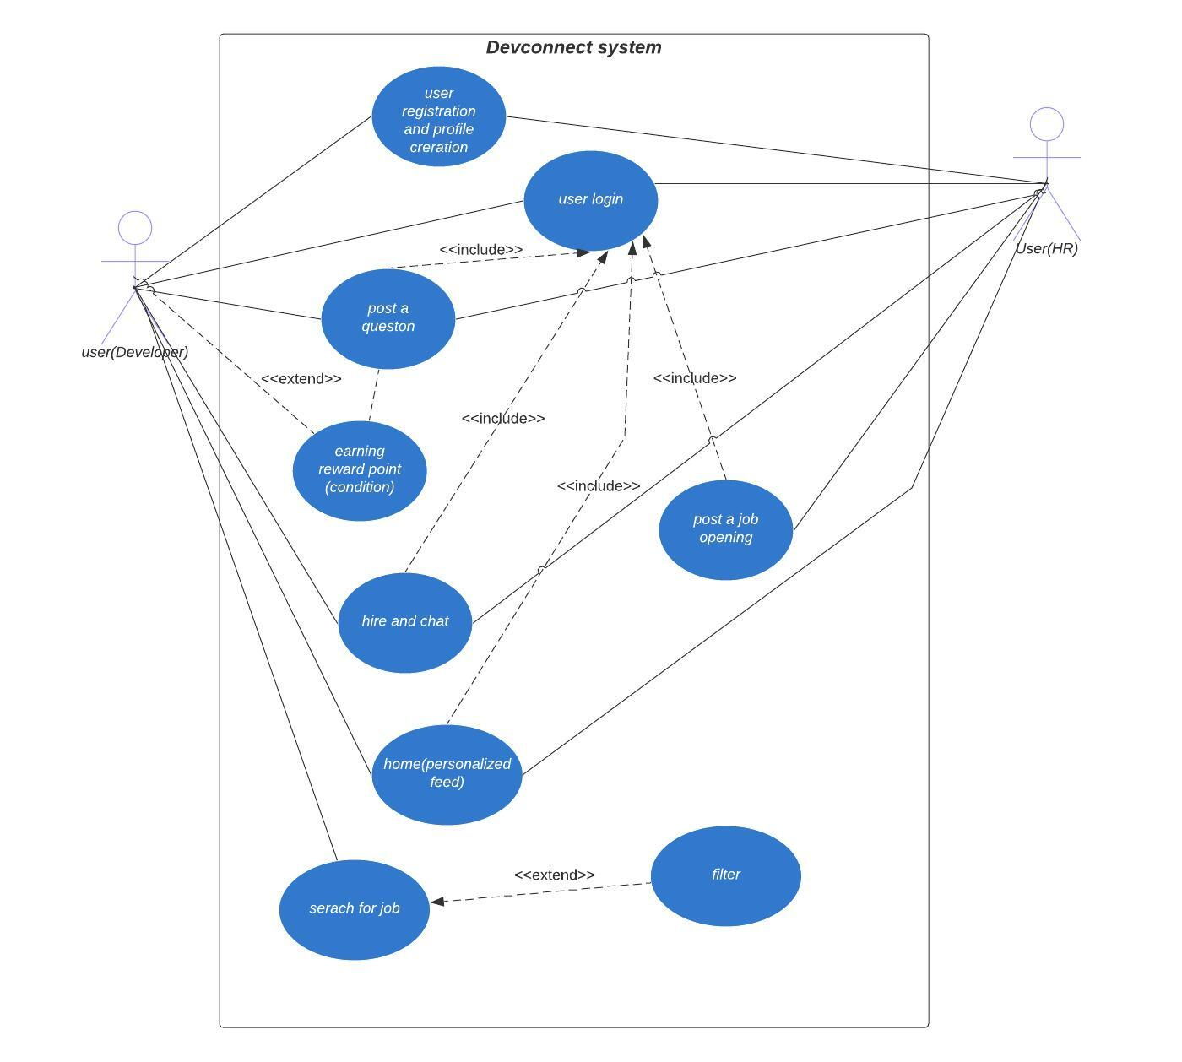
USE CASE DIAGRAM

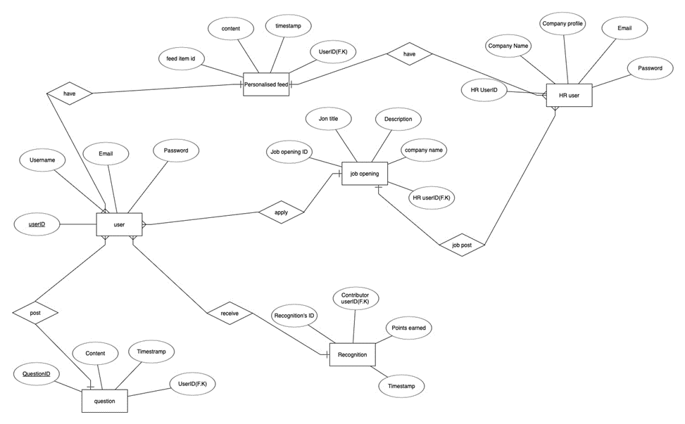

ERD-DIAGRAM

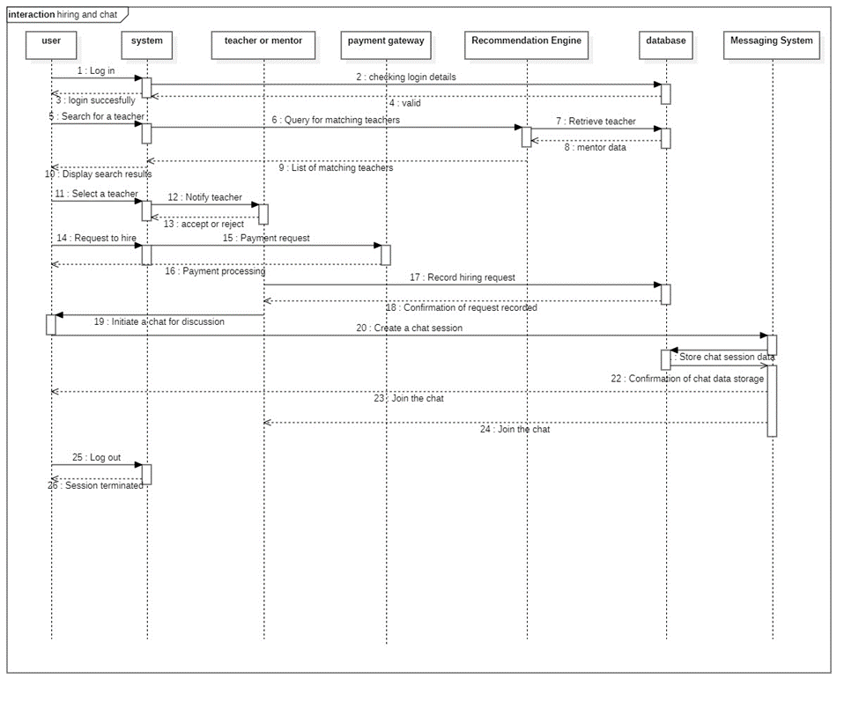

Sequence#01 (Hiring and chat)

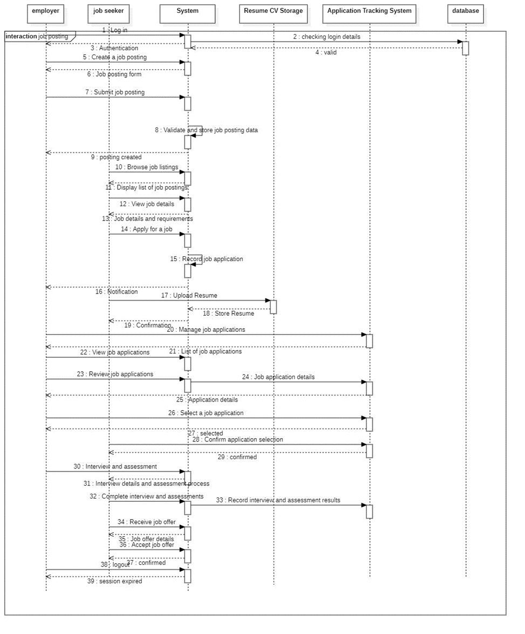

Sequence#02 (Job Posting)

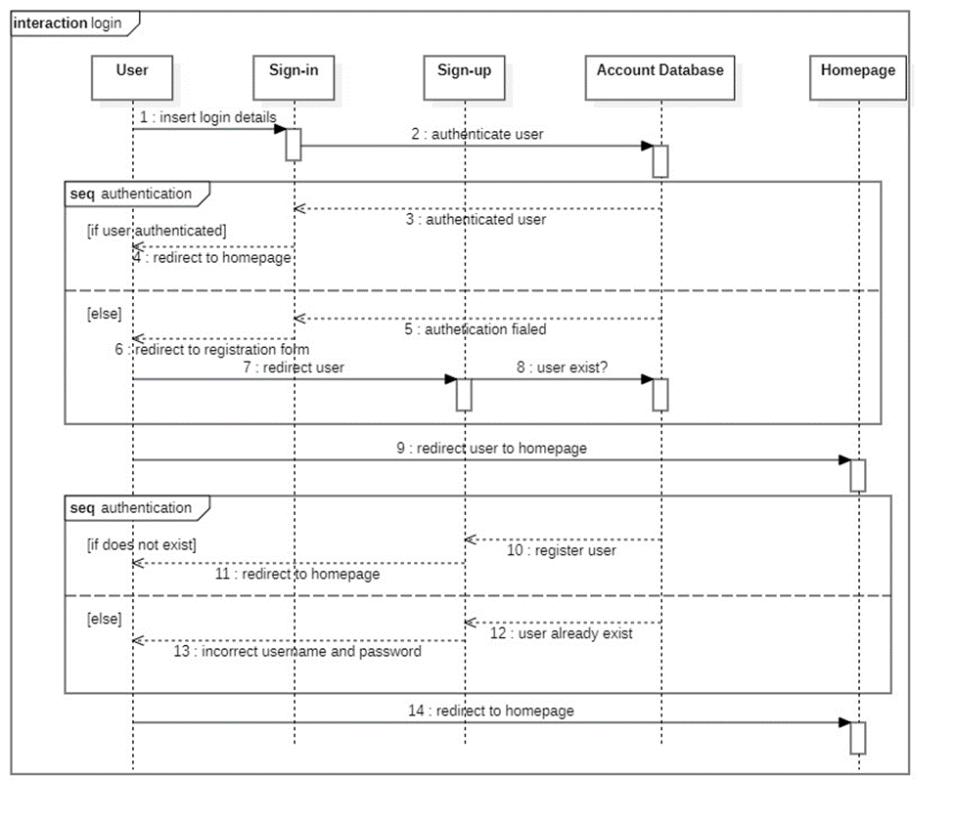

Sequence#03 (Login)

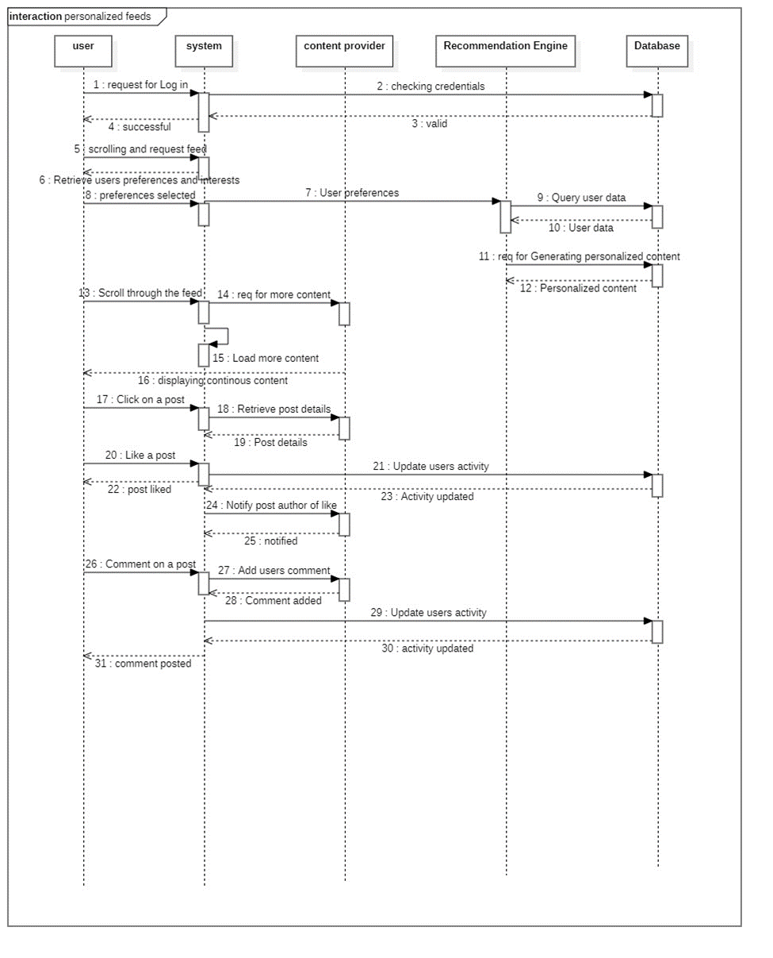

Sequence #04 (Personalized feeds)

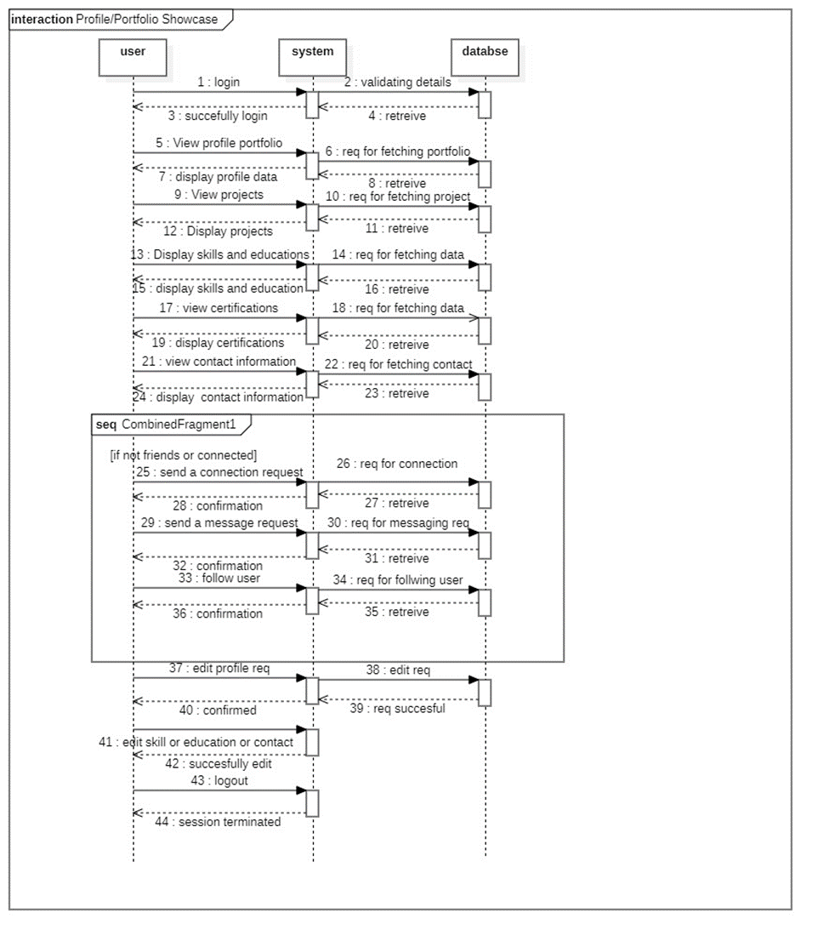

Sequence #05 (Profile Showcase)

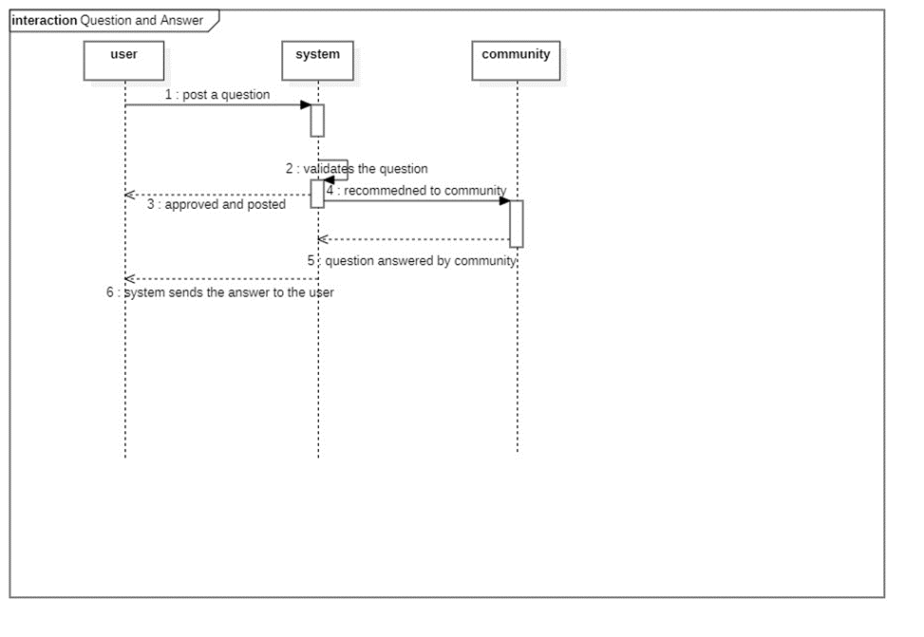

Sequence #06 (Question and Answers)

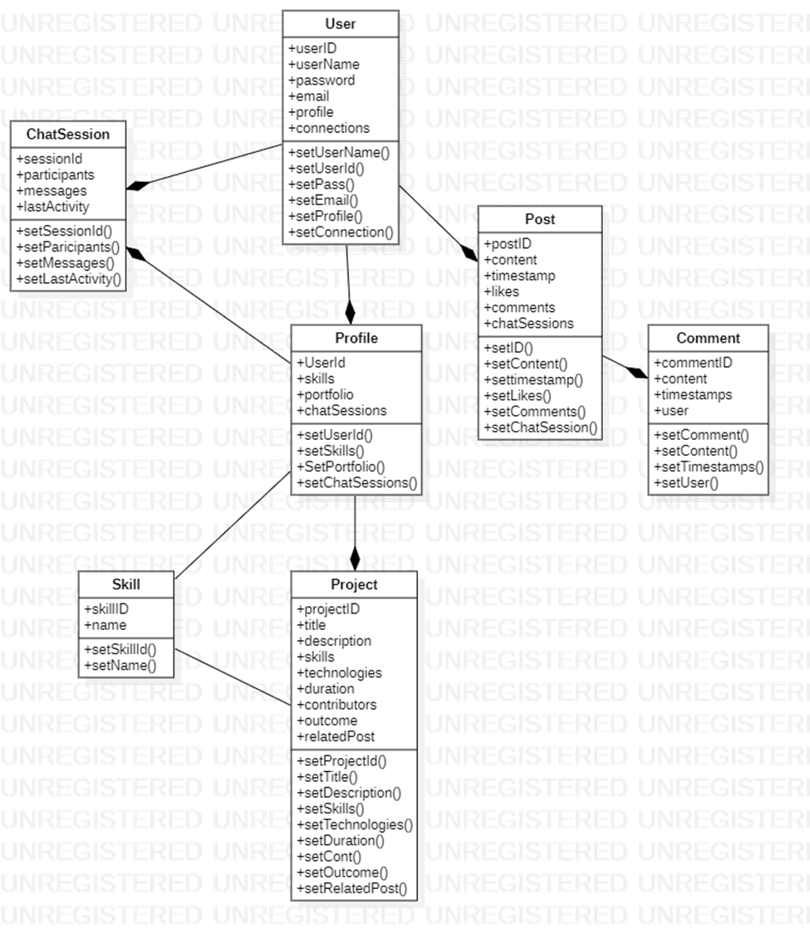

Class Diagram

Nonfunctional Requirements

Performance Requirements
1. Response Time:

- Requirement: The system must respond to user actions (e.g., page loading, content loading, search queries) within 2 seconds under normal traffic conditions.

- Rationale: A fast response time enhances user experience and engagement. Users are more likely to stay and interact with the platform when actions are quickly executed.

2. Scalability:

- Requirement: DevConnect must be designed to handle a minimum of 10,000 concurrent users without significant performance degradation.

- Rationale: As the user base grows, the platform should remain responsive and maintain optimal performance. Scalability ensures the platform can accommodate increasing traffic.

3. Database Query Performance:

- Requirement: Database queries for user profiles, content recommendations, and search functions must return results within 1 second, even when the database contains millions of records.

- Rationale: Efficient database query performance is crucial for providing personalized recommendations and search results in a timely manner.

4. Content Delivery Speed:

- Requirement: Images and videos must load within 3 seconds on both desktop and mobile devices.

- Rationale: Fast content delivery enhances the viewing experience and encourages users to engage with multimedia content.

5. Error Handling:

- Requirement: Error messages and notifications (e.g., for failed login attempts or payment processing issues) must be displayed within 1 second of the error occurrence.

- Rationale: Prompt error handling provides users with immediate feedback and enhances the platform's usability.

6. Concurrent User Sessions:

- Requirement: Each user should be able to maintain multiple concurrent sessions (e.g., open tabs or devices) without experiencing session conflicts or data loss.

- Rationale: Developers may engage with DevConnect from different devices or multiple browser tabs simultaneously. The platform should handle these scenarios seamlessly.

7. Resource Usage Optimization:

- Requirement: DevConnect should optimize resource usage (CPU and memory) on the user's device to ensure the platform runs smoothly without causing excessive load.

- Rationale: Efficient resource usage contributes to a positive user experience and minimizes strain on users' devices.

These performance requirements are crucial to ensure that DevConnect offers a responsive and reliable user experience, even under heavy traffic and usage conditions. They guide design choices and help in achieving the desired performance levels for the platform.

Safety Requirements
1. Data Privacy and Protection:

- Requirement: DevConnect must implement robust data privacy measures, including encryption of sensitive user data, to prevent unauthorized access or data breaches.

- Safeguards: User data, such as personal information and payment details, must be encrypted both in transit and at rest. Access controls and authentication mechanisms should be in place to restrict access to authorized personnel only.

2. User-Generated Content Moderation:

- Requirement: DevConnect should employ content moderation mechanisms to prevent the posting of offensive, abusive, or harmful content.

- Safeguards: Automated content filters and reporting mechanisms should be implemented to detect and remove inappropriate content. Human moderators may also be appointed to review and act on reported content.

3. Compliance with Data Protection Regulations:

- Requirement: DevConnect must comply with relevant data protection regulations, such as GDPR (General Data Protection Regulation), CCPA (California Consumer Privacy Act), and others applicable to the platform's user base.

- Safeguards: User data handling, consent mechanisms, and data deletion processes should align with the requirements of applicable data protection regulations. Users must be provided with clear information about data usage and their rights.

4. User Safety Reporting:

- Requirement: DevConnect should provide users with a clear and accessible mechanism for reporting safety concerns, including harmful content or inappropriate behavior.

- Safeguards: Reported safety concerns should be addressed promptly, and appropriate actions, such as content removal or user warnings, should be taken.

5. Compliance Certification:

- Requirement: DevConnect should seek and obtain relevant safety and data protection certifications, if applicable to the platform's target regions and user base.
- Safeguards: The platform should undergo audits and assessments to ensure compliance with safety and data protection standards. Certifications, if achieved, should be prominently displayed to build user trust.

These safety requirements aim to protect user data, prevent harmful content, and ensure compliance with data protection regulations, ultimately fostering a safe and secure environment for all users of the platform.

Security Requirements
1. User Identity Authentication:

- Requirement: Users must authenticate their identity using secure login credentials (e.g., username and password) or multi-factor authentication (MFA) before accessing the platform.

- Rationale: User authentication ensures that only authorized individuals can access the platform and their data, enhancing security.

2. Password Security:

- Requirement: DevConnect should enforce password security measures, including minimum length, complexity, and expiration policies.

- Rationale: Strong password policies reduce the risk of unauthorized access due to weak or compromised passwords.

3. Data Encryption:

- Requirement: User data, including personal information, payment details, and communications, must be encrypted during transmission (HTTPS) and storage (at rest).

- Rationale: Data encryption safeguards user information and communications from unauthorized access during transmission and storage.

4. Access Control:

- Requirement: Role-based access control (RBAC) should be implemented to ensure that users have access only to the features and data relevant to their roles and responsibilities.

- Rationale: Access control minimizes the risk of unauthorized access to sensitive data and functionality.

5. Security Auditing and Logging:

- Requirement: DevConnect should maintain comprehensive logs of system activities and access attempts for security auditing and monitoring purposes.

- Rationale: Security logs enable the detection of suspicious activities and assist in investigating security incidents.

6. Data Privacy Compliance:

- Requirement: The platform must comply with relevant data protection regulations, such as GDPR, CCPA, and others applicable to the user base.

- Rationale: Data privacy compliance safeguards user rights and data protection, enhancing trust in the platform.

7. Security Patch Management:

- Requirement: DevConnect should have a process in place for promptly applying security patches and updates to the underlying software stack to address known vulnerabilities.

- Rationale: Timely patch management helps protect the platform from known security vulnerabilities.

8. Secure Payment Processing:

- Requirement: Payment processing must adhere to Payment Card Industry Data Security Standard (PCI DSS) requirements if applicable.

- Rationale: Secure payment processing safeguards user payment details and prevents unauthorized access to financial information.

9. Security Certifications:

- Requirement: DevConnect should seek and obtain relevant security certifications, if applicable to the platform's target regions and user base.

- Rationale: Security certifications demonstrate the platform's commitment to security and may enhance user trust.

These security requirements are vital to protect user data, secure user accounts, and maintain a safe and trustworthy environment within DevConnect. They align with industry best practices and data protection regulations.

Additional Software Quality Attributes
1. Usability

- Attribute: DevConnect should be user-friendly and intuitive.

- Requirement: Usability testing should achieve a minimum score of 80 out of 100 on standardized usability evaluation scales such as the System Usability Scale (SUS).

2. Maintainability

- Attribute: DevConnect should be easy to maintain and update.

- Requirement: Code should be well-documented, and the development team should be able to make updates or bug fixes within 24 hours of identifying an issue.

3. Availability

- Attribute: DevConnect should be highly available.

- Requirement: The platform should have an uptime of 99.9%, with planned maintenance communicated to users in advance.

4. Robustness

- Attribute: DevConnect should be resilient to errors and unexpected inputs.

- Requirement: The system should gracefully handle unexpected errors, preventing system crashes or data corruption.

5. Interoperability

- Attribute: DevConnect should seamlessly integrate with external services and applications.

- Requirement: The platform should provide well-documented APIs and support industry-standard data exchange formats.

6. Portability

- Attribute: DevConnect should be accessible across various devices and platforms.

- Requirement: The platform should be compatible with major web browsers (e.g., Chrome, Firefox, Safari, Edge) and responsive across desktop and mobile devices
.
7. Testability

- Attribute: DevConnect should be easily testable to ensure functionality and performance.

- Requirement: The platform should support automated testing frameworks, and a suite of automated tests should cover critical functionalities.

8. Flexibility

- Attribute: DevConnect should be adaptable to changing user needs.

- Requirement: The system architecture should support the addition of new features and modules without major code restructuring.

These additional quality attributes reflect the desire to create a platform that not only meets functional and performance requirements but also provides a positive user experience and remains adaptable to future enhancements and changes.

Other Requirements
1. Database Requirements

- Requirement: DevConnect should use a relational database management system (RDBMS) to store user data and platform content.

- Rationale: An RDBMS provides structured data storage and efficient query capabilities, supporting the platform's functionality.

2. External API Integration

- Requirement: DevConnect should integrate with external APIs for features like content recommendations, payment processing, and social media sharing.

- Rationale: External API integration enhances platform functionality and user experience.

3. Legal Compliance

- Requirement: DevConnect must comply with all relevant local and international laws and regulations, including copyright, data protection, and accessibility standards.

- Rationale: Legal compliance is essential to avoid legal disputes and ensure ethical operation.

4. Internationalization

- Requirement: DevConnect should support multiple languages and internationalization features, allowing users from different regions to access and interact with the platform.

- Rationale: Internationalization broadens the platform's user base and global reach.

5. Reuse Objectives

- Requirement: DevConnect should follow best practices for code modularity and documentation to facilitate code reuse in future projects.

- Rationale: Code reuse can save development time and resources in future projects.

6. Data Backup and Recovery

- Requirement: Regular data backups should be performed, and a robust data recovery mechanism should be in place in case of data loss or system failures.

- Rationale: Data loss prevention and recovery are critical to maintain user trust and prevent service interruptions.

These other requirements ensure that DevConnect complies with legal standards, supports international users, facilitates code reuse, and maintains data integrity and accessibility.

Revised Project Plan

Summary: The project has made significant progress since the initial proposal. All key project phases have been initiated, and several milestones have been achieved on or ahead of schedule. This includes the successful completion of the project's requirements gathering and design phases.

Current Status:
Status: The project is currently ahead of schedule. This is primarily due to effective project planning and resource allocation.

Gantt Chart:

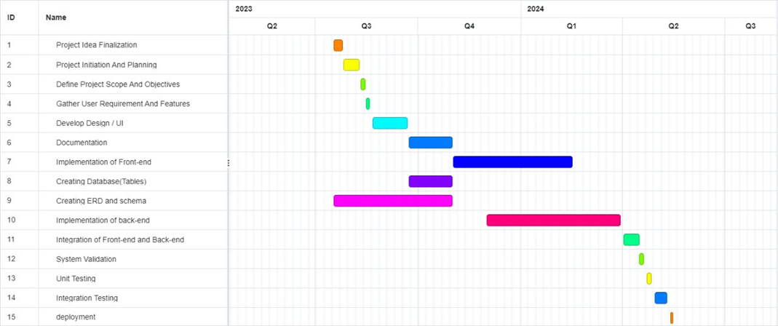

Updated Project Plan:
Revisions: The project plan has undergone minor revisions to adjust to the accelerated pace. These revisions include shorter development and testing cycles, enabling an earlier project completion date. Task dependencies have been carefully managed to maintain a coherent project flow.

Key Milestones:
Milestone 1 - Requirements Gathering (Completed): Completed on Aug 7, 2023. All project requirements have been documented and approved.
Milestone 2 - Design Phase (Completed): Completed on Aug 15, 2023. Detailed system design and architecture have been finalized.
Milestone 3 - Development Phase (Ongoing): Expected completion till deployment by April, 2024. Development work is proceeding as planned.

Risk Assessment:
Risk: While the project is ahead of schedule, there is a potential risk of increased complexity during the integration and testing phases. Close monitoring and thorough testing will be essential to mitigate this risk.

Next Steps:
Next Steps: The next immediate steps include intensive testing and integration activities to ensure the robustness of the system. User acceptance testing (UAT) will follow shortly. Additionally, preparations for deployment and user training are underway, with deployment scheduled for April, 2024.

References
- M. Christ, A. W. Kempa-Liehr, and M. Feindt. Distributed and Parallel Time Series Feature Extraction
- for Industrial Big Data Applications. Asian Machine Learning Conference. Workshop on Learning on
- Big Data, 2016. https://arxiv.org/abs/1610.07717v1.

- K. Fauvel, T. Lin, V. Masson, E. Fromont, and A. Termier. XCM: An Explainable Convolutional Neural `
- Network for Multivariate Time Series Classification, 2020. https://arxiv.org/abs/2009.04796.

- S. Hochreiter and J. Schmidhuber. Long Short-Term Memory. Neural Computation, 9(8):17351780,
- 1997.

- Oguiza. tsai - A State-of-the-art Deep Learning Library for Time Series and Sequential Data, 2020.
- https://github.com/timeseriesAI/tsai.

- Kollnig, K., Datta, S., & Shadbolt, N. (2022, February 23). Imagining, Studying and Realizing a Less Harmful App Ecosystem. Department of Computer Science, University of Oxford, Oxford, United Kingdom. Retrieved from ["https://arxiv.org/pdf/2205.00774.pdf"].

- K. Weinberger and L. Saul. Distance Metric Learning for Large Margin Nearest Neighbor Classification.
- Journal of Machine Learning Research, 10(2):207244, 2009.

- X. Zou, Z. Wang, Q. Li, and W. Sheng. Integration of Residual Network and Convolutional Neural
- Network along with Various Activation Functions and Global Pooling for Time Series Classification.
- Neurocomputing, 367:3945, 2019.

- Appendix A: Glossary
- API: Application Programming Interface - A set of rules and protocols that allows different software applications to communicate with each other.
- CMS: Content Management System - A software application used to create, edit, manage, and publish digital content, typically used for websites and blogs.
- CSS: Cascading Style Sheets - A style sheet language used for describing the look and formatting of a document written in HTML.
- CCPA: California Consumer Privacy Act - A data privacy law that grants California residents specific rights regarding their personal information.
- DBMS: Database Management System - Software that manages databases, allowing users to store, retrieve, and manipulate data.
- GDPR: General Data Protection Regulation - A European Union regulation that governs data protection and privacy for individuals within the EU.
- HTML: Hypertext Markup Language - The standard language for creating and designing web pages and web applications.
- HTTPS: Hypertext Transfer Protocol Secure - A secure version of HTTP, used for encrypted communication over a computer network.
- MFA: Multi-Factor Authentication - A security process in which users are required to provide multiple forms of identification before accessing an account.
- PCI DSS: Payment Card Industry Data Security Standard - A set of security standards designed to ensure that all companies that accept, process, store, or transmit credit card information maintain a secure environment.
- RDBMS: Relational Database Management System - A type of DBMS that uses a relational model for storing and managing data.
- RBAC: Role-Based Access Control - A security method that restricts system access to authorized users based on their roles and responsibilities.
- SRS: Software Requirements Specification - A document that describes the features, functionalities, and constraints of a software project.
- SUS: System Usability Scale - A widely used questionnaire for measuring the usability and user-friendliness of software and other systems.

- UI: User Interface - The means by which a user interacts with a software application or website.
- UX: User Experience - The overall experience a user has while interacting with a software application or website.
- URL: Uniform Resource Locator - A web address used to access resources on the internet, such as web pages and files.
- RBAC- Definition: Role-Based Access Control, a method of managing system access based on user roles and permissions.
Appendix B: IV & V Report
(Independent verification & validation)
IV & V Resource

Name Signature

S# | Defect Description | Origin Stage | Status | Fix Time
 |  |  |  | Hours | Minutes
1
2
3
…
Table 1: List of non-trivial defects

