BSSE FINAL PROJECT
Design and Test Specification

DEVCONNECT: EMPOWERING DEVELOPERS NETWORK (THROUGH AI)



Project Advisor

SAIRA LATIF

Presented by:
Group ID: F23SE104

Student Reg Student Name

L1S20BSSE0011 ABDULLAH ZAHID
L1S20BSSE0016 AHSAN AHMAD
L1F19BSSE0248 UMAIR SHOKAT

Faculty of Information Technology

University of Central Punjab
Design and Test Specification
SDP Phase III

DEVCONNECT: EMPOWERING DEVELOPERS NETWORK (THROUGH AI)
Advisor: Saira Latif

Team: F23SE104
Member Name | Primary Responsibility
ABDULLAH ZAHID | DOCUMENTATION
AHSAN AHMAD | UML MODELLING
UMAIR SHOUKAT | PROTOTYPE/UI

Table of Contents
Table of Contents i
Revision History iii
Abstract iv
1. Introduction 1
1.1 Product 1
1.2 Background 1
1.3 Objective(s)/Aim(s)/Target(s) 1
1.4 Scope 1
1.5 Business Goals 1
1.6 Document Conventions 2
1.7 Miscellaneous 2
2. Technical Architecture 3
2.1 Application and Data Architecture 5
2.1.1 ER diagram 5
2.1.2 use case diagram 6
2.1.3 Activity diagram 7
2.1.4 Class diagram 8
2.1.5 Dataflow diagram 9
2.1.6 Architecture diagram 10
2.1.7 SEQUENCE DIAGRAMS (LOGIN) 11
2.1.8 QUESTION AND ANSWERS: 12
2.1.9 QUESTION AND ANSWERS: 13
2.1.10 PERSONALIZED FEEDS 14
2.1.11 PORTFOLIO SHOWCASE 15
2.1.12 HIRING AND CHAT 16
2.2 Component Interactions and Collaborations 18
2.3 Design Reuse and Design Patterns 18
2.4 Technology Architecture 18
2.5 Architecture Evaluation 19
3. Detailed/Component Design 20
3.1 Component-Component Interface 20
3.2 Component-External Entities Interface 20
3.3 Component-Human Interface 20
4. Screenshots/Prototype 21
4.1 Workflow 21
4.2 Screens 22
5. Other Design Details 30
6. Test Specification and Results 30
6.1 Test Case Specification 30
6.1.1 User Registration 30
6.1.2 Profile Creation 31
6.1.3 Post a Coding Question 31
6.1.4 Recognize Contributors 32
6.1.5 Post a Job Opening 32
6.1.6 Teacher Hire and Chat 33
6.1.7 Personalized Feeds 34
7. References 35
Appendix A: Glossary 36
• API: Application Programming Interface - A set of rules and protocols that allows different software applications to communicate with each other. 36
• CMS: Content Management System - A software application used to create, edit, manage, and publish digital content, typically used for websites and blogs. 36
• CSS: Cascading Style Sheets - A style sheet language used for describing the look and formatting of a document written in HTML. 36
• CCPA: California Consumer Privacy Act - A data privacy law that grants California residents specific rights regarding their personal information. 36
• DBMS: Database Management System - Software that manages databases, allowing users to store, retrieve, and manipulate data. 36
• GDPR: General Data Protection Regulation - A European Union regulation that governs data protection and privacy for individuals within the EU. 36
• HTML: Hypertext Markup Language - The standard language for creating and designing web pages and web applications. 36
• HTTPS: Hypertext Transfer Protocol Secure - A secure version of HTTP, used for encrypted communication over a computer network. 36
• MFA: Multi-Factor Authentication - A security process in which users are required to provide multiple forms of identification before accessing an account. 36
• PCI DSS: Payment Card Industry Data Security Standard - A set of security standards designed to ensure that all companies that accept, process, store, or transmit credit card information maintain a secure environment. 36
• RDBMS: Relational Database Management System - A type of DBMS that uses a relational model for storing and managing data. 36
• RBAC: Role-Based Access Control - A security method that restricts system access to authorized users based on their roles and responsibilities. 36
• SRS: Software Requirements Specification - A document that describes the features, functionalities, and constraints of a software project. 37
Appendix B: IV & V Report 38

Revision History
Name | Date | Reason For Changes | Version

Abstract

In the ever-evolving landscape of software engineering, our project titled "DevConnect" emerges as a dynamic solution to address the challenges that developers face in their daily pursuits. DevConnect is designed as a comprehensive platform that fosters collaboration, learning, and professional growth within the developer community. This project seeks to resolve the persistent issues of personalized assistance, fragmented learning resources, and limited networking opportunities that developers encounter.

By leveraging the knowledge areas of machine learning, web development, and database management, DevConnect offers a feature-rich environment where developers can connect with like-minded peers, seek guidance from experienced mentors, showcase their skills and projects, and discover tailored learning resources. The platform employs sophisticated content recommendation algorithms, ensuring that users receive content and answers that align with their unique interests and needs.

Our project's significance lies in its potential to transform the developer community, promoting a culture of collaboration and knowledge sharing. DevConnect aims to bridge the gap between novice and experienced developers, facilitating skill development and career advancement for all. By the conclusion of this project, we anticipate a thriving online ecosystem that empowers developers to connect, learn, and excel in their professional journeys.

Introduction
By leveraging the knowledge areas of machine learning, web development, and database management, DevConnect offers a feature-rich environment where developers can connect with like-minded peers, seek guidance from experienced mentors, showcase their skills and projects, and discover tailored learning resources. The platform employs sophisticated content recommendation algorithms, ensuring that users receive content and answers that align with their unique interests and needs.

Product
DevConnect is a comprehensive software platform designed to address the challenges faced by developers within the ever-evolving software engineering domain. The problem statement revolves around the fragmentation of developer resources, the lack of personalized assistance, and limited networking opportunities for developers worldwide.

Background
The field of software engineering is marked by continuous innovation and rapid technological advancements. Developers often find themselves inundated with vast amounts of information, ranging from coding queries to learning resources. Existing platforms may not effectively cater to the individual needs and personalized growth of developers. DevConnect is conceived as a solution to these challenges, creating a platform where developers can collaborate, learn, and showcase their skills.

Objective(s)/Aim(s)/Target(s)
The objectives of the DevConnect project are as follows:

- To create a dynamic platform where developers can connect and collaborate.
- To provide personalized learning resources and assistance.
- To facilitate mentorship and skill development.
- To offer a space for developers to showcase their projects.
- To streamline the job search process for developers.

Scope
This SRS document outlines the requirements for the development of the DevConnect platform, encompassing its core functionalities, user interactions, and system behavior.

Business Goals
DevConnect aligns with several business goals, including:

- Enhancing user engagement and retention.
- Attracting potential recruiters and job opportunities.
- Building a thriving developer community.
- Providing value-added services to users.

Document Conventions
This SRS document follows standard typographical conventions, such as using headings for section titles and bullet points for listing items. However, the writing style is “Times”. Moreover, “✔️” – represents feature present in the system and “❌” - represents feature absent in the system in the heading 1.10. Also, the paragraph font size is 12px. Sub-heading font size is 14px and heading font size is 18px.

Miscellaneous
There are multiple factors that can be helpful in conducting the project work, for example project management plan, task allocation and responsibilities, risk management and visiting software house and observing their projects similar to ours. This will provide better understanding of the tools and techniques used in the project.

Technical Architecture
Is the system custom-built? COTS?
- Yes, our platform/system is custom built web-based platform specifically designed to meet the needs of the developer community. It includes unique features like Q&A section, personalized profiles , recruitment space and machine learning based feeds
What type of processing is the current system responsible for?
- DevConnect involves online processing in which the platform records user interactions and relations with other users and posts. Online processing is used to provide user with quick run time suggestions based on his activity patterns. (Batch processing is used to train ML models periodically for providing users with accurate suggestions and making his profile personalized).
Transaction processing and/or analytical reporting
- The system handles transaction processing (e.g., posting questions, hiring teachers) and analytical reporting (e.g., personalized content delivery through machine learning).
What are the major application components?
- User Interface(UI): web bases UI for interaction and providing utility to user.
- Business Logic: this component involves core functionalities which involve Q&A handling, user and job post handling, hiring and learning as well as chat system. Moreover, it also deals with ML model for recommendations.
- Database: this component involves storing, fetching and manipulating user data.
- Middleware: this component facilitates communication between the UI, business logic and database, in DevConnect we use several middleware such as Express, Mongoose etc.
- API: Connects various components and possibly external services. In our platform we use cloudinary api to store user profile pictures and avatar and neo4j api to communicate with neo4j database, as well as our platform has RESTful api.
What data does the current system collect and manage?
- User Profiles : username, email, password, user skills, user interests, user avatar, user type and user portfolio.
- Q&A: text containing actual question or answer, interactions on the posted question, images relating to text.
- User Activities : user interactions for personalized feeds
- Job Posts: similar to Q&A post with addition of skills required for job and the job position
What is the basic application architecture (layered, client/server, etc.)?
- DevConnect has client/server architecture as user interacts from web and our server handles the requests and sends responds accordingly
What programming language is the current system built in?
- The platform is currently built on Nodejs which is based on JavaScript. The framework of node used is Express.
What is the hardware platform that supports the current system?
- Our system is supported by cloud based Infrastructure for scalability and reliability.
What database platform supports the current system?
- Our platform uses two databases a MongoDB which is NoSQL for all data recording and manipulation and a graph data base Neo4j for recommendations
Does the system have an end-user interface? If so, what type of user interface? (e.g., browser based, thick client)?
- Our platform has browser based interface as our platform is built using react which works on browser.
What is the basic network architecture (e.g., available on LAN, WAN, Internet)?
- Internet: as DevConnect is web-based platform hence it is accessible over internet, allowing global access.
Where is the system hosted (e.g., Enterprise Data Center, Other CMS Data Center, External Data Center)?
- External Data Center: For security, readability and ease of access DevConnect is hosted on cloud data center.

Application and Data Architecture

ER diagram

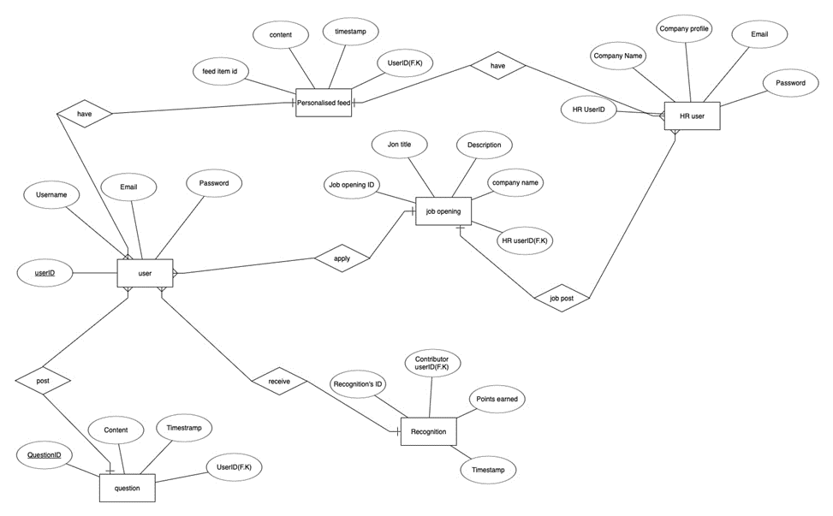

use case diagram

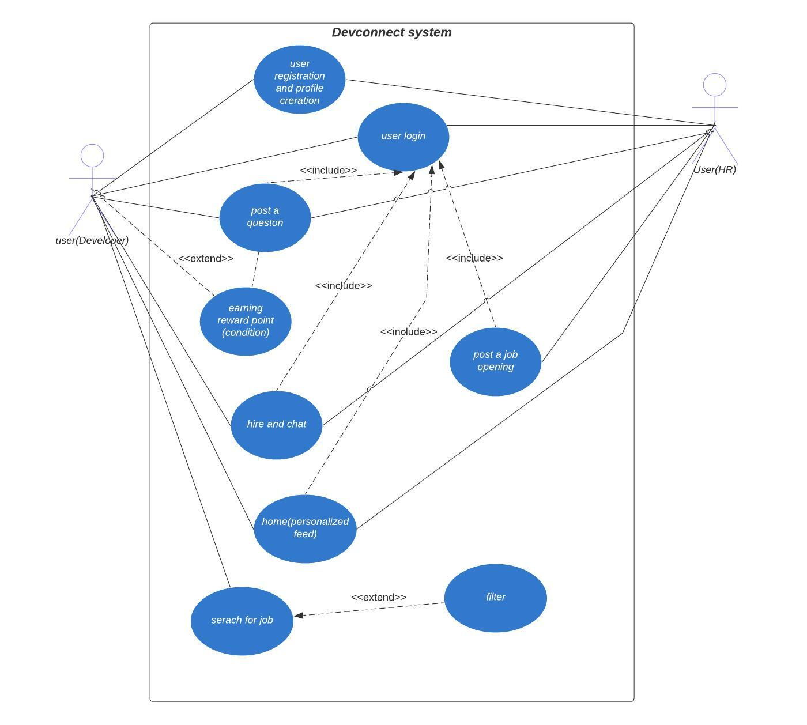

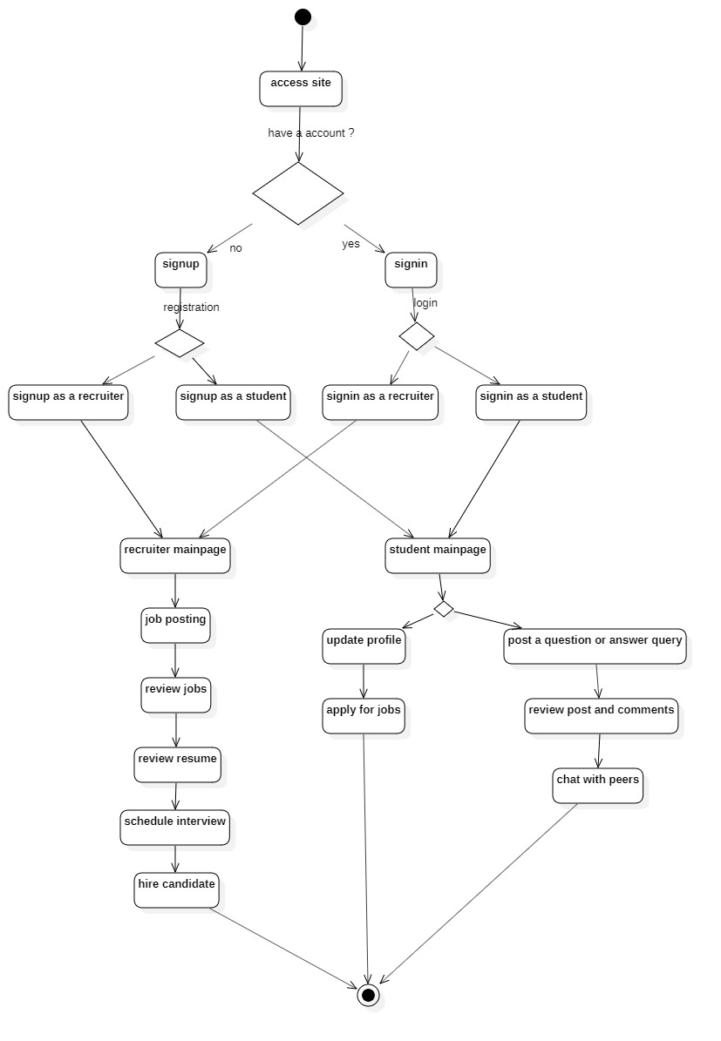

Activity diagram

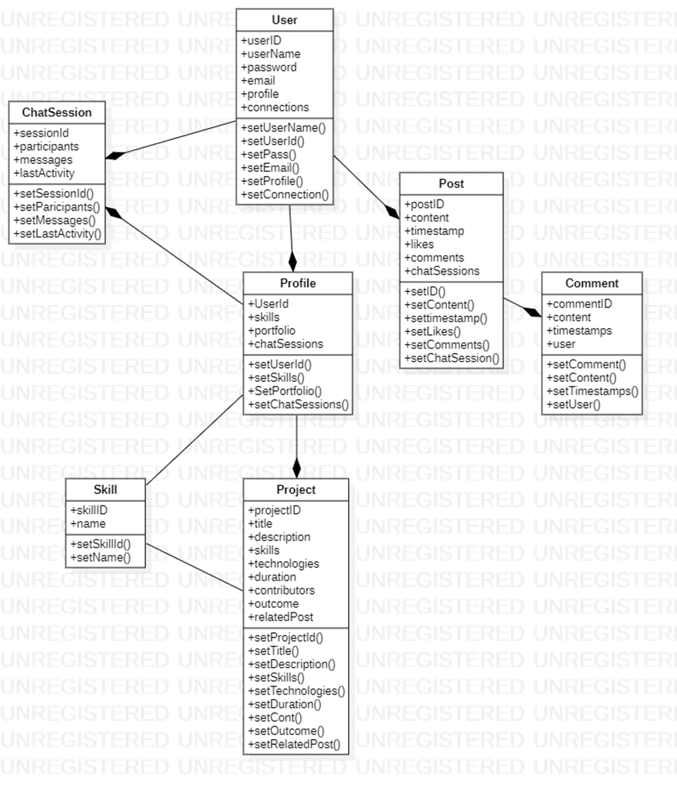

Class diagram

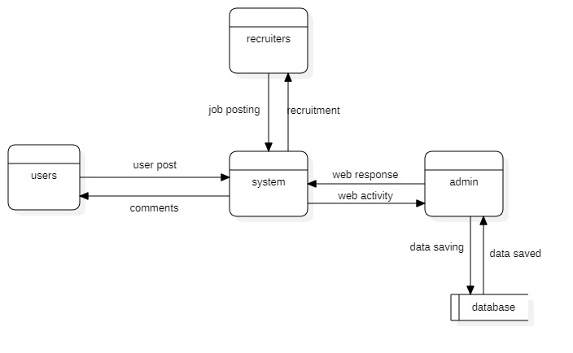

Dataflow diagram

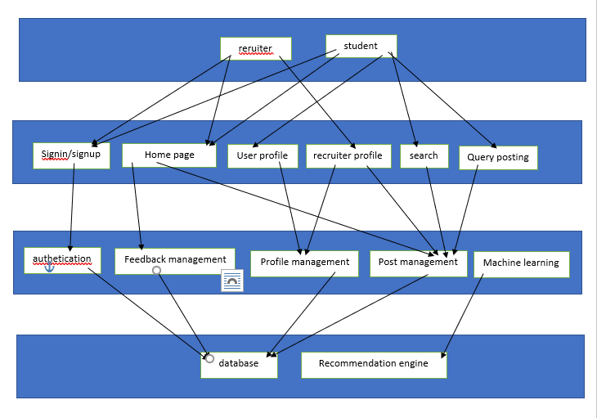

Architecture diagram

SEQUENCE DIAGRAMS (LOGIN)

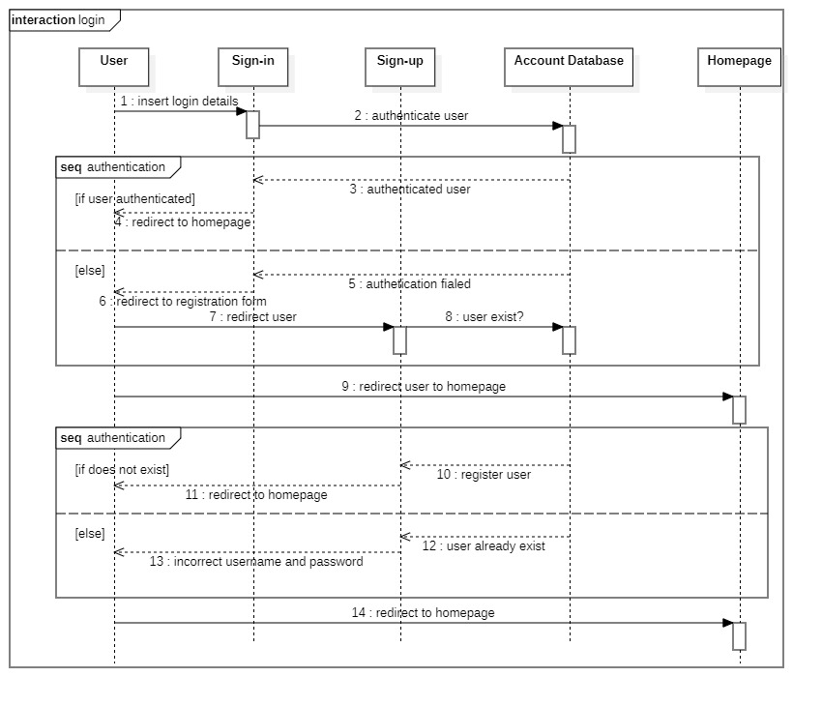

QUESTION AND ANSWERS:
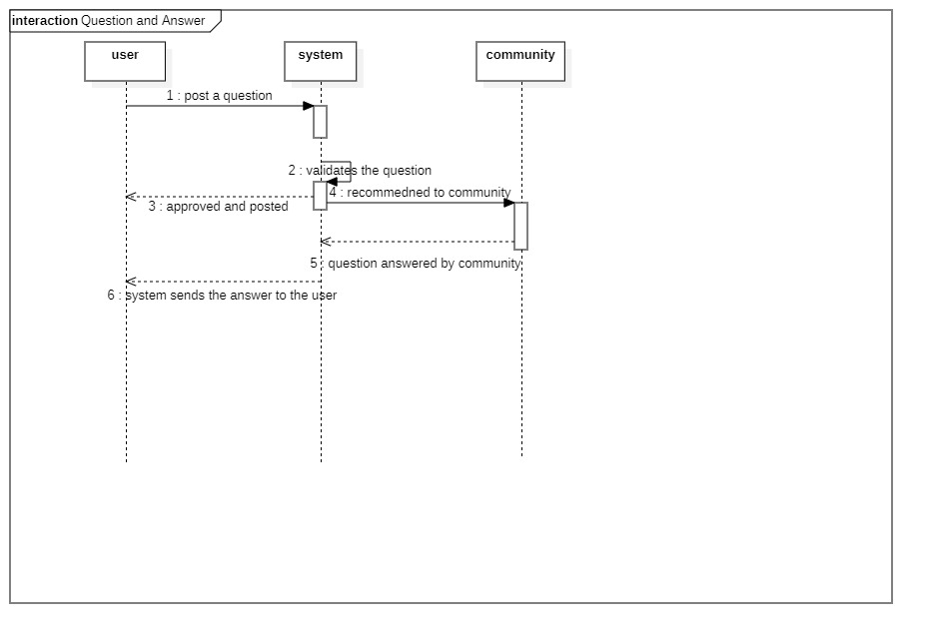

QUESTION AND ANSWERS:
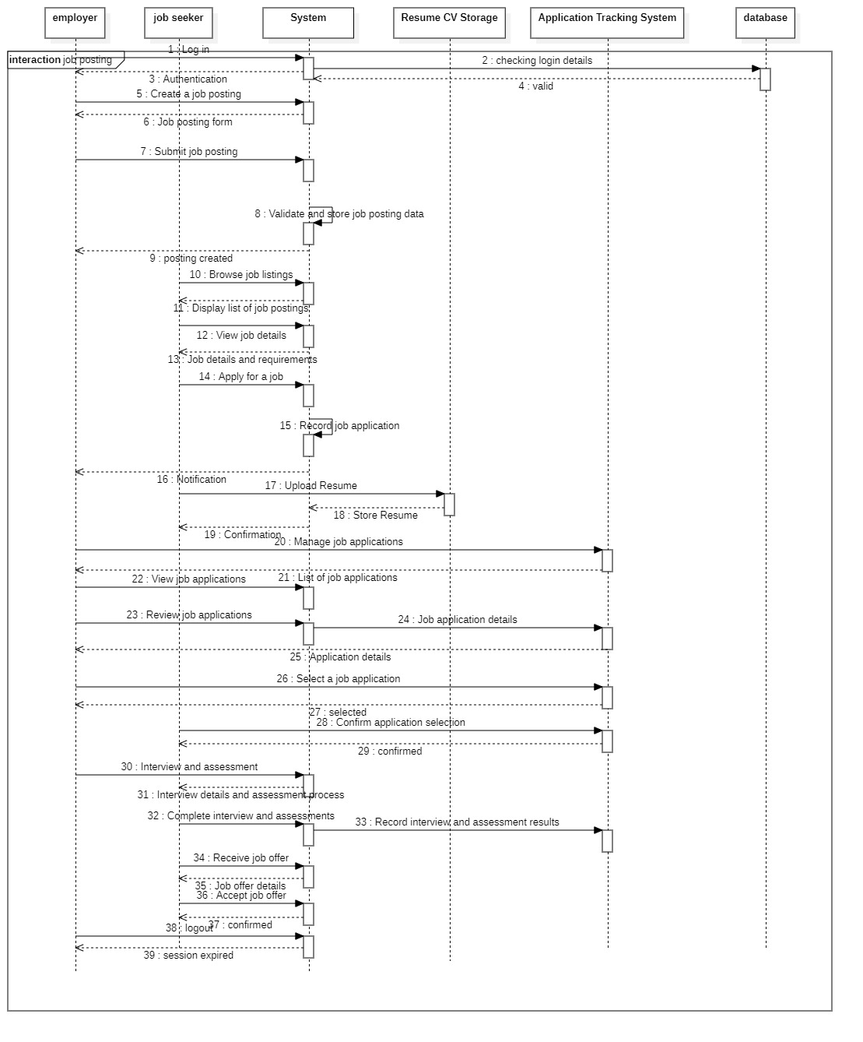

PERSONALIZED FEEDS
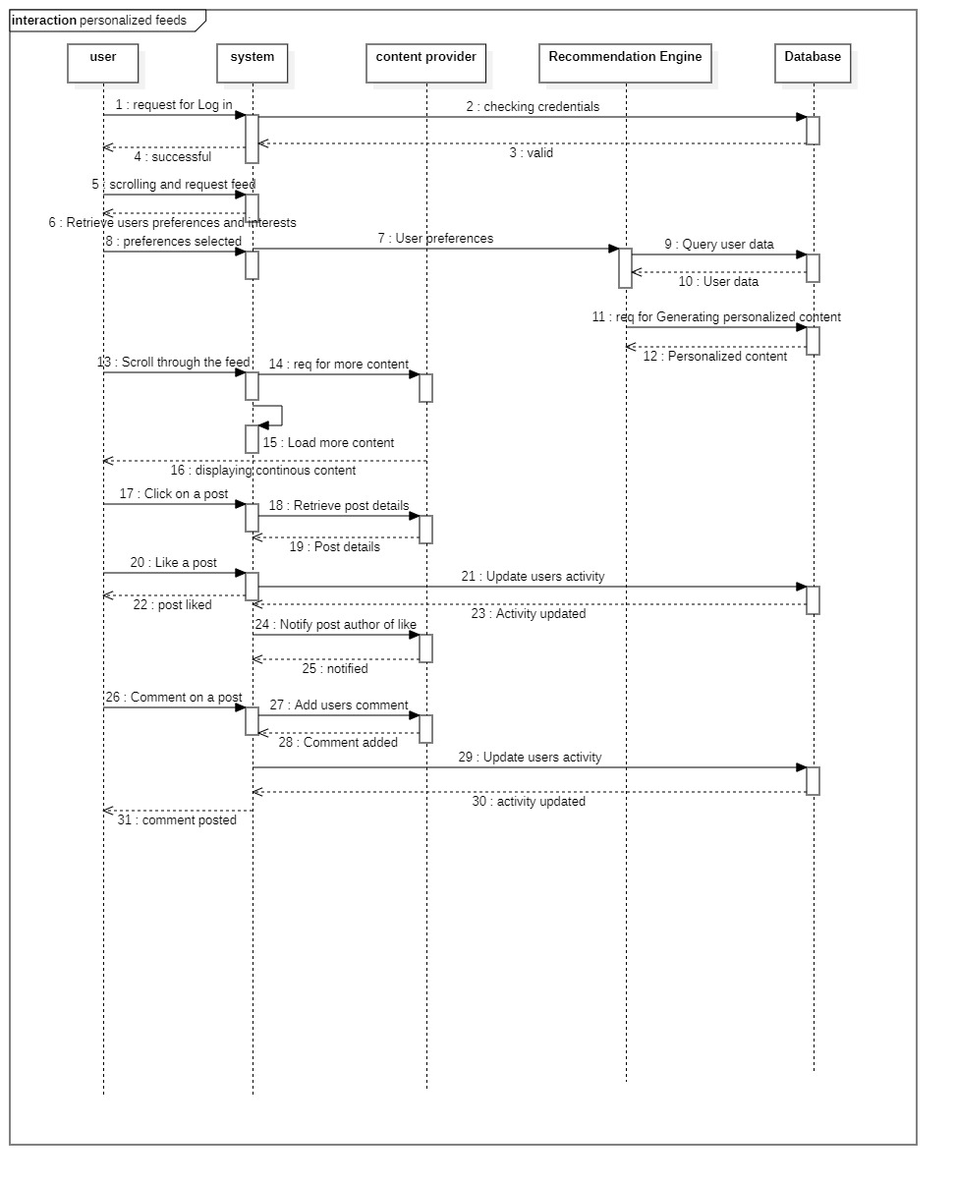

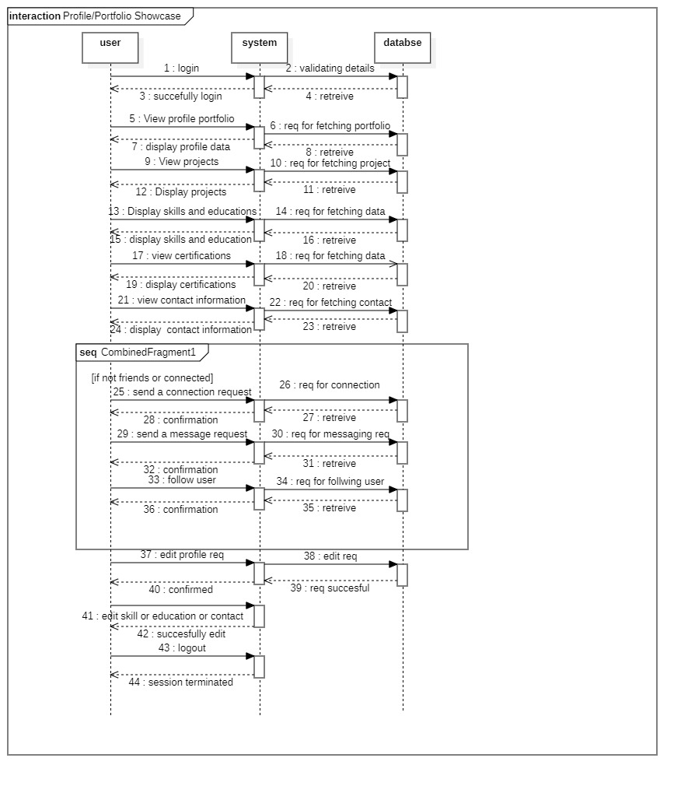
PORTFOLIO SHOWCASE

HIRING AND CHAT
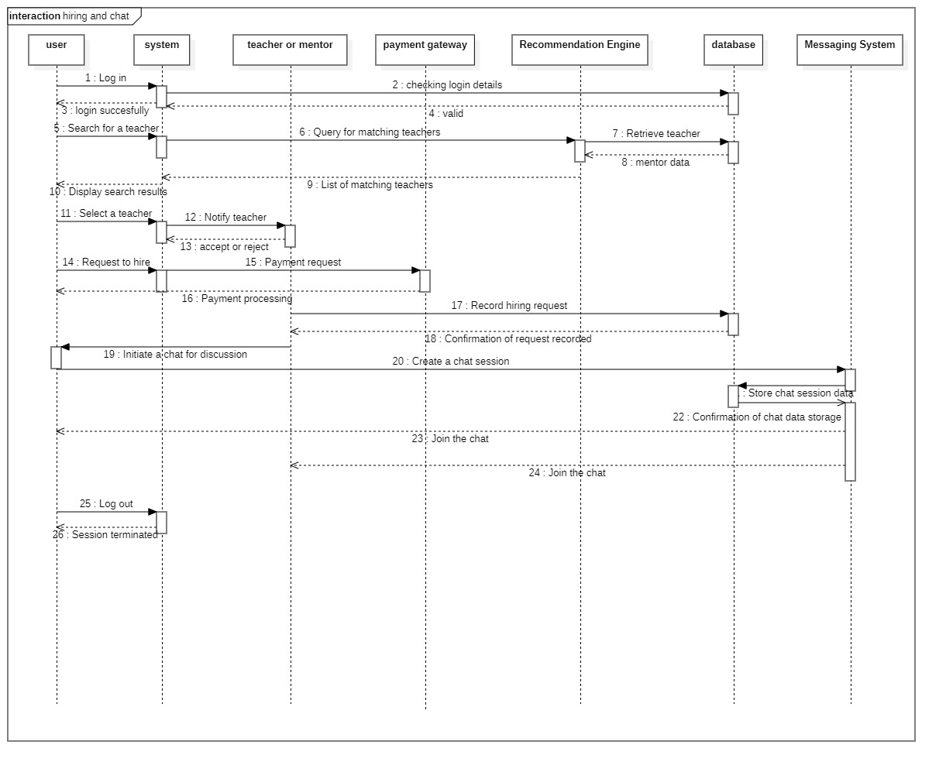

Features | DevConnect | Stack Overflow | GitHub | StudyPool | LinkedIn
User Profiles | ✔️ | ✔️ | ✔️ | ✔️ | ✔️
Question and Answer System | ✔️ | ✔️ | ❌ | ❌ | ❌
Personalized Feeds | ✔️ | ❌ | ❌ | ❌ | ✔️
Hire and Real-Time Chat | ✔️ | ❌ | ❌ | ❌ | ❌
Job Postings | ✔️ | ❌ | ❌ | ❌ | ✔️
Portfolio Showcase | ✔️ | ❌ | ❌ | ❌ | ✔️
Reputation System | ✔️ | ✔️ | ❌ | ✔️ | ✔️
Skill Endorsements | ✔️ | ❌ | ❌ | ❌ | ✔️
Community Forums | ✔️ | ✔️ | ❌ | ❌ | ❌
Collaborative Coding w.r.t problem solving | ✔️ | ✔️ | ❌ | ❌ | ❌

Component Interactions and Collaborations
. All these diagrams are placed aboved.

Design Reuse and Design Patterns

Technology Architecture
- Platform:
  - Web Application: Dev Connect will primarily operate as a web-based platform built using the MERN stack.

- System Hosting:
  - Cloud Infrastructure: Host the application on cloud platforms like AWS (Amazon Web Services), Azure, or GCP for scalability and flexibility.
  - Server Hosting: Utilize virtual machines (VMs) or containers (e.g., Docker) to host Node.js server instances running the Express.js framework.

- Database:
- MongoDB Atlas: Host the MongoDB database on MongoDB Atlas, a fully managed cloud database service, for seamless scalability and automatic backups.

- Connectivity Requirements:
- Internet Connectivity: Ensure reliable internet connectivity for users to access the web application.
- API Integrations: Implement RESTful APIs using Express.js to facilitate communication between the client-side (React.js) and server-side (Node.js) components.

- Modes of Operations:
- 24/7 Availability: Design the infrastructure to ensure continuous availability of the web application, leveraging auto-scaling features of cloud platforms.
- Horizontal Scaling: Employ horizontal scaling by adding more server instances or containers to handle increasing user traffic.

- Security Measures:
- Data Encryption: Implement encryption for data transmission using HTTPS protocol to secure communication between client and server.
- Authentication and Authorization: Implement authentication using JWT (JSON Web Tokens) and authorization middleware in Express.js to control access to resources.
- Firewalls and Security Groups: Configure firewalls and security groups on cloud platforms to restrict access to servers and databases.

- Data Backup and Disaster Recovery:
- Automated Backups: Set up automated backups for MongoDB using MongoDB Atlas to ensure data integrity and resilience against data loss.
- Disaster Recovery Plan: Develop a disaster recovery plan outlining procedure to restore the application in the event of system failures or data breaches.

- Monitoring and Analytics:
- Application Monitoring: Utilize monitoring tools like AWS CloudWatch or third-party services to monitor server performance, resource utilization, and application health.

- Compliance and Regulations:
- Regular Security Audits: Conduct regular security audits and vulnerability assessments to identify and mitigate potential security risks.

Architecture Evaluation
<Describe the reason(s) behind the decision related to selection of infrastructure/technology being used. Discuss pros and cons of the selected technology/infrastructure and the alternative technology/infrastructure. For example why have your group selected a particular API from a list of APIs? Why have your group preferred a particular framework over an alternative framework.>

Detailed/Component Design
Class diagram, scheme of database , sequence diagram , use case diagram are all used above.

Component-Component Interface

Component-External Entities Interface
Used sequence diagram for component interaction above.

Component-Human Interface
Provided below

Screenshots/Prototype

Workflow

Screens

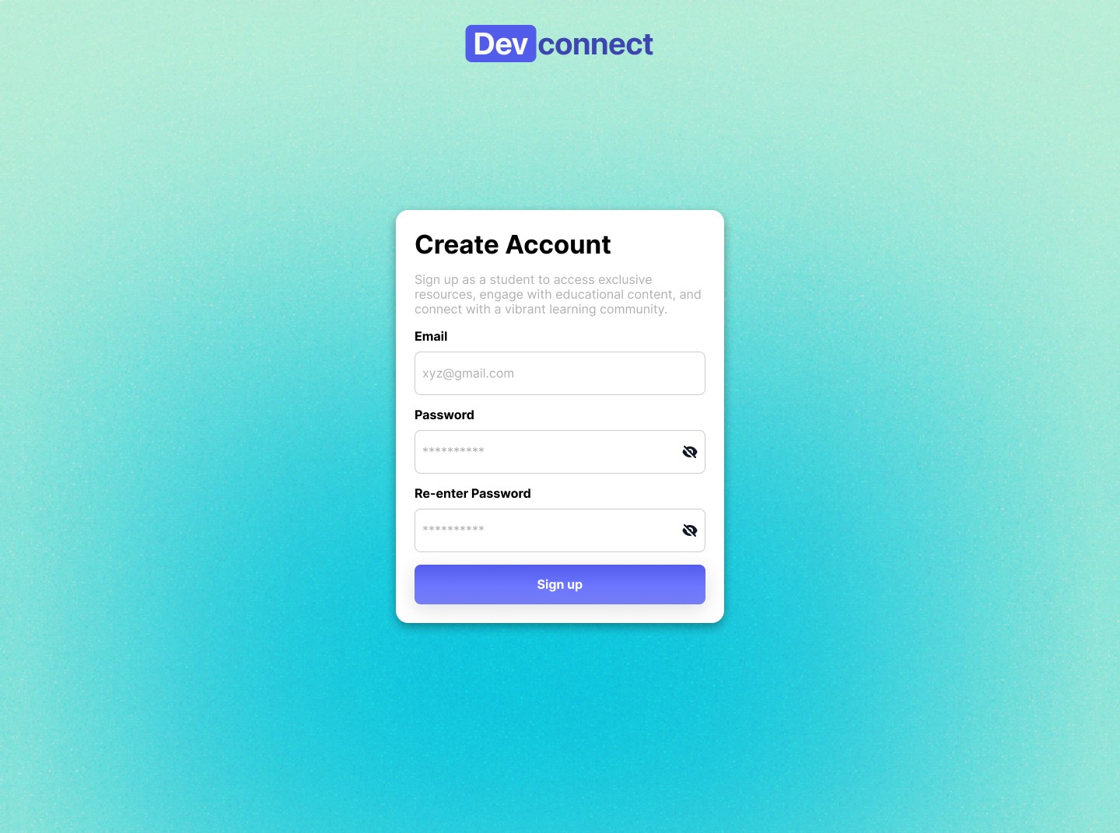

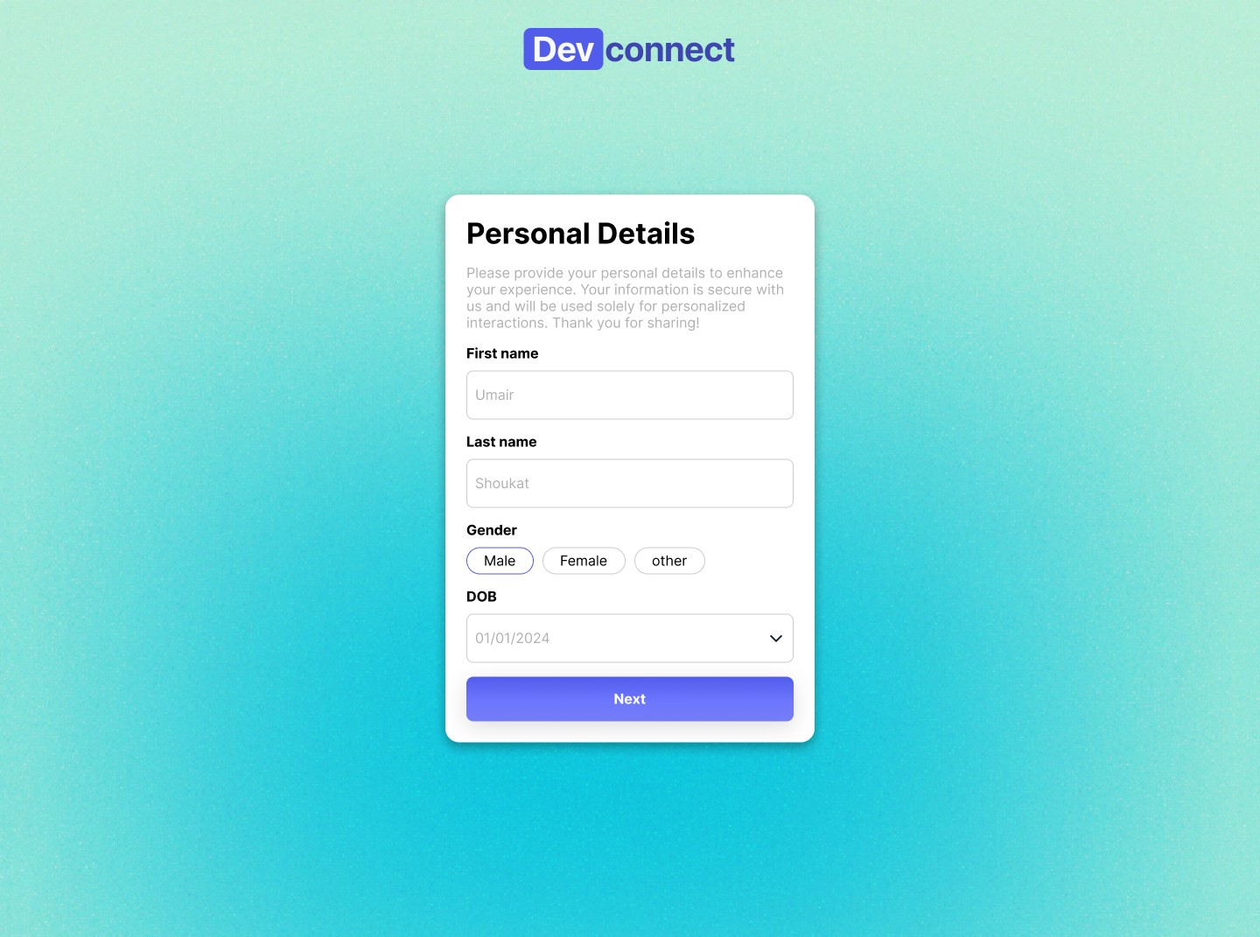

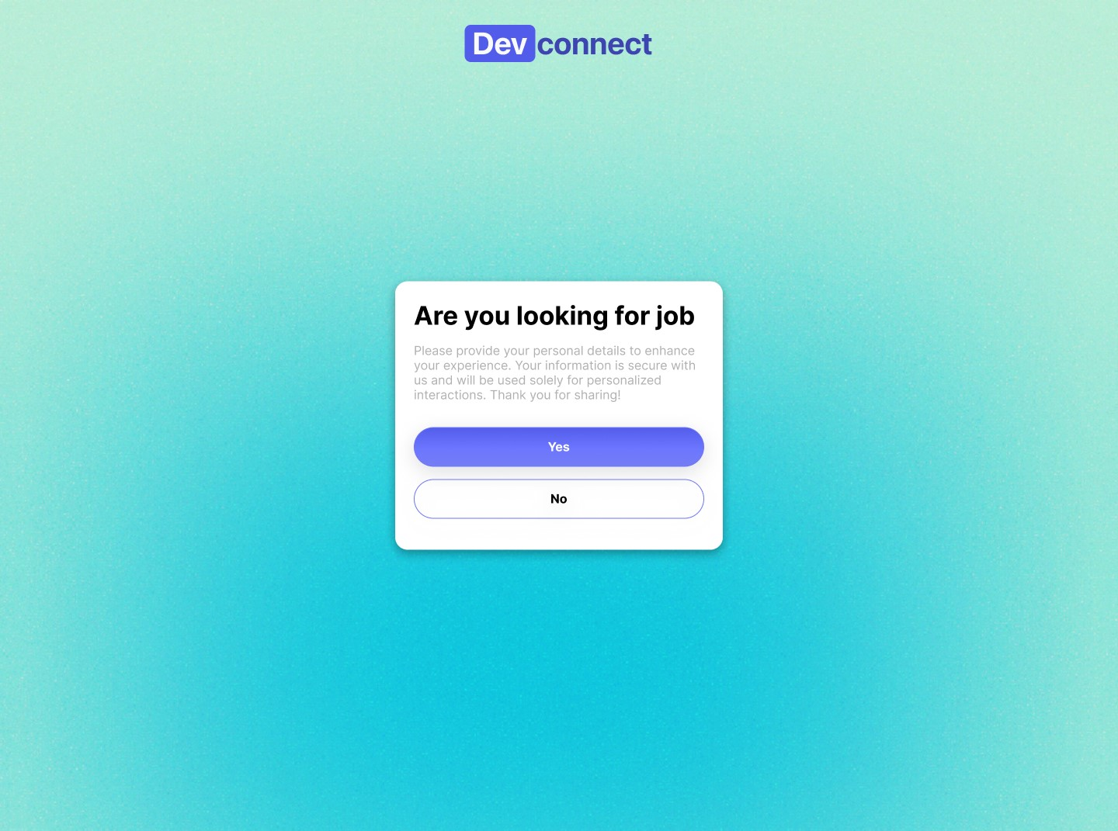

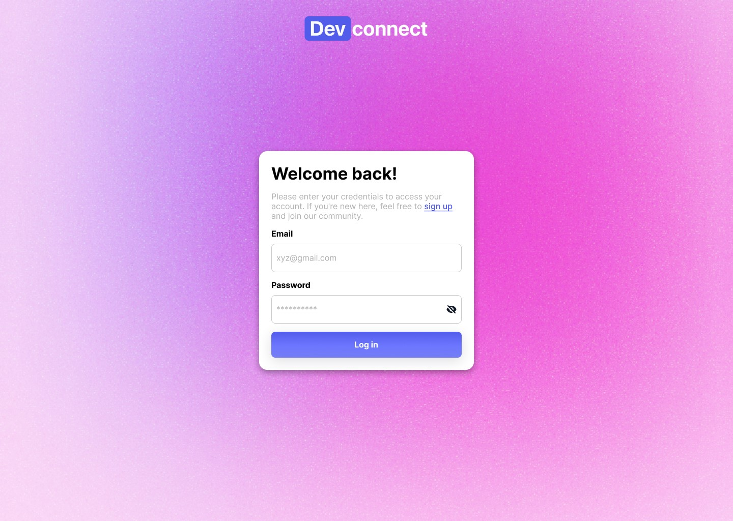

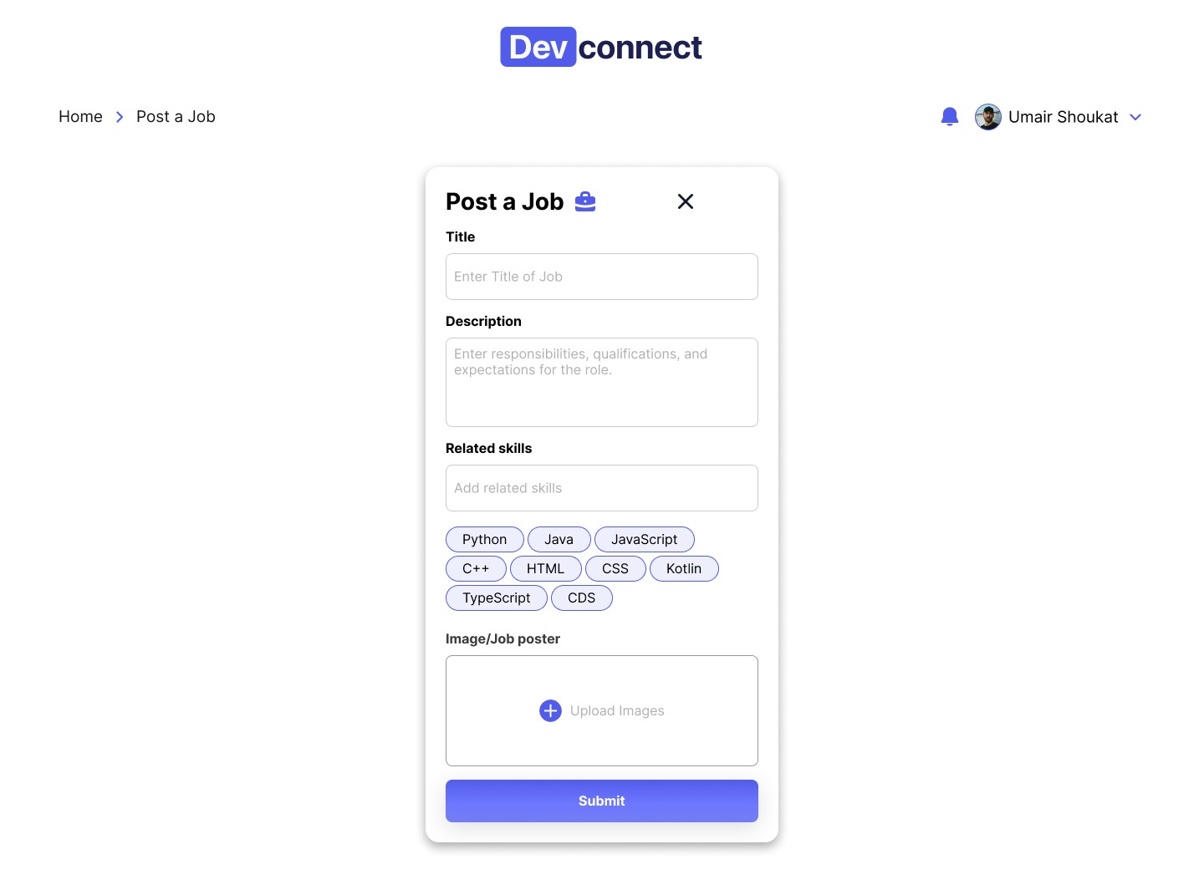

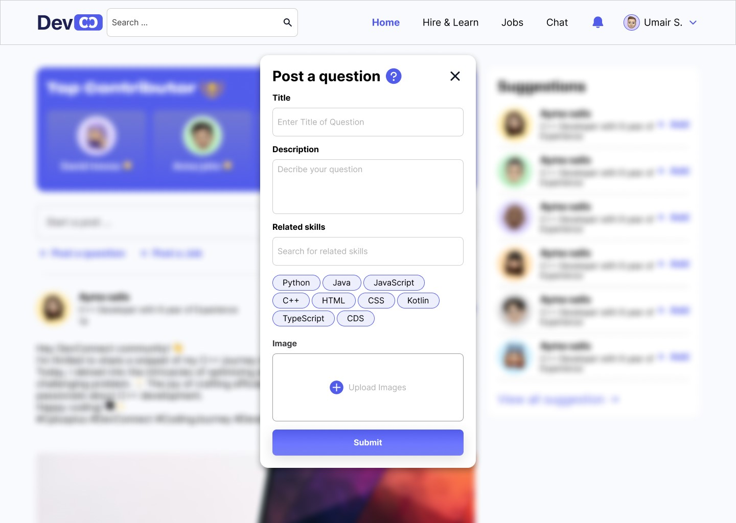
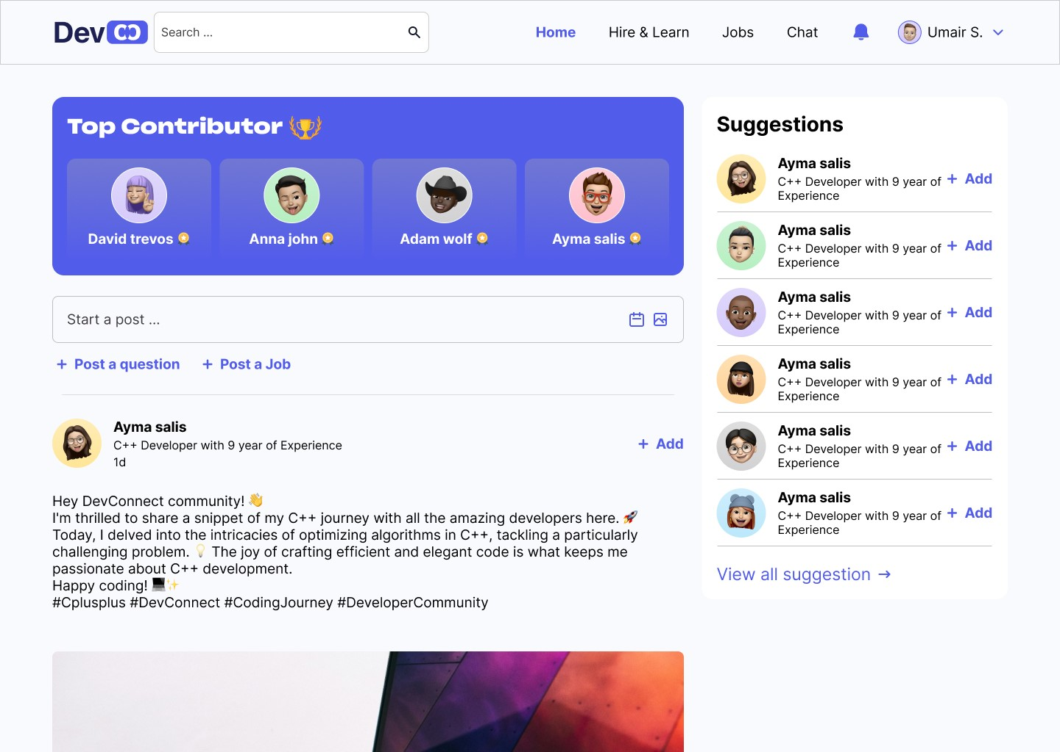

Other Design Details
No other design details

Test Specification and Results

Test Case Specification

User Registration
Identifier |  | User Registration
Purpose |  | To allow users to create accounts on the platform.
Priority |  | High
Pre-conditions |  | User accesses the registration page.
Post-conditions |  | User has a registered account.
Typical Course of Action
S# | Actor Action |  | System Response
1 | User navigates to the registration page. |  | System displays the registration form.
2 | User enters required registration details (e.g., username, email, password). |  | System validates and stores user information.
3 | User submits the registration form. |  | System creates a new user account.
Alternate Course of Action
S# | Actor Action |  | System Response
1 | User tries to register with an existing email or username. |  | System displays an error message.
2 | User enters invalid registration information. |  | System prompts the user to correct the information.

Table 1: UC-1

Profile Creation
Identifier |  | Profile Creation
Purpose |  | To enable users to create and customize their developer profiles.
Priority |  | High
Pre-conditions |  | User is registered and logged in.
Post-conditions |  | User has a personalized developer profile.
Typical Course of Action
S# | Actor Action |  | System Response
1 | User navigates to their profile settings.. |  | System displays profile editing options.
2 | User adds or updates profile information (e.g., skills, experience, portfolio). |  | System saves the changes to the user's profile..
Alternate Course of Action
S# | Actor Action |  | System Response
1 | User attempts to edit the profile without being logged in. |  | System prompts the user to log in.
2 | User enters incomplete or invalid information. |  | System displays error messages and asks the user to correct the information.
Table 2: UC-2

Post a Coding Question
Identifier |  | Post a Coding Question
Purpose |  | To enable users to post coding-related questions.
Priority |  | High
Pre-conditions |  | User is logged in.
Post-conditions |  | The user's question is posted on the platform.
Typical Course of Action
S# | Actor Action |  | System Response
1 | User navigates to the question posting section. |  | System displays the question posting interface.
2 | User enters the question's title, description, and tags. |  | System validates the information.
3 | User submits the question. |  | System adds the question to the platform's question database..
4 | System notifies the user that the question has been posted successfully.
Alternate Course of Action
S# | Actor Action |  | System Response
1 | User attempts to post a question without being logged in. |  | System prompts the user to log in.
2 | User enters incomplete or invalid information. |  | System displays error messages and asks the user to provide the required details.
Table 3: UC-3

Recognize Contributors
Identifier |  | Recognize Contributors
Purpose |  | To recognize and reward users for their contributions to the platform.
Priority |  | Medium
Pre-conditions |  | User contributes to the platform (e.g., posts questions, provides answers).
Post-conditions |  | User receives recognition and rewards..
Typical Course of Action
S# | Actor Action |  | System Response
1 | User actively contributes to the platform (e.g., posts high-quality content, helps others). |  | System tracks user contributions.
2 | System periodically evaluates user contributions. |  | System calculates recognition points and rewards.
3 | User receives notifications or badges for their contributions. |  | User profile displays earned recognition and rewards.
Table 4: UC-4

Post a Job Opening
Identifier |  | Post a Job Opening
Purpose |  | To enable recruiters to post job openings on the platform.
Priority |  | High
Pre-conditions |  | Recruiter is logged in.
Post-conditions |  | The job opening is posted on the platform
Typical Course of Action
S# | Actor Action |  | System Response
1 | Recruiter navigates to the job posting section. |  | System displays the job posting interface..
2 | Recruiter enters job details (e.g., title, description, requirements). |  | System validates the information.
3 | Recruiter submits the job posting. |  | System adds the job opening to the platform's job listings.
4 | System notifies the recruiter that the job has been posted successfully.
Alternate Course of Action
S# | Actor Action |  | System Response
1 | Recruiter attempts to post a job without being logged in. |  | System prompts the recruiter to log in.
2 | Recruiter enters incomplete or invalid job information.. |  | System displays error messages and asks the recruiter to provide the required details.
Table 5: UC-5

Teacher Hire and Chat
Identifier |  | Hire a Teacher and Chat
Purpose |  | To allow users to hire experienced developers for mentorship and have real-time chat sessions.
Priority |  | High
Pre-conditions |  | User is logged in.
Post-conditions |  | User hires a teacher and can initiate a chat session.
Typical Course of Action
S# | Actor Action |  | System Response
1 | User searches for available teachers. |  | System displays a list of available teachers
2 | User selects a teacher and initiates a mentorship request. |  | System notifies the teacher and awaits their response.
3 | Teacher accepts the request.. |  | System establishes a real-time chat session between the user and teacher.
Alternate Course of Action
S# | Actor Action |  | System Response
1 | User attempts to initiate a chat without being logged in. |  | System prompts the user to log in.
2 | Teacher declines the mentorship request. |  | System notifies the user that the request was declined.

Table 6: UC-6

Personalized Feeds
Identifier |  | Personalized Feeds
Purpose |  | To present users with personalized feeds of content based on their interests and activities.
Priority |  | Medium
Pre-conditions |  | User is logged in
Post-conditions |  | User views their personalized feed.
Typical Course of Action
S# | Actor Action |  | System Response
1 | User navigates to the personalized feed section. |  | System retrieves and displays relevant content based on user interests.
2 | User scrolls through the feed. |  | System

References
- M. Christ, A. W. Kempa-Liehr, and M. Feindt. Distributed and Parallel Time Series Feature Extraction
- for Industrial Big Data Applications. Asian Machine Learning Conference. Workshop on Learning on
- Big Data, 2016. https://arxiv.org/abs/1610.07717v1.

- K. Fauvel, T. Lin, V. Masson, E. Fromont, and A. Termier. XCM: An Explainable Convolutional Neural `
- Network for Multivariate Time Series Classification, 2020. https://arxiv.org/abs/2009.04796.

- S. Hochreiter and J. Schmidhuber. Long Short-Term Memory. Neural Computation, 9(8):1735–1780,
- 1997.

- Oguiza. tsai - A State-of-the-art Deep Learning Library for Time Series and Sequential Data, 2020.
- https://github.com/timeseriesAI/tsai.

- Kollnig, K., Datta, S., & Shadbolt, N. (2022, February 23). Imagining, Studying and Realizing a Less Harmful App Ecosystem. Department of Computer Science, University of Oxford, Oxford, United Kingdom. Retrieved from ["https://arxiv.org/pdf/2205.00774.pdf"].

- K. Weinberger and L. Saul. Distance Metric Learning for Large Margin Nearest Neighbor Classification.
- Journal of Machine Learning Research, 10(2):207–244, 2009.

- X. Zou, Z. Wang, Q. Li, and W. Sheng. Integration of Residual Network and Convolutional Neural
- Network along with Various Activation Functions and Global Pooling for Time Series Classification.
- Neurocomputing, 367:39–45, 2019.

Appendix A: Glossary
- API: Application Programming Interface - A set of rules and protocols that allows different software applications to communicate with each other.
- CMS: Content Management System - A software application used to create, edit, manage, and publish digital content, typically used for websites and blogs.
- CSS: Cascading Style Sheets - A style sheet language used for describing the look and formatting of a document written in HTML.
- CCPA: California Consumer Privacy Act - A data privacy law that grants California residents specific rights regarding their personal information.
- DBMS: Database Management System - Software that manages databases, allowing users to store, retrieve, and manipulate data.
- GDPR: General Data Protection Regulation - A European Union regulation that governs data protection and privacy for individuals within the EU.
- HTML: Hypertext Markup Language - The standard language for creating and designing web pages and web applications.
- HTTPS: Hypertext Transfer Protocol Secure - A secure version of HTTP, used for encrypted communication over a computer network.
- MFA: Multi-Factor Authentication - A security process in which users are required to provide multiple forms of identification before accessing an account.
- PCI DSS: Payment Card Industry Data Security Standard - A set of security standards designed to ensure that all companies that accept, process, store, or transmit credit card information maintain a secure environment.
- RDBMS: Relational Database Management System - A type of DBMS that uses a relational model for storing and managing data.
- RBAC: Role-Based Access Control - A security method that restricts system access to authorized users based on their roles and responsibilities.
- SRS: Software Requirements Specification - A document that describes the features, functionalities, and constraints of a software project.
Appendix B: IV & V Report
(Independent verification & validation)
IV & V Resource

Name Signature

S# | Defect Description | Origin Stage | Status | Fix Time
 |  |  |  | Hours | Minutes
1
2
3
…
Table 1: List of non-trivial defects

This document has been adapted from the following:
- Previous project templates at UCP
- High-level Technical Design, Centers for Medicare & Medicaid Services. (www.cms.gov)

