BSSE FINAL PROJECT
Software Design Specification

DEVCONNECT: EMPOWERING DEVELOPERS NETWORK (THROUGH AI)



Project Advisor

SAIRA LATIF

Presented by:
Group ID: F23SE104

Student Reg Student Name

L1S20BSSE0011 ABDULLAH ZAHID
L1S20BSSE0016 AHSAN AHMAD
L1F19BSSE0248 UMAIR SHOKAT

Faculty of Information Technology

University of Central Punjab
Software Design Specification
SDP Phase II

DEVCONNECT: EMPOWERING DEVELOPERS NETWORK (THROUGH AI)
Advisor: Saira Latif

Team: F23SE104
Member Name | Primary Responsibility
ABDULLAH ZAHID | DOCUMENTATION
AHSAN AHMAD | UML MODELLING
UMAIR SHOUKAT | PROTOTYPE/UI

Table of Contents
Table of Contents i
Revision History iii
Abstract iv
1. Introduction 1
1.1 Product 1
1.2 Background 1
1.3 Objective(s)/Aim(s)/Target(s) 1
1.4 Scope 1
1.5 Business Goals 1
1.6 Document Conventions 1
1.7 Miscellaneous 2
2. Overall Description 3
2.1 Product Features 3
2.2 FUNCTIONAL DESCRIPTION 3
2.2.1 User Registration and Profile Creation: 3
2.2.2 Q&A Community: 3
2.2.3 Mentorship and Chat: 3
2.2.4 Feeds and Content Discovery: 4
2.2.5 Recruitment and Job Discovery: 4
2.2.6 Reward System: 4
2.2.7 Admin Panel: 4
2.3 User Classes and Characteristics 5
2.3.1 Developers 5
2.3.2 MENTORS AND TEACHERS 5
2.3.3 RECRUITERS 5
2.3.4 ADMINISTRATORS 5
2.3.5 MODERATORS 6
2.4 Design and Implementation Constraints 6
2.4.1 Corporate and Regulatory Policies 6
2.4.2 Hardware Limitations 6
2.4.3 Interfaces to Other Applications 6
2.4.4 Specific Technologies and Tools 6
2.4.5 Database Management Systems 7
2.4.6 Security Considerations 7
2.4.7 Design Conventions and Programming Standards 7
2.5 Assumptions and Dependencies 7
3. Technical Architecture 9
3.1 Application and Data Architecture 10
3.1.1 ER DIAGRAM: 11
3.1.3 ACTIVITY DIAGRAM 13
3.1.4 CLASS DIAGRAM 14
3.1.5 DATA FLOW DIAGRAM 15
3.2 Component Interactions and Collaborations 16
3.2.1 SEQUENCE DIAGRAMS (LOGIN) 16
3.2.2 QUESTION AND ANSWERS: 17
3.2.3 JOB POSTING 18
3.2.4 PERSONALIZED FEEDS 19
3.2.5 PORTFOLIO SHOWCASE 20
3.2.6 HIRING AND CHAT 21
3.3 Design Reuse and Design Patterns 22
3.4 Technology Architecture 22
4. Screenshots/Prototype 24
4.1 Workflow 24
4.2 Screens 25
5. Revised Project Plan 30
6. References 31
Appendix A: Glossary 32
• API: Application Programming Interface - A set of rules and protocols that allows different software applications to communicate with each other. 32
• CMS: Content Management System - A software application used to create, edit, manage, and publish digital content, typically used for websites and blogs. 32
• CSS: Cascading Style Sheets - A style sheet language used for describing the look and formatting of a document written in HTML. 32
• CCPA: California Consumer Privacy Act - A data privacy law that grants California residents specific rights regarding their personal information. 32
• DBMS: Database Management System - Software that manages databases, allowing users to store, retrieve, and manipulate data. 32
• GDPR: General Data Protection Regulation - A European Union regulation that governs data protection and privacy for individuals within the EU. 32
• HTML: Hypertext Markup Language - The standard language for creating and designing web pages and web applications. 32
• HTTPS: Hypertext Transfer Protocol Secure - A secure version of HTTP, used for encrypted communication over a computer network. 32
• MFA: Multi-Factor Authentication - A security process in which users are required to provide multiple forms of identification before accessing an account. 32
• PCI DSS: Payment Card Industry Data Security Standard - A set of security standards designed to ensure that all companies that accept, process, store, or transmit credit card information maintain a secure environment. 32
• RDBMS: Relational Database Management System - A type of DBMS that uses a relational model for storing and managing data. 32
• RBAC: Role-Based Access Control - A security method that restricts system access to authorized users based on their roles and responsibilities. 32
• SRS: Software Requirements Specification - A document that describes the features, functionalities, and constraints of a software project. 32
• SUS: System Usability Scale - A widely used questionnaire for measuring the usability and user-friendliness of software and other systems. 32
• UI: User Interface - The means by which a user interacts with a software application or website. 33
• UX: User Experience - The overall experience a user has while interacting with a software application or website. 33
• URL: Uniform Resource Locator - A web address used to access resources on the internet, such as web pages and files. 33
RBAC- Definition: Role-Based Access Control, a method of managing system access based on user roles and permissions. 33
Appendix B: IV & V Report 33

Revision History
Name | Date | Reason For Changes | Version

Abstract
In the ever-evolving landscape of software engineering, our project titled "DevConnect" emerges as a dynamic solution to address the challenges that developers face in their daily pursuits. DevConnect is designed as a comprehensive platform that fosters collaboration, learning, and professional growth within the developer community. This project seeks to resolve the persistent issues of personalized assistance, fragmented learning resources, and limited networking opportunities that developers encounter.

By leveraging the knowledge areas of machine learning, web development, and database management, DevConnect offers a feature-rich environment where developers can connect with like-minded peers, seek guidance from experienced mentors, showcase their skills and projects, and discover tailored learning resources. The platform employs sophisticated content recommendation algorithms, ensuring that users receive content and answers that align with their unique interests and needs.

Our project's significance lies in its potential to transform the developer community, promoting a culture of collaboration and knowledge sharing. DevConnect aims to bridge the gap between novice and experienced developers, facilitating skill development and career advancement for all. By the conclusion of this project, we anticipate a thriving online ecosystem that empowers developers to connect, learn, and excel in their professional journeys.

Introduction

Product
DevConnect is a comprehensive software platform designed to address the challenges faced by developers within the ever-evolving software engineering domain. The problem statement revolves around the fragmentation of developer resources, the lack of personalized assistance, and limited networking opportunities for developers worldwide.

Background
The field of software engineering is marked by continuous innovation and rapid technological advancements. Developers often find themselves inundated with vast amounts of information, ranging from coding queries to learning resources. Existing platforms may not effectively cater to the individual needs and personalized growth of developers. DevConnect is conceived as a solution to these challenges, creating a platform where developers can collaborate, learn, and showcase their skills.

Objective(s)/Aim(s)/Target(s)
The objectives of the DevConnect project are as follows:

- To create a dynamic platform where developers can connect and collaborate.
- To provide personalized learning resources and assistance.
- To facilitate mentorship and skill development.
- To offer a space for developers to showcase their projects.
- To streamline the job search process for developers.

Scope
This SRS document outlines the requirements for the development of the DevConnect platform, encompassing its core functionalities, user interactions, and system behavior.

Business Goals
DevConnect aligns with several business goals, including:

- Enhancing user engagement and retention.
- Attracting potential recruiters and job opportunities.
- Building a thriving developer community.
- Providing value-added services to users.

Document Conventions
This SRS document follows standard typographical conventions, such as using headings for section titles and bullet points for listing items. However, the writing style is “Times”. Moreover, “✔️” – represents feature present in the system and “❌” - represents feature absent in the system in the heading 1.10. Also, the paragraph font size is 12px. Sub-heading font size is 14px and heading font size is 18px.

Miscellaneous
There are multiple factors that can be helpful in conducting the project work, for example project management plan, task allocation and responsibilities, risk management and visiting software house and observing their projects similar to ours. This will provide better understanding of the tools and techniques used in the project.

Overall Description

Product Features
DevConnect encompasses a range of major features, including but not limited to:

- User Profiles: Developers can create detailed profiles showcasing their skills, experience, and portfolios.
- Q&A Module: Users can post coding-related questions and receive answers from the developer community.
- Content Recommendation: A personalized recommendation system suggests learning resources, articles, and questions to users based on their interests and activities.
- Mentorship and Teacher-Hire: Users can seek mentorship and hire experienced developers for one-on-one guidance.
- Job Posting and Matching: Recruiters can post job openings, and developers receive job recommendations based on their skills and preferences.
- Collaborative Feeds: A dynamic feed displays content and updates relevant to a user's interests.
- Recognition and Rewards: Users earn points for active participation and quality contributions.

FUNCTIONAL DESCRIPTION
Our project involves creating a platform for developers with features such as profile creation, Q&A community, mentorship, feeds, recruitment, and an admin panel. Here's a more tailored functional description for "Dev Connect":

User Registration and Profile Creation:
- Developers can register on Dev Connect, providing essential details like skills, projects, and industry expertise.
- Profile creation includes options for uploading a profile picture, creating a bio, and showcasing a developer's portfolio.

Q&A Community:
- Developers can post questions related to programming, software development, or any tech-related queries.
- Questions can be in various formats: text, images, or videos.
- Peers can respond with answers in the form of text, images, or videos.
- A gamified reward system grants points to users for providing helpful answers.

Mentorship and Chat:
- Developers can offer mentorship services, listing their areas of expertise and availability.
- The platform includes a chat system for users to connect for mentorship sessions or general discussions.
- Mentorship sessions may involve a payment system facilitated by integrated payment gateways.

Feeds and Content Discovery:
- An AI-driven content recommendation system tailors feeds based on user preferences and activities.
- Users can discover relevant articles, projects, or discussions in their personalized feed.

Recruitment and Job Discovery:
- Recruiters can post job openings and reach out to developers directly through targeted feeds.
- Developers receive job recommendations based on their skills and interests.

Reward System:
  - Users earn points for various activities, including answering questions, contributing to discussions, and successful mentorship sessions.
  - Points can be redeemed for premium features or services within the platform.

Admin Panel:
- An admin panel provides administrators with tools to manage users, monitor activities, and ensure the platform's integrity.

User Classes and Characteristics

Developers
Characteristics:
- Diverse technical backgrounds, from novices to experts.
- Varying levels of experience in software development.
- Active participation in discussions, knowledge sharing, and learning.
- Regularly post questions, answers, and contribute to the community.
Requirements:
- Access to a personalized feed of content and questions.
- Ability to create user profiles showcasing their skills and portfolios.
- Post questions and answers in various formats (text, image, video).
- Earn points and badges for contributions.

MENTORS AND TEACHERS
Characteristics:
- Experienced developers with a strong desire to mentor others.
- Technical expertise in specific areas of software development.
- Willingness to provide guidance and support to less experienced developers.
Requirements:
- Ability to offer mentorship services.
- Set availability for mentoring sessions.
- Receive payments for mentorship services.

RECRUITERS
Characteristics:
- Represent companies or individuals seeking to hire developers.
- HR professionals or hiring managers.
- Focused on identifying suitable candidates for job openings.
Requirements:
- Post job openings and descriptions.
- Search and filter developer profiles.
- Contact potential candidates.

ADMINISTRATORS
Characteristics:
- System administrators responsible for platform maintenance.
- Technical expertise in system administration.
- Monitor and ensure platform security and stability.
Requirements:
- Manage user accounts and permissions.
- Implement security measures.
- Monitor system health and performance.

MODERATORS
Characteristics:
- Experienced and trusted users within the community.
- Responsible for ensuring content quality and adherence to guidelines.
- Actively report and address inappropriate content.
- Requirements:
- Review and moderate user-generated content.
- Enforce community guidelines.
- Maintain a safe and respectful environment.

These user classes have distinct characteristics and play various roles within the DevConnect ecosystem. The platform's success relies on meeting the needs and expectations of each user class, fostering collaboration and knowledge sharing among developers, and providing value to recruiters and mentors.

Design and Implementation Constraints

Corporate and Regulatory Policies
- Constraints: DevConnect must adhere to corporate and regulatory policies regarding data privacy, security, and user rights. Compliance with industry-specific regulations may impose limitations on data handling and storage.

- Impact: The platform's design and implementation must incorporate robust security measures, data encryption, and strict access controls to comply with these policies.

Hardware Limitations
- Constraints: The platform's performance may be limited by the hardware capabilities of users' devices, such as processing power and memory. Mobile devices, in particular, may have resource constraints.

- Impact: DevConnect's design should optimize resource usage, and its user interface should be responsive across a range of devices and screen sizes.

Interfaces to Other Applications
- Constraints: DevConnect may need to integrate with external applications or services, such as payment gateways, content recommendation engines, and social media platforms.

- Impact: Compatibility and API availability must be considered during development to ensure seamless interactions with these external services.

Specific Technologies and Tools
- Constraints: DevConnect development may be constrained by the choice of specific technologies, frameworks, and tools, especially if they are mandated by the project's stakeholders or organization.

- Impact: Development teams must work within the constraints of the chosen technology stack, potentially limiting flexibility in tool selection.

Database Management Systems
- Constraints: The choice of the database management system (e.g., MongoDB) may impose constraints on data storage and retrieval.

- Impact: Data models and queries must be designed to align with the selected database system, potentially affecting the schema and data storage structure.

Security Considerations
- Constraints: Security is a paramount concern, imposing constraints on data handling, authentication, authorization, and encryption.

- Impact: Developers must implement robust security measures, including protection against SQL injection, cross-site scripting (XSS), and other common vulnerabilities.

Design Conventions and Programming Standards
- Constraints: If the customer's organization has specific design conventions or programming standards, DevConnect development must align with these guidelines.

- Impact: Development teams must follow these conventions, potentially affecting code structure, naming conventions, and code review processes.

Meeting these constraints is essential to ensure the successful design and implementation of DevConnect while aligning with corporate policies, regulatory requirements, and user expectations.

Assumptions and Dependencies
Assumptions:

- User Data Accuracy: It is assumed that users will provide accurate and truthful information when creating their profiles, including skills, experience, and portfolio details.

- Community Guidelines Adherence: Users are assumed to adhere to the community guidelines and standards, promoting respectful and constructive interactions within the platform.

- External Services Availability: DevConnect assumes that third-party services, such as content recommendation engines and payment gateways, will be available and reliable for integration.

- Server and Hosting Reliability: The project assumes that the hosting and server infrastructure will be reliable and available, minimizing downtime.

Dependencies:

- Third-Party APIs: DevConnect depends on third-party APIs for features like content recommendations and payment processing. Any changes or discontinuation of these APIs could impact the platform's functionality.

- External Libraries and Frameworks: The project relies on external libraries and frameworks as part of the chosen technology stack (e.g., React, Node.js). Updates or changes to these libraries may require adjustments in the codebase.

- User-Generated Content: The platform's activity and engagement depend on user-generated content, including questions, answers, and discussions. A lack of user contributions could affect the platform's vibrancy.

- Data Storage and Database Systems: DevConnect depends on data storage and database management systems for user profiles, content, and interactions. Any issues with these systems could impact data availability and performance.

These assumptions and dependencies should be considered throughout the project's development lifecycle, as changes or inaccuracies in these factors may influence project outcomes and timelines.

Technical Architecture
< Identify and describe the technical architecture of the current system. Include a high-level architecture diagram that highlights major subsystems and components.>

- System Type The system is custom-built, developed specifically to address the needs and requirements of Dev Connect.

- Processing Type: The system handles both batch and online processing. It caters to transaction processing for user interactions (e.g., posting, commenting) and analytical reporting for generating insights from user data.

  - Major Application Components: Frontend components developed using React.js for the web application. Backend components developed using Node.js and Express.js for server-side logic. Database management system (DBMS) components for data storage and retrieval.

  - Data Management: The system collects and manages various types of user data, including user profiles, skills, project information, content metadata, and user interactions.

  - Application Architecture: The basic application architecture follows a client/server model. It is designed with a layered architecture, separating presentation, business logic, and data access layers.

  - Programming Language: The system is primarily built using JavaScript for both frontend (React.js) and backend (Node.js/Express.js) development.

- -Hardware Platform: The system is designed to be platform-agnostic, capable of running on various hardware configurations that support Node.js runtime environments.

  - Database Platform: MongoDB is the preferred database platform supporting the system, offering scalability and flexibility for managing diverse data types.

  - End-User Interface: The system provides a browser-based user interface for end-users to interact with the platform. It is accessible via modern web browsers across different devices.

  - Network Architecture: The system is accessible over the Internet, providing global reach to users. It may also be accessible within LAN/WAN environments depending on organizational requirements.

  - Hosting Environment: The system can be hosted in various environments, including enterprise data centers, cloud-based infrastructure (e.g., AWS, Azure), or external data centers based on organizational preferences and infrastructure capabilities.

Application and Data Architecture
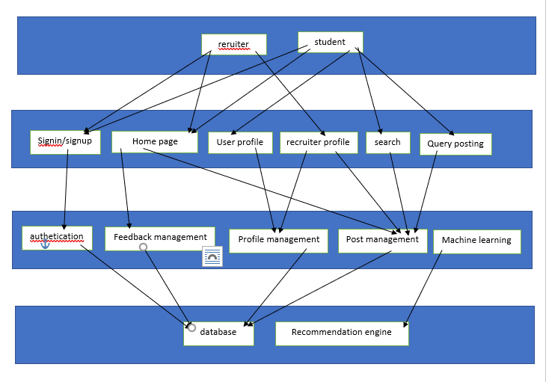

ER DIAGRAM:

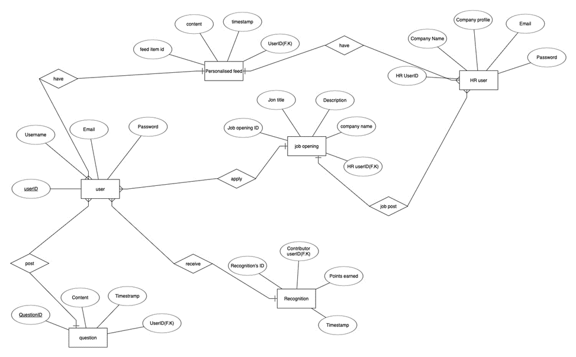

3.1.2 USE CASE DIAGRAM:

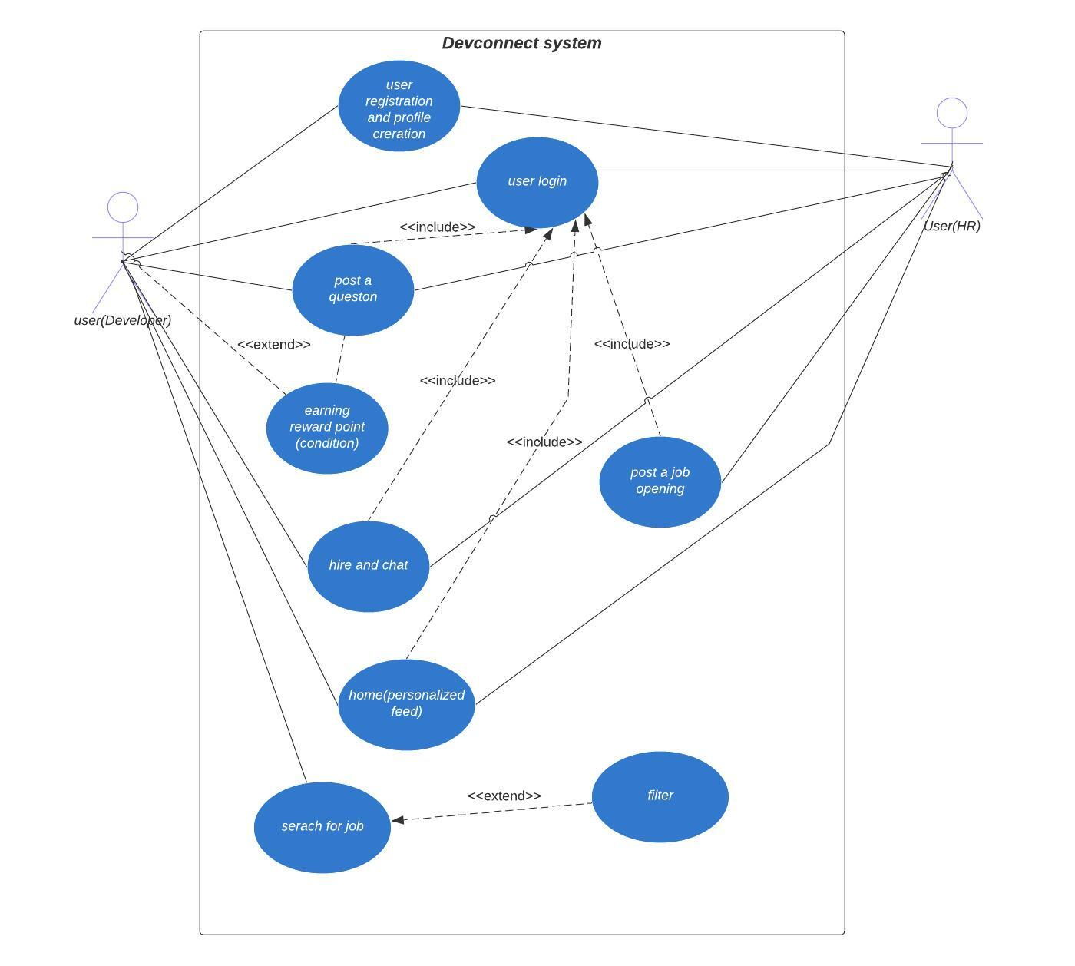

ACTIVITY DIAGRAM

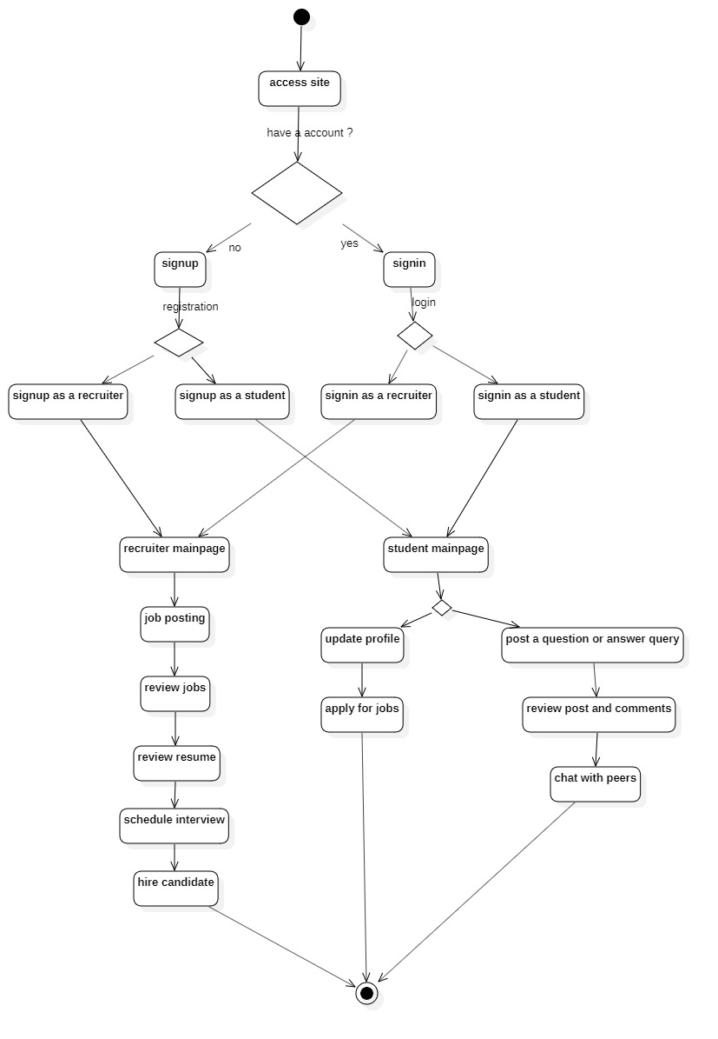

CLASS DIAGRAM

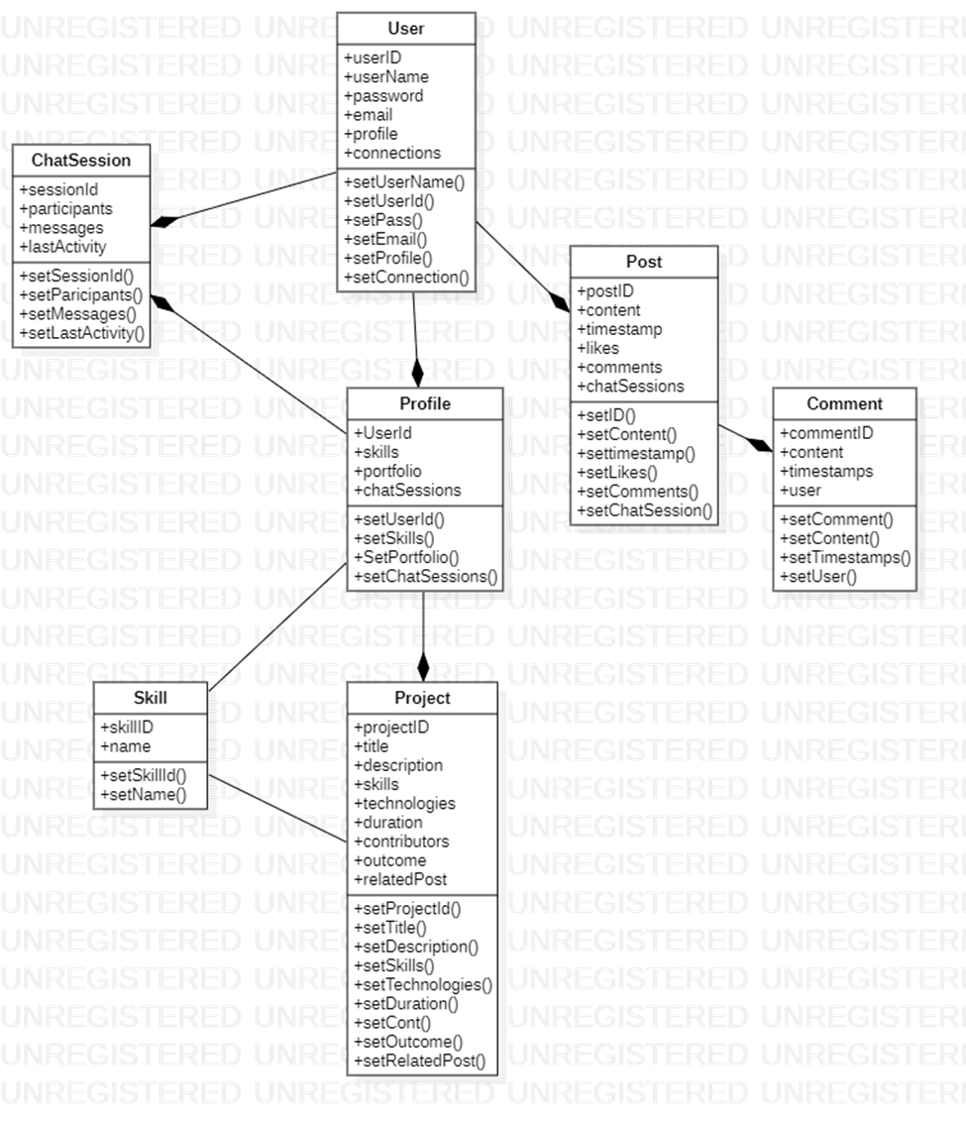

DATA FLOW DIAGRAM

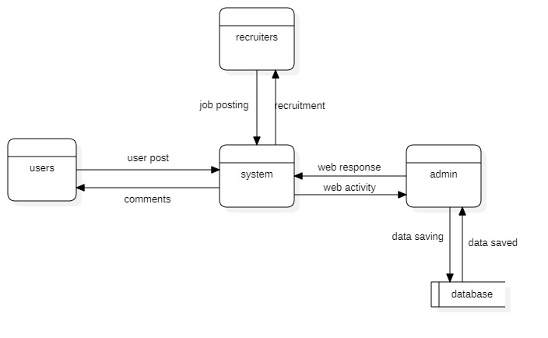

Component Interactions and Collaborations

SEQUENCE DIAGRAMS (LOGIN)

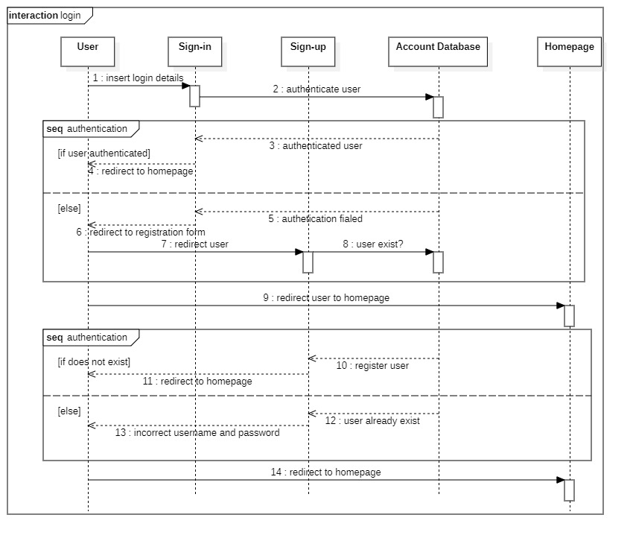

QUESTION AND ANSWERS:
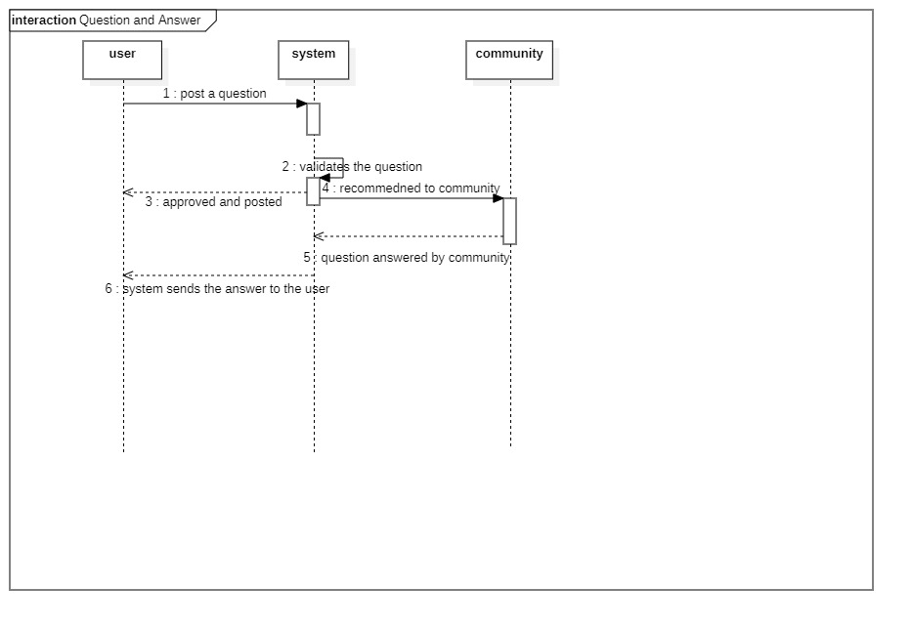

JOB POSTING

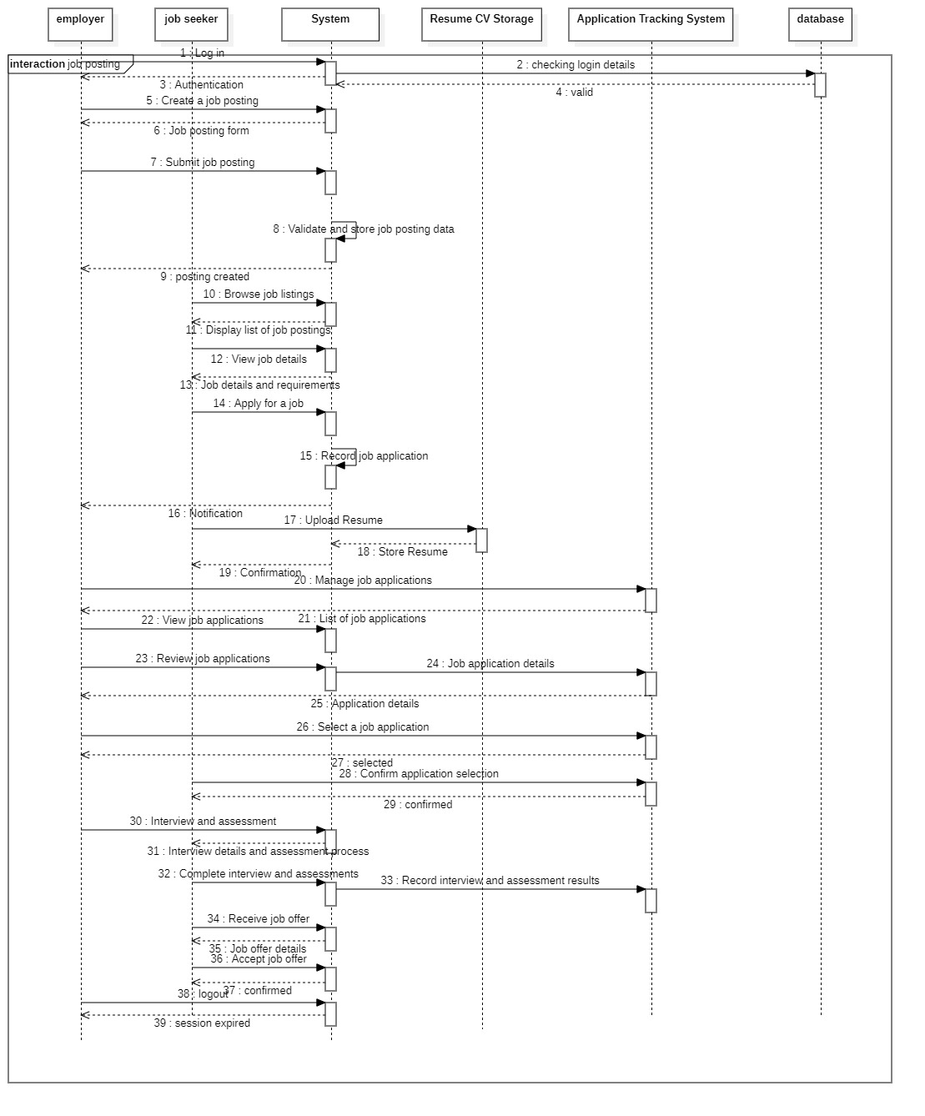

PERSONALIZED FEEDS
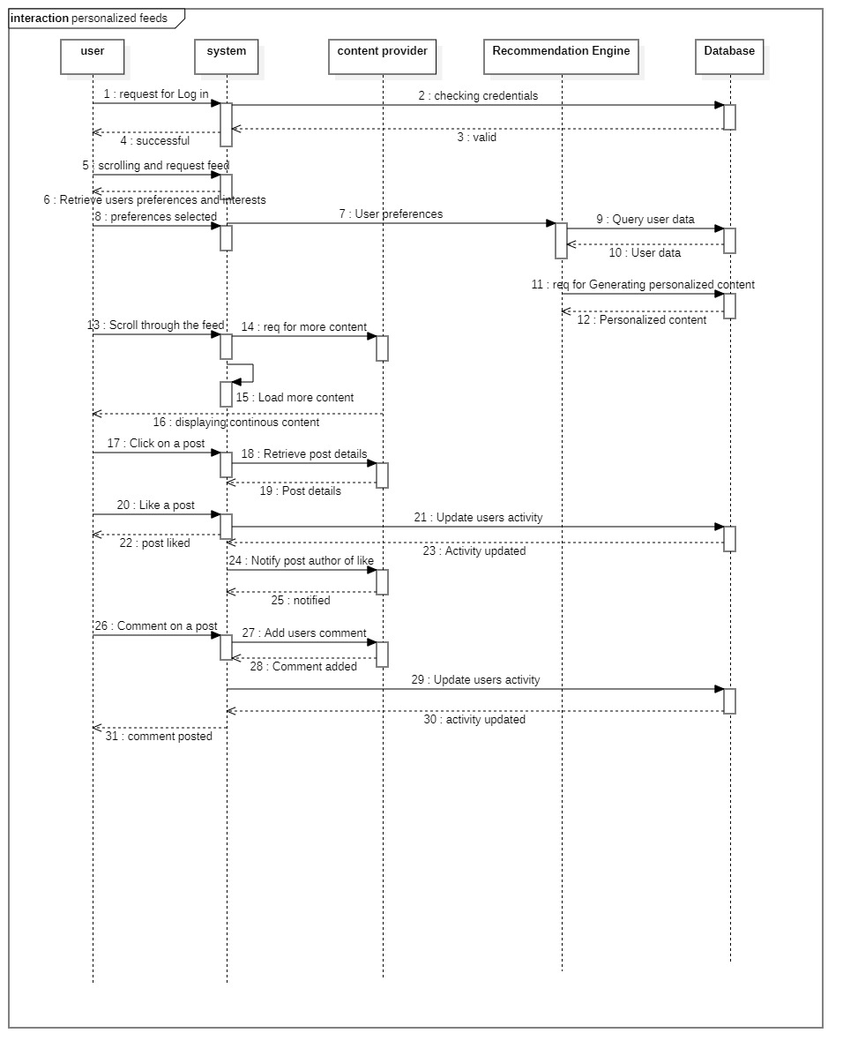

PORTFOLIO SHOWCASE

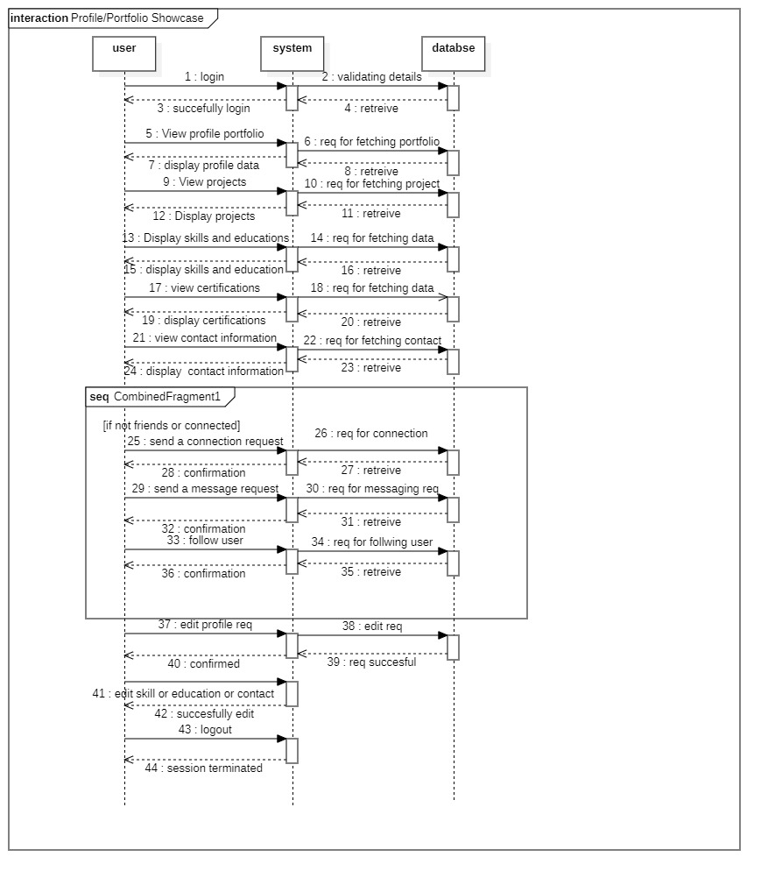

HIRING AND CHAT
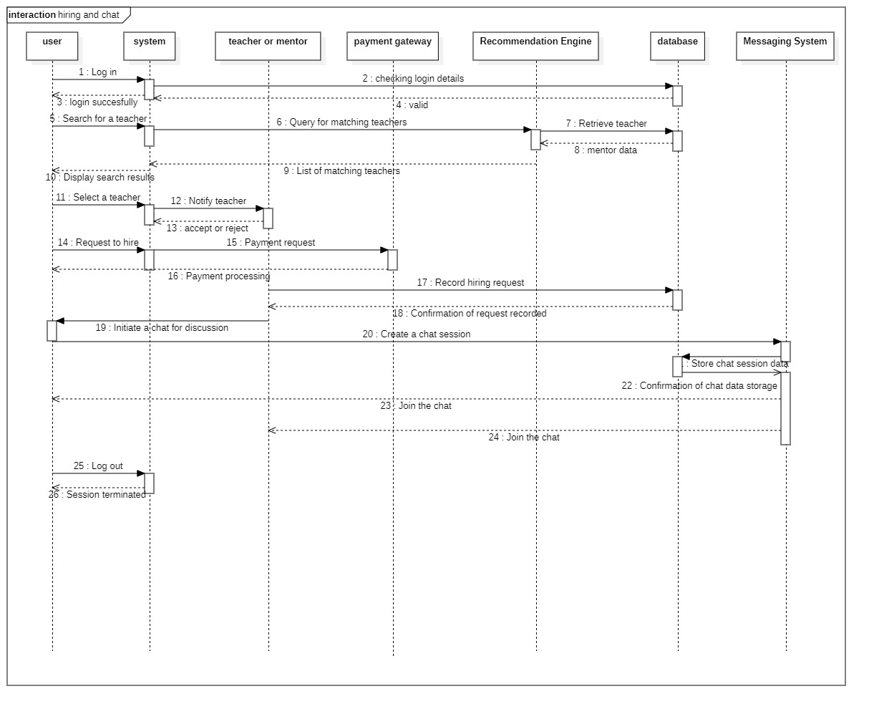

Design Reuse and Design Patterns
- Component-Based Architecture: We will adopt a component-based architecture, common in React.js development, to facilitate code reuse and modular development. Components such as navigation bars, user profiles, and feed sections will be designed as reusable building blocks that can be easily integrated into different parts of the application.
- Model-View-Controller (MVC): In the backend development using Express.js and Node.js, we will adhere to the MVC design pattern. This separation of concerns allows for better code organization, reuse of models and controllers, and easier maintenance.
- Higher-Order Components (HOCs): In React.js, we will utilize Higher-Order Components to encapsulate and share common functionality across different components. HOCs enable code reuse by abstracting logic into reusable functions that can be applied to multiple components.
- Singleton Pattern: Certain modules, such as database connections or logging utilities, will be implemented using the Singleton pattern. This ensures that only one instance of these modules exists throughout the application, promoting resource efficiency and consistency.
- Factory Pattern: In cases where we need to create objects based on certain conditions or configurations, we will employ the Factory pattern. This pattern abstracts the object creation process, allowing for flexibility and easy extension in the future.
- Observer Pattern: For implementing real-time features like notifications or live feeds, we will utilize the Observer pattern. This pattern facilitates communication between components by allowing them to subscribe to and receive updates from observable objects.
- Service-Oriented Architecture (SOA): We will design the system with a service-oriented architecture in mind, breaking down functionalities into separate, loosely coupled services. This promotes reusability, scalability, and easier maintenance of the system as a whole.

Technology Architecture

- Platform:
  - Web Application: Dev Connect will primarily operate as a web-based platform built using the MERN stack.

- System Hosting:
  - Cloud Infrastructure: Host the application on cloud platforms like AWS (Amazon Web Services), Azure, or GCP for scalability and flexibility.
  - Server Hosting: Utilize virtual machines (VMs) or containers (e.g., Docker) to host Node.js server instances running the Express.js framework.

- Database:
- MongoDB Atlas: Host the MongoDB database on MongoDB Atlas, a fully managed cloud database service, for seamless scalability and automatic backups.

- Connectivity Requirements:
- Internet Connectivity: Ensure reliable internet connectivity for users to access the web application.
- API Integrations: Implement RESTful APIs using Express.js to facilitate communication between the client-side (React.js) and server-side (Node.js) components.

- Modes of Operations:
- 24/7 Availability: Design the infrastructure to ensure continuous availability of the web application, leveraging auto-scaling features of cloud platforms.
- Horizontal Scaling: Employ horizontal scaling by adding more server instances or containers to handle increasing user traffic.

- Security Measures:
- Data Encryption: Implement encryption for data transmission using HTTPS protocol to secure communication between client and server.
- Authentication and Authorization: Implement authentication using JWT (JSON Web Tokens) and authorization middleware in Express.js to control access to resources.
- Firewalls and Security Groups: Configure firewalls and security groups on cloud platforms to restrict access to servers and databases.

- Data Backup and Disaster Recovery:
- Automated Backups: Set up automated backups for MongoDB using MongoDB Atlas to ensure data integrity and resilience against data loss.
- Disaster Recovery Plan: Develop a disaster recovery plan outlining procedure to restore the application in the event of system failures or data breaches.

- Monitoring and Analytics:
- Application Monitoring: Utilize monitoring tools like AWS CloudWatch or third-party services to monitor server performance, resource utilization, and application health.

- Compliance and Regulations:
- Regular Security Audits: Conduct regular security audits and vulnerability assessments to identify and mitigate potential security risks.

Screenshots/Prototype

Workflow

Screens
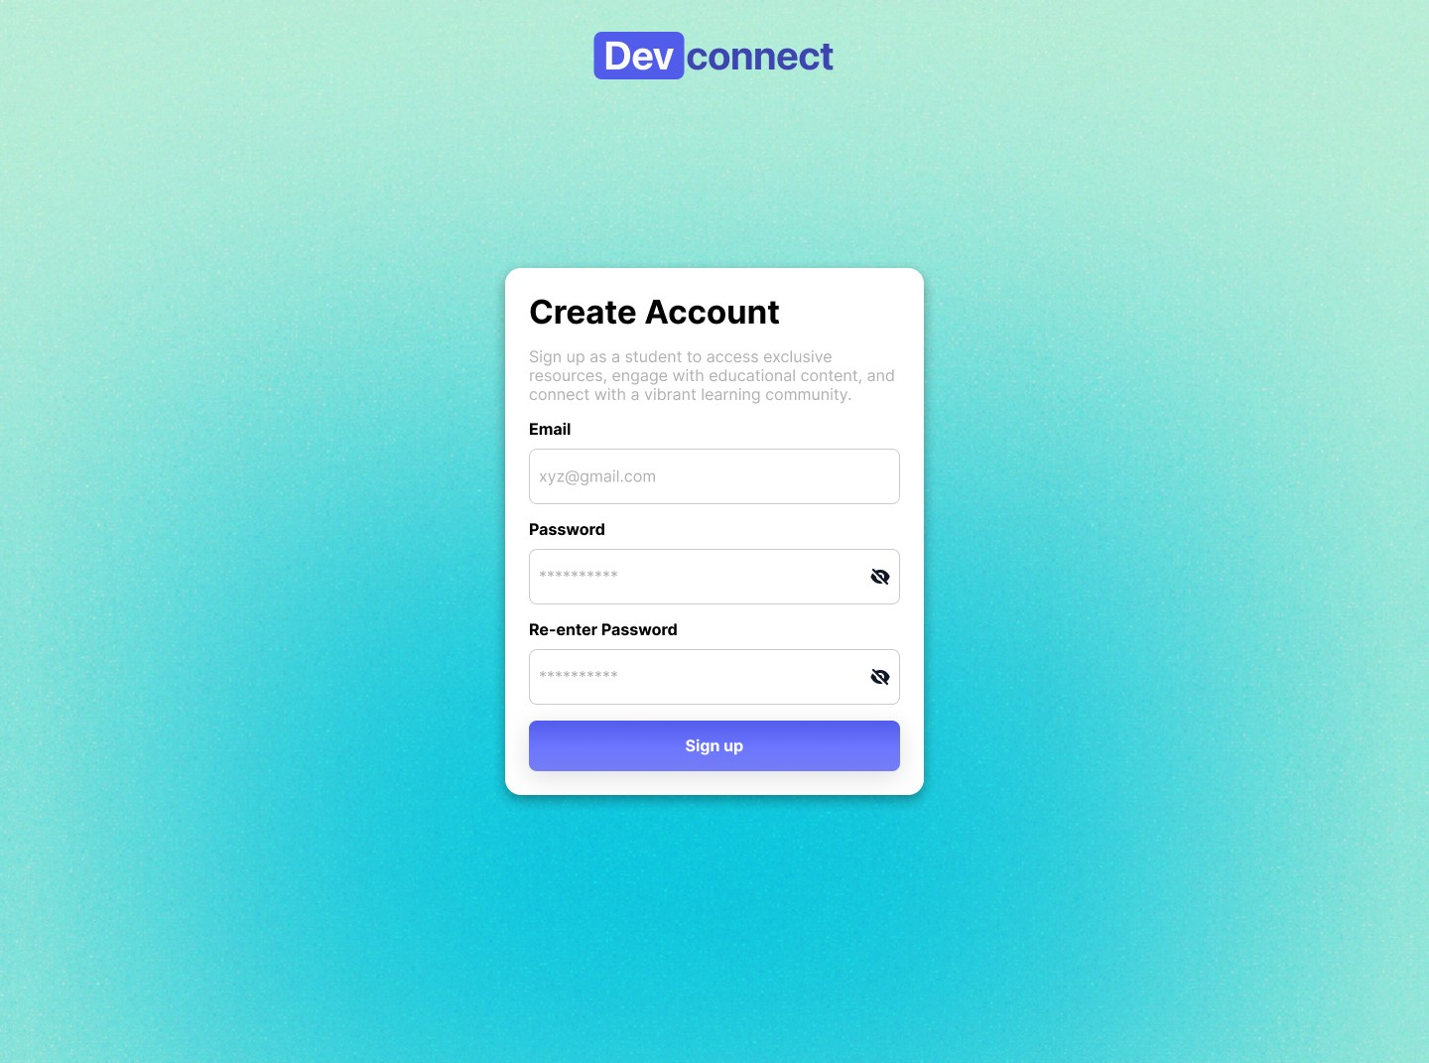

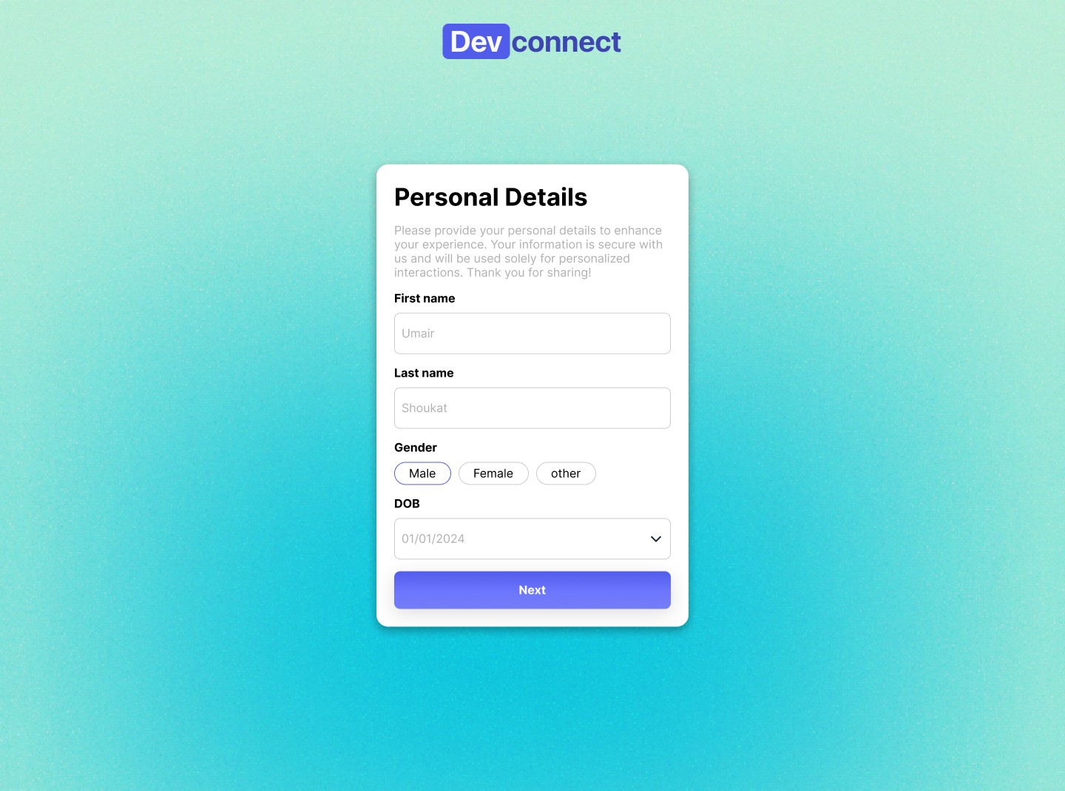

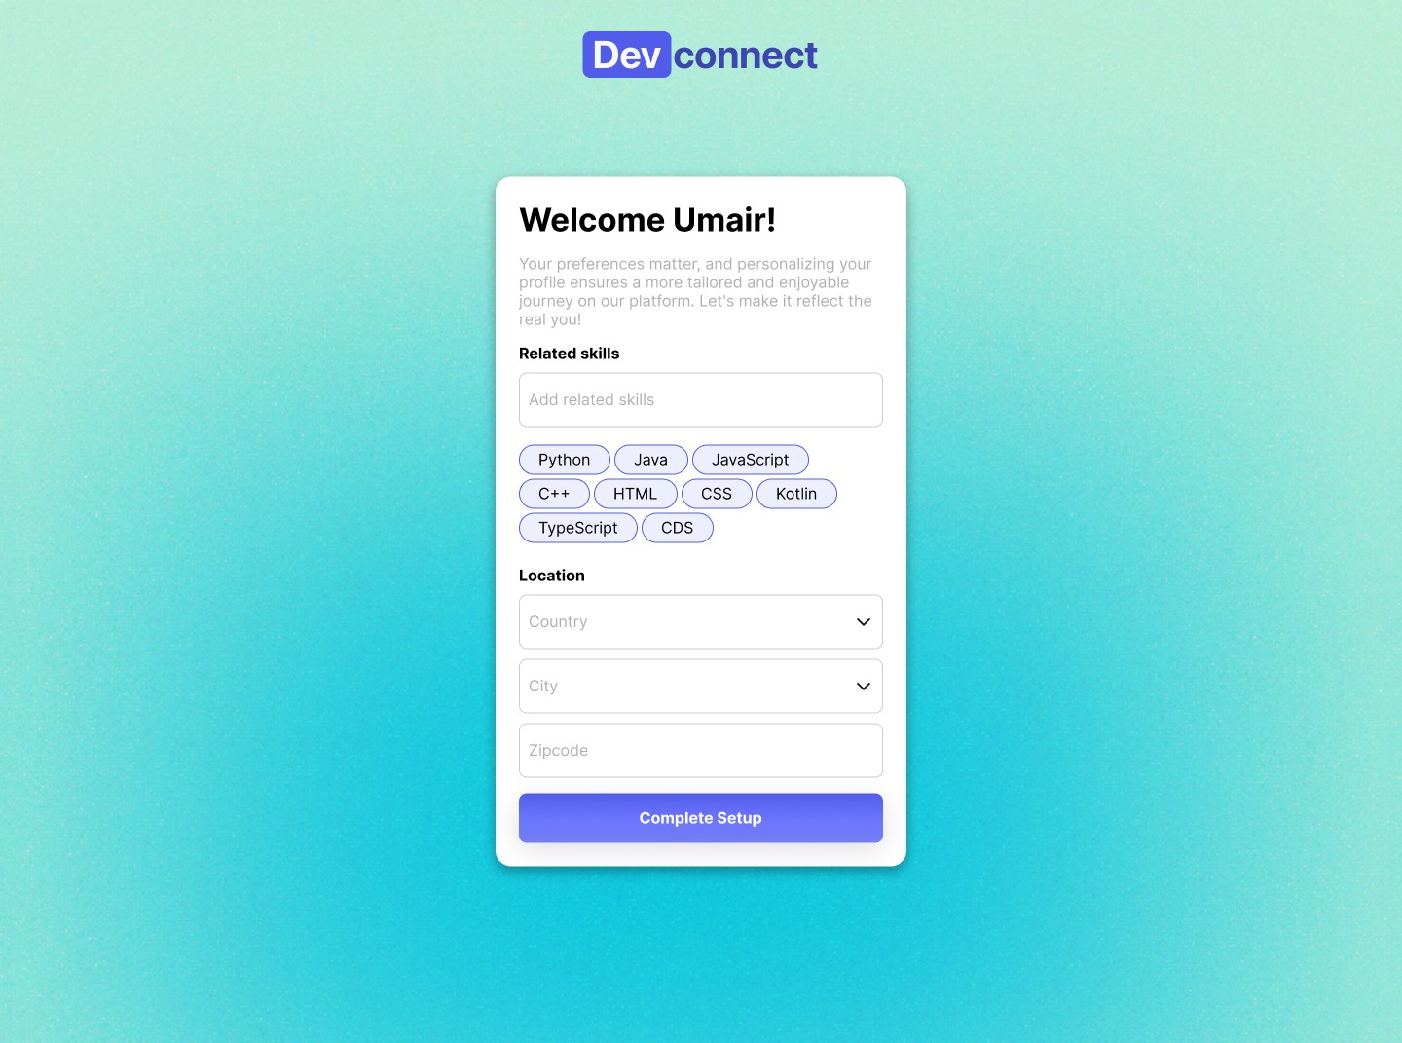

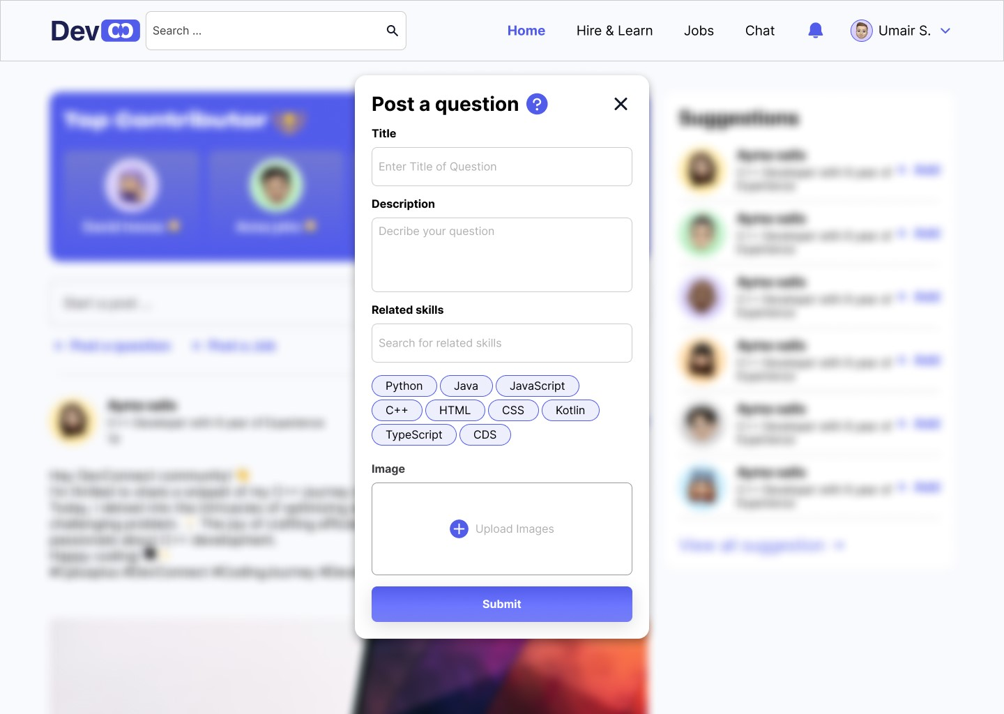

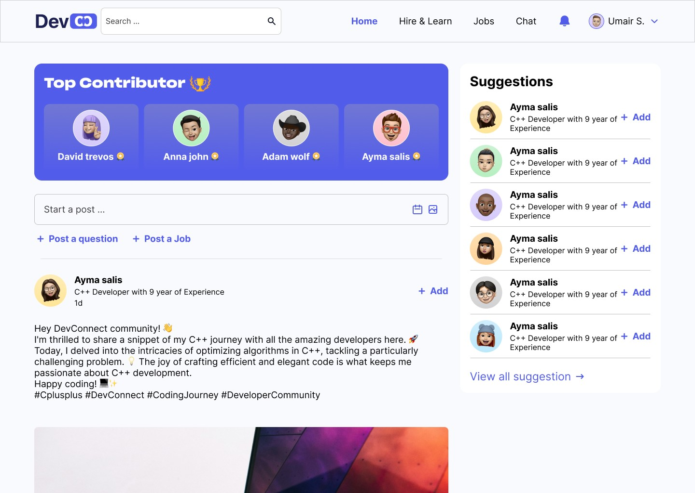

Revised Project Plan
Summary: The project has made significant progress since the initial proposal. All key project phases have been initiated, and several milestones have been achieved on or ahead of schedule. This includes the successful completion of the project's requirements gathering and design phases.

Current Status:
Status: The project is currently ahead of schedule. This is primarily due to effective project planning and resource allocation.

Gantt Chart:

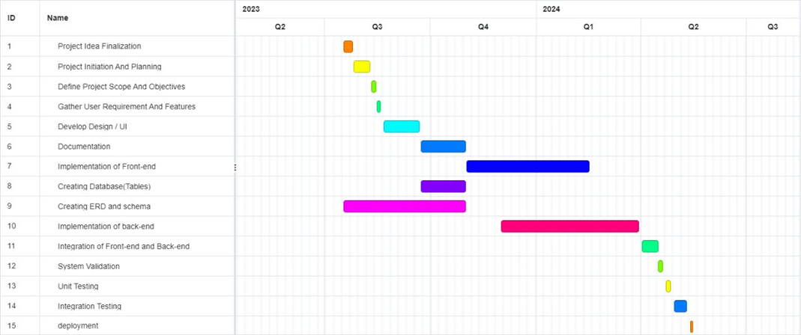

Updated Project Plan:
Revisions: The project plan has undergone minor revisions to adjust to the accelerated pace. These revisions include shorter development and testing cycles, enabling an earlier project completion date. Task dependencies have been carefully managed to maintain a coherent project flow.

Key Milestones:
Milestone 1 - Requirements Gathering (Completed): Completed on Aug 7, 2023. All project requirements have been documented and approved.
Milestone 2 - Design Phase (Completed): Completed on Aug 15, 2023. Detailed system design and architecture have been finalized.
Milestone 3 - Development Phase (started).

References
- M. Christ, A. W. Kempa-Liehr, and M. Feindt. Distributed and Parallel Time Series Feature Extraction
- for Industrial Big Data Applications. Asian Machine Learning Conference. Workshop on Learning on
- Big Data, 2016. https://arxiv.org/abs/1610.07717v1.

- K. Fauvel, T. Lin, V. Masson, E. Fromont, and A. Termier. XCM: An Explainable Convolutional Neural `
- Network for Multivariate Time Series Classification, 2020. https://arxiv.org/abs/2009.04796.
- S. Hochreiter and J. Schmidhuber. Long Short-Term Memory. Neural Computation, 9(8):1735–1780,
- 1997.

- Oguiza. tsai - A State-of-the-art Deep Learning Library for Time Series and Sequential Data, 2020.
- https://github.com/timeseriesAI/tsai.

- Kollnig, K., Datta, S., & Shadbolt, N. (2022, February 23). Imagining, Studying and Realizing a Less Harmful App Ecosystem. Department of Computer Science, University of Oxford, Oxford, United Kingdom. Retrieved from ["https://arxiv.org/pdf/2205.00774.pdf"].

- K. Weinberger and L. Saul. Distance Metric Learning for Large Margin Nearest Neighbor Classification.
- Journal of Machine Learning Research, 10(2):207–244, 2009.

- X. Zou, Z. Wang, Q. Li, and W. Sheng. Integration of Residual Network and Convolutional Neural
- Network along with Various Activation Functions and Global Pooling for Time Series Classification.
- Neurocomputing, 367:39–45, 2019.
Appendix A: Glossary
- API: Application Programming Interface - A set of rules and protocols that allows different software applications to communicate with each other.
- CMS: Content Management System - A software application used to create, edit, manage, and publish digital content, typically used for websites and blogs.
- CSS: Cascading Style Sheets - A style sheet language used for describing the look and formatting of a document written in HTML.
- CCPA: California Consumer Privacy Act - A data privacy law that grants California residents specific rights regarding their personal information.
- DBMS: Database Management System - Software that manages databases, allowing users to store, retrieve, and manipulate data.
- GDPR: General Data Protection Regulation - A European Union regulation that governs data protection and privacy for individuals within the EU.
- HTML: Hypertext Markup Language - The standard language for creating and designing web pages and web applications.
- HTTPS: Hypertext Transfer Protocol Secure - A secure version of HTTP, used for encrypted communication over a computer network.
- MFA: Multi-Factor Authentication - A security process in which users are required to provide multiple forms of identification before accessing an account.
- PCI DSS: Payment Card Industry Data Security Standard - A set of security standards designed to ensure that all companies that accept, process, store, or transmit credit card information maintain a secure environment.
- RDBMS: Relational Database Management System - A type of DBMS that uses a relational model for storing and managing data.
- RBAC: Role-Based Access Control - A security method that restricts system access to authorized users based on their roles and responsibilities.
- SRS: Software Requirements Specification - A document that describes the features, functionalities, and constraints of a software project.
- SUS: System Usability Scale - A widely used questionnaire for measuring the usability and user-friendliness of software and other systems.

- UI: User Interface - The means by which a user interacts with a software application or website.
- UX: User Experience - The overall experience a user has while interacting with a software application or website.
- URL: Uniform Resource Locator - A web address used to access resources on the internet, such as web pages and files.
RBAC- Definition: Role-Based Access Control, a method of managing system access based on user roles and permissions.
Appendix B: IV & V Report
(Independent verification & validation)
IV & V Resource

Name Signature

S | Defect Description | Origin Stage | Status | Fix Time
 |  |  |  | Hours | Minutes
1
2
3
…
Table 1: List of non-trivial defects

