BSSE FINAL PROJECT
Design and Test Specification

DEVCONNECT: EMPOWERING DEVELOPERS NETWORK (THROUGH AI)



Project Advisor

SAIRA LATIF

Presented by:
Group ID: F23SE104

Student Reg Student Name

L1S20BSSE0011 ABDULLAH ZAHID
L1S20BSSE0016 AHSAN AHMAD
L1F19BSSE0248 UMAIR SHOKAT

Faculty of Information Technology

University of Central Punjab
Design and Test Specification
SDP Phase IV

DEVCONNECT: EMPOWERING DEVELOPERS NETWORK (THROUGH AI)
Advisor: Saira Latif

Team: F23SE104
Member Name | Primary Responsibility
ABDULLAH ZAHID | Back-End
AHSAN AHMAD | Front-End
UMAIR SHOUKAT | User Interface

Table of Contents
Table of Contents i
Revision History iii
Abstract iv
1. Introduction 1
1.1 Product 1
1.2 Background 1
1.3 Objective(s)/Aim(s)/Target(s) 1
1.4 Scope 1
1.5 Business Goals 1
1.6 Document Conventions 2
1.7 Miscellaneous 2
2. Technical Architecture 3
2.1 Application and Data Architecture 5
2.1.1 ER diagram 5
2.1.2 use case diagram 6
2.1.3 Activity diagram 7
2.1.4 Class diagram 8
2.1.5 Dataflow diagram 9
2.1.6 Dataflow diagram 10
2.1.7 SEQUENCE DIAGRAMS (LOGIN) 11
2.1.8 QUESTION AND ANSWERS: 12
2.1.9 QUESTION AND ANSWERS: 13
2.1.10 PERSONALIZED FEEDS 14
2.1.11 PORTFOLIO SHOWCASE 15
2.1.12 HIRING AND CHAT 16
2.1.13 Feature box 17
2.1.14 COMPONENT DIAGRAM 18
2.2 Component Interactions and Collaborations 19
2.3 Design Reuse and Design Patterns 19
2.4 Technology Architecture 19
2.5 Architecture Evaluation 20
3. Detailed/Component Design 21
3.1 Component-Component Interface 21
3.2 Component-Human Interface 21
4. Screenshots/Prototype 21
4.1 Workflow 22
4.2 Screens 24
4.3 Screens 24
4.4 Additional Information 32
Test Specification and Results 32
4.4.1 User Registration 32
4.4.2 Profile Creation 33
4.4.3 Post a Coding Question 33
4.4.4 Recognize Contributors 34
4.4.5 Post a Job Opening 34
4.4.6 Teacher Hire and Chat 35
4.4.7 Personalized Feeds 36
5. Other Design Details 37
6. Test Specification and Results 37
6.1 Test Case Specification 37
6.1.1 Login Test Case 37
6.1.2 SIGNUP TEST CASE 37
6.1.3 Logout Test Case 38
6.1.4 Main Screen Test Case 38
6.2 Summary of Test Results 39
7. Project Completion Status 39
8. Deployment/Installation Guide 40
9. User Manual 40
9.1.1 User Manual for MERN Stack Application 40
9.1.2 1. Introduction 40
9.1.3 2. System Requirements 41
9.1.4 3. Installation Guide 41
9.1.5 4. Starting the Application 41
9.1.6 5. Using the Application 42
9.1.7 6. Troubleshooting 43
9.1.8 7. FAQ 43
9.1.9 8. Support 43
10. References 44
11. Project Summary Form 45
Appendix A: Glossary 48
Appendix B: IV & V Report 49

Revision History
Name | Date | Reason For Changes | Version

Abstract
In the ever-evolving landscape of software engineering, our project titled "DevConnect" emerges as a dynamic solution to address the challenges that developers face in their daily pursuits. DevConnect is designed as a comprehensive platform that fosters collaboration, learning, and professional growth within the developer community. This project seeks to resolve the persistent issues of personalized assistance, fragmented learning resources, and limited networking opportunities that developers encounter.

By leveraging the knowledge areas of machine learning, web development, and database management, DevConnect offers a feature-rich environment where developers can connect with like-minded peers, seek guidance from experienced mentors, showcase their skills and projects, and discover tailored learning resources. The platform employs sophisticated content recommendation algorithms, ensuring that users receive content and answers that align with their unique interests and needs.

Our project's significance lies in its potential to transform the developer community, promoting a culture of collaboration and knowledge sharing. DevConnect aims to bridge the gap between novice and experienced developers, facilitating skill development and career advancement for all. By the conclusion of this project, we anticipate a thriving online ecosystem that empowers developers to connect, learn, and excel in their professional journeys.

Introduction
By leveraging the knowledge areas of machine learning, web development, and database management, DevConnect offers a feature-rich environment where developers can connect with like-minded peers, seek guidance from experienced mentors, showcase their skills and projects, and discover tailored learning resources. The platform employs sophisticated content recommendation algorithms, ensuring that users receive content and answers that align with their unique interests and needs.

Product
DevConnect is a comprehensive software platform designed to address the challenges faced by developers within the ever-evolving software engineering domain. The problem statement revolves around the fragmentation of developer resources, the lack of personalized assistance, and limited networking opportunities for developers worldwide.

Background
The field of software engineering is marked by continuous innovation and rapid technological advancements. Developers often find themselves inundated with vast amounts of information, ranging from coding queries to learning resources. Existing platforms may not effectively cater to the individual needs and personalized growth of developers. DevConnect is conceived as a solution to these challenges, creating a platform where developers can collaborate, learn, and showcase their skills.

Objective(s)/Aim(s)/Target(s)
The objectives of the DevConnect project are as follows:

- To create a dynamic platform where developers can connect and collaborate.
- To provide personalized learning resources and assistance.
- To facilitate mentorship and skill development.
- To offer a space for developers to showcase their projects.
- To streamline the job search process for developers.

Scope
This SRS document outlines the requirements for the development of the DevConnect platform, encompassing its core functionalities, user interactions, and system behavior.

Business Goals
DevConnect aligns with several business goals, including:

- Enhancing user engagement and retention.
- Attracting potential recruiters and job opportunities.
- Building a thriving developer community.
- Providing value-added services to users.

Document Conventions
This SRS document follows standard typographical conventions, such as using headings for section titles and bullet points for listing items. However, the writing style is “Times”. Moreover, “✔️” – represents feature present in the system and “❌” - represents feature absent in the system in the heading 1.10. Also, the paragraph font size is 12px. Sub-heading font size is 14px and heading font size is 18px.

Miscellaneous
There are multiple factors that can be helpful in conducting the project work, for example project management plan, task allocation and responsibilities, risk management and visiting software house and observing their projects similar to ours. This will provide better understanding of the tools and techniques used in the project.

Technical Architecture
Is the system custom-built? COTS?
- Yes, our platform/system is custom built web-based platform specifically designed to meet the needs of the developer community. It includes unique features like Q&A section, personalized profiles , recruitment space and machine learning based feeds
What type of processing is the current system responsible for?
- DevConnect involves online processing in which the platform records user interactions and relations with other users and posts. Online processing is used to provide user with quick run time suggestions based on his activity patterns. (Batch processing is used to train ML models periodically for providing users with accurate suggestions and making his profile personalized).
Transaction processing and/or analytical reporting
- The system handles transaction processing (e.g., posting questions, hiring teachers) and analytical reporting (e.g., personalized content delivery through machine learning).
What are the major application components?
- User Interface(UI): web bases UI for interaction and providing utility to user.
- Business Logic: this component involves core functionalities which involve Q&A handling, user and job post handling, hiring and learning as well as chat system. Moreover, it also deals with ML model for recommendations.
- Database: this component involves storing, fetching and manipulating user data.
- Middleware: this component facilitates communication between the UI, business logic and database, in DevConnect we use several middleware such as Express, Mongoose etc.
- API: Connects various components and possibly external services. In our platform we use cloudinary api to store user profile pictures and avatar and neo4j api to communicate with neo4j database, as well as our platform has RESTful api.
What data does the current system collect and manage?
- User Profiles : username, email, password, user skills, user interests, user avatar, user type and user portfolio.
- Q&A: text containing actual question or answer, interactions on the posted question, images relating to text.
- User Activities : user interactions for personalized feeds
- Job Posts: similar to Q&A post with addition of skills required for job and the job position
What is the basic application architecture (layered, client/server, etc.)?
- DevConnect has client/server architecture as user interacts from web and our server handles the requests and sends responds accordingly
What programming language is the current system built in?
- The platform is currently built on Nodejs which is based on JavaScript. The framework of node used is Express.
What is the hardware platform that supports the current system?
- Our system is supported by cloud based Infrastructure for scalability and reliability.
What database platform supports the current system?
- Our platform uses two databases a MongoDB which is NoSQL for all data recording and manipulation and a graph data base Neo4j for recommendations
Does the system have an end-user interface? If so, what type of user interface? (e.g., browser based, thick client)?
- Our platform has browser based interface as our platform is built using react which works on browser.
What is the basic network architecture (e.g., available on LAN, WAN, Internet)?
- Internet: as DevConnect is web-based platform hence it is accessible over internet, allowing global access.
Where is the system hosted (e.g., Enterprise Data Center, Other CMS Data Center, External Data Center)?
External Data Center: For security, readability and ease of access DevConnect is hosted on cloud data center.

Application and Data Architecture

ER diagram

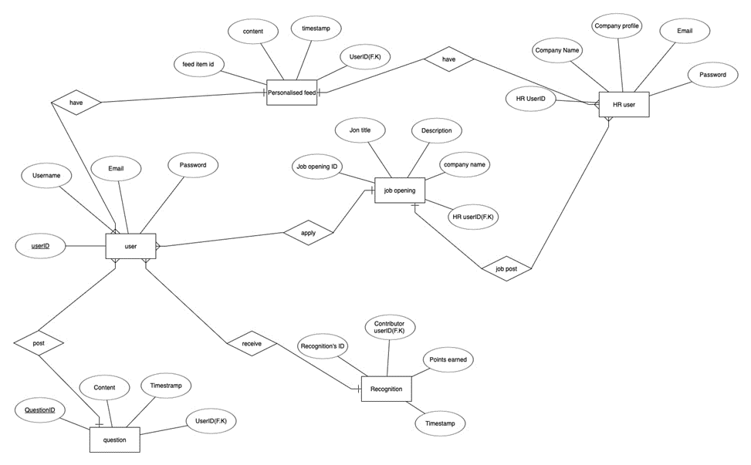

use case diagram

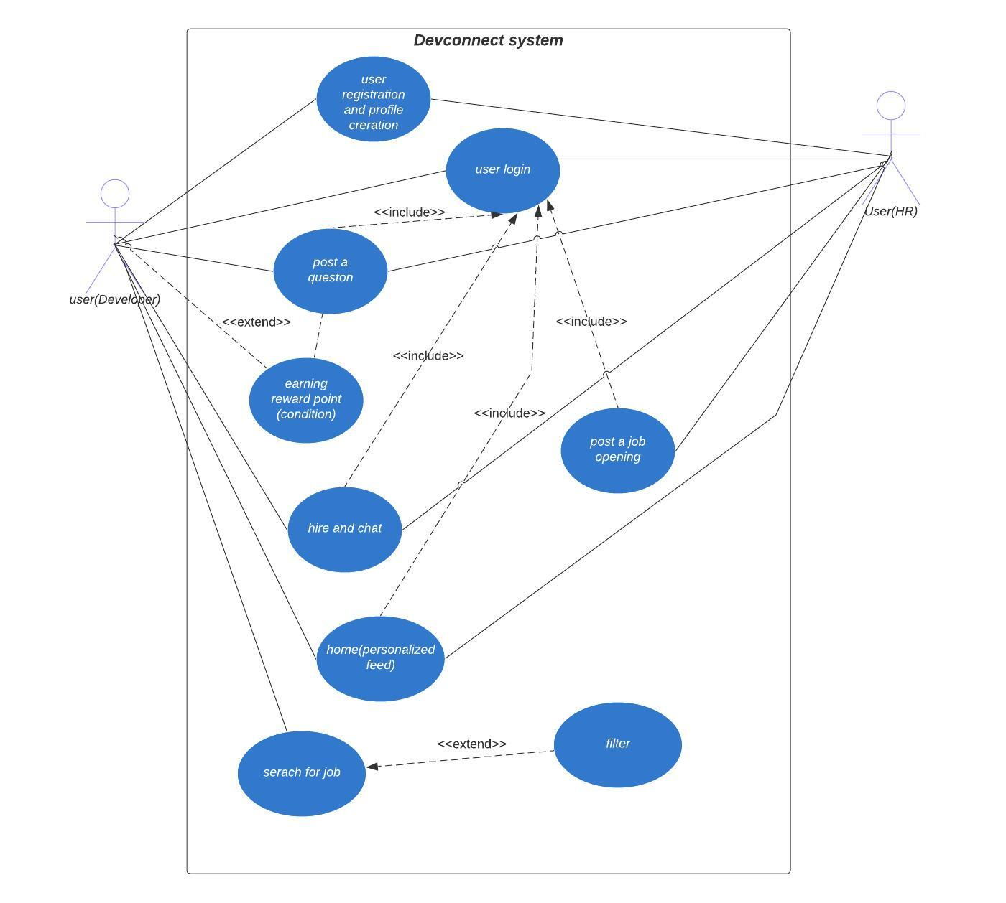

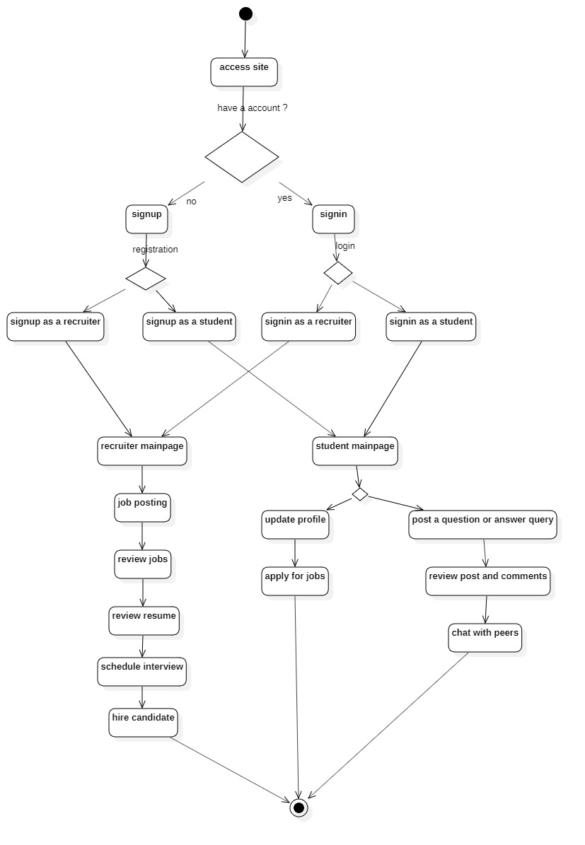

Activity diagram

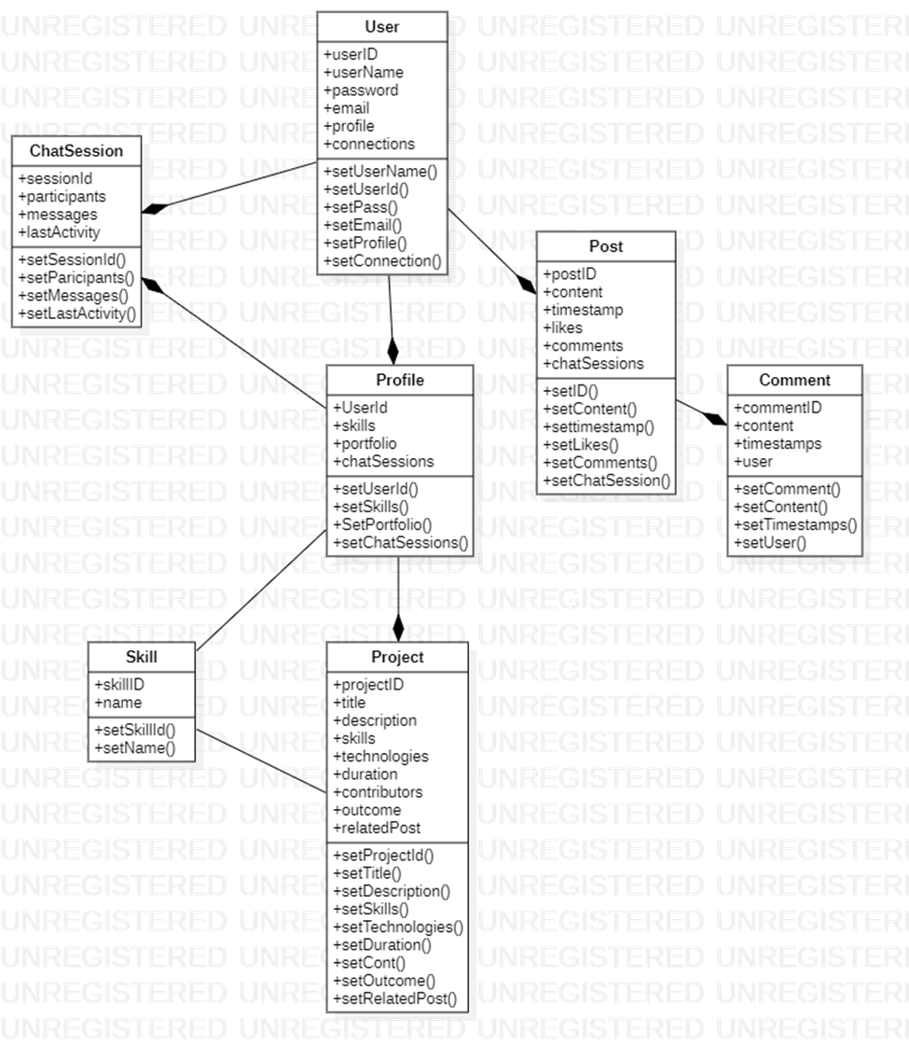

Class diagram

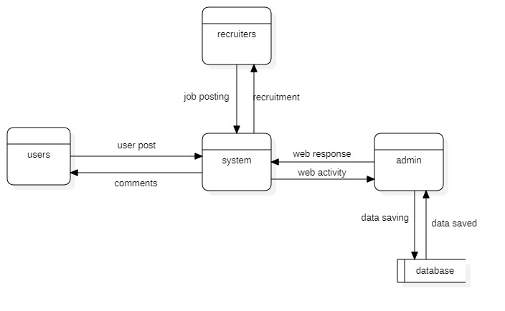

Dataflow diagram

Dataflow diagram

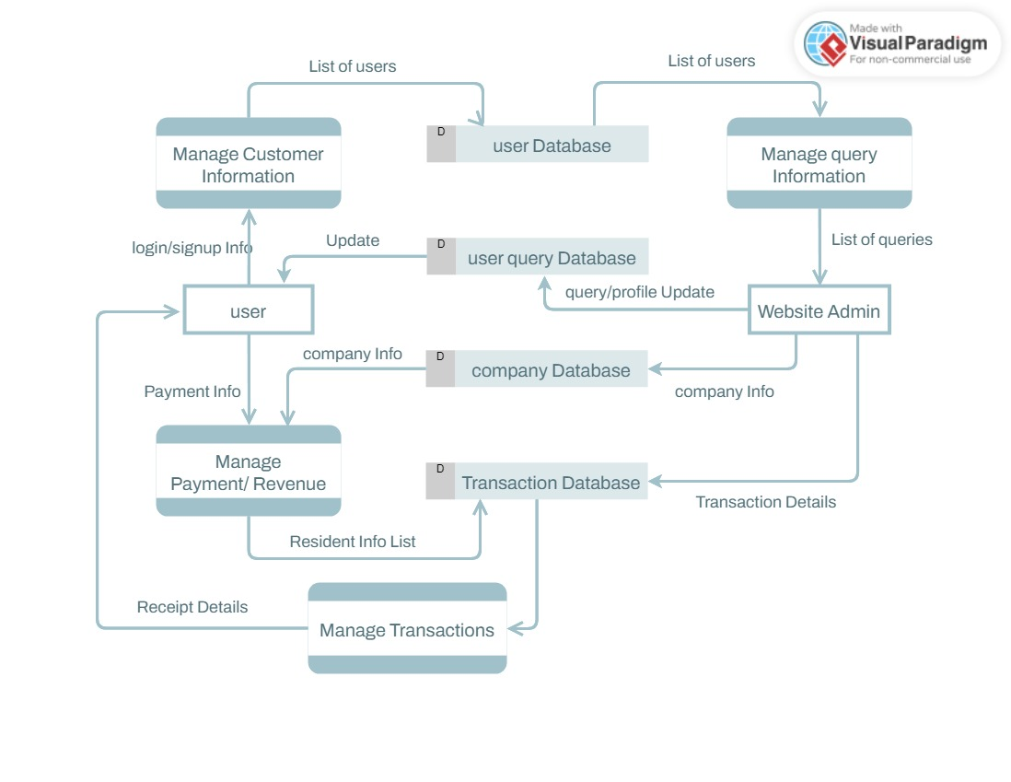

SEQUENCE DIAGRAMS (LOGIN)

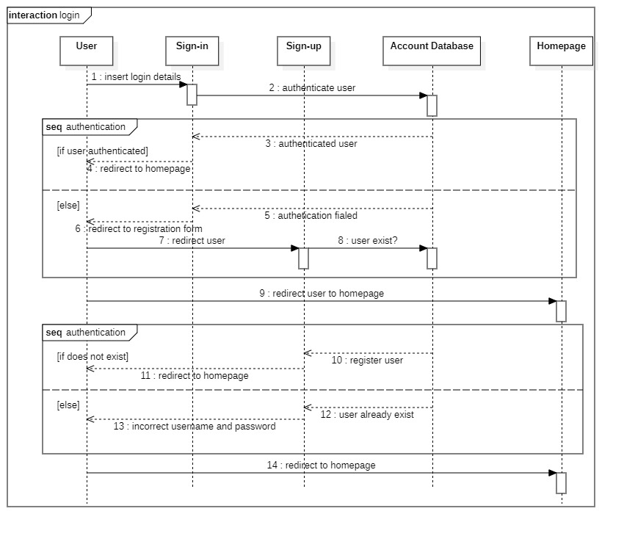

QUESTION AND ANSWERS:
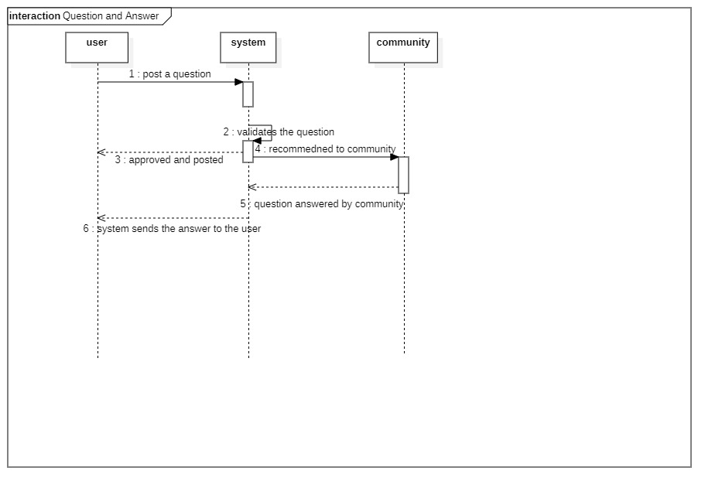

QUESTION AND ANSWERS:
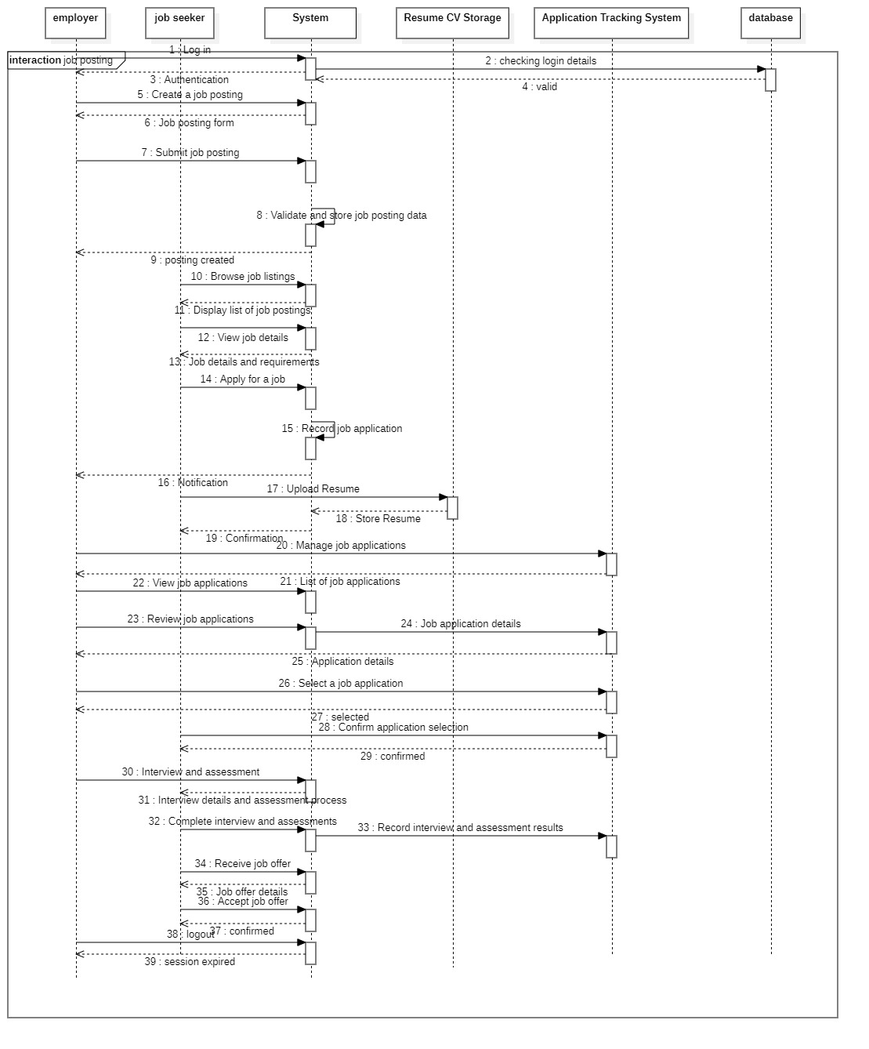

PERSONALIZED FEEDS
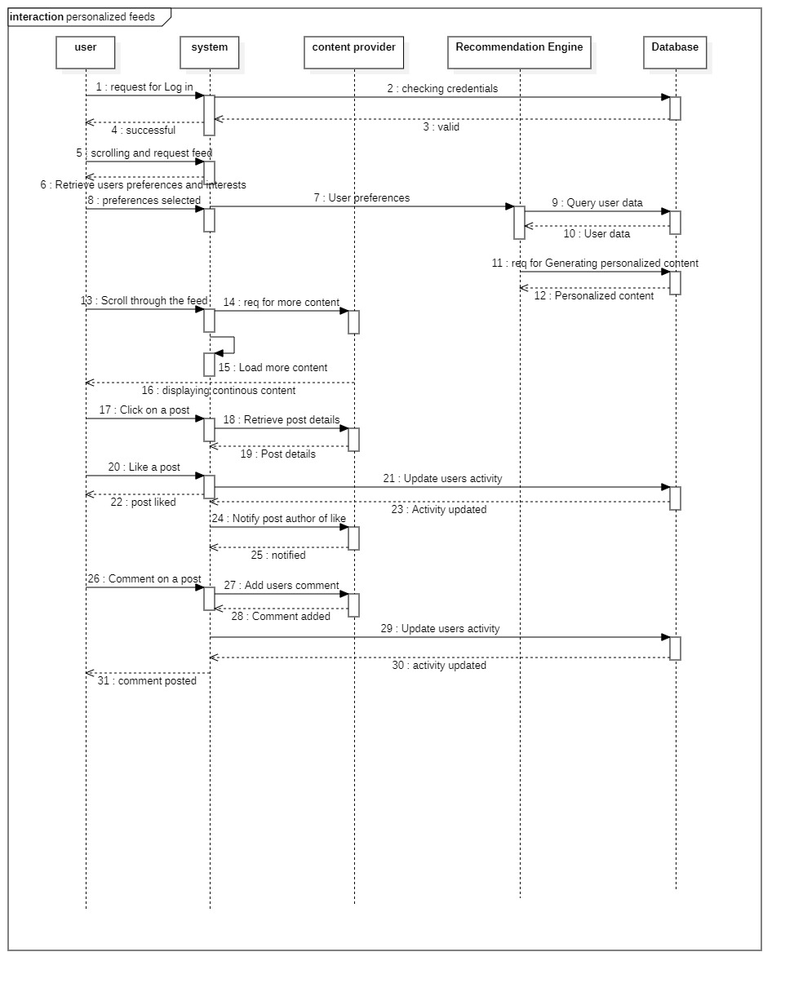

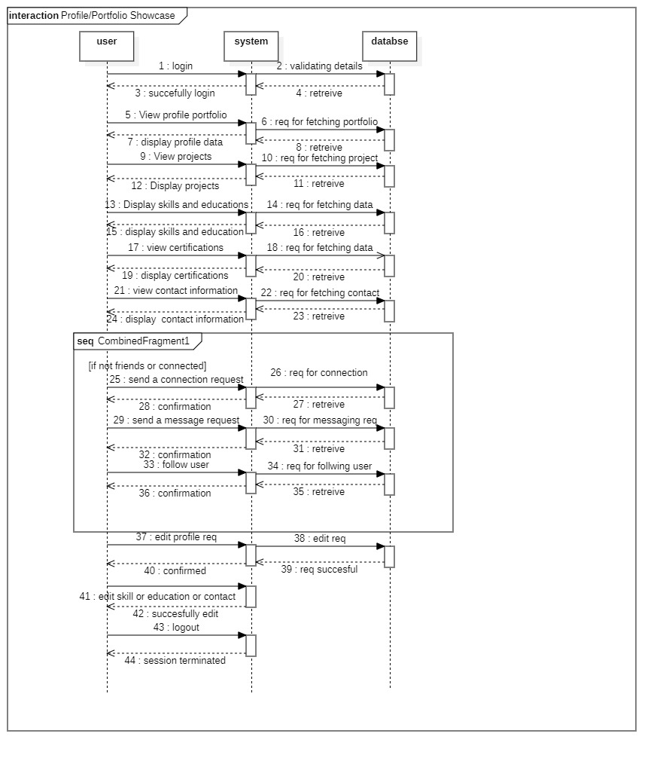
PORTFOLIO SHOWCASE

HIRING AND CHAT
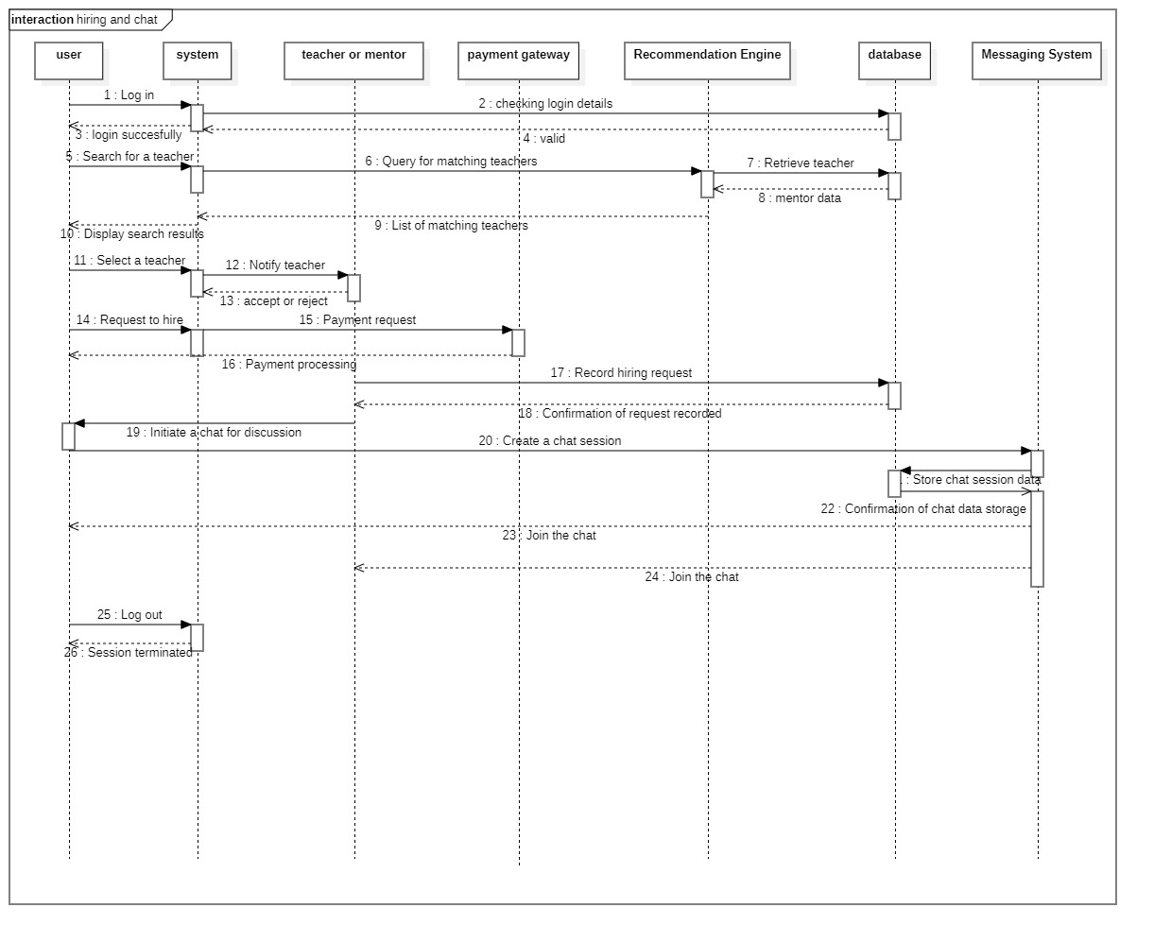

Feature box

Features | DevConnect | Stack Overflow | GitHub | StudyPool | LinkedIn
User Profiles | ✔️ | ✔️ | ✔️ | ✔️ | ✔️
Question and Answer System | ✔️ | ✔️ | ❌ | ❌ | ❌
Personalized Feeds | ✔️ | ❌ | ❌ | ❌ | ✔️
Hire and Real-Time Chat | ✔️ | ❌ | ❌ | ❌ | ❌
Job Postings | ✔️ | ❌ | ❌ | ❌ | ✔️
Portfolio Showcase | ✔️ | ❌ | ❌ | ❌ | ✔️
Reputation System | ✔️ | ✔️ | ❌ | ✔️ | ✔️
Skill Endorsements | ✔️ | ❌ | ❌ | ❌ | ✔️
Community Forums | ✔️ | ✔️ | ❌ | ❌ | ❌
Collaborative Coding w.r.t problem solving | ✔️ | ✔️ | ❌ | ❌ | ❌

COMPONENT DIAGRAM

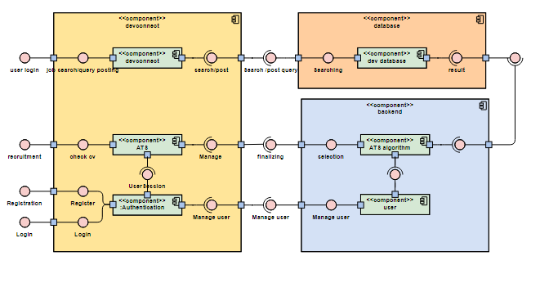

Component Interactions and Collaborations
All diagram are placed above.

Design Reuse and Design Patterns
No resue

Technology Architecture
The infrastructure required to support the application and information architecture for this project involves several key components. Below are the details of the technology architecture:

Platform
- Frontend: React.js
  - A JavaScript library for building user interfaces, React.js is used for creating dynamic and responsive web applications.
- Backend: Node.js with Express.js
  - Node.js provides a runtime environment for server-side applications, while Express.js is a web application framework for handling routing, middleware, and more.

Connectivity Requirements
- API Communication: RESTful APIs
  - The application utilizes RESTful APIs for communication between the frontend and backend. This includes endpoints for user authentication, data retrieval, and data submission.
- Real-time Communication: Socket.io
  - For real-time chat functionality, Socket.io is used. It enables bidirectional communication between the client and server.

Modes of Operations
- Development Environment: Local machines and cloud-based development environments
  - Developers work in local environments configured with the necessary tools and libraries.
- Staging Environment: A staging server for pre-production testing
  - Before deployment to production, changes are tested in a staging environment to ensure functionality and performance.

External APIs
- Cloudinary API
  - Cloudinary is used for managing and delivering images and videos in the application. It provides functionalities such as image upload, storage, transformation, and delivery.

Architecture Evaluation
The decision to use the MERN stack (MongoDB, Express.js, React.js, Node.js) for our project was driven by several key factors. The MERN stack allows for seamless integration between the frontend and backend, as all components use JavaScript, simplifying development and maintenance. MongoDB provides a flexible, schema-less database structure that is ideal for handling diverse data types, while Node.js and Express.js offer a powerful backend framework for building scalable server-side applications.
React.js was chosen for the frontend due to its component-based architecture and efficient rendering, which enhances user experience. For real-time communication, Socket.io was selected for its ease of integration and robust performance in handling bidirectional data flow, essential for chat functionality. Cloud nary was chosen for image and video management because of its advanced capabilities in media processing and delivery, streamlining these tasks significantly.
The external API for geographical data was selected based on its comprehensive coverage and ease of use, ensuring accurate and reliable location data. While alternatives like the MEAN stack (using Angular instead of React) or traditional SQL databases could have been considered, the MERN stack's flexibility, modern development practices, and strong community support were decisive factors in its selection. Additionally, Cloudinary and Socket.io offered the best balance of features and ease of implementation compared to their alternatives.

Detailed/Component Design
Class diagram, scheme of database, sequence diagram , use case diagram are all used above.

Component-Component Interface

Component-Human Interface
All screens are pasted below

Screenshots/Prototype
All pasted below

Workflow

Screens

Screens

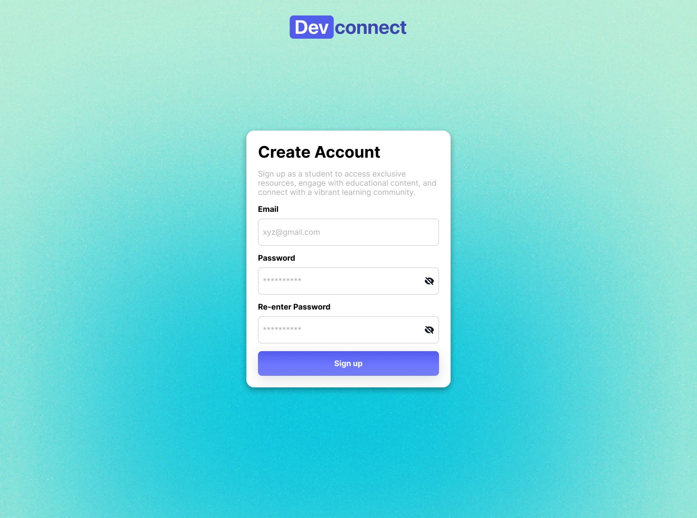

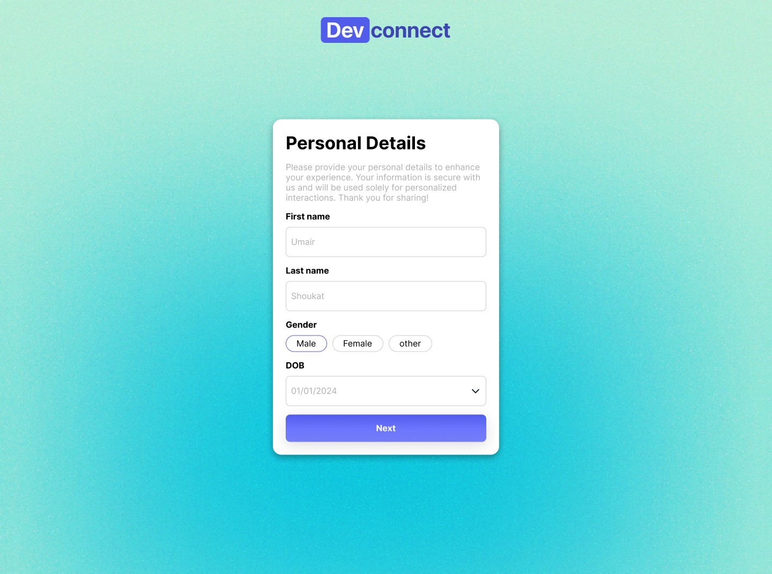

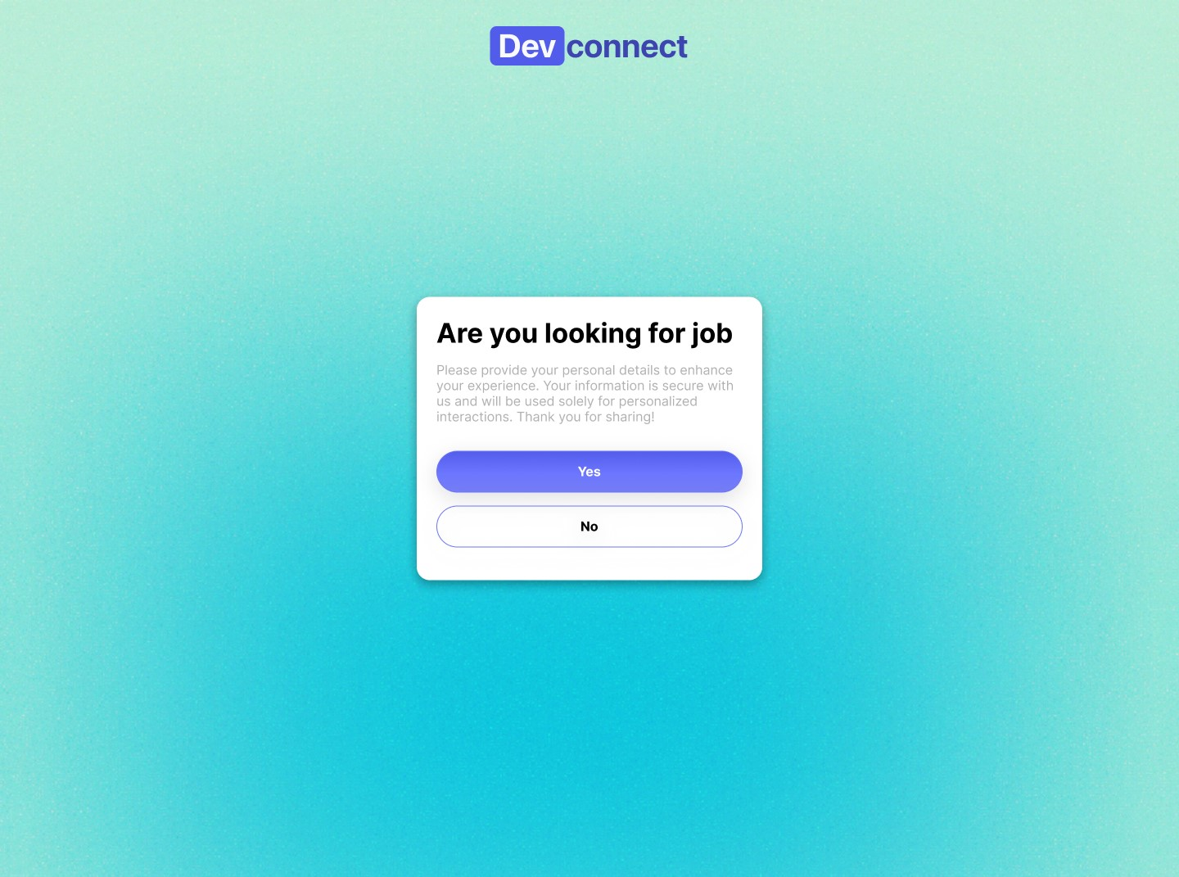

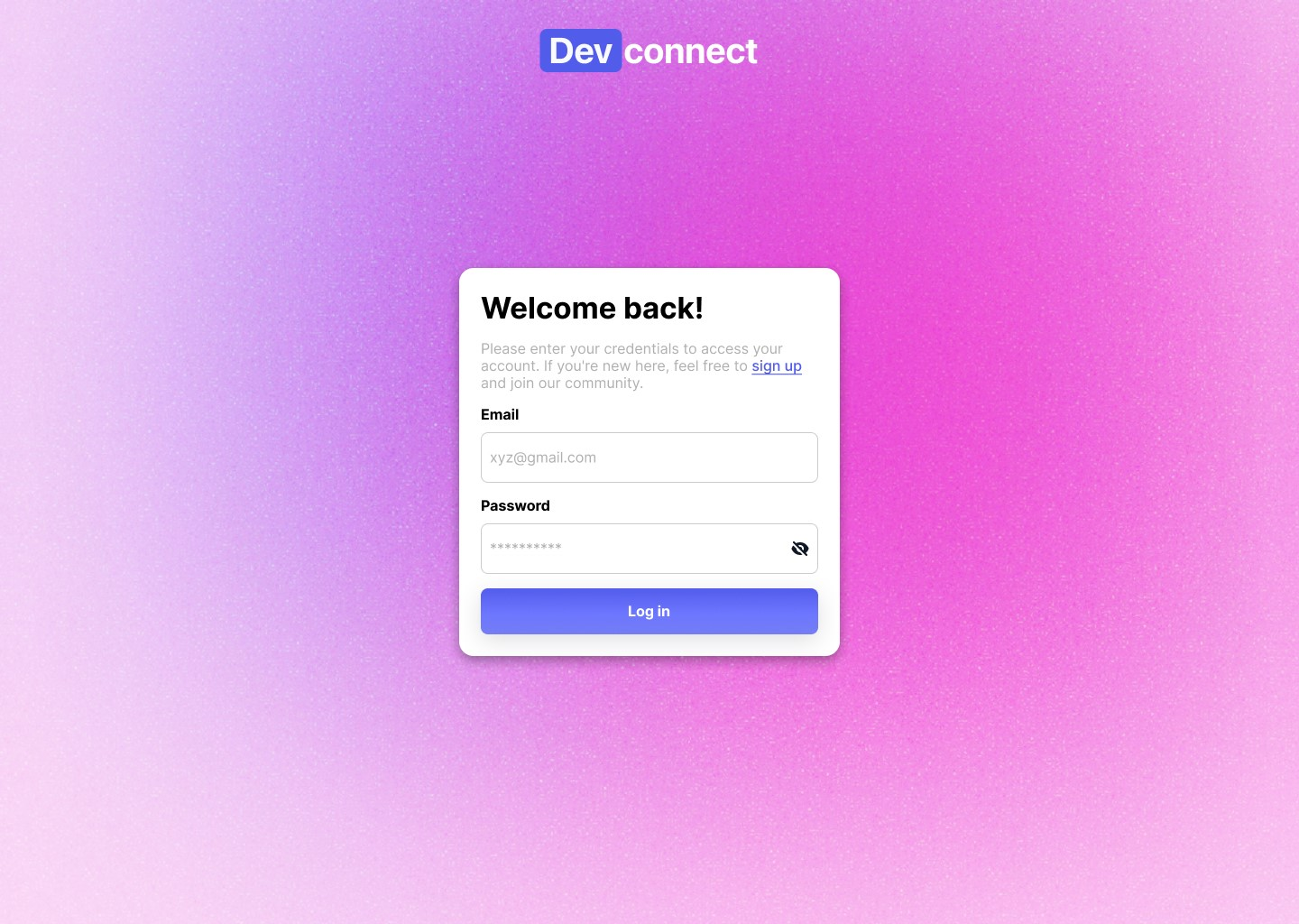

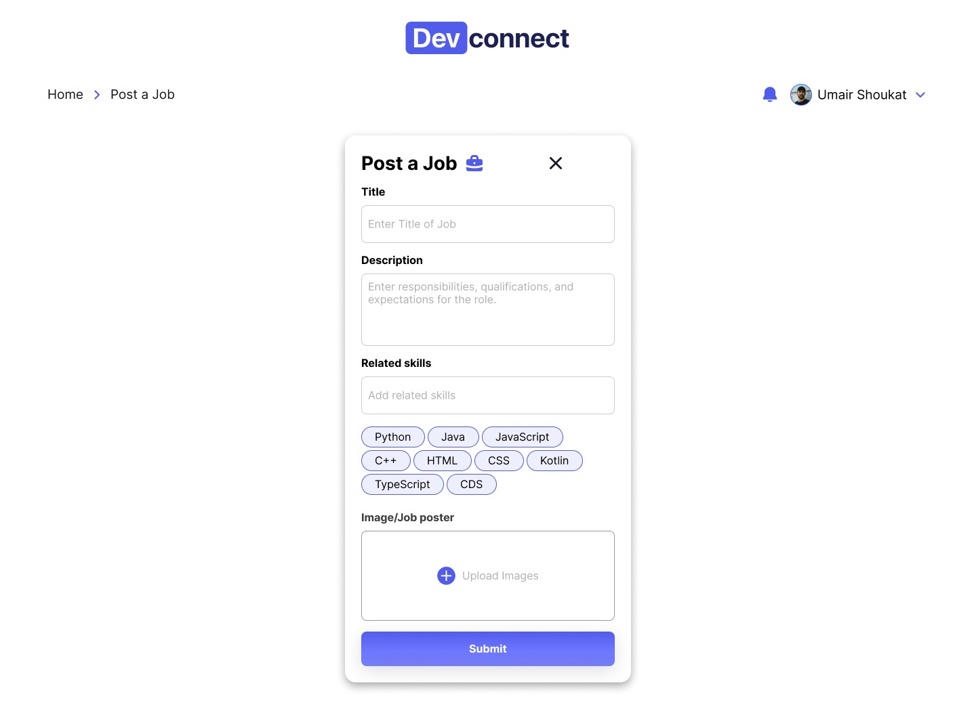

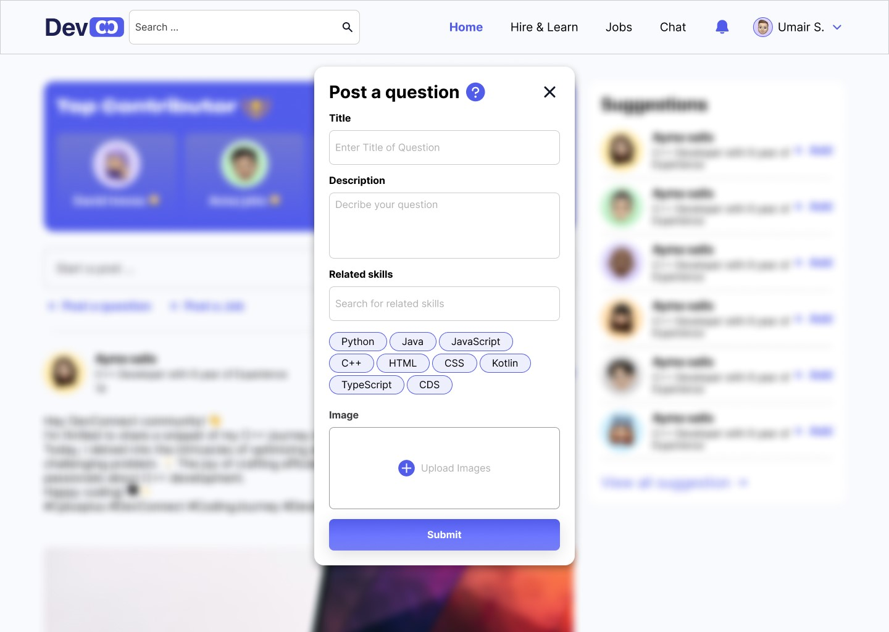
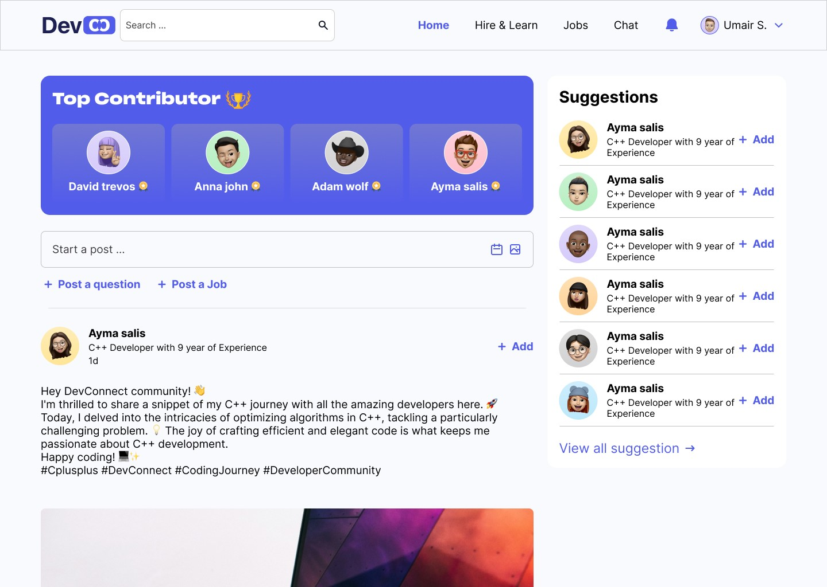

Additional Information

Test Specification and Results

User Registration
Identifier |  | User Registration
Purpose |  | To allow users to create accounts on the platform.
Priority |  | High
Pre-conditions |  | User accesses the registration page.
Post-conditions |  | User has a registered account.
Typical Course of Action
S# | Actor Action |  | System Response
1 | User navigates to the registration page. |  | System displays the registration form.
2 | User enters required registration details (e.g., username, email, password). |  | System validates and stores user information.
3 | User submits the registration form. |  | System creates a new user account.
Alternate Course of Action
S# | Actor Action |  | System Response
1 | User tries to register with an existing email or username. |  | System displays an error message.
2 | User enters invalid registration information. |  | System prompts the user to correct the information.

Table 1: UC-1

Profile Creation
Identifier |  | Profile Creation
Purpose |  | To enable users to create and customize their developer profiles.
Priority |  | High
Pre-conditions |  | User is registered and logged in.
Post-conditions |  | User has a personalized developer profile.
Typical Course of Action
S# | Actor Action |  | System Response
1 | User navigates to their profile settings.. |  | System displays profile editing options.
2 | User adds or updates profile information (e.g., skills, experience, portfolio). |  | System saves the changes to the user's profile..
Alternate Course of Action
S# | Actor Action |  | System Response
1 | User attempts to edit the profile without being logged in. |  | System prompts the user to log in.
2 | User enters incomplete or invalid information. |  | System displays error messages and asks the user to correct the information.
Table 2: UC-2

Post a Coding Question
Identifier |  | Post a Coding Question
Purpose |  | To enable users to post coding-related questions.
Priority |  | High
Pre-conditions |  | User is logged in.
Post-conditions |  | The user's question is posted on the platform.
Typical Course of Action
S# | Actor Action |  | System Response
1 | User navigates to the question posting section. |  | System displays the question posting interface.
2 | User enters the question's title, description, and tags. |  | System validates the information.
3 | User submits the question. |  | System adds the question to the platform's question database..
4 | System notifies the user that the question has been posted successfully.
Alternate Course of Action
S# | Actor Action |  | System Response
1 | User attempts to post a question without being logged in. |  | System prompts the user to log in.
2 | User enters incomplete or invalid information. |  | System displays error messages and asks the user to provide the required details.
Table 3: UC-3

Recognize Contributors
Identifier |  | Recognize Contributors
Purpose |  | To recognize and reward users for their contributions to the platform.
Priority |  | Medium
Pre-conditions |  | User contributes to the platform (e.g., posts questions, provides answers).
Post-conditions |  | User receives recognition and rewards..
Typical Course of Action
S# | Actor Action |  | System Response
1 | User actively contributes to the platform (e.g., posts high-quality content, helps others). |  | System tracks user contributions.
2 | System periodically evaluates user contributions. |  | System calculates recognition points and rewards.
3 | User receives notifications or badges for their contributions. |  | User profile displays earned recognition and rewards.
Table 4: UC-4

Post a Job Opening
Identifier |  | Post a Job Opening
Purpose |  | To enable recruiters to post job openings on the platform.
Priority |  | High
Pre-conditions |  | Recruiter is logged in.
Post-conditions |  | The job opening is posted on the platform
Typical Course of Action
S# | Actor Action |  | System Response
1 | Recruiter navigates to the job posting section. |  | System displays the job posting interface..
2 | Recruiter enters job details (e.g., title, description, requirements). |  | System validates the information.
3 | Recruiter submits the job posting. |  | System adds the job opening to the platform's job listings.
4 | System notifies the recruiter that the job has been posted successfully.
Alternate Course of Action
S# | Actor Action |  | System Response
1 | Recruiter attempts to post a job without being logged in. |  | System prompts the recruiter to log in.
2 | Recruiter enters incomplete or invalid job information.. |  | System displays error messages and asks the recruiter to provide the required details.
Table 5: UC-5

Teacher Hire and Chat
Identifier |  | Hire a Teacher and Chat
Purpose |  | To allow users to hire experienced developers for mentorship and have real-time chat sessions.
Priority |  | High
Pre-conditions |  | User is logged in.
Post-conditions |  | User hires a teacher and can initiate a chat session.
Typical Course of Action
S# | Actor Action |  | System Response
1 | User searches for available teachers. |  | System displays a list of available teachers
2 | User selects a teacher and initiates a mentorship request. |  | System notifies the teacher and awaits their response.
3 | Teacher accepts the request.. |  | System establishes a real-time chat session between the user and teacher.
Alternate Course of Action
S# | Actor Action |  | System Response
1 | User attempts to initiate a chat without being logged in. |  | System prompts the user to log in.
2 | Teacher declines the mentorship request. |  | System notifies the user that the request was declined.

Table 6: UC-6

Personalized Feeds
Identifier |  | Personalized Feeds
Purpose |  | To present users with personalized feeds of content based on their interests and activities.
Priority |  | Medium
Pre-conditions |  | User is logged in
Post-conditions |  | User views their personalized feed.
Typical Course of Action
S# | Actor Action |  | System Response
1 | User navigates to the personalized feed section. |  | System retrieves and displays relevant content based on user interests.
2 | User scrolls through the feed. |  | System

Other Design Details
Its not a research based.

Test Specification and Results

Test Case Specification

Login Test Case

Identifier: TC-Login-1
Identifier | TC-Login-1
Related requirements(s) | <Include use-case identifier(s) for functional requirement(s) and SRS section/sub-section number(s) for other requirement(s).>
Short description | Verify that the user can successfully log into the application.
Pre-condition(s) | The user must have an existing account with valid credentials.
Input data | Valid username and password.
Detailed steps | 1. Navigate to the login page.<br>2. Enter the valid username and password.<br>3. Click on the "Login" button.
Expected result(s) | The user is successfully logged into the application and redirected to the main screen.
Post-condition(s) | The user is logged in and their session is active.
Actual result(s)
Test Case Result

SIGNUP TEST CASE

Identifier: TC-Signup-1
Identifier | TC-Signup-1
Related requirements(s) | <Include use-case identifier(s) for functional requirement(s) and SRS section/sub-section number(s) for other requirement(s).>
Short description | Verify that a new user can successfully sign up for an account.
Pre-condition(s) | The user is on the signup page.
Input data | New username, password, email address, and any other required information.
Detailed steps | 1. Navigate to the signup page.<br>2. Enter the new username, password, email address, and other required information.<br>3. Click on the "Sign Up" button.
Expected result(s) | The user account is created successfully, and the user is logged in or redirected to the login page.
Post-condition(s) | The new user account is created and can be used to log in.
Actual result(s)
Test Case Result

Logout Test Case

Identifier: TC-Logout-1
Identifier | TC-Logout-1
Related requirements(s) | <Include use-case identifier(s) for functional requirement(s) and SRS section/sub-section number(s) for other requirement(s).>
Short description | Verify that the user can successfully log out of the application.
Pre-condition(s) | The user must be logged into the application.
Input data | N/A
Detailed steps | 1. Click on the "Logout" button or link.<br>2. Confirm the logout action if prompted.
Expected result(s) | The user is successfully logged out of the application and redirected to the login page.
Post-condition(s) | The user's session is terminated.
Actual result(s)
Test Case Result

Main Screen Test Case

Identifier: TC-MainScreen-1
Identifier | TC-MainScreen-1
Related requirements(s) | <Include use-case identifier(s) for functional requirement(s) and SRS section/sub-section number(s) for other requirement(s).>
Short description | Verify that the main screen displays correctly after login.
Pre-condition(s) | The user must be logged into the application.
Input data | N/A
Detailed steps | 1. Log into the application.<br>2. Observe the main screen.
Expected result(s) | The main screen displays the correct elements such as user information, navigation menu, and any other relevant data.
Post-condition(s) | The main screen is functional and displays all necessary elements.
Actual result(s)
Test Case Result

Summary of Test Results
Module Name | Test Cases Run | Number of Defects Found | Number of Defects Corrected So Far | Number of Defects Still Need to be Corrected
Login Module | TC-Login-1, TC-Login-2 | 3 | 2 | 1
Signup Module | TC-Signup-1, TC-Signup-2 | 2 | 2 | 0
Logout Module | TC-Logout-1 | 1 | 1 | 0
Main Screen Module | TC-MainScreen-1, TC-MainScreen-2 | 4 | 3 | 1
Chat Module | TC-Chat-1, TC-Chat-2, TC-Chat-3 | 5 | 4 | 1
Image/Video Management Module | TC-Cloudinary-1, TC-Cloudinary-2 | 2 | 1 | 1
Geographical Data Module | TC-GeoData-1, TC-GeoData-2 | 3 | 2 | 1
… | … | … | … | …
Complete System | <Sum all of the above> | 20 | 15 | 5

Project Completion Status
Table 7.1: Project Completion Status
Module Name | Status  (Complete, Partially Implemented, Not Implemented)
Module 1 (UI) | completed
Module 2 ( front end) | completed
Module 3 (backend / machine learning) | Completed / partially completed
Complete System | completed

Table 7.2: Objective(s)/Target(s) Status
Target/Objective | Status  (Completed,  Partially Completed,  Not Completed) | Reason(s)
UI | Completed
Front end | Completed
backend | Completed
Number of Targets Completed | 3
Number of Targets Partially Completed | 0
Number of Targets Not Completed | 0

Deployment/Installation Guide
no

User Manual

User Manual for MERN Stack Application

Table of Contents
- Introduction
- System Requirements
- Installation Guide
- Starting the Application
- Using the Application
- Troubleshooting
- FAQ
- Support

1. Introduction
Welcome to the MERN Stack Application User Manual. This document provides step-by-step instructions for installing, starting, and using a generic MERN (MongoDB, Express.js, React.js, Node.js) stack application on your local server. This manual is intended for all users regardless of the specific features of the application.

2. System Requirements
Before installing the application, ensure your system meets the following requirements:
- Operating System: Windows, macOS, or Linux
- Node.js: Version 12.x or higher
- npm (Node Package Manager): Version 6.x or higher
- MongoDB: Version 4.x or higher (Ensure MongoDB is installed and running)
- Git: Version control system for cloning the repository

3. Installation Guide

3.1 Clone the Repository
First, clone the application repository from the source control platform (e.g., GitHub).
bash
Copy code
git clone https://github.com/your-repository-url.git
Navigate to the project directory.
bash
Copy code
cd your-repository-name

3.2 Install Dependencies
Install the required dependencies for both the backend and frontend.

Backend (Node.js and Express.js)
Navigate to the backend directory and install dependencies.
bash
Copy code
cd backend
npm install

Frontend (React.js)
Navigate to the frontend directory and install dependencies.
bash
Copy code
cd ../frontend
npm install

4. Starting the Application

4.1 Start MongoDB
Ensure MongoDB is running on your system. You can start MongoDB using the following command:
bash
Copy code
mongod

4.2 Start the Backend Server
Navigate to the backend directory and start the server.
bash
Copy code
cd backend
npm start
The backend server should start and listen on the configured port (e.g., http://localhost:5000).

4.3 Start the Frontend Server
Open a new terminal, navigate to the frontend directory, and start the frontend server.
bash
Copy code
cd frontend
npm start
The frontend server should start and open the application in your default web browser (e.g., http://localhost:3000).

5. Using the Application
Once the application is running, you can access it through your web browser. Below are the common functionalities and their usage:

5.1 User Registration
- Navigate to the signup page.
- Fill in the required details such as username, email, and password.
- Click the "Sign Up" button to create a new account.

5.2 User Login
- Navigate to the login page.
- Enter your username and password.
- Click the "Login" button to access your account.

5.3 Logout
- Click on the "Logout" button in the navigation menu to log out of your account.

5.4 Main Features
- Feature 1: Description of the first main feature and how to use it.
- Feature 2: Description of the second main feature and how to use it.
- Feature 3: Description of the third main feature and how to use it.

6. Troubleshooting

Common Issues and Solutions
- Issue: Backend server fails to start.
  - Solution: Ensure MongoDB is running and the connection string in the configuration file is correct.
- Issue: Frontend server fails to start.
  - Solution: Check for any missing dependencies and install them using npm install.
- Issue: Unable to connect to the backend server.
  - Solution: Verify that both servers are running and the frontend is configured to point to the correct backend URL.

7. FAQ

Q: How do I reset my password?
A: Navigate to the "Forgot Password" page and follow the instructions to reset your password.

Q: How do I update my profile information?
A: After logging in, go to the "Profile" page and update your information. Click "Save" to apply the changes.

Q: How can I contact support?
A: Refer to the Support section below for contact information.

8. Support
For further assistance, please contact our support team at:
- 0300-1234567
Thank you for using our application. We hope this manual helps you get started and make the most of the system.

References
- M. Christ, A. W. Kempa-Liehr, and M. Feindt. Distributed and Parallel Time Series Feature Extraction
- for Industrial Big Data Applications. Asian Machine Learning Conference. Workshop on Learning on
- Big Data, 2016. https://arxiv.org/abs/1610.07717v1.

- K. Fauvel, T. Lin, V. Masson, E. Fromont, and A. Termier. XCM: An Explainable Convolutional Neural `
- Network for Multivariate Time Series Classification, 2020. https://arxiv.org/abs/2009.04796.

- S. Hochreiter and J. Schmidhuber. Long Short-Term Memory. Neural Computation, 9(8):1735–1780,
- 1997.

- Oguiza. tsai - A State-of-the-art Deep Learning Library for Time Series and Sequential Data, 2020.
- https://github.com/timeseriesAI/tsai.

- Kollnig, K., Datta, S., & Shadbolt, N. (2022, February 23). Imagining, Studying and Realizing a Less Harmful App Ecosystem. Department of Computer Science, University of Oxford, Oxford, United Kingdom. Retrieved from ["https://arxiv.org/pdf/2205.00774.pdf"].

- K. Weinberger and L. Saul. Distance Metric Learning for Large Margin Nearest Neighbor Classification.
- Journal of Machine Learning Research, 10(2):207–244, 2009.

- X. Zou, Z. Wang, Q. Li, and W. Sheng. Integration of Residual Network and Convolutional Neural
- Network along with Various Activation Functions and Global Pooling for Time Series Classification.
- Neurocomputing, 367:39–45, 2019.

Project Summary Form
Name of Project | Dev connect empowering developer network throught AI
Project Type | Web based Forum
Department | FOIT
Start Date | Oct 2023
Completion Date | July 2024
Supervisor / Team Leader | saira latif/ Abdullah zahid
Team Members (if any) | umair Shoukat/ ahsan ahmad
Funding Agency (if any) | no
Amount of Funding (if any) | no
Assign SDGs to Project | Industry innovation and infrastructure
Motivation of Project | The primary motivation behind this project stems from the need to create a comprehensive, user-friendly platform that leverages modern technology to solve real-world problems efficiently. In an era where digital transformation is paramount, our aim is to build an application that seamlessly integrates various functionalities such as user management, real-time communication, and dynamic data processing.
Abstract | In the ever-evolving landscape of software engineering, our project titled "Devconnect" emerges as a dynamic solution to address the challenges that developers face in their daily pursuits. DevConnect is designed as a comprehensive platform that fosters collaboration, learning, and professional growth within the developer community. This project seeks to resolve the persistent issues of personalized assistance, fragmented learning resources, and limited networking opportunities that developers encounter.
Key Technical Features | User Profiles Question and Answer System, Personalized Feeds Hire and Real-Time Chat Job Postings Portfolio Showcase Reputation System Skill Endorsements Community Forums Collaborative Coding w.r.t problem solving
Projects Images / Screenshots | 

Appendix A: Glossary
- API: Application Programming Interface - A set of rules and protocols that allows different software applications to communicate with each other.
- CMS: Content Management System - A software application used to create, edit, manage, and publish digital content, typically used for websites and blogs.
- CSS: Cascading Style Sheets - A style sheet language used for describing the look and formatting of a document written in HTML.
- CCPA: California Consumer Privacy Act - A data privacy law that grants California residents specific rights regarding their personal information.
- DBMS: Database Management System - Software that manages databases, allowing users to store, retrieve, and manipulate data.
- GDPR: General Data Protection Regulation - A European Union regulation that governs data protection and privacy for individuals within the EU.
- HTML: Hypertext Markup Language - The standard language for creating and designing web pages and web applications.
- HTTPS: Hypertext Transfer Protocol Secure - A secure version of HTTP, used for encrypted communication over a computer network.
- MFA: Multi-Factor Authentication - A security process in which users are required to provide multiple forms of identification before accessing an account.
- PCI DSS: Payment Card Industry Data Security Standard - A set of security standards designed to ensure that all companies that accept, process, store, or transmit credit card information maintain a secure environment.
- RDBMS: Relational Database Management System - A type of DBMS that uses a relational model for storing and managing data.
- RBAC: Role-Based Access Control - A security method that restricts system access to authorized users based on their roles and responsibilities.
- SRS: Software Requirements Specification - A document that describes the features, functionalities, and constraints of a software project.

Appendix B: IV & V Report
(Independent verification & validation)
IV & V Resource

Name Signature

S# | Defect Description | Origin Stage | Status | Fix Time
 |  |  |  | Hours | Minutes
1
2
3
…
Table B.1: List of non-trivial defects

This document has been adapted from the following:
- Previous project templates at UCP
- High-level Technical Design, Centers for Medicare & Medicaid Services. (www.cms.gov)

