|  |  |  |  |
| --- | --- | --- | --- |
| **القسم** | **المجموعة** | **السكشن** | **الاسم** |
| **عام** | **1** | **8** | طه مصطفي عباس عقيلي |
| **عام** | **1** | **9** | عبدالله صلاح عبدالله علي |
| **عام** | **1** | **9** | عبدالرؤف عصام عبدالرؤف عبدالفتاح |
| **عام** | **1** | **9** | عبدالرحمن عمر فاروق محمد |
| **عام** | **1** | **9** | عبدالرحمن محمد عبدالعظيم عبدالعزيز |
| **عام** | **1** | **7** | سلمي أبو بكر محمود عمر |
| **عام** | **1** | **6** | روضه عبدالراضي محمد صياح |

**Project Charter**

|  |  |
| --- | --- |
| *Project name /* |  |
| *Project Sponsor* | | *Project Manager* |
| *Date OF Project Approval* | | *Last Revision Date* |
| 1. the description &   Purpose | The goal of this project is to create an easy way to deliver customers' things in an easy and safe way, to ensure the safety of products from damage or theft, to purchase goods, and to provide job opportunities . |
| 1. Business cases | It works in all cases and increases in cases where customers do not want to move their things themselves because of the weather or the difficulty of transportation. |
| 1. key deliverables | The first strategy for success is to focus on customer satisfaction, and deliver products safely to customers. |
| 1. General statement | Customers will contact the staff to make an order through a mobile application or customer service. |
| 1. Basic timeline | The project will be ready after one year from the date of beginning. |
| 1. Resources | Transportation from cars, planes, ships, bicycles and good packing materials. |
| 1. Budget | From 1 Million $ to 5 Million $. |
| 1. Staff | Company manager, packing and quality manager, reception staff and delivery workers. |
| 1. Vendors | Customers: Everyone wants to deliver something legal safely and securely. |
| 1. Summary budget | 5 Millions $ Approximately |
| 1. Assumptions and   constraints | The company will be international in 10 years. |
| 1. Risks | * A defect in the information related to the goods. * Loss of a customer's merchandise. * Delayed delivery * Commercial lines malfunction. |

**Scope**

|  |  |
| --- | --- |
| *Project name /* | | *Delivery Company* |
| 1) Project scope description: | Includes the requests required by the project, such as equipment and techniques that assist tasks within the project. |
| 2) Product acceptance  criteria: | Effective and reliable mechanisms for targeting audiences and customers, and robust marketing schemes that contributes to enterprise proliferation and competitiveness. |
| 3) project deliverables: | The deliverables that the project will create are the :-   * the application * the trade name * the company’s marketing plan * as well as the equipment and reports it works with |
| 4) project exclusions | The project will work at its inception locally and will work to deliver customers' requests from anywhere to anywhere and will not work on importing or exporting abroad. |

Cost OR Budget :-

Million Dollar budget will be your project constraint, and you have to complete the project under this budget.

Deadlines OR Time :-

Time is Money..!

This project must be completed in only a year from the beginning of this month until 12 months cars, and the same number of bikes.

Resources :-

The project’s resources are not limited to employees only. We will need at least a private plane, a ship, three or four cars, and the same number of bikes. Then they should increase later.

preferred vendors :-

Customers are anyone who wants to deliver anything legal safely to anywhere in the world. He is a customer for us, and the most important thing in delivering things is customer satisfaction with the service.

OR :-

They are the big customers who always send many things, such as companies exporting and importing products.

Required technology:-

Mobile applications should be used for ease of customer interaction with the company, websites for shopping, and a strong company database to store information about goods and customers.

**There are some risks that will occur during the implementation of the project, and we must put solutions to them in advance to prevent the failure of the project or reduce the damage from it.**

*For Example :-*

1 - The company's database may fail and we lose all the information of the goods and customers and this will lead to a great risk and there must be a copy of the company's information to avoid this risk.

2- Goods may be lost and must be insured.

3- A malfunction of one of the means of transportation and the delay in the arrival of goods, and this will lead to a loss of the company’s credibility and losses may occur.

4-Customers are not satisfied with the service, so the service must be improved and developed to satisfy customers.

**Work Breakdown Structre**

**WBS Dictionary**

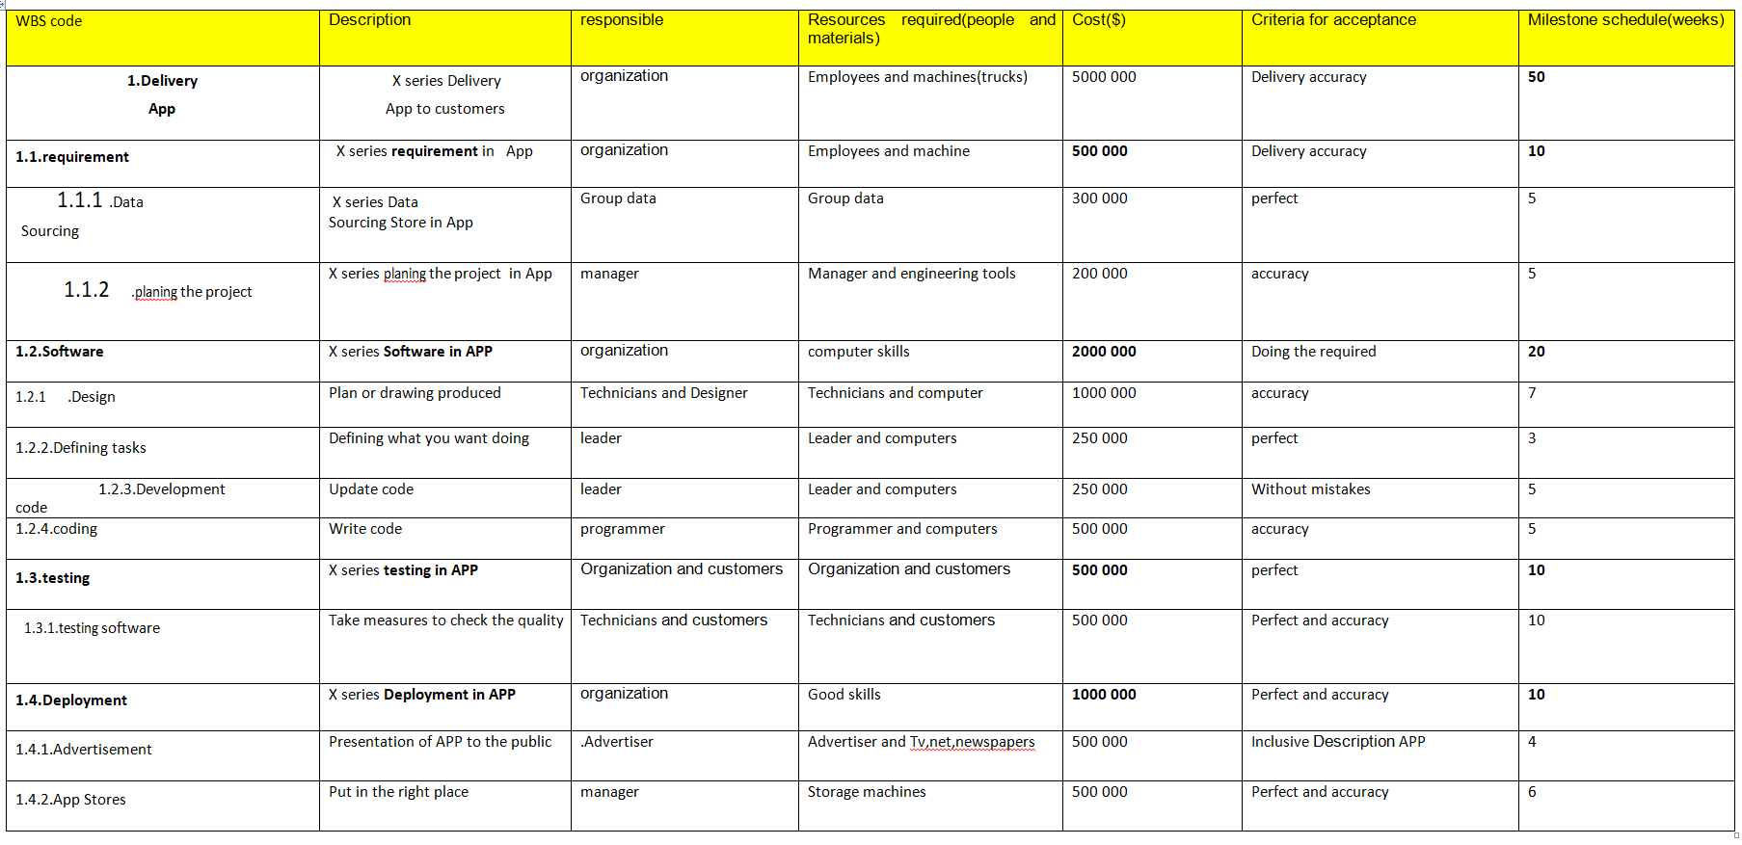

**Risks and monitoring**

1. **the risks can face the project:**
2. a defect in the information related to the goods.
3. loss of customer’s merchandise.
4. delayed delivery.
5. commercial lines malfunction.

**2)How we deal with these risks:**

a)we will employ excellent driver and we will use a high security methods to reduce the damage expected as we can .

b)we will employ how check after every step all the orders of all customers to reduce this problem and solve it fast.

c)we will use a lot of transition to deliver the good as fast as we can .

d) we will work on many malfunction lines to reduce this problem.

**3)how we monitor our project:**

We will employ a good team and we will watching them carefully to complete the project successfully

And with least resource and high quality.

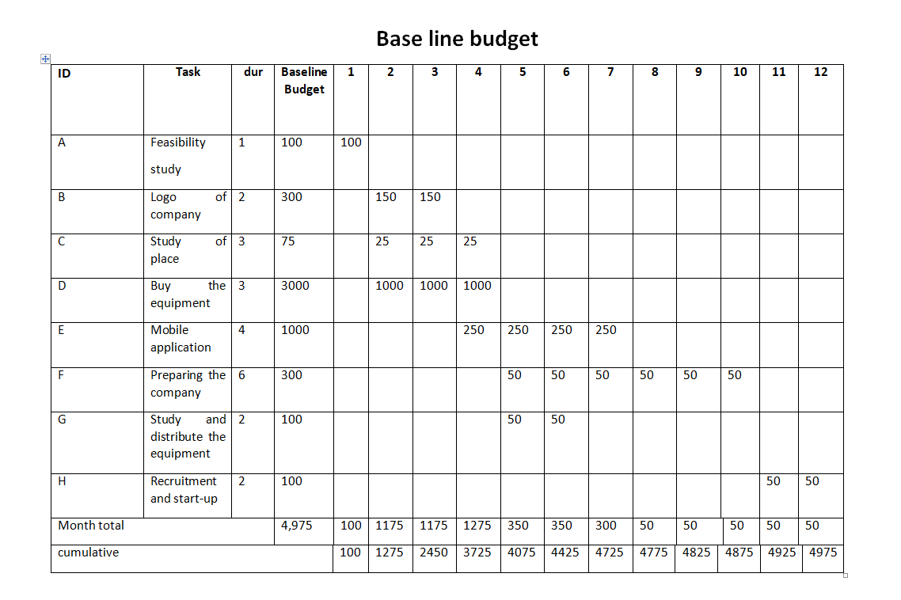

**Cumulative base line budget (PV)**

**Network And Resources**

