Quality Nursing Management for Women’s Health
From 11 December to 22 December 2022

Ss | Image/L'image  الصورة الشخصية | Country/Pays  البلد | Name  Nom  الإسم | Age  Âge  السن | Qualifications المؤهل الدراسى | Place Of Work/  Lieu De Travail  مكان العمل | Job Title And Job Description /  Titre Du Poste Et Responsabilités  المسمى الوظيفي و مهام الوظيفة | Yrs. Of Exp. /Année D'expé  سنوات الخبرة | Email/Phone No.  البريد الإلكترونى- رقم التليفون | Preferred Language Of Certificate/  Langue Preferee Du Certificat
 | 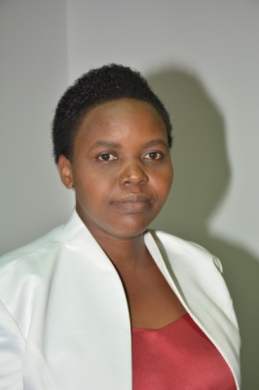  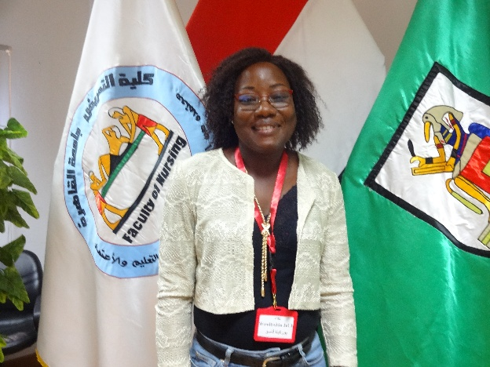 | BURKINA FASO | ILBOUDO WENDLASIDA JULIE | 42 | INFIMIERE | CHUYO | PRISE EN CHARGE DES FEMMES POST OP | 1O | Ilbolie30@yahoo.com  22670126260 | francais
 | 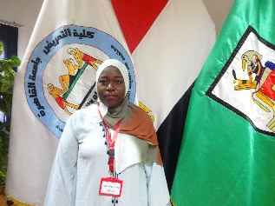 | COMORE | ANRABIASAID | 32 | SAGE FEMME | PS HOANI | POINT FOCAL NUTRITION | 5 | Saidanrabia3600695gmail.com | FRENCH
 | 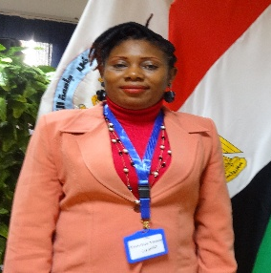 | CAMEROON | MORH FRANCISCA | 42 | NURSE SPECIALISED IN MASTERS REPRODUCTIVE HEALTH | GYNAECO OBSTETRIC AND PAEDIATRICS HOSPITAL YAOUNDE | PAEDIATRIC NURSE(NEONATAL UNIT) | 13 | Frankybrown71@yahoo.com.  237 679709529 | ENGLISH
 | 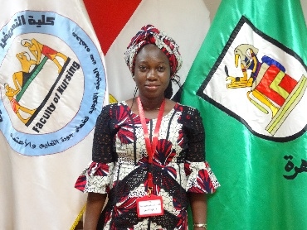 | BURKINA FASO | SAWADOGO NOOMTONDO JULIETTE | 38 | SAGE FEMME | CSPS DE OUFRE | PRISE EN CHARGE ET ASSISTANCE DE FEMME EN AGE D PROCREATION | 5 | Sawadogojuliette93@gmail.com  226 71058193 | FRENCH
 | 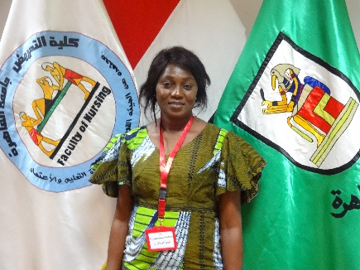 | GUINEE | FOFANA MAIMOUNA | 36 | SAGE FEMME | HOPITAL PREFECTORAL DE MACENTA | CHARGE DE SOINS ET PRISE EN CHARGE DES FEMMES EN AGE DE PROCREATION | 6 | Maimounafof1@gmail.com  224 621676422 | FRENCH
 | 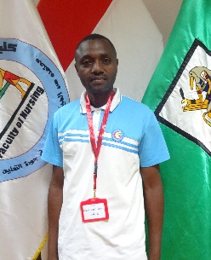 | BURUNDI | AIME NSHIMIRIMANA | 38 | LICENCE EN SANTE COMMUNAUTAIRE | CDS RUMEZA | TECHNICIEN POUR LA PROMOTION DE LA SANTE | 1 | nshimirimaaime66@gmail.com | FRENCH
 | 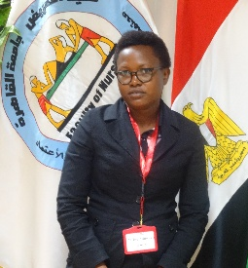 | BURUNDI | NDUWAYO ALINE | 39 | LICENCE EN SANTE PUBLIQUE | CDS MUTAKURA | - TITULAIRE DE CENTRE | 17 | Nduwayoaline1@gmail.com | FRENCH
 | 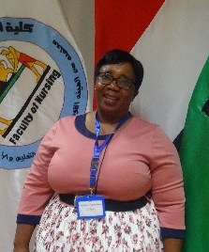 | ZIMBABWE | CHARITY ZVIKOMBORERO GARWE | 50 | REGISTERED GENERAL NURSE  MIDWIFE  PEADIATRIC NURSE  NURSE ADMINSTRATOR | GWERU PROVINCIAL HOSPITAL | SENIOR NURSE MANAGER 11  SUPPORT AND SUPERVISION OF MIDWIVES AND PEADIATRIC NURSES  RESOURCE MOBILIZATION  POLICY IMPLIMENTATION | 29 | garwecz@gmail.com | ENGLISH

Ss | Image/L'image  الصورة الشخصية | Country/Pays  البلد | Name  Nom  الإسم | Age  Âge  السن | Qualifications المؤهل الدراسى | Place Of Work/  Lieu De Travail  مكان العمل | Job Title And Job Description /  Titre Du Poste Et Responsabilités  المسمى الوظيفي و مهام الوظيفة | Yrs. Of Exp. /Année D'expé.  سنوات الخبرة | Email/Phone No.  البريد الإلكترونى- رقم التليفون | Preferred Language Of Certificate/  Langue Preferee Du Certificat
 | 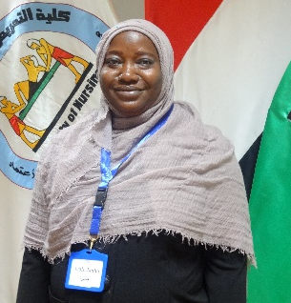 | THE GAMBIA | AMIE JANHA | 44 | BACHELOR DEGREE IN GENERAL NURSING | KANIFING GENERAL HOSPITAL | SENIOR NURSING OFFICER TO GIVE CARE TO ANTENATAL,DEIVERY,POSTNATAL TO WOMEN OF REPRODUCTIVE AGE GROUP | 22 | amiejanha2003@gmail.com TEL; 2209919748,2207689966 | ENGLISH
 | 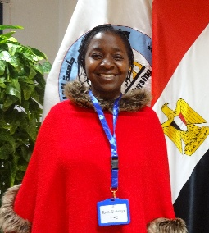 | ZAMBIA | RUTH BALENGU MANJIMELA | 39 | BACHELOR OF SCIENCE DEGREE IN NURSING, ADANCED DIPLOMA IN MIDWIFERY | LEVY MWANAWASA UNIVERSITY TEACHING HOSPITAL | ACTING NURSING OFFICER FOR OBSTETRICS AND GYNAECOLOGY | 17 | ruthmanjimela@gmail.com  Phone : +260966708414 | ENGLISH
 | 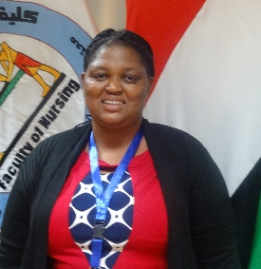 | ZIMBABWE | BARBRA NDHLOVU | 45 | DIPLOMA IN NURSING ADMINISTRATION  DIPLOMA IN PAEDIATRICS  DIPLOMA IN MIDWIFERY  DIPLOMA IN GENERAL NURSING | PARIRENYATWA GROUP OF HOSPITALS ZIMBABWE | SENIOR NURSING OFFICER | 13 | babndhlovu@gmail.com  +263773740343 | ENGLISHZ
 | 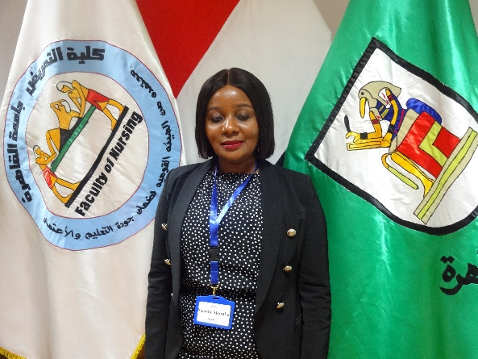 | ZAMBIA | KUNDA MUMBA | 39 | DIPLOMA IN NURSING ADVANCED DIPLOMA IN MIDWIFERY BSC MIDWIFERY | CHELSTONE ZONAL HOSPITAL | SENIOR NURSE MIDWIFE CONDUCTING ANTENATEL CARE DELIVERIES POSTNATAL CARE KAGAROO CARE FOR PRETERM BABIES | 13 | Kundamumba99@gmail.com +260977441315 | ENGLISH
 | 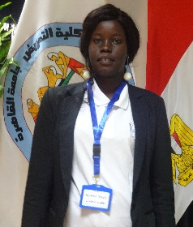 | SOUTHSUDAN | AGOROT YOULMONYKUER | 28 | BACHELOR OF NURSING | EGYPTION CLINCANDLOUCLINICHOSPITAL | GENEREL NURSING | 3 | AGOROTYOUL@GAMIL.COME  00211929483360 | ENGLISH
 | 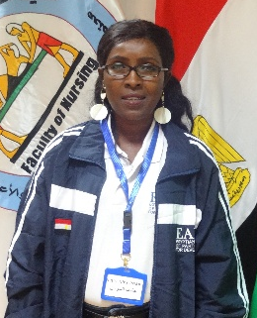 | SOUTHSUDAN | JENTYALEXISSAM | 34 | BACHELOR OF NURSING | EGYPTIAN CLINIC | GENEREL NURSING | 7 | JANTIALEX90@GMAIL.COM  00211917121976 | ENGLISH
 | 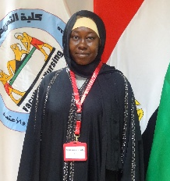 | TCHAD | ACHE DANAMA KADRE | 42 | DOCTORAT OF MEDECINE | MINISTERE DE LA SANTE PUBLIQUE ET DE LA PREVENTION | SERVICE DE LA SANTE SEXUELLE ET REPRODUCTIVE DES ADOLESCENT ET DES JEUNES | 10 | danacheka@yahoo.fr  0023566247060 | FRANÇAIS
 | 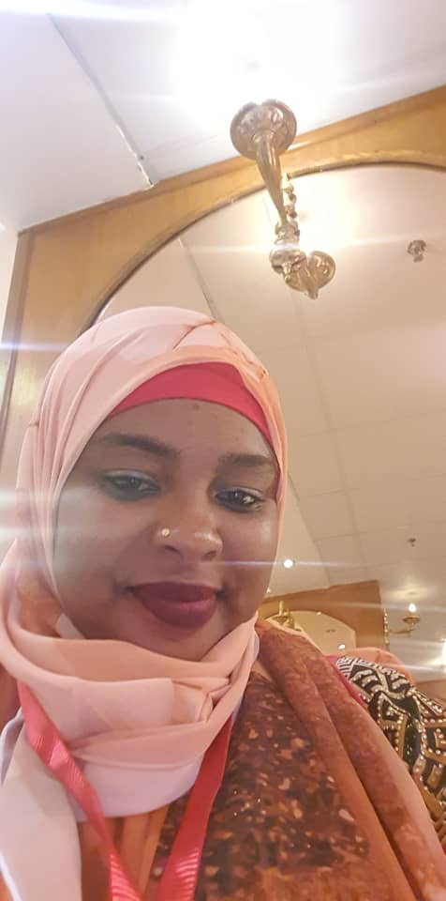 | COMORES | MARIE SAIDOU | 36 | SAGE FEMME SPECIALISEE EN ECHOGRAPHIE OBSTETRICALE | CENTRE HOSPITALIER NATIONAL ELMAAROUF (CHN) | SURVEILLANTE DU SERVICE DE L’ECHOGRAPHIE | 9 | Saindoumafa2018@gmail.com | FRANÇAISc
 | 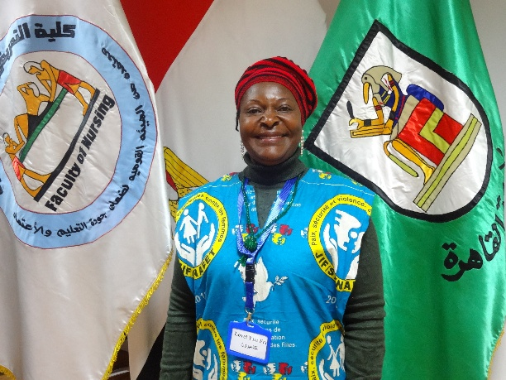 | Cameroon | MBATU LOVEIYNE FRU | 45 | NURSE  HND(MIDWERY)  BSc(MIDWERY) | BAMENDA REGIONAL HOSPITAL | FOLLOW UP PREGNANT WOMEN FROM ANC LABOUR AND DELIVERY POST NATAL CARE FAMILY PLANING | 15 | frumbatu@gmail.com  +237675841212 | ENGLISH
 | 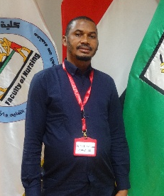 | GUINEE | DIALLO  ALPHA IBRAHIMA | 36 | INFIRMIER  PEDIATRE | HOPITAL REGIONAL DE NZEREKORE | RESPONSABLE DE  L’UNITE DE NEONATOLOGIE  SOINS INFIRMIERS | 7 | dialloalphaibrahima89@gmail.com  00224 628 390 229 | FRANCAIS
 | 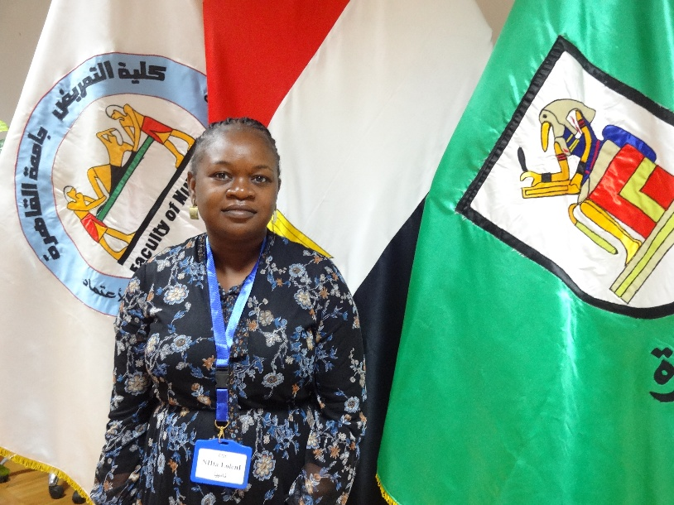 | Namibia | Niita Loleni Joseph | 34 | Bachelor of Nursing Clinical (Honors) | Intermediate Hospital Katutura/Windhoek/Namibia  (MATERNITY DEPARTMENT | Senior Registered Nurse  Supervision of Midwives , coordination of midwives daily activities, supervision and implementation of policies, Reviewing of maternal and neonatal deaths and reporting them to the National level | 8 | nlorrien@gmail.com  +264 813872044 | English
 | 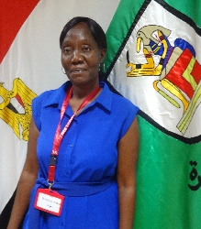 | Seychelles | Yvonne Goza | 49 | Certificate in general nursing and midwifery | Female surgical unit  Seychelles hospital | Senior nursing officer and acting nurse manager  Overall running of the unit.  Pre and post-operative care of women from 12 years above  Early obstetric and gynecological care | 26 | yvonnetraore@yahoo.com  +2482597985 | English

