|  |
| --- |
| **Department of Computer Engineering**  **Course Name: Software Engineering Course Number: 10636312**  **Assignment Report** |

|  |
| --- |
| Instructor: Dr. Haya Samaana |
| Academic Year: 2022-2023 |
| Semester: 2nd |

|  |  |
| --- | --- |
| **Students** | |
| 1. Abdullah Ghassan Sholi | 1. Mohamad Kamal Hara |
|  |  |

Our results after following the Jenkins tutorial:

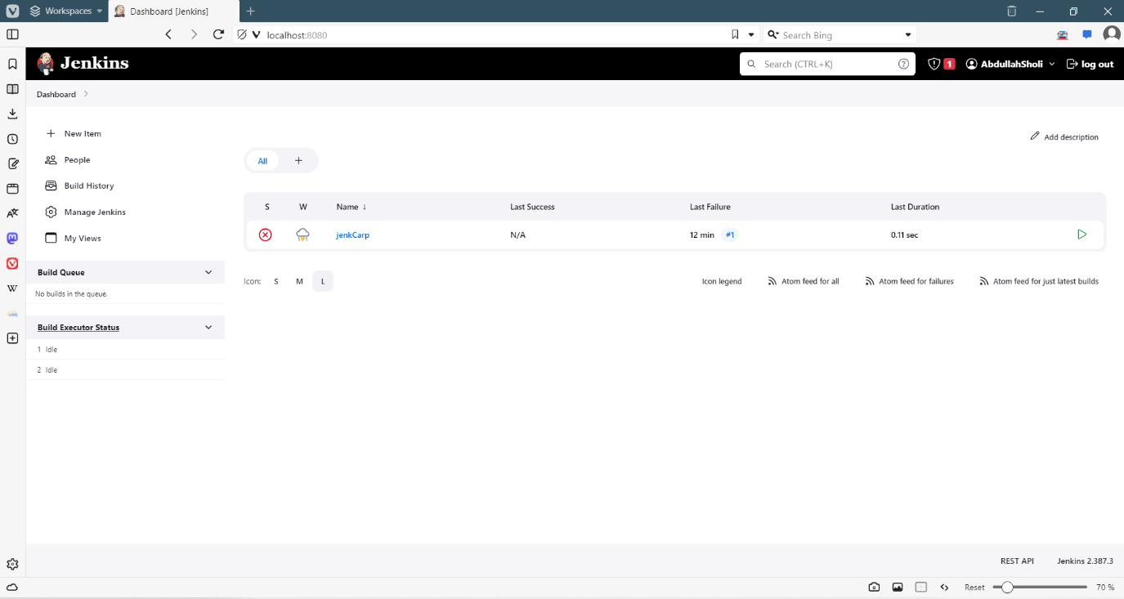

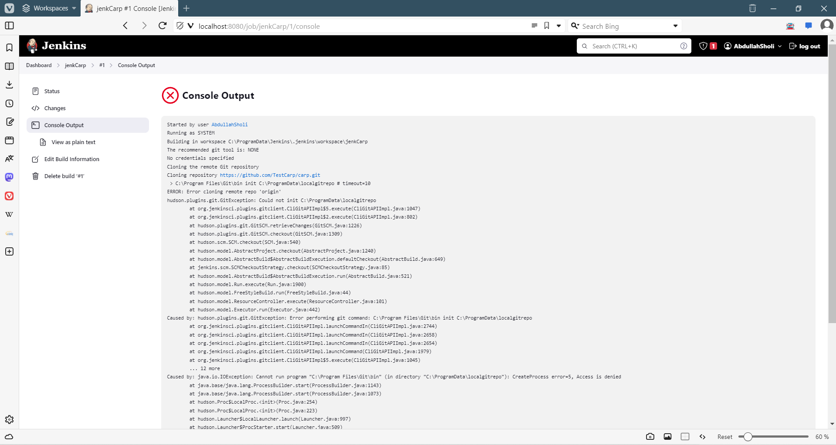

Results from applying Sonar:

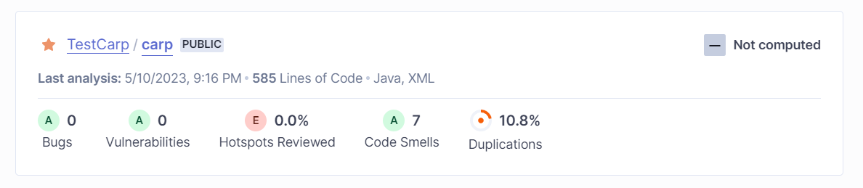

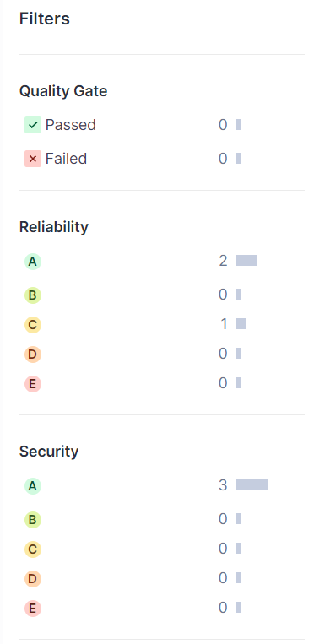

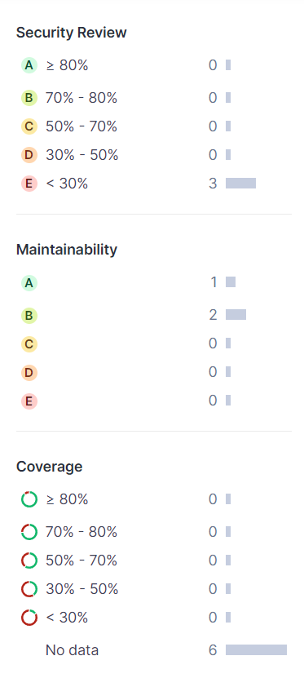

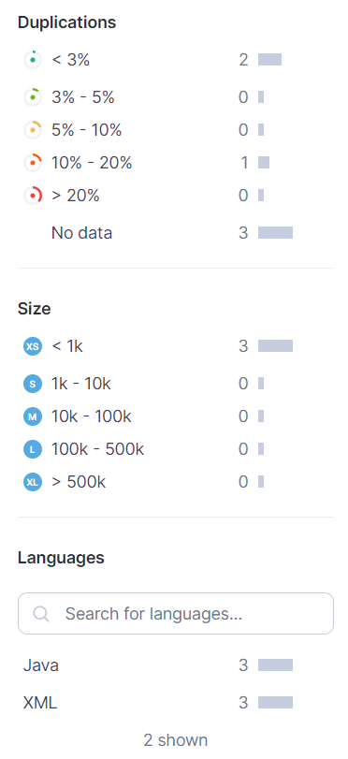

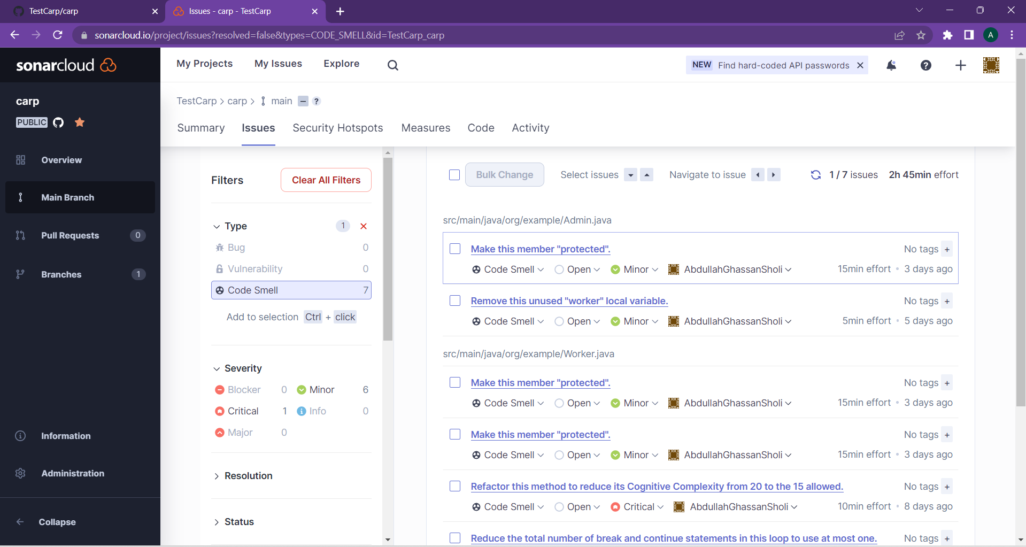

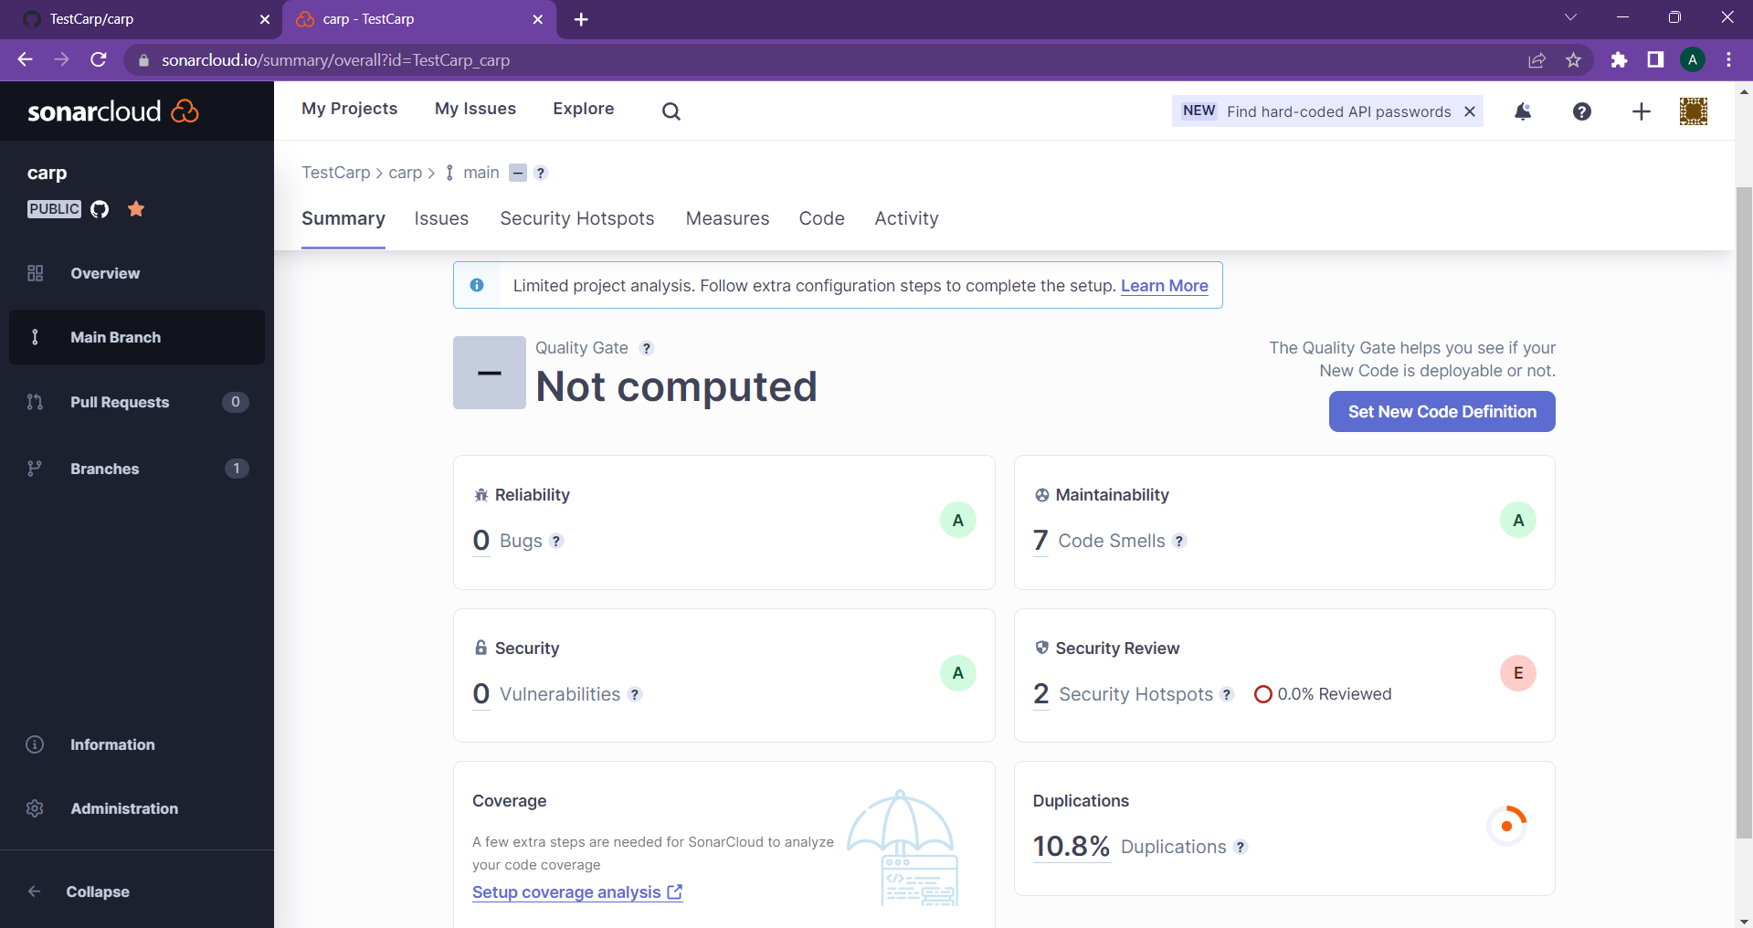

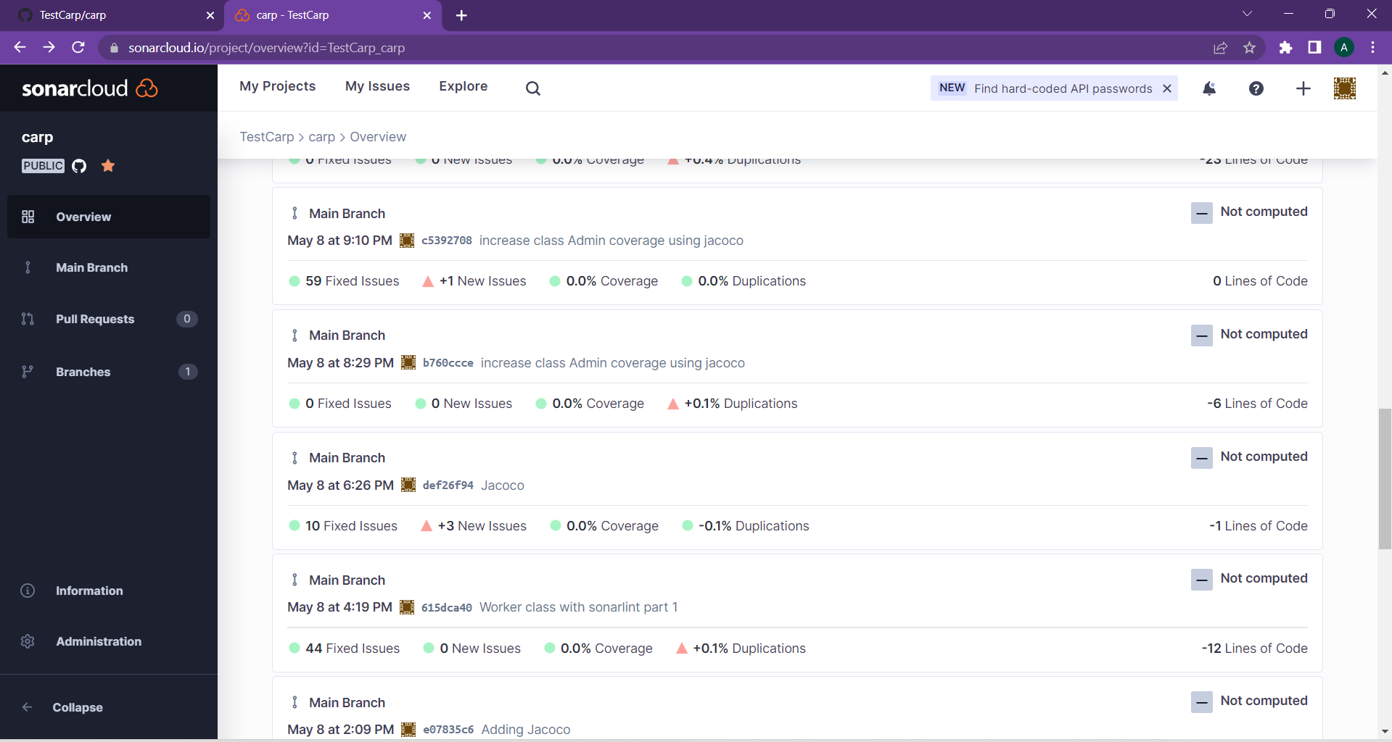

Our results after applying the Jacoco tutorial:

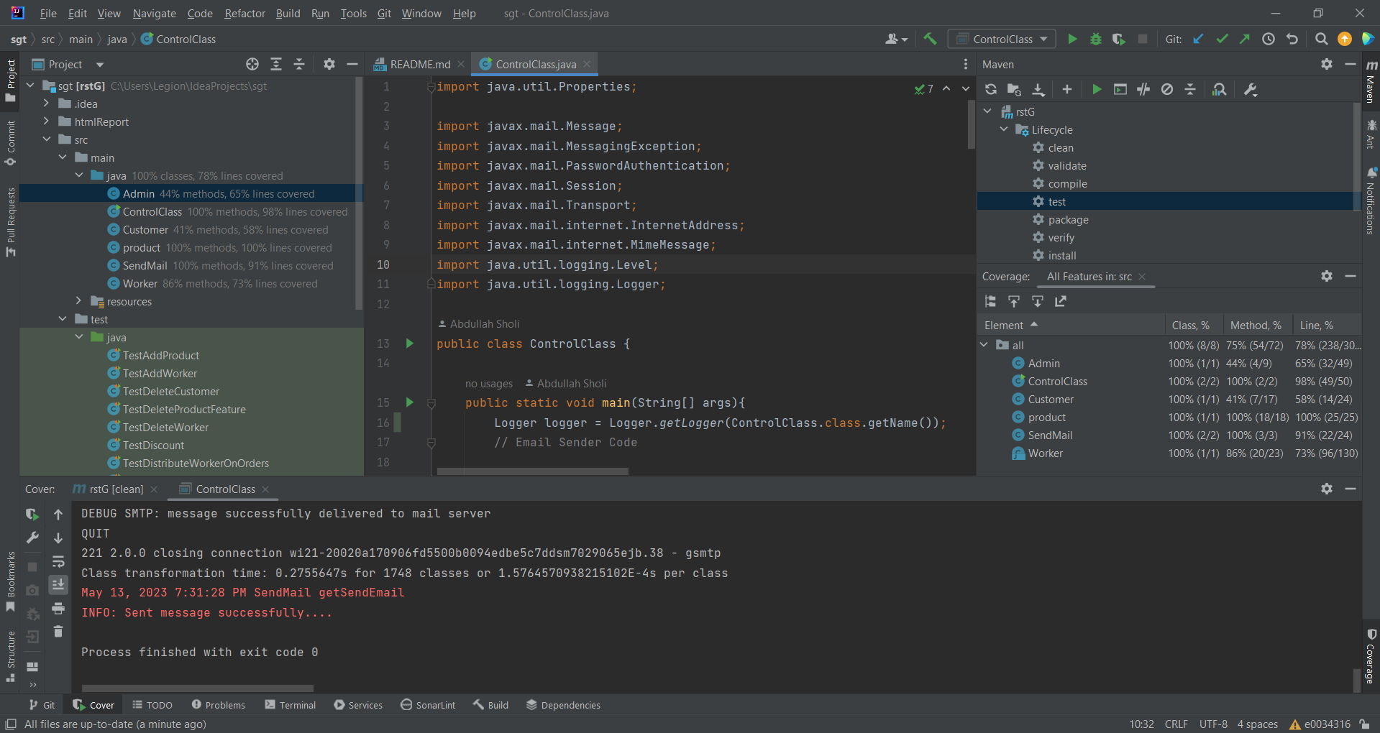

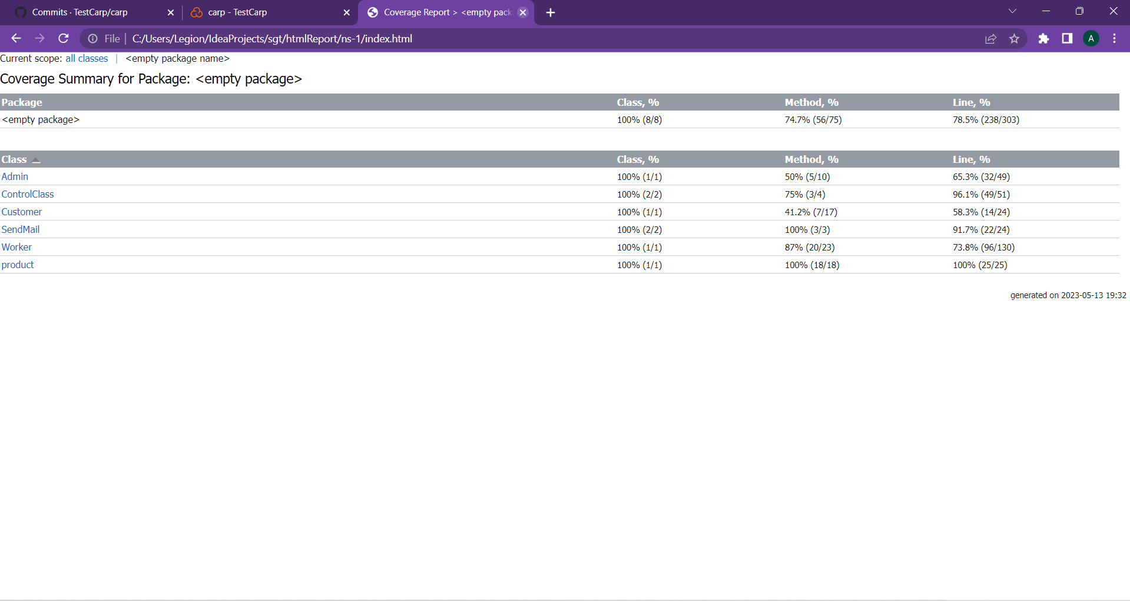

All test Cases True :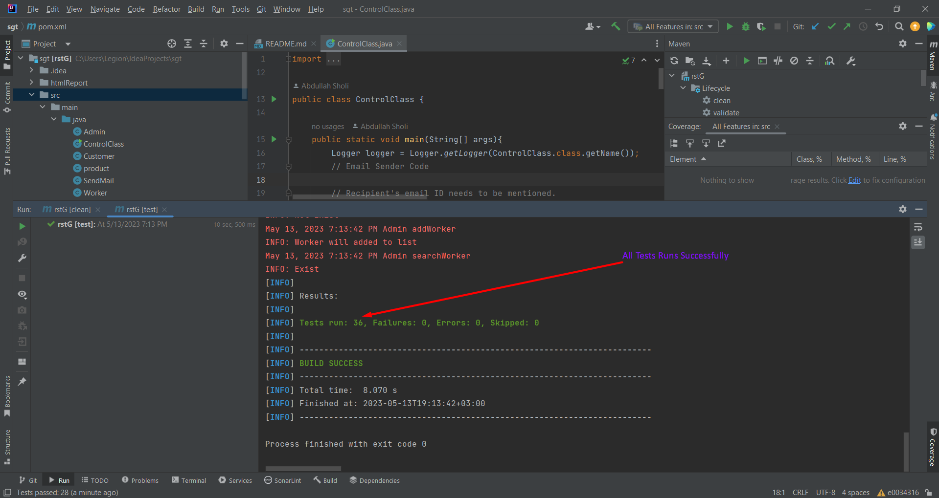

All features True :

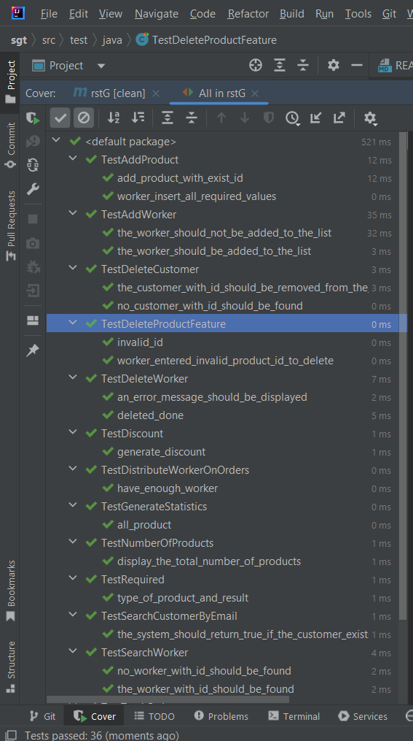

The generated UML diagram:

