

**Cloud Computing**

Práctica 1

Autor

Abdullah Taher Saadoon AL-Musawi



Escuela Técnica Superior de Ingenierías Informática y de Telecomunicación

—

Granada, Mayo de 2019

**Content Index**

1. The Problem and solution……………………………
2. Design …………………………………………….
3. Deployment ……………………………………………
4. Bibliography …………………………………………..

**The Problem and solution**

The problem is how to use Infrastructure as a Service (IaaS) and Software as a Service (SaaS),

Laas is a form of cloud computing that provides virtualized computing resources over the internet. IaaS is one of the three main categories of cloud computing services, alongside software as a service (SaaS) and platform as a service (PaaS). In an IaaS model, a cloud provider hosts the infrastructure components traditionally present in an on-premises data center, including servers, storage and networking hardware, as well as the virtualization or hypervisor layer,

Software as a service (SaaS) is a software distribution model in which a third-party provider hosts application and makes them available to customers over the Internet. SaaS is one of three main categories of cloud computing, alongside infrastructure as a service (IaaS) and platform as a service (PaaS).

To solve this problem and achieve to use LaaS we have to create virtualized computing resources over the internet, so we will use Microsoft azure to create VMs.

And to achieve to use SaaS we will provide an application accessible to many users for sharing and managing files ´OwnCloud´ which will be developed on our MVs. That application needs authentication so we will use ´LDAP´,

And we will need database that we will use MySQL server which will be connected with OwnCloud.

**The design**

To use LaaS and SaaS we have to develop an application which the following services LDAP, OwnCloud and database, for that we will need creating three VMs on Azure or One VM with three Containers,

A Docker provides so suitable ways to do that, Docker is an open source software platform to create, deploy and manage virtualized application containers on a common operating system (OS), with an ecosystem of allied tools. Docker Inc., the company that originally developed Docker, supports a commercial edition and is the principal sponsor of the open source tool

.

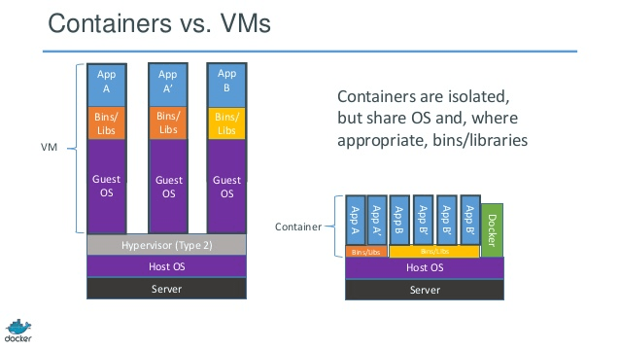

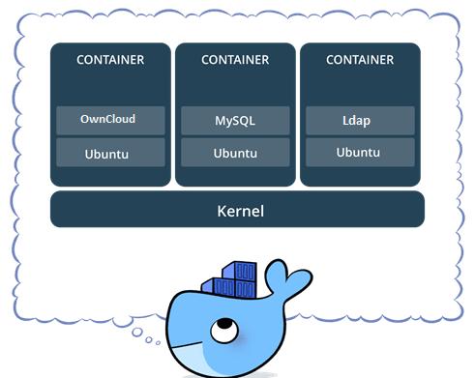So, I’m going to use one virtual machine contains 3 docker containers

OwnCloud: is open-source software, first developed in 2010, that allows you to run a personal cloud file storage service. It has features that are comparable to other cloud storage services such as Dropbox.

The ownCloud server software can be installed free of charge on Linux, and the client software can be installed on computers running Windows, OS X, or Linux. Mobile apps are also available for Android and iOS.

In 2016, the development of ownCloud was split, and many of the original developers forked the source code to create a competing product, called Nextcloud.

LDAP:(Lightweight Directory Access Protocol) is a software protocol for enabling anyone to locate organizations, individuals, and other resources such as files and devices in a network, whether on the public Internet or on a corporate intranet. LDAP is a "lightweight" (smaller amount of code) version of Directory Access Protocol (DAP),

**Creating a Virtual machine:**

its configuration:

1. OS: Ubuntu Server 18.04
2. Region: France Central.
3. Authentication: password.
4. user: AbdullahTaher
5. Ip address: static
6. Open ports: SSH (22) for connection and HTTP (80) for OwnCloud, and (3306) for MySQL server (389) for Ldap.

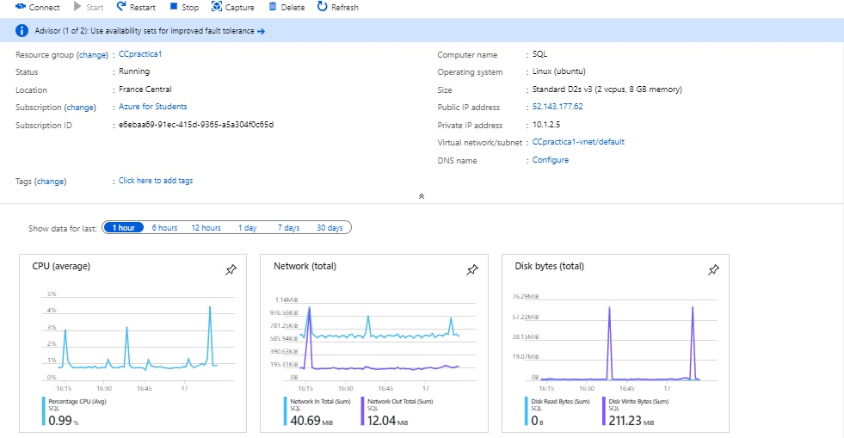

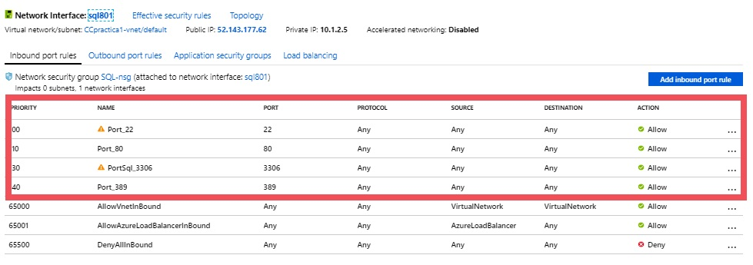

**Connecting the containers:**

The first thing we have to do it, it is connecting Database with OwnCloud by its ports (3306) with same IP of VMs which is hosted them,

.

After that we have to connect Ldap(container) with OwnCloud(container) by its ports (389)

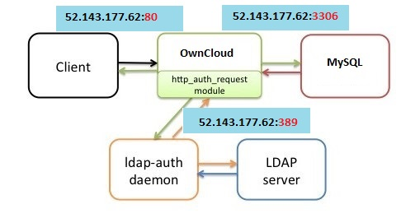

**The development**

* creating VMs with 4 ports (22,80,3309,389),that is following the steps below:
* open Microsoft Azure with this Link(<https://portal.azure.com/#home>)
* create VM
* open 4 ports

now we are ready to access to our server by using git-bash

with this line ssh [abdullah@52.143.177.62](mailto:abdullah@52.143.177.62)

