

**Critical System**

Práctica

Self-Driving

Autor

Abdullah Taher Saadoon AL-Musawi

DNI: A11518169

Email: abdullahtaher@correo.ugr.es



Escuela Técnica Superior de Ingenierías Informática y de Telecomunicación

—

Granada, abril de 2020

1. **self-driving car:** also known as an autonomous vehicle (AV), connected and autonomous vehicle (CAV), driverless car, robo-car, or robotic car, is a vehicle that is capable of sensing its environment and moving safely with little or no human input, Self-driving cars combine a variety of sensors to perceive their surroundings, such as radar, lidar, sonar, GPS, odometry and inertial measurement units. Advanced control systems interpret sensory information to identify appropriate navigation paths, as well as obstacles and relevant signage.

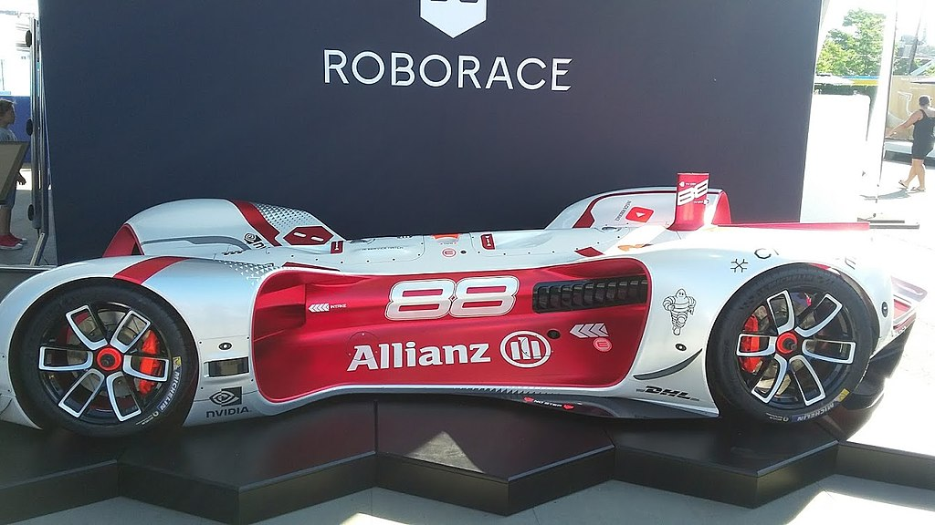

Autonomous racing car on display at the [2017 New York City ePrix](https://en.wikipedia.org/wiki/2017_New_York_City_ePrix)

1. **Self-driving cars with Carla and Python:**
2. **Carla:**

which is an open-source autonomous driving environment that also comes with a Python API to interact with it. The main idea of Carla is to have the environment (server) and then agents (clients). This server/client architecture means that we can of course run both the server and client locally on the same machines, but we could also run the environment (server) on one machine and multiple clients on multiple other machines, which is pretty cool.

With Carla, we get a car (obviously), an environment to drive that car in, and then we have a bunch of sensors that we can place upon the car to emulate real-life self-driving car sensors. Things like LIDAR, cameras, accelerometers, and so on.