PLANTILLA DE PERSONAJE
Nombre | Muhammad Alis | 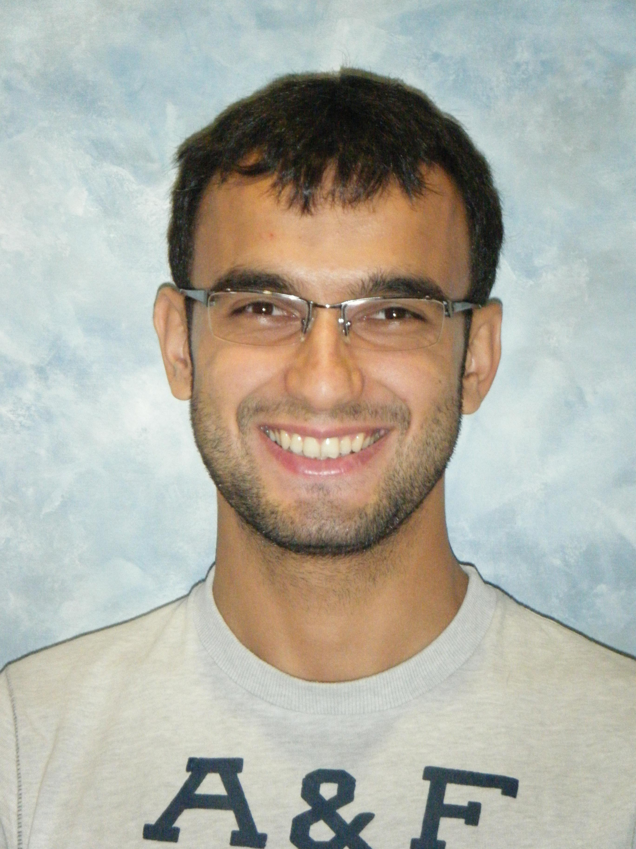
Edad | 26
Sexo | M
Educación | Master’s Degree
Contexto de uso
Cuándo | He uses it any time , at mooring when he wants to check his Emails, at noon when he works at his company at evening too
Dónde | He uses it at Everywhere but the most time uses it at work
Tipo de ordenador | laptop and mobile phone
Misión
Objetivo | helps anyone to communication with other speak Spanish language
Expectativas | Converts the Words and the phrases these are most used
Motivación
Urgencia | he wants to communicate with other by easy way
Deseo | To uses it all time until he back to his country and it Will be useful for him
Actitud hacia la tecnología

PLANTILLA DE ESCENARIO
Nombre persona | Muhmmed Ali
Objetivo persona | Learns the Spanish language to start with PhD degree.
Escenario
He came to Spain for studying PhD degree in information engineering in Granada university He has arrived in last summer, he can’t speak Spanish language and he hasn’t any ideas about this language so that before he comes to Spain when he searched about an application provides to him a lot of phrases and vocabulary and it don’t need connecting with WIFI he found an application called Habla Español, started using it, when he arrived to Barajas airport wanted asking about way of The Metro because his university in Granada , he arrived to Granada by helping this application
When he was hangry used it to take his food and buy for it , after that he had reservation in hotel with this application took a Taxi to hotel, just he needed click on the phrases what he wanted really it was working he trusted it more he started using it in all time, at mooring he started searching about apartment because he will stay long time in Spain one more time he used it to get a room in an apartment yes he did it, he got a room in an apartment with 3 Spanish parsons He gave a greeting to them
And he asked him when he clicked in his phone about place of studying
day after day he Cannot leave it, after that he got B1 in Spanish language when he was studying Spanish was using Google translator, and anther application to help him understand in better way so now he has B1 but he still needing a lot of phrases and vocabulary to help him in his life in Spain so
“Habla Español” still in his favorite applications the reasons were
He doesn’t need connecting with Wi-Fi, easy to use and speed, translate what he wants exactly, so it has become part of his life in Spain,

