**Tarea5.1**

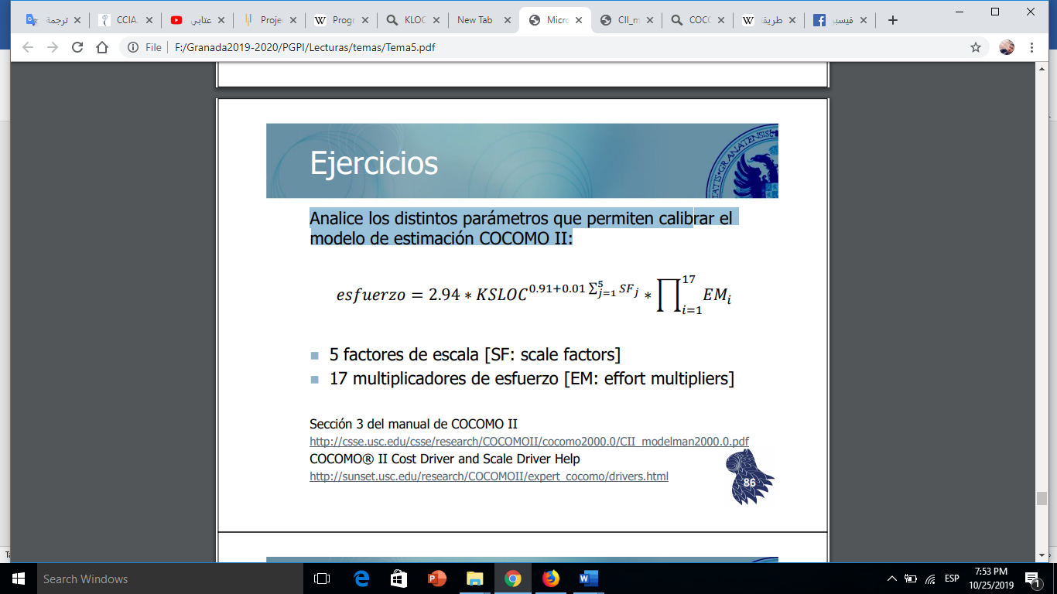

**Scala Factors:**

The application size exponent is aggregated of five scale factors (SF) that describe relative economies or diseconomies of scale that are encountered for software projects of dissimilar magnitude. A project exhibits economy of scale if the exponent is less than one i.e. effort is non-linearly reduced. Economies and diseconomies of scale are in balance should the exponent hold a value of one. A project exhibits diseconomy of scale if the exponent is more than one i.e. effort is non-linearly increased. These are:

* **Scala Factor PREC**

|  |  |  |  |
| --- | --- | --- | --- |
| * Feature | Very Low | Nominal/High | Extra High |
| Organizational understanding of product objectives | General | Considerable | Thorough |
| Experience in working with related software systems | Moderate | Considerable | Extensive |
| Concurrent development of associated new hardware and operational procedures | Extensive | Moderate | Some |
| Need for innovative data processing architectures, algorithms | Considerable | Some | Minimal |

Scale Factors for COCOMO.II Early Design and Post-Architecture Models

|  |  |  |  |  |  |  |
| --- | --- | --- | --- | --- | --- | --- |
| PREC Descriptors | thoroughly unprecedented | largely unprecedented | somewhat unprecedented | generally familiar | largely familiar | thoroughly familiar |
| Rating Levels | Very Low | Low | Nominal | High | Very High | Extra High |
| Value | 6.20 | 4.96 | 3.72 | 2.48 | 1.24 | 0.00 |

* **Scala Factor FLEX**

|  |  |  |  |
| --- | --- | --- | --- |
| Feature | Very Low | Nominal/High | Extra High |
| Need for software conformance with preestablished requirements | Full | Considerable | Basic |
| Need for software conformance with external interface specifications | Full | Considerable | Basic |
| Combination of inflexibilities above with premium on early completion | High | Medium | Low |

* Scale Factors for COCOMO.II Early Design and Post-Architecture Models

|  |  |  |  |  |  |  |
| --- | --- | --- | --- | --- | --- | --- |
| FLEX Descriptors | rigorous | occasional relaxation | some relaxation | general conformity | some conformity | general goals |
| Rating Levels | Very Low | Low | Nominal | High | Very High | Extra High |
| Value | 5.07 | 4.05 | 3.04 | 2.03 | 1.01 | 0.00 |

* **Scala Factor RESL**

|  |  |  |  |  |  |  |
| --- | --- | --- | --- | --- | --- | --- |
| * Feature | Very Low | Low | Nominal | High | Very High | Extra High |
| Risk Management Plan identifies all critical risk items, establishes milestones for resolving them by PDR or LCA. | None | Little | Some | Generally | Mostly | Fully |
| Schedule, budget, and internal milestones through PDR or LCA compatible with Risk Management Plan. | None | Little | Some | Generally | Mostly | Fully |
| Percent of development schedule devoted to establishing architecture, given general product objectives. | 5 | 10 | 17 | 25 | 33 | 40 |
| Percent of required top software architects available to project. | 20 | 40 | 60 | 80 | 100 | 120 |
| Tool support available for resolving risk items, developing and verifying architectural specs. | None | Little | Some | Good | Strong | Full |
| Level of uncertainty in key architecture drivers: mission, user interface, COTS, hardware, technology, performance. | Extreme | Significant | Considerable | Some | Little | Very Little |
| Number and criticality of risk items. | > 10 Critical | 5-10 Critical | 2-4 Critical | 1 Critical | > 5 Non-Critical | < 5 Non-Critical |

Scale Factors for COCOMO.II Early Design and Post-Architecture Models

|  |  |  |  |  |  |  |
| --- | --- | --- | --- | --- | --- | --- |
| RESL Descriptors | little (20%) | some (40%) | often (60%) | generally (75%) | mostly (90%) | full (100%) |
| Rating Levels | Very Low | Low | Nominal | High | Very High | Extra High |
| Value | 7.07 | 5.65 | 4.24 | 2.83 | 1.41 | 0.00 |

* **Scala Factor TEAM**

|  |  |  |  |  |  |  |
| --- | --- | --- | --- | --- | --- | --- |
| * Characteristic | Very Low | Low | Nominal | High | Very High | Extra High |
| Consistency of stakeholder objectives and cultures | Little | Some | Basic | Considerable | Strong | Full |
| Ability, willingness of stakeholders to accommodate other stakeholders’ objectives | Little | Some | Basic | Considerable | Strong | Full |
| Experience of stakeholders in operating as a team | None | Little | Little | Basic | Considerable | Extensive |
| Stakeholder teambuilding to achieve shared vision and commitments | None | Little | Little | Basic | Considerable | Extensive |

Scale Factors for COCOMO.II Early Design and Post-Architecture Models

|  |  |  |  |  |  |  |
| --- | --- | --- | --- | --- | --- | --- |
| TEAM Descriptors | very difficult interactions | some difficult interactions | basically cooperative interactions | largely cooperative | highly cooperative | seamless interactions |
| Rating Levels | Very Low | Low | Nominal | High | Very High | Extra High |
| Value | 5.48 | 4.38 | 3.29 | 2.19 | 1.10 | 0.00 |

* **Scala Factor PMAT**

Overall Maturity Level:

* CMM Level 1 (lower half)
* CMM Level 1 (upper half)
* CMM Level 2
* CMM Level 3
* CMM Level 4
* CMM Level 5

Scale Factors for COCOMO.II Early Design and Post-Architecture Models

|  |  |  |  |  |  |  |
| --- | --- | --- | --- | --- | --- | --- |
| PMAT Descriptors | CMM Level 1 (lower half) | CMM Level 1 (upper half) | CMM Level 2 | CMM Level 3 | CMM Level 4 | CMM Level 5 |
| Rating Levels | Very Low | Low | Nominal | High | Very High | Extra High |
| Value | 7.80 | 6.24 | 4.68 | 3.12 | 1.56 | 0.00 |

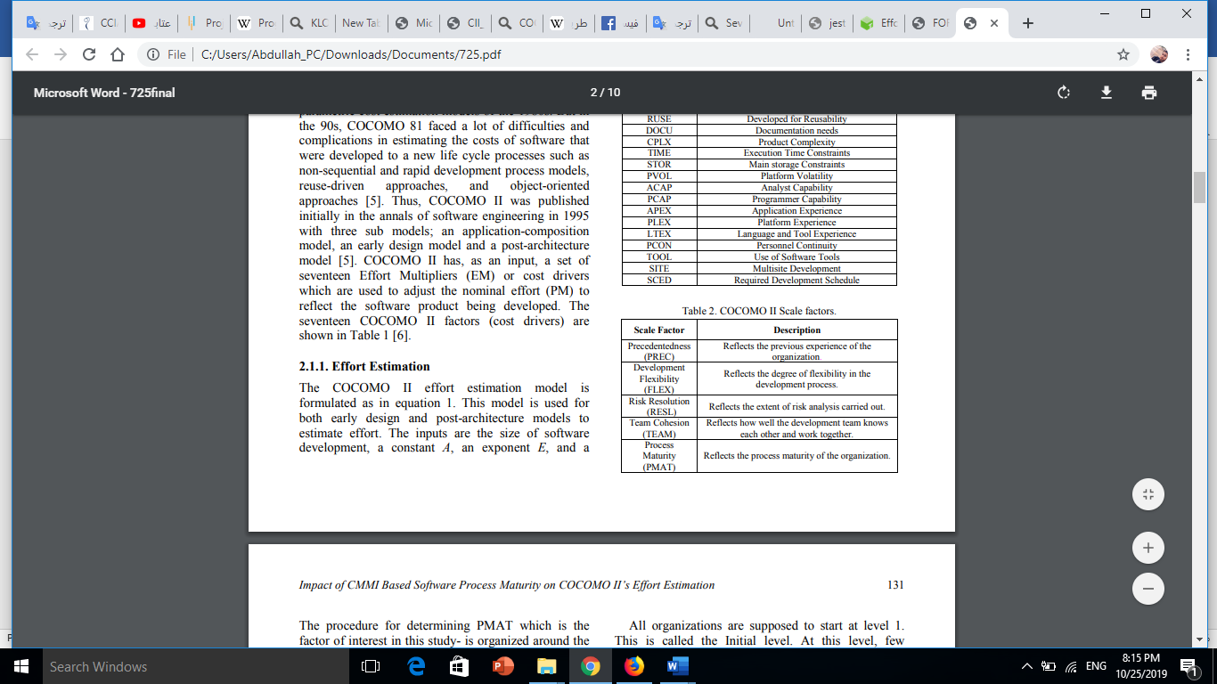

**Effort multipliers**

Seventeen Post-Architecture (EM) effort multipliers are used in the COCOMO II model to adjust the nominal, person-month effort in software product development. They are the following:

* **Product attributes**
* Required Software Reliability(RELY)
* Database size(DATA)
* Product Complexity(CPLX)
* **Computer attributes**
* Execution Time Constraint(TIME)
* Main Storage Constraint(STOR)
* Virtual Machine Volatility(VIRT)
* Computer Turnaround Time(TURN)
* **Personal attributes**
* Analyst Capability(ACAP)
* Application Experience(AEXP)
* Programmer Capability(PCAP)
* Virtual Machine Experience(VEXP)
* Programming Language Experience(LEXP)
* **Project attributes**
* Modern Programming Practices(MODP)
* Use Of Software Tools(TOOL)
* Required Development Schedule(SCED)

**Tarea5.2**

Para proyectos del mismo tamaño (en KSLOC), compruebe el efecto que tiene el ajuste de dichos parámetros en diferentes escenarios. En particular, realice estimaciones para los siguientes proyectos:

1. Aplicación web desarrollada por un equipo experimentado en el uso de las herramientas necesarias para el proyecto.

* **Scala Factors**

|  |  |  |  |  |  |  |
| --- | --- | --- | --- | --- | --- | --- |
| Scala Factors | Very Low | Low | Nominal | High | Very High | Extra High |
| PREC |  |  |  |  | **X** |  |
| FLEX |  |  | **X** |  |  |  |
| RESL |  |  | **X** |  |  |  |
| TEAM |  |  |  |  | **X** |  |
| PMAT |  |  | **X** |  |  |  |

* **Effort multipliers**

|  |  |  |  |  |  |  |  |
| --- | --- | --- | --- | --- | --- | --- | --- |
|  | *Product* | | | | | | |
| Scala Factors | Very Low |  | Low | Nominal | High | Very High | Extra High |
| RELY | **X** |  |  |  |  |  |  |
| DATA |  |  |  | **X** |  |  |  |
| CPLX |  |  |  | **X** |  |  |  |

|  |  |  |  |  |  |  |  |
| --- | --- | --- | --- | --- | --- | --- | --- |
|  | *Computer* | | | | | | |
| Scala Factors | Very Low |  | Low | Nominal | High | Very High | Extra High |
| TIME |  |  |  | **X** |  |  |  |
| STOR |  |  |  | **X** |  |  |  |
| VIRT |  |  |  |  | **X** |  |  |
| TURN |  |  | **X** |  |  |  |  |

|  |  |  |  |  |  |  |  |
| --- | --- | --- | --- | --- | --- | --- | --- |
|  | *Personal* | | | | | | |
| Scala Factors | Very Low |  | Low | Nominal | High | Very High | Extra High |
| ACAP |  |  | **X** |  |  |  |  |
| AEXP |  |  |  |  |  | **X** |  |
| PCAP |  |  |  | **X** |  |  |  |
| VEXP |  |  |  |  | **X** |  |  |
| LTEX |  |  |  |  | **X** |  |  |

|  |  |  |  |  |  |  |  |
| --- | --- | --- | --- | --- | --- | --- | --- |
|  | *Project* | | | | | | |
| Scala Factors | Very Low |  | Low | Nominal | High | Very High | Extra High |
| TOOL |  |  |  |  | **X** |  |  |
| MODP |  |  | **X** |  |  |  |  |
| SCED |  |  | **X** |  |  |  |  |

1. Middleware de alto rendimiento para la construcción de sistemas distribuidos heterogéneos

* **Scala Factors**

|  |  |  |  |  |  |  |
| --- | --- | --- | --- | --- | --- | --- |
| Scala Factors | Very Low | Low | Nominal | High | Very High | Extra High |
| PREC |  |  |  |  | **X** |  |
| FLEX |  |  | **X** |  |  |  |
| RESL |  |  | **X** |  |  |  |
| TEAM |  |  |  |  | **X** |  |
| PMAT |  |  | **X** |  |  |  |

* **Effort multipliers**

|  |  |  |  |  |  |  |  |
| --- | --- | --- | --- | --- | --- | --- | --- |
|  | *Product* | | | | | | |
| Scala Factors | Very Low |  | Low | Nominal | High | Very High | Extra High |
| RELY |  |  | **X** |  |  |  |  |
| DATA |  |  |  | **X** |  |  |  |
| CPLX |  |  |  |  | **X** |  |  |

|  |  |  |  |  |  |  |  |
| --- | --- | --- | --- | --- | --- | --- | --- |
|  | *Computer* | | | | | | |
| Scala Factors | Very Low |  | Low | Nominal | High | Very High | Extra High |
| TIME |  |  |  |  | **X** |  |  |
| STOR |  |  |  |  | **X** |  |  |
| VIRT |  |  |  | **X** |  |  |  |
| TURN |  |  | **X** |  |  |  |  |

|  |  |  |  |  |  |  |  |
| --- | --- | --- | --- | --- | --- | --- | --- |
|  | *Personal* | | | | | | |
| Scala Factors | Very Low |  | Low | Nominal | High | Very High | Extra High |
| ACAP |  |  | **X** |  |  |  |  |
| AEXP |  |  | **X** |  |  |  |  |
| PCAP |  | **X** |  |  |  |  |  |
| VEXP |  |  | **X** |  |  |  |  |
| LTEX |  |  |  | **X** |  |  |  |
|  |  |  |  |  |  |  |  |

|  |  |  |  |  |  |  |  |
| --- | --- | --- | --- | --- | --- | --- | --- |
|  | *Project* | | | | | | |
| Scala Factors | Very Low |  | Low | Nominal | High | Very High | Extra High |
| TOOL |  |  |  |  | **X** |  |  |
| MODP |  |  | **X** |  |  |  |  |
| SCED |  |  | **X** |  |  |  |  |

**Tarea5.3**

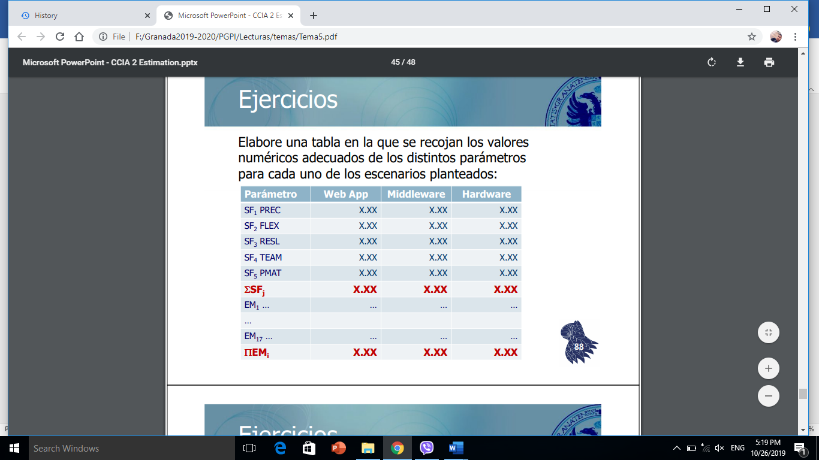

|  |  |  |  |
| --- | --- | --- | --- |
| Parámetro | Web App | Middleware | Hardware |
| SF1 PREC | 1.24 | 3.72 | 6.2 |
| SF2 PREC | 3.04 | 3.04 | 4.05 |
| SF3 PREC | 4.24 | 4.24 | 2.83 |
| SF4 PREC | 1.10 | 3.29 | 4.38 |
| SF5 PREC | 4.68 | 4.68 | 4.68 |
| ΣSFj | 14.3 | 18.97 | 22.14 |
|  | | | |
| EM1 | 0.82 | 1.0 | 1.0 |
| EM2 | 1.0 | 1.0 | 1.0 |
| EM3 | 1.0 | 1.34 | 1.34 |
| EM4 | 1.07 | 1.07 | 1.0 |
| EM5 | 1.11 | 1.23 | --- |
| EM6 | 1.0 | 1.11 | 1.0 |
| EM7 | 1.0 | 1.0 | 1.0 |
| EM8 | 1.15 | 1.0 | 1.15 |
| EM9 | 1.0 | 1.0 | 1.0 |
| EM10 | --- | 1.0 | 1.0 |
| EM11 | 0.9 | 1.12 | 0.9 |
| EM12 | 0.81 | 1.0 | 1.22 |
| EM13 | 0.85 | 1.0 | 1.19 |
| EM14 | 0.84 | 0.91 | 1.09 |
| EM15 | 0.78 | 0.9 | 1.0 |
| EM16 | 1.0 | 1.22 | 1.0 |
| EM17 | 1.0 | 1.0 | 1.0 |
| ΠEMi | 0.45 | 2.19 | 2.19 |

**Tarea5.3**

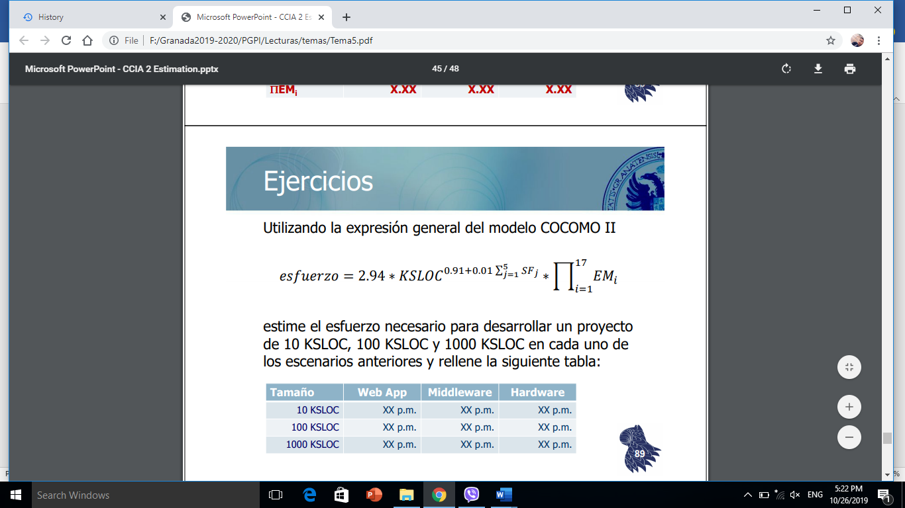

|  |  |  |  |
| --- | --- | --- | --- |
| Tamaño | Web App | Middleware | Hardware |
| 10 KSLOC | 14.94 p.m | 81.0 p.m | 87.13 p.m |
| 100 KSLOC | 168.87 p.m | 1019.0 p.m | 1179.2 p.m |
| 1000 KSLOC | 1907.91 p.m | 12820.1 p.m | 15958.47 p.m |

**References**

<http://www.functionpointmodeler.com/fpm-infocenter/index.jsp?topic=%2Fcom.functionpointmodeler.fpm.help%2Fditafiles%2Fconcepts%2Fcc-38.html>

<https://www.coursehero.com/file/p7hnfcq/1-Product-attributes-a-Required-Software-ReliabilityRELY-b-Database-sizeDATA-c/?utm_source=shareasale&utm_campaign=sharea&utm_medium=affiliate>