# Estimates

## Activity Decomposition

|  |  |  |  |  |  |  |
| --- | --- | --- | --- | --- | --- | --- |
| Module | Plan | Análisis | Diseño | Código | Test | TOTAL |
| DB |  | 0,1 | 0,3 | 0,15 | 0,4 | 0,95 |
| Model |  | 0,2 | 0,8 | 0,1 | 0,2 | 1,3 |
| Algorithms |  | 0,5 | 1 | 3,5 | 1,5 | 6,5 |
| Networks |  | 0,8 | 0,6 | 0,5 | 1 | 2,9 |
| UI |  | 0,6 | 2 | 1 | 1 | 4,6 |
| Total | 0,3 | 2,2 | 4,7 | 5,25 | 4,1 | 16,55 |
| % | 1,812688822 | 13,2930514 | 28,3987915 | 31,7220544 | 24,7734139 | 100 |
|  |  |  |  |  |  |  |
| Salary | Estimate |  |  |  |  |  |
| 4000 | 66200 |  |  |  |  |  |
|  |  |  |  |  |  |  |

## Construx Estimate

### Contrux Estimate Graphs

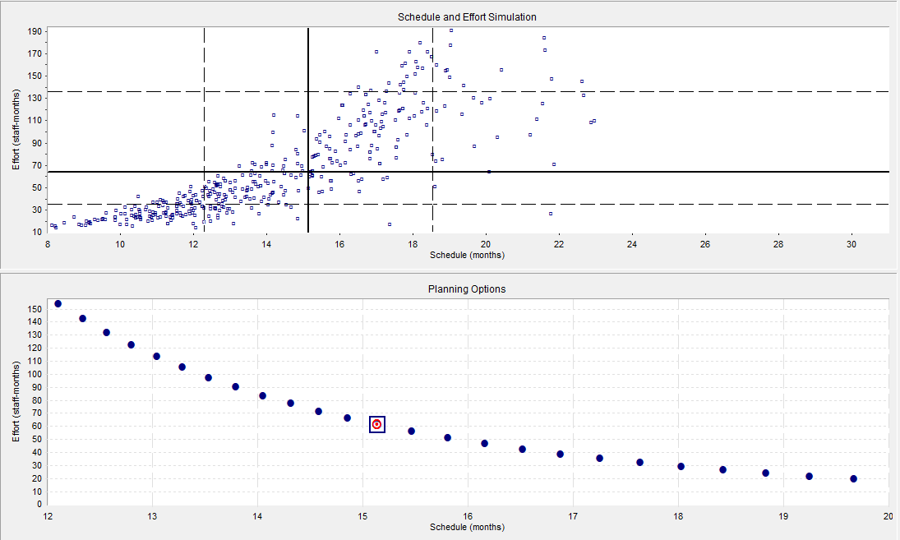

### Contrux Estimate Optimum Plan

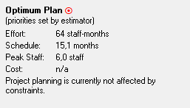

## COCOMO II Estimate

|  |  |
| --- | --- |
| Parámetro | Management Platform |
| SF1 PREC | 2,48 |
| SF2 FLEX | 4,05 |
| SF3 RESL | 4,24 |
| SF4 TEAM | 4,38 |
| SF5 PMAT | 4,68 |
| Sum SFj | 19,83 |
| EM1 RELY | 1,26 |
| EM2 DATA | 1,14 |
| EM3 CPLX | 1 |
| EM4 RUSE | 1 |
| EM5 DOCU | 1,11 |
| EM6 TIME | 1,11 |
| EM7 STOR | 1 |
| EM8 PVOL | 1,15 |
| EM9 ACAP | 0,85 |
| EM10 PCAP | 0,88 |
| EM11 PCON | 1 |
| EM12 APEX | 1 |
| EM13 PLEX | 0,91 |
| EM14 LTEX | 1 |
| EM15 TOOL | 0,9 |
| EM16 SITE | 0,93 |
| EM17 SCED | 1 |
| Mul Emj | 1,159545093 |

|  |  |
| --- | --- |
| KLOC | Effort |
| 50000 | 550178,2642 |