

**PGPI**

Práctica 7

Risks

Autor

Abdullah Taher Saadoon AL-Musawi

Y

OSCAR RUBIO GARCÍA



Escuela Técnica Superior de Ingenierías Informática y de Telecomunicación

—

Granada, Noviembre de 2019

# List of identified risks

* 1. Executive Support
     1. Executives fail to support project
     2. Executives become disengaged with project
     3. Executive or key worker turnover disrupts project
  2. Scope
     1. Scope creep inflates scope
     2. Estimates are inaccurate
     3. Dependencies are inaccurate
     4. Activities are missing from scope
  3. Cost Management

1.3.1- Cost forecasts are inaccurate

1.3.2- Exchange rate variability

1.4- Change Management

1.4.1- Stakeholder conflict over proposed changes

1.4.2- Lack of a change management system or process

1.4.3- Low quality of change requests

1.4.4- Change request conflicts with requirements

1.5-Stakeholders

1.5.1- Client/Stakeholders have inaccurate expectations

1.5.2- Stakeholders fail to support project

1.5.3- Process inputs are low quality

1.6- Communication

1.6.1- Project team misunderstand requirements

1.6.2- Users have inaccurate expectations

1.6.3- Bad communication with the client

1.7- Resources & Team

1.7.1- Resource shortfall

1.7.3- Team members with negative attitudes towards the project

1.7.4- Low team motivation

1.7.5- Lack of commitment from functional managers

1.7.6- Damage to work teams

1.8- Design

1.8.1- Design becomes infeasible

1.8.2- Design lacks flexibility

1.8.3- Design is not fit for purpose

1.9- Requirements

1.9.1- Requirements fail to align with strategy

1.9.2- Requirements fail to align with systems

1.9.3- Requirements have compliance issues

1.10- Implementation

1.10.1- Final users reject new system

1.10.2- Final system integration requires additional costs

# Detailed evaluation of the most important risks

|  |
| --- |
| **Identifier: EXEFASUPO** |
| **Name: Executives fail to support project** |
| **Description**: |
| The project team may lack the authority to achieve project objectives. In such cases, executive management support is fundamental to the project’s success. When this doesn't materialize the project fails. |
| **Risk impact**: |
| The Probability of occurrence it 20%, the Risk impact must be at least, less than 2% which represent the Best case. |
| **Risk monitoring**: |
| Continuous communication between the development team and the executive branch in the company, to ensure the full cooperation and support of the executives. |
| **Prevention plan**: |
| Weekly reunions with the executives between the executives themselves and the project boss a development team boss. This way the communication between the 2 groups will be ensured and fluid communication can be achieved in order to prevent or quickly resolve conflicts. |
| **Contingency plan**: |
| Emergency meetings between executives, client and development bosses can be arranged in order to pressure executives to support the project or study other views that could be accepted by them. |
| **Necessary resources**: |
| Scheduling of weekly meetings between development bosses and executives, being able to organize emergency meetings if an impasse is reached. |

|  |
| --- |
| **Identifier: COFOARIN** |
| **Name:** **Cost forecasts are inaccurate** |
| **Description:** |
| Inaccurate cost estimates and forecasts. The total cost of the project or of its subdivisions is highly inaccurate compared to reality, increasing the total price of the project cost. |
| **Risk impact:** |
| The Probability of occurrence 30%, the Risk impact must be at least, less than 10% which represent the Best case. |
| **Risk monitoring:** |
| Weekly checkup on total costs spent on the project at its current iteration, this way we will be able to easily track the total cost for the project as it advances during its development phases. This way we will be able to quickly notice when the total cost of the project starts deviating from its planned costs. |
| **Prevention plan:** |
| Hiring the professional help of an economist for the development of the project’s costs document, should leverage overall cost view of the project, giving us a more accurate budget. |
| **Contingency plan:** |
| Calling an emergency meeting with the executives and if need be the client in order to inform them of the current budget situation. Depending on the severity of the budget, there could be features or hardware cut out of the projects scope, or even a decrease in the total company benefit. |

|  |
| --- |
| **Identifier: RESSHORT** |
| **Name: Resource shortfalls** |
| **Description:** |
| The projects main resources to be used in the company or in the development of the project shortfall, example: the computers used in the development of the project brick or break. |
| **Risk impact:** |
| The Probability of occurrence 20%, the Risk impact must be at least, less than 10% which represent the Best case. |
| **Risk monitoring:** |
| Status check of all hardware used in the development of the project and of other physical resources used. |
| **Prevention plan:** |
| Weekly or occasional project backups in order to minimize the damage done to the project’s development cycle and additional purchase of some spare equipment in case of resource shortfall. |
| **Contingency plan:** |
| Use of company funds in order to purchase new resources for immediate use in the project’s development. If project data was lost in the shortfall, attempts to recover loss data or use of back up data must be done as fast as possible. |

|  |
| --- |
| **Identifier: STAFASUPO** |
| **Name: Stakeholders fail to support project** |
| **Description:** |
| When stakeholders have a negative attitude towards the project and wish to see it fail. |
| **Risk impact:** |
| The Probability of occurrence 5%, the Risk impact must be at least, less than 40% which represent the Best case. |
| **Risk monitoring:** |
| Continuous information sharing between the stakeholders and the project leader, in order to ease possible doubts or inconveniences between the stakeholders and the project. |
| **Prevention plan:** |
| Project leader will attempt to hype up the project and ensure the stakeholders have a positive view of the project itself. Creation of weekly reports that document the projects strengths and current development state would be used to ease stakeholders. |
| **Contingency plan:** |
| Emergency meeting with stakeholders in order to attempt dialogue with the main objective being the easing of all possible issues the stakeholders may have towards the project. |

|  |
| --- |
| **Identifier: FISYINREADCO** |
| **Name: Final system integration requires additional costs** |
| **Description:** |
| In a matrix organization your team may report to functional managers. These functional managers are important stakeholders whose support is critical. |
| **Risk impact:** |
| The Probability of occurrence 10%, the Risk impact must be at least, less than 5% which represent the Best case. |
| **Risk monitoring:** |
| Planned visits to the target hospitals in order to ensure the technology used in their current system is compatible with the system being developed. |
| **Prevention plan:** |
| Initial analysis of the current system being used in the target Hospitals and planned recursive visits to the hospitals in order to ensure the knowledge of their current system and its compatibility. |
| **Contingency plan:** |
| Additional costs might have to be taken care of by the company due to insufficient planning of the new systems compatibility with the current system. This could lead to a small or medium project schedule increase and additional hardware or development costs that most likely would be charged by the company in exchange for reduced overall project benefit. |

|  |
| --- |
| **Identifier: DESBEIN** |
| **Name: Design becomes infeasible** |
| **Description:** |
| The design develops to become impossible, its excessively costly or doesn't support the requirements as expected. |
| **Risk impact:** |
| The Probability of occurrence 20%, the Risk impact must be at least, less than 40% which represent the Best case. |
| **Risk monitoring:** |
| The project manager will weekly communicate with the development teams in order to stablish a better view of how the development process is going and in order to quickly detect possible bottlenecks. |
| **Prevention plan:** |
| Initial development of the systems requirements supported by professional quality analysts in order to achieve a high-quality document that fully encapsulates the projects requirements and design. |
| **Contingency plan:** |
| Feature prune the project in the worst-case scenario, with the previous approval of the client or clients representative. Other options may include the extension of the end delivery line of the project or the use of crunch philosophy. |

|  |
| --- |
| **Identifier: LOTEMO** |
| **Name: Low team motivation** |
| **Description:** |
| Developments team´s motivation plummets slowing down work or increasing the amount of errors done in it. |
| **Risk impact:** |
| The Probability of occurrence 40%, the Risk impact must be at least, less than 15% which represent the Best case. |
| **Risk monitoring:** |
| Development team leader will consider during the weekly team reunions, the current mood of its developers, in order to notice low motivation symptoms or toxic personalities. |
| **Prevention plan:** |
| Healthy work environment for all workers in the company accompanied by weekly team meetings in which the team leader must attempt to raise morale. Flexible work schedule offered to the workers. |
| **Contingency plan:** |
| Depending on the cause of the team’s low motivation, creative seminars or side projects could be presented to the team in order to boost their creativity and morale. If the cause of the low team morale is due to toxic behavior from a coworker, emergency decisions related to the toxic workers current work status must be planned, causing either a loss in the projects team or a rescheduling of their work. |

|  |
| --- |
| **Identifier: EXTURDIPRO** |
| **Name: Executive or key worker turnover disrupts project** |
| **Description:** |
| A key executive or team member leaves the company; the resulting disruption becomes an issue in the project. |
| **Risk impact:** |
| The Probability of occurrence 10%, the Risk impact must be at least, less than 60% which represent the Best case. |
| **Risk monitoring:** |
| Team leader must stablish an open communication with their worker teams in order to know their current opinion on the company or their working position. Executives must also keep a keen eye between each other. |
| **Prevention plan:** |
| Healthy work environment for both the executives and the workers would ensure basic work necessities are met. Flexible schedules and an active executive ladder could ensure worker retention in the company. |
| **Contingency plan:** |
| Emergency bartering between the company and its leaving executive/worker in order to hire them for better conditions/salary or attempt at hiring them with better conditions and salary only for the duration of the project. If no deal can be struck, team leader or other high-ranking executive must take a stand and either re-hire someone in order to take over the empty work position, move a similar worker from a different department or plan for the projects delay due to unforeseen events. |

|  |
| --- |
| **Identifier: ESTARIN** |
| **Name: Estimates are inaccurate** |
| **Description:** |
| Project and task estimates tend to be off. In fact, bad estimates are one of the most persistent and destructive problems facing managers everywhere. Bad estimates can destroy your plans, schedules, budget and credibility. Many managers try to get around the problem by padding estimates. However, a bad estimate that's been padded is still a bad estimate. High estimates can lead to low productivity and low stakeholder confidence. Low estimates lead to cost and schedule overruns. |
| **Risk impact:** |
| The Probability of occurrence 30%, the Risk impact must be at least, less than 50% which represent the Best case. |
| **Risk monitoring:** |
| Continuous scheduling revision and checkups in order to assure the projects schedule is going up to date in accordance to the planned estimates. |
| **Prevention plan:** |
| Micro patches done to the projects schedule in order to fix small errors done in the estimates or prevent future bottlenecks. |
| **Contingency plan:** |
| Additional time can be requested in order to finish the project, payed overtime might have to be offered to the workers in order to satisfy the deadlines imposed by the inaccurate estimates. |

|  |
| --- |
| **Identifier: CLIHAINEX** |
| **Name: Client/Stakeholders have inaccurate expectations** |
| **Description:** |
| The client or stakeholders develop inaccurate expectations (believe that the project will achieve something not in the requirements, plan, etc.). Rejection to implement the expectations from the users, due to opposition to change, or due to rejection from the developers or final users. |
| **Risk impact:** |
| The Probability of occurrence 15%, the Risk impact must be at least, less than 20% which represent the Best case. |
| **Risk monitoring:** |
| Initial project presentation and analysis of features with client or clients representative or stakeholders present. Open communication between the client/stakeholders and the project leader. |
| **Prevention plan:** |
| Creation of workflows and prototypes in order to mimic the features of the full system wherever possible, minimizing the possibility of stakeholders or the client having inaccurate expectations of the project. |
| **Contingency plan:** |
| Emergency meeting with the client/stakeholders in order to reach an agreement to appease their expectations or to clarify possible misconceptions they might’ve come up with. |

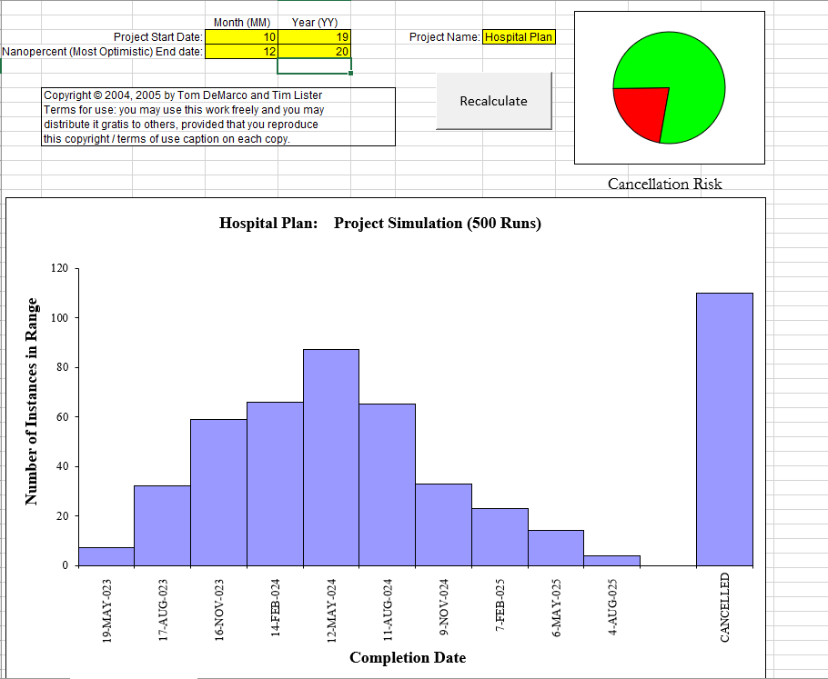

Image 1: Projects predicted outcome using the top 10 most important risks described above, done using Riskology

# Budget modifications due to Risks

An overall percentage of the risks worst-case scenario, and best-case scenario was developed in order to assume the 2 more extreme outcomes. This percentage was then either applied to a specific category within the projects budget or added to the overall projects costs as a safety cushion.

|  |  |  |  |  |
| --- | --- | --- | --- | --- |
| Risk ID | Worst – Case Penalty (%) | Best – Case Penalty (%) | Critical Error (%) | Project Stages Involved |
| EXEFASUPO | 15 | 2 |  | Overall Project |
| COFOARIN | 20 | 10 |  | Overall Project |
| RESSHORT | 15 | 10 |  | Overall Project |
| STAFASUPO |  |  | 5 | Overall Project |
| FISYINREADCO | 10 | 5 |  | Final Project Stage |
| DESBEIN |  |  | 20 | Overall Project |
| LOTEMO | 30 | 15 |  | Development Stage |
| EXTURDIPRO | 70 | 10 |  | Overall Project |
| ESTARIN | 25 | 15 |  | Overall Project |
| CLIHAINEX | 45 | 20 |  | Overall Project |
| TOTAL | 230 | 87 | 25 |  |

The following tables shows the final budget increase if all the detected risks described above would happen during the project. We calculated the worst-case scenario of a budget increase for our project and the best-case scenario. Ideally, we would use the best-case scenario as our overall budget. It is important to note that the risks whose existence could cause the project to fail where not taken into consideration, as no matter how much money we throw at them they will not be fixed.





# Total Budget Modifications due to oversight

The overall increase in total budget in comparison with the previous Budget developed was due to an error being overseen until now. This error was rectified and lead us to the following overall overview of the projects budget:



The error being the dismissal of multiplying each worker overall work period by their monthly salary.

# Schedule modifications due to Risk existence