Autores:

Oscar Rubio García  
Abdullah AL-Musawi

PracticaL A

PGPI

# Practical A

## Network Organization Objectives Checklist

|  |  |
| --- | --- |
|  | Task |
|  | Me he informado de la industria del cliente y a la competencia. |
|  | Entiendo la estructura corporativa del cliente |
|  | He hecho una lista de los objetivos de negocio del cliente, empezando por el objetivo general del negocio que explica el propósito principal del proyecto de diseño de red. |
|  | El cliente ha identificado las operaciones críticas. |
|  | Entiendo el criterio de éxito del cliente, y las consecuencias de los fallos. |
|  | Entiendo el alcance del diseño del proyecto. |
|  | He identificado las aplicaciones de red del cliente. |
|  | El cliente ha explicado sus políticas de fabricantes, protocolos o plataformas aceptadas. |
|  | El cliente ha explicado sus políticas sobre soluciones abiertas frente a soluciones propietarias. |
|  | El cliente ha explicado sus políticas sobre autoridad distribuida para el diseño de la red y la implementación. |
|  | Sé cuál es el presupuesto del proyecto. |
|  | Conozco el calendario del proyecto, incluidos la fecha de entrega final y los hitos principales, y creo que es alcanzable. |
|  | Sé qué conocimiento técnico tienen mis clientes y el personal relacionado con el proyecto. |
|  | He discutido sobre el plan de formación del personal con el cliente |
|  | Soy consciente de las políticas de oficina que puedan afectar al diseño de la red. |
|  |  |

## Organization Objectives

|  |  |  |
| --- | --- | --- |
| Business objective | Info | Comments |
| System should deploy to floors 4, 6 and 7. | At bare minimum deployed to Telepathology and pathology sectors. | Critical Goal |
| System should connect both telepathology labs. |  | Critical Goal |
| System should be deployed by June. |  |  |
|  |  |  |

## Network Technical Objectives Checklist

|  |  |
| --- | --- |
|  | Task |
|  | He documentado los planes del cliente para expandir durante los  próximos dos años el número de localizaciones, usuarios y servidores. |
|  | El cliente me ha contado los planes de migración de servidores  departamentales a un centro de datos centralizado. |
|  | El cliente me ha contado los planes sobre integrar los datos  almacenados en mainframes antiguos dentro de la red de la empresa. |
|  | El cliente me ha contado los planes sobre implementar una extranet  para comunicarse con socios u otras compañías. |
|  | He documentado el objetivo de disponibilidad de la red en tiempo de y/  o MTBF y MTTR. |
|  | He documentado los objetivos de utilización máxima media de la red. |
|  | He documentado los objetivos de tasa de transferencia de la red. |
|  | He documentado los objetivos de tasa de paquetes por segundo en los  dispositivos de interconexión de red. |
|  | He documentado los objetivos de precisión y tasa de error aceptable. |
|  | He discutido con el cliente la importancia de usar tramas grandes para  maximizar la eficiencia. |
|  | He discutido con el cliente las decisiones de compromiso asociados  con tamaños de trama grandes, y el retardo de serialización. |
|  | He identificado las aplicaciones que requieren un tiempo de respuesta  más restrictivo que el estándar o inferiores a 100ms. |
|  | He discutido con el cliente los riesgos de seguridad y los requisitos. |
|  | He obtenido los requisitos de gestión de la red, incluyendo las metas de  rendimiento, fallo, configuración seguridad y gestión de contabilidad. |
|  | He actualizado el diagrama de aplicaciones de red para incluir los objetivos técnicos de las aplicaciones. |
|  | Junto al cliente, he desarrollado una lista de objetivos de la red,  incluyendo tanto objetivos técnicos como de negocio. La lista  comienza con un objetivo general e incluye el resto de las metas en  orden de prioridad. Se han marcado las metas críticas. |
|  |  |

## Technical Objectives

|  |  |  |
| --- | --- | --- |
| Technical objective | Info | Comments |
| QPath Telepathology network will be able to tackle real time image viewing. | QPath service should not be interrupted. | It could use fiber optic cable.  Critical Goal. |
| All systems will attempt to use free software. |  |  |
| Security enhancement | The security should be so highly | The security, covering the new changes and improvements provided |
| Reliability improvement for critical applications |  | Critical Goal |

## Organization Restrictions

### Business restrictions Table

|  |  |  |
| --- | --- | --- |
| Business restrictions | Info | Comments |
| Project must be finished before June | The director wants the project to be done by June. |  |
| Maximum deployment budget of 118000€ |  |  |
| The telepathology system must always connect with the other labs and at least 1 floor. |  |  |
| There will be a service migration in 2 months. | Cannot touch the data center until then. |  |
| Traumatology must be connected to the system before the due date. |  |  |
| The new lab will offer 6 new job offers. |  |  |
| No software can be installed without the permission of the IT chief, Arturo. |  |  |
| The deployment can be done now if the service in each floor isn’t interrupted. | Service hours in floor 7 start from 8:00 – 15:00 and 16:30-21:00 but might have delays sometimes. |  |
| Internet network should be expanded to floors 4, 6 and 7. | Floor 4 could need a check-up of its network. |  |
| There will be a new clinic branch being opened in the future. | Could plan for expansion of system into new branch. |  |
| New telepathology lab next door must be connected to current telepathology lab. |  |  |
| Hardware must be from brand JUNIPER for the next 2 years. |  |  |

### Technical restrictions

|  |  |  |
| --- | --- | --- |
| Technical restrictions | Info | Comments |
| All apps will be deployed in the 2nd column of servers. |  |  |
| Telepathology QPath will transfer 2-4 gigabytes per image used. | It will require enough broadband to cover the size of the images used. |  |
| Apps installed must be compatible with Windows 7 and libreOffice basic package |  |  |
| Equipment for the new lab is already established. |  |  |
| There exists approximately a 99ms delay between each connection to the data centre. |  |  |
| Switch on bottom floor is mislabelled, it’s a router. |  |  |
| Switch bought must have a minimum of 8 access ports, |  |  |

## Network apps analysis

### Basic characteristics of the network apps

|  |  |  |  |  |  |
| --- | --- | --- | --- | --- | --- |
| App name | Type of app | Is it new? | Is it critical? 1.- Very critical  2.- Some critical  3.- Not critical | Location | Comments ¿Will it still be used? ¿Will it be used in the calendar? Etc. |
| libreOffice | Software, Word editing | No | 2 | All computers in each floor |  |
| Windows 7 | Operating system | No | 1 | All computers in each floor | Needed to work. |
| Default Browser | Internet Browser | No | 1 | All computer in each floor | Needed to access critical programs. |
| WakeOnLan | Automatization of remote computers | No | 3 | Used from remote master computer. | Used only for automatization of deployment. |
| Rembo | Automatization of remote computers | No | 3 | Used from remote master computer. | Used only for automatization of deployment. |
| Clinical Registry app | Used for clinical records and radiography | No | 1 | All floor clinics. | It will almost always be used, since there is a chance the network could fail accessing the company app. |
| Analysis results app | Used for accessing results. | No | 1 | All floor clinics. | It will always be used if there is internet access. |
| 4K images app | Used for accessing images. | No | 1 | Traumatology and ophthalmology | It will always be used if there is internet access. |
| Company app | Used via the web browser. | No | 1 | All floor clinics. | It will always be used if there is internet access. |
| QPath | Real time data transfer app, uses image transfer. | Yes | 1 | Telepathology | It will be used in the future and must have uninterrupted internet access. |

### Technical requirements of apps

information has been searched on the web about each of these required parameters.

|  |  |  |  |  |
| --- | --- | --- | --- | --- |
| App name | MTBF/MTTR (Cada cuanto falla) | Cost of service shutdown | Required transfer rate | Required latency |
| LibreOffice | Low / low | Low | None | None |
| Mozilla Firefox | Medium / low | very high | 1 Mbps | low |
| Corporate History Application | Medium / Medium | high | 1 Mbps | Medium |
| Qpath | Medium / high | very high | 8 Mbps | low |
| WakeOnLan y Rembo | low / low | low | 1 Mbps | Medium |
| Videoconferencing server | high / high | high | 18 Mbps | low |
| Videoconferencing client | low / Medium | low | 3 Mbps | low |
| Instant messaging client. | low / Medium | low | 1 Mbps | Medium |
| Auto Configuration Service  of WIFI clients | low / low | low | 500Kbps | high |
| Voice over IP client | high / low | Medium | 2Mbps | Medium |
| Dropbox | low /medio | Medium | 5 Mbps | Medium |

## Network characteristics

### User characteristics table

|  |  |  |  |
| --- | --- | --- | --- |
| Users community name | Number of members | Location | Apps used |
| Traumatology Clinic, 4th floor. | 1 | 4th floor | Windows 7, LibreOffice, default browser, company app, clinical registry app, 4K images app, Analysis results app. |
| IT department. | 5 | 2nd floor | Windows 7, LibreOffice, default browser, Rembo, WakeOnLan |
| Pathology lab, 3rd floor | 6 | 3rd floor | Windows 7, LibreOffice, default browser, company app, clinical registry app, Analysis results app. |
| Secretary | 2 | 2nd floor | Windows 7, LibreOffice, default browser |
| Telepathology lab | 4 | 1st floor | Windows 7, LibreOffice, default browser, company app, QPath. |

### Network traffic generated by apps Table

|  |  |  |  |  |  |  |
| --- | --- | --- | --- | --- | --- | --- |
| App | Type of data flow | Protocols used by app | Communities that use the app | Data bases | Required Bandwidth | QoS |
| LibreOffice | Unidirectional | none | All users | Local hard drive | none | Low |
| Mozilla Firefox | Unidirectional | HTTPS | All users | Local hard drive | 1 Mbps | high |
| Corporate History Application | Unidirectional | HTTPS | Doctors | Corresponding server | 100 Mbps | high |
| Qpath | Unidirectional | HTTPS | Doctors and telepathology | Corresponding server | 150 Mbps | high |
| WakeOnLan y Rembo | Unidirectional | SSH | ITs | Corresponding server | 10 Mbps | Low |
| Videoconferencing server | Unidirectional | TCP,UDP,P2P, VoIP | ITs | Corresponding server | 500 Mbps | Medium |
| Videoconferencing client | Bidirectional | TCP,UDP,P2P, VoIP | Doctors, ITs and management | Local hard drive | 3 Mbps | Medium |
| Instant messaging client. | Bidirectional | TCP,UDP,P2P | All users | Local hard drive | 1 Mbps | Medium |
| Auto Configuration Service  of WIFI clients | Unidirectional | HTTPS | ITs | Corresponding server | 500Kbps | Medium |
| Voice over IP client | Bidirectional | TCP,UDP,P2P, VoIP | All users | Local hard drive | 2Mbps | Medium |
| Dropbox | Unidirectional | FTP, HTTPS | All users | Local hard drive | 5 Mbps | Low |

## Network elements Map

### Map depicting the location of all network elements and user communities in the system.

We will now show 1st a collection of images depicting each floor in the hospital and its elements. The first maps will show the physical locations of the hospital communities and its main switches/router/servers.

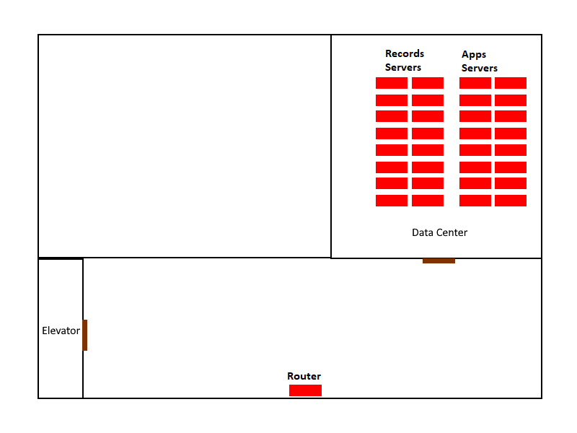

Illustration : Floor -1

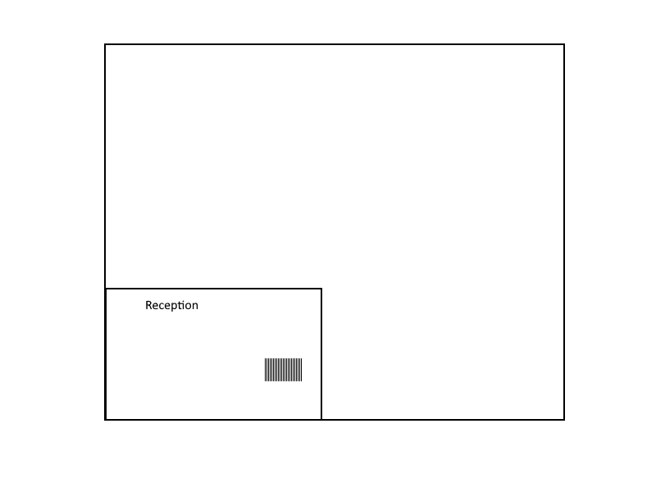

Illustration 2: Bottom Floor

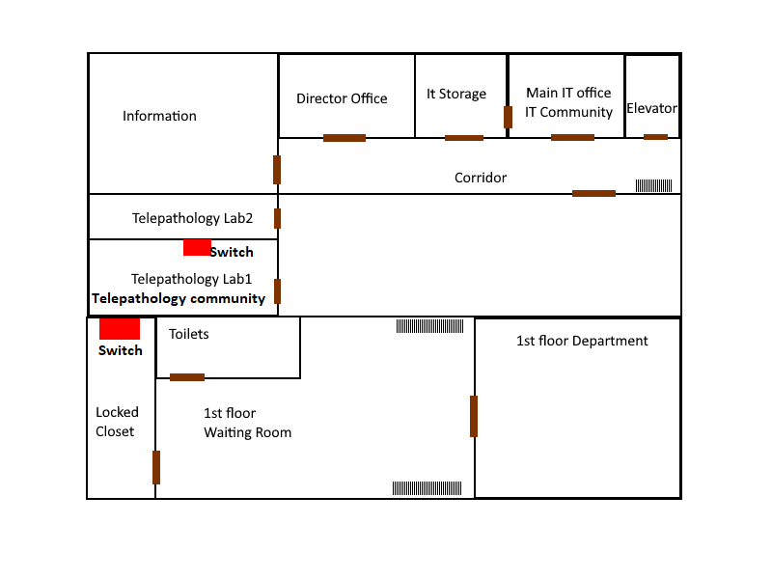

Illustration 3: 1st Floor

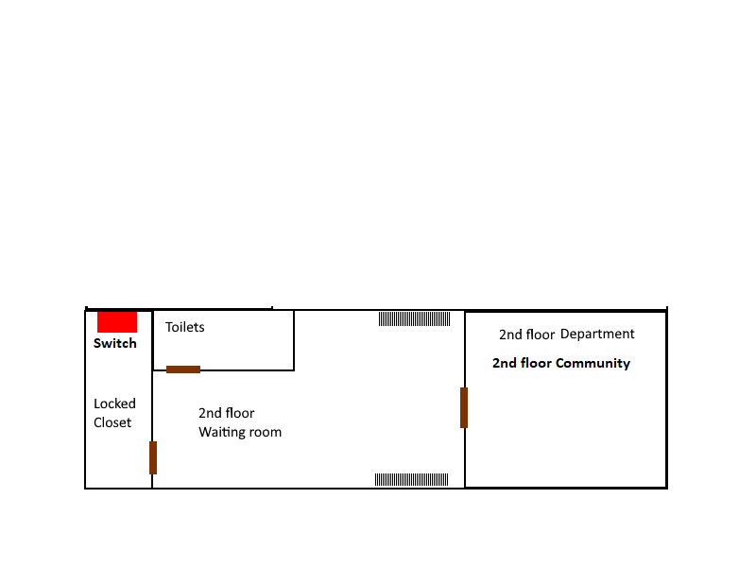

Illustration : 2nd Floor

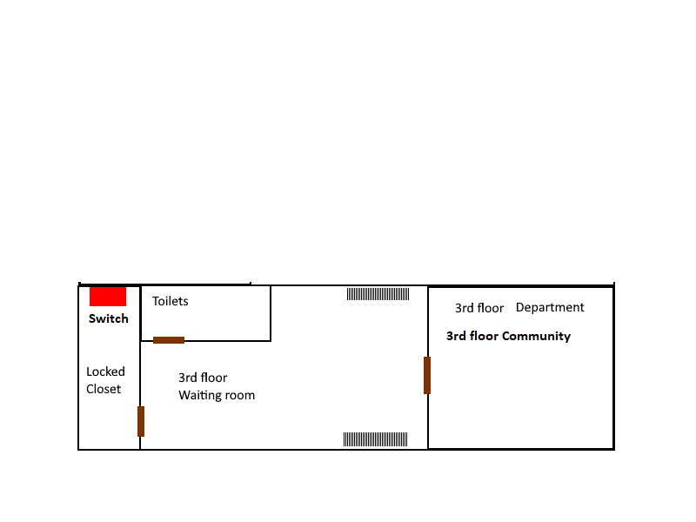

Illustration : 3rd Floor

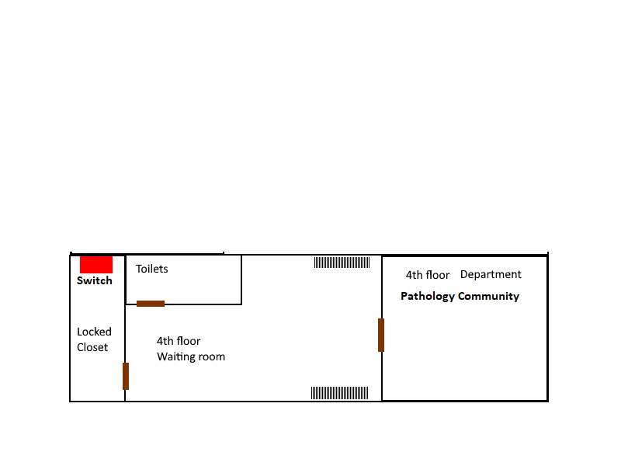

Illustration : 4th Floor

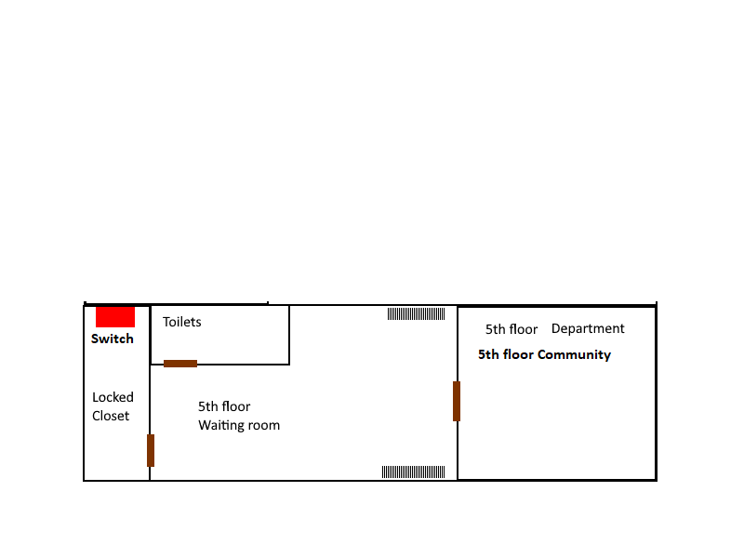

Illustration : 5th Floor

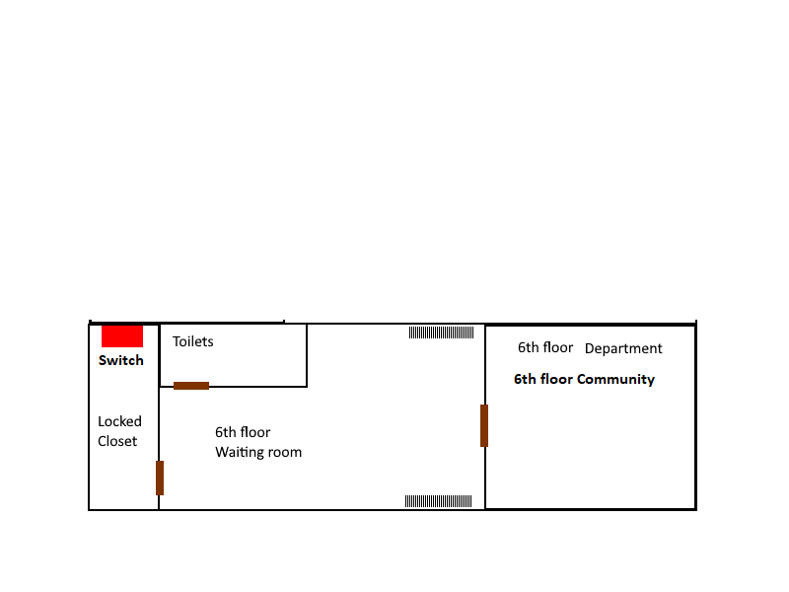

Illustration : 6th Floor

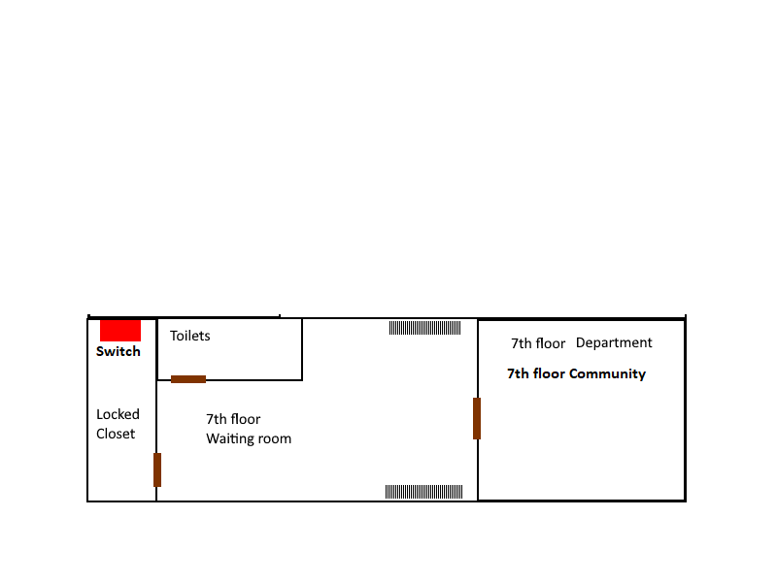

Illustration 9: 7th Floor

The following diagram will show a recap of all electronic equipment found, with its corresponding Ip addresses in the hospital. The floor is ordered color wise.

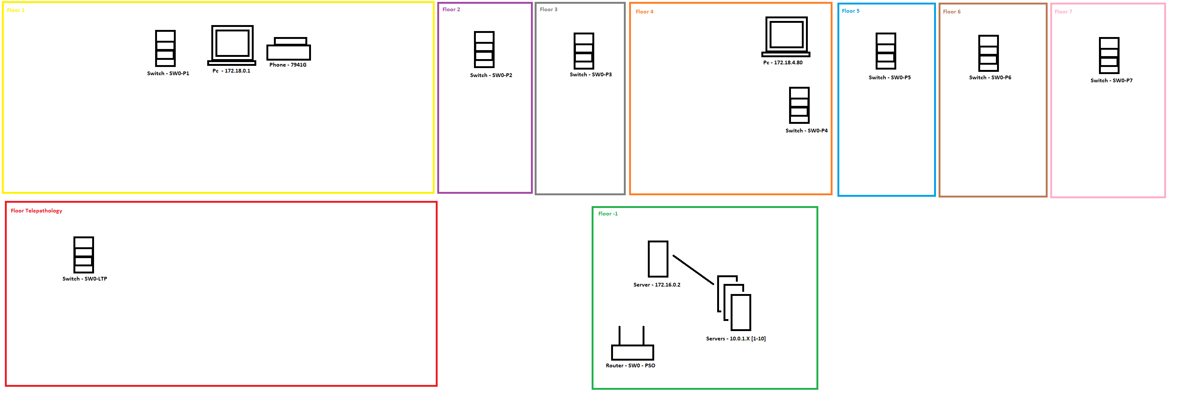

Overall, we detected the following communities:

* IT community, 1st floor.
* Telepathology community, 1st floor.
* 2nd floor community.
* 3rd floor community.
* Pathology floor community, 4th floor.
* 5th floor community.
* 6th floor community.
* 7th floor community.
* Data Center community, floor -1.

We also detected the following electronic devices:

* Floor -1,
  + Server farm: IP - 172.16.0.2
  + Servers: IP – 10.0.1.X [1-10]
  + Router – SW0 – PSO
* Floor 1,
  + Pc x6: IP – 172.18.0.1
  + Phone – 7941G
  + Switch: SW0-P1
* Floor 2,
  + Switch: SW0-P2
* Floor 3,
  + Switch: SW0-P3
* Floor 4,
  + Switch: SW0-P4
* Floor 5,
  + Switch: SW0-P5
* Floor 6,
  + Switch: SW0-P6
* Floor 7,
  + Switch: SW0-P7

We also assumed the existence of at least:

* 1 more pc and telephone in each floor, much like the ones in the 4th floor.
* Multiple additional computers at the information desk, information office, director’s office, etc.